


United Nations Development Programme

Project title: Reducing Pollution and Preserving Environmental Flows in the East Asian Seas through the Implementation of Integrated River Basin Management in ASEAN Countries
Countries: Cambodia, Indonesia, Lao PDR, Malaysia, Myanmar, Philippines, Vietnam | Implementing Partner: PEMSEA Resource Facility (PRF) |  |  |  | Management Arrangements: NGO Implementation
UNDAF/Country Programme Outcome:
Cambodia: By 2018, people living in Cambodia, in particular youth, women and vulnerable groups, are enabled to actively participate in and benefit equitably from growth and development that is sustainable and does not compromise the well – being or natural or cultural resources of future generation.

Indonesia: Strengthened climate change mitigation and adaptation and environmental sustainability measures in targeted vulnerable provinces, sectors and communities.
Lao PDR: Forests and other ecosystems are protected and enhanced, and people are less vulnerable to climate-related events and disasters.

Malaysia: Implementation of a national development agenda that enables green growth through climate - resilient measures, sustainable management of energy and natural resources, and improved risk governance.
Myanmar: By 2022, Myanmar becomes more resilient to climate and disaster risk with efficient environmental governance and sustainable use of natural resource.
Philippines: National and local government and key stakeholders ensure that urbanization, economic growth, and climate change actions are converging for a resilient, sustainable and equitable development path of communities.
Vietnam: By 2021, Viet Nam has accelerated its transition to low-carbon and green development, and enhanced its adaptation and resilience to climate change and natural disasters, with a focus on empowering the poor and vulnerable groups.
UNDP Strategic Plan Output:
Output 1.3: Solutions scaled up for sustainable management of natural resources, including sustainable commodities and green and inclusive value chains.

UNDP Social and Environmental Screening Category: Moderate Risk |  |  | UNDP Gender Marker: 1
Atlas Project ID (formerly Award ID): 00104039 |  |  | Atlas Output ID (formerly Project ID): 00105778
UNDP-GEF PIMS ID number: 5635 |  |  | GEF ID number: 9654
Planned start date: June 2019 |  |  | Planned end date: June 2024
PAC meeting date: November 2018
Brief project description:
The project goal is to establish functional integrated river basin management mechanisms in priority river basins of 7 ASEAN countries for reducing pollution and sustaining freshwater environmental flows as well as adapting to climate change vulnerabilities.
The project objective is to improve governance and management responsiveness and capacities in integrated water resources management, pollution load reduction from nutrients and other land-based activities, protection and conservation of freshwater environmental flows, and alleviation of climate vulnerability through demonstrations, planning, and strengthening of integrated river basin management in priority river basins of 7 ASEAN countries.
Financing Plan
GEF Trust Fund |  |  | USD8,479,123
UNDP TRAC resources |  |  | USD
Cash co-financing to be administered by UNDP |  |  | USD
- Total Budget administered by UNDP |  |  | USD8,479,123
Parallel co-financing
UNDP |  |  | USD197,403
National Government |  |  | USD104,565,183
Sub-national/Local Government |  |  | USD12,132,922
JICA (Vietnam) |  |  | USD4,600,000
PEMSEA |  |  | USD296,087
- Total co-financing |  |  | USD121,791,595
- Grand-Total Project Financing (1)+(2) |  |  | USD130,270,718
Signatures
Signature: print name below |  | Agreed by Government of Cambodia |  | Date/Month/Year:
Signature: print name below |  | Agreed by Government of Indonesia |  | Date/Month/Year:
Signature: print name below |  | Agreed by Government of Lao PDR |  | Date/Month/Year:
Signature: print name below |  | Agreed by Government of Malaysia |  | Date/Month/Year:
Signature: print name below |  | Agreed by Government of Myanmar |  | Date/Month/Year:
Signature: print name below |  | Agreed by Government of Philippines |  | Date/Month/Year:
Signature: print name below |  | Agreed by Government of Vietnam |  | Date/Month/Year:
Signature: print name below |  | Agreed by UNDP |  | Date/Month/Year:

Table of Contents
I. Table of Contents 4
II. Development Challenge 5
III. Strategy 9
IV. Results and Partnerships 13
Component 1:Baseline Assessment of Source to Sea Management Continuum 15
Component 2: IRBM Pilot Projects for Improved Governance and Management of River Basins/Sub-Basins and Associated Coastal Areas 23
Component 3: Knowledge Management, Capacity Development, and Monitoring and Evaluation 39
V. Project Management 53
VI. Project Results Framework 56
VII. Monitoring and Evaluation (M&E) Plan 65
VIII Governance and Management Arrangements 70
IX. Financial Planning and Management 75
X. Total Budget and Work Plan 81
XI. Legal Context 89
XII. Risk Management 89
XIII. Mandatory Annexes 92
Annex A: Multi Year Work Plan 93
Annex B: GEF Core Indicators (at baseline) 95
Annex C: Overview of Technical Consultancies 99
Annex D: Terms of Reference 104
Annex E. Social and Environmental Screening Procedure and Plans 110
Annex F. Stakeholder Engagement Plan 128
Annex G: Gender Analysis and Action Plan 148
Annex H: UNDP Risk Log 176
Annex I: Results of the capacity assessment of the project implementing partner and HACT micro assessment 183
Annex J: Additional Agreements 184
Annex K: National IRBM Pilot Project Proposals and River Basin Profiles 200

Development Challenge
Ecosystems along a continuum from source to sea are being degraded as an unintended consequence of economic activities that might happen far upstream or downstream in the source-to-sea system (Granit. J. et al, 2017). This is happening primarily for two reasons: 1) lack of awareness and understanding of the land-to-sea ecosystem linkages and flows of water, sediment, pollutants, biota and ecosystem services; and 2) lack of adequate governance and management arrangements to address the land-to-sea linkages and the multiple sectors that are involved. The impacts of climate change currently add further stresses in river basins and coastal and sea areas in most regions of the world. It is clearly evident that the UN Sustainable Development Goals (SDG) include a number of targets that are directly dependent upon the ability of governments and their partners to overcome these barriers. This project has been designed to strengthen capacities and accelerate required changes in seven ASEAN countries in support of national priorities, objectives and commitments to these global targets.

As a region, the ASEAN economy is the seventh-largest in the world, with a combined GDP of $2.77 trillion in 2017 and it is projected to rise to fourth by 2050. With globalization, continued rapid development in the region is expected to have far-reaching global socio-economic and environmental consequences.

Water use among ASEAN countries is growing rapidly, while water quality and quantity challenges persist in such a way that the situation in some areas has threatened to derail economic growth. Increased population has intensified water usage. Water demand is increasing drastically due to rapid urbanization, industrialization and agriculture intensification and expansion, and many areas in the region are projected to be water stressed by 2025 (Lee 2013).

Most river systems in the ASEAN flow through large cities and urban areas towards and into the adjacent seas and oceans. Continental Southeast Asia (Myanmar, Thailand, Lao PDR, Cambodia, and Vietnam) is drained by five major river systems (i.e., Irrawaddy River, Salween River, Chao Phraya River, Mekong River, and Red River) whereas archipelagic Southeast Asia (Malaysia, Singapore, Indonesia, Philippines, and Brunei Darussalam) hosts several major rivers all of which directly drain into the seas. These rivers transport sediments, nutrients, and other forms of pollution to the adjacent seas and oceans which ultimately serve as pollution sinks (Table 1).

Table 1: Major Rivers/Pollutant Loadings to LMEs in ASEAN Region

Country | Number of Principal River Drainage Basins | Watershed Area of Major River Basins (km²) | % of Watershed Area in Total Land Area
Cambodia | 37 | 103,600 | 57.2
Indonesia | 131 | 1,331,000 | 69.9
Lao PDR | 31 | 148,848 | 62.9
Malaysia | 88 | 196,259 | 59.5
Myanmar | 60 | 608,400 | 90
Philippines | 82 | 178,024 | 52
Thailand | 254 | 313,003 | 61
Vietnam | <89 | 142,420 | 43
Total | <772 | 3,021,554 | 66.9

The use of these rivers and the ocean for waste disposal is a common practice across the region. A good example is marine litter. Marine litter has been recognized as a global environmental problem (GEF STAP, 2011), with negative impacts on receiving ecosystems and consequences on the food system. Specifically, the amount of plastic waste entering the global oceans has been estimated at up to 12.7 million tonnes, with East and Southeast Asian countries identified as major contributors to the problem (Jambeck et al 2015). A global model of plastic emissions further estimated that between 1.15 and 2.41 million tonnes of plastic currently flow from the global riverine system into the oceans every year. The same model identified that the top 20 polluting rivers were mostly located in Asia and accounted for more than two thirds (67%) of the global annual input, while covering only 2.2% of the continental surface area and representing 21% of the global population (Labreton et al. 2017).

Nutrient loadings in rivers and large marine ecosystems (LMEs) of the region are also a recognized threat to both fresh- and coastal water ecosystem health. The major anthropogenic sources of river nutrient loading are land runoff from fertilizer use and livestock production, domestic sewage, and atmospheric nitrogen deposition. Excess nutrients – nitrogen (N), phosphorus (P) and silica (Si) – entering coastal waters result in algal blooms, which lead to reduced oxygen conditions, increased number of dead zones in coastal waters, increased turbidity, and changes in community composition, as well as threats to human health, among other effects. In 2015, the GEF-supported Transboundary Water Assessment Programme (TWAP) identified the Bay of Bengal, South China Sea and East China Sea as high-risk areas for coastal eutrophication from nutrient loadings. Furthermore, the risk for coastal eutrophication was predicted to increase in these LMEs by 2050 based on current trends (IOC-UNESCO and UNEP (2016). Large Marine Ecosystems: Status and Trends).

Many Southeast Asia countries also face problems of deforestation in upstream areas, high sedimentation and erosion in watersheds, floods in rainy season and long droughts in dry season, and urbanization and mobilization of inhabitants surrounding the flood plains and deltas. Climate change is expected to worsen the situation significantly through impacts on hydrologic processes (IPCC 4th Assessment Report). The Third Asia-Pacific Water Summit, convened in Yangon, Myanmar in December 2017, iterated that approximately 1.1 billion people in Asia live in areas currently experiencing severe water stress. Unless significant action is taken, the number of affected populations is expected to increase by more than 40% by 2050. The outcome of the Summit, the “Yangon Declaration: The Pathway Forward”, set out a course for sustainable development in the region with a perspective on water, committing that achieving the 2030 Agenda for Sustainable Development and its SDGs can only materialize if water is valued and if water resources are effectively protected and managed for the enhancement of water security in all countries of the region.

A number of initiatives have already been undertaken at the regional and country levels, particularly related to SDG targets 6.5 and 6.6 (i.e., implement IWRM at all levels; and protect and restore forests, wetlands, rivers, etc.) and targets 14.1 and 14.2 (i.e., prevent and reduce marine pollution; and sustainably manage and protect marine and coastal ecosystems). For example, the ASEAN Long Term Strategic Plan of Action for Water Resources Management was endorsed by the ASEAN environment ministers in 2002. The vision for water in Southeast Asia by 2025 is: “the attainment of sustainability of water resources to ensure sufficient water quantity of acceptable quality to meet the needs of the people of Southeast Asia in terms of health, food security, economy and environment.” To ensure that concrete actions were undertaken, the ASEAN Socio-Cultural Community (ASCC) adopted “Blueprint 2009-2015”, which outlined a set of actions to fulfill the Strategic Objectives related to water resources management. Among others, the actions included promoting the implementation of integrated river basin management (IRBM), strengthening public awareness and partnerships to enhance integrated water resources management (IWRM), and improving regional cooperation on water conservation measures and programs as well as scientific and technological innovations in water quality improvement and supply. With respect to the coastal area and in recognition of the region’s 173,000 km of coastline, the same Blueprint committed to “ensure ASEAN’s coastal and marine environment are sustainably managed …” and “promote cooperation in addressing pollution of coastal and marine environment from land-based sources.”

At the national level, a number of the ASEAN Member States have adopted water-related/IWRM policy and practices at national and basin levels, as outlined in Table 2. Whereas some countries, notably Indonesia, Lao PDR, Malaysia, the Philippines, and Vietnam have made progress by putting in place governance mechanisms in priority river basins and developing and adopting multi-year action plans, operationalizing these mechanisms and action plans have faced difficulties. Barriers for effective national implementation are multiple including:

- Coordination and cooperation between national and basin level institutional arrangements and among the different departments and levels of government remains a challenge as a consequence of “siloed approaches” to developing and managing watershed and coastal areas on a sector-by-sector basis.
- There is a lack of available scientific knowledge and input to water resource management and environmental flows in the river basins and associated coastal areas, which could help solve conflicting uses of water and ecosystem functionality and health (e.g., extreme variations in hydraulic flow conditions as a consequence of upstream dam (hydro-electric and irrigation) operations).
- Limited technical capacity to address complex, inter-related pollution reduction problems (e.g., untreated and partially treated domestic and industrial wastewaters being discharged into the rivers and coastal waters; municipal, industrial and institutional solid wastes (including plastics) being dumped directly and indirectly into rivers and drainage systems and flushing to coastal waters; nutrient runoff from agricultural lands and livestock rearing areas; erosion and sedimentation from deforested land areas due to uncontrolled urban and agricultural development) and climate hazards (e.g., flooding; droughts; landslides; etc.) in an holistic manner.
- There is limited enforcement of policy and regulatory frameworks to protect water resources and related ecosystems.
- There is insufficient investment to meet the specific needs and conditions across the river basins and coastal areas.
- There is a lack of monitoring data and information on water quality, water quantity and water use across sectors and sources/loadings of land-based pollution.

LME projects undertaken in the region (Table 3) have also highlighted the significance of land-based pollution and its impact on the coastal and marine environment. Ongoing and planned SAP implementation programs, such as the upscaling of PEMSEA’s SDS-SEA, clearly complement IRBM initiatives of countries with their focus on transboundary issues, such as land- and sea-based pollution, habitat degradation, impairment of ecosystem services, and climate change. The investment by GEF in integrated river basin and coastal management is fully aligned with the mission of the SDS-SEA 2015 to foster and sustain healthy and resilient oceans, coasts, communities and economies across the Seas of East Asia through integrated management solutions and partnerships. The strategy specifically notes the importance of “…extending the implementation of integrated watershed development and management programmes to all major river basins, lakes, and international water systems in the region….”

Table 2: Review of IRBM-related Laws, Policies and Strategies for
River Basin Governance in the ASEAN Region

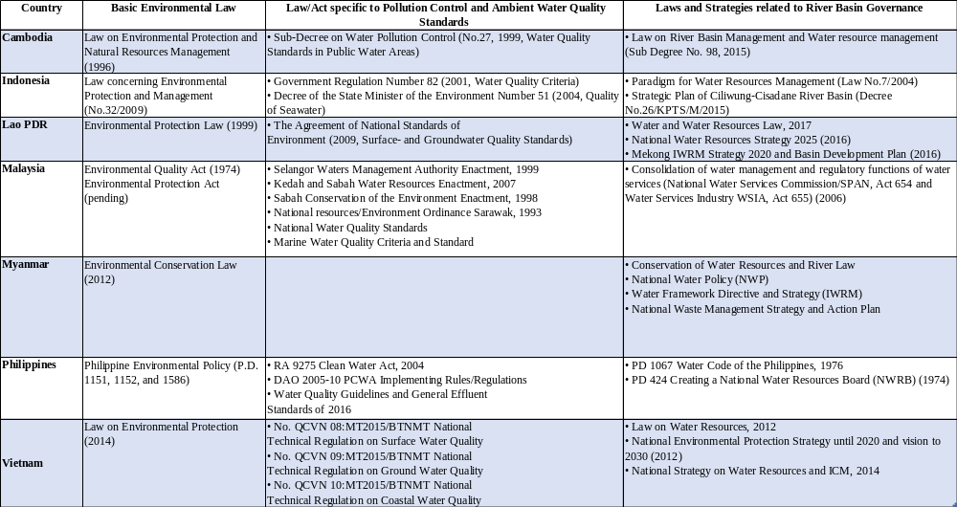

Table 3: Highlights from Transboundary Diagnostic Analyses (TDAs) and Strategic Action Programs (SAPs) of Applicable LMEs in the Asia-Pacific Region

LME (Year) | Highlights of Findings on Land-based Pollution
South China Sea and Gulf of Thailand  (TDA – 2000;  SAP – 2008) | During the late 1990s, river basins in China, Indonesia, Philippines, Thailand, Vietnam, with the exception of Cambodia and Malaysia are moderate to heavily polluted using standard water quality parameters such as BOD, nutrients (N and P), TSS and oil. The mouths of the rivers are pollution hotspots, and mitigation at the source end from both point and diffuse sources were recommended to be dealt with. The SAP identifies regional actions to support management of land-based pollution loadings into the coasts, including preparation of environmental quality guidelines and tools for dissemination and adoption in the region, including development of common methodologies that will generate comparable data among participating countries.
Bay of Bengal (TDA – 2012;  SAP – 2014) | This LME includes some of the ASEAN countries, including Indonesia, Malaysia, Myanmar and Thailand. The TDA assessed eight major contaminants using secondary data, including sewage, organic load, solid waste/marine litter, nutrients, oils (hydrocarbons), sediments, POPs and heavy metals. Most of these pollutants are a problem in varying degrees in all the 4 ASEAN countries in the 2000s. The SAP identifies as a priority, the development of national action plans to address land- and sea-based sources of marine pollution, in particular excess nutrients. It included targets to: a) reduce discharge of untreated sewage and wastewater into river, coastal and marine waters; b) reduce and control nutrient loading; c) minimize solid waste and marine litter.
Arafura and Timor Seas  (TDA – 2011;  SAP – 2014) | Indonesia is the only ASEAN country in this LME (Timor Leste, Papua New Guinea and Australia are the other countries). The TDA indicated that due to sparse population, land-based pollution impacts are largely localized and confined to areas where mining operations are ongoing or with poor catchment practices. Sediments and other pollutants are discharged to the coasts through rivers and tributaries. Objective 3.1 of the SAP aims to prevent and reduce inputs of pollutants from point land sources (wastewater, sewage and industrial) and diffused sources (land-use).
Sulu Celebes Seas (TDA* – 2014;  SAP – 2013) | The littoral countries in this LME are Indonesia, Malaysia and the Philippines. About a billion tons of sediments representing 20-25% of global sediment export were estimated from river systems in the Philippines, Borneo and Sulawesi Islands. Other pollution-related issues include solid waste, chemical contamination and oil spills and eutrophication leading to harmful algal blooms and fish kills in coastal areas. The SAP focused on fisheries and did not include specific actions to address land-based pollution. A second phase which is in the pipeline seeks to expand the scope of the SAP to include land-based pollution.
East Asian Seas: Sustainable Development Strategy for the Seas of East Asia (SDS-SEA)  (2003; revised 2015) | The SDS-SEA covers all the countries proposed in this project, except Myanmar. The SDS-SEA emphasizes the ecological significance of river basins in the region with a total watershed area of 8.6 million km². The rivers, which mostly flow within national boundaries, transport large flows of water, sediment, nutrients and pollutants into adjacent estuaries affecting the Seas of East Asia. Among the many priority strategies to address land-based pollution to maintain and enhance the quality of coastal waters is “extending the implementation of integrated watershed development and management programs to all major river basins, lakes and international water systems in the region”.

Strategy
The STAP Advisory Document, entitled A conceptual framework for governing and managing key flows in a source-to-sea continuum (Granit. J. et al, 2017), states that source-to-sea governance is a complex technical, cross-sectoral and diplomatic challenge that is ever-changing as a consequence of natural- and man-induced changes, conditions, and impacts. Source-to-sea governance processes demand adaptation and learning. Furthermore, because of conflicting and competing uses of limited resources, such governance processes are often politically charged. It is therefore essential that source-to-sea governance and management be recognized as socio-political processes driven by economic interests and political priorities, and not simply a set of scientific and engineering problems and challenges.

The theory of change framework proposed in the aforementioned STAP Advisory Document identifies four orders of outcomes in response to changing societal, economic and environmental conditions, leading to the ultimate long-term goal of sustainable forms of development. The four orders were described in the document, as summarized in Table 4, but with acknowledgement that the outcomes associated with each order do not accumulate in a strictly sequential manner in complex source-to-sea systems. The STAP Advisory Document noted that, “…the assembly of First Order outcomes at the full source-to-sea system scale often requires decades of effort and the skillful practice of adaptive management – a systematic approach for improving resources management by learning from management outcomes – as ecosystem processes evolve.”

Table 4. A theory of change framework for the governance of source-to-sea systems – measurable outcomes disaggregated into four ‘orders’. (Granit. J. et al, 2017)

Order of outcomes: Description:
First Creation of the enabling conditions for a source-to-sea governance initiative.
Second Changed behaviour of resource users and key institutions.
Third Achievement of desired changes in societal and environmental conditions.
Fourth A more sustainable and resilient source-to-sea system. Blue and green growth opportunities materialize.

This project’s strategy is in-line with the aforementioned theory of change framework, with due consideration to the varying IRBM governance and management conditions in the seven participating countries and the selected river basins. As illustrated in Table 2, most of the participting countries have IRBM-related legislation, policies, strategies and action plans in place or under development. However, as determined during the project preparation phase, there has been limited progress in operationalizing IRBM mechanisms in the 7 countries. The national level and/or basin-level coordinating organizations are performing some initial activities, such as developing action plans, communicating with stakeholders, and conducting water quality monitoring, but they have not yet been able to mount major actions aimed at the multitude of threats that are occurring in the river basins.

As a foundational project, the theory of change for this project (Figure 1) primarily focuses on the first, second and third order of outcomes as defined in the STAP Advisory Document, namely:
- First Order of Outcome: creating enabling conditions for a source- to-sea governance initiative. The project targets the development and adoption of a river basin strategy and action plan with goals, governmental commitments, and supportive constituencies to S2S management in the selected river basins/coastal areas. The project also targets enhancing and enabling existing river basin and coastal governance mechanisms (e.g., Philippines, Indonesia, Vietnam, Malaysia) and setting up and enabling new governance mechanisms (Cambodia, Lao PDR, Myanmar).
- Second Order of Outcome: changing behaviours of resource users so that stresses in the source-to-sea system are reduced. The project will achieve this outcome in a pilot demonstration site within the selected river basin/coastal area in each country. The focus will be to create working and sustainable solutions to priority problems/issues within the river basin, but at a pilot scale. The working solutions will be used as learning experiences for leaders, managers, practitoners and beneficiaries of the resources, as a basis for enacting change across the entire river basin, and replication to other river basins.
- Third Order of Outcome: achieving desired changes in societal and environmental conditions. The project will build capacities and experience in “how” to achieve desired societal and environmental changes, through development and demonstration of solution packages/templates at pilot demonstration sites that cut across the key issues in the S2S continuum under a variety of political, social and economic conditions in the 7 countries.

The project strategy is to apply a solution-oriented approach that builds on the existing foundation of IRBM and ICM governance mechanisms at the national and river basin/coastal area levels, including the framework of laws, strategies and action plans that have been adopted. The project strategy focuses on:
- Improving stakeholder awareness and understanding of the interconnectiveness of the environment, economy and society in the respective river basins and coastal areas, including gender-related concerns and women’s empowerment, with the development and implementation of a State of River Basin reporting system that will employ a common sets of indicators and monitoring protocols to allow comparative analysis across source-to-sea systems.
- Assessing and strengthening governance systems, identifying issues that can be addressed, and ensuring that the planned courses of action beyond the life of the project are calibrated to the particular strengths and weaknesses of the governance systems and capacities of the institutions and stakeholders involved.
- Piloting stress-reduction projects that address priority hotspot issues/problem locations in each river basin on a “no-regrets” basis, thereby facilitating a learning-by-doing approach within the governance system and across the various stakeholder groups. This approach is designed to help national and local governments, communities and other users and beneficiaries of the freshwater/marine water resource learn from their experiences and ultimately transfer proven templates, good practices and experiences into scaling up interventions, increasing the efficiency and effectiveness of IRBM programs, and building sustainability.
- Promoting cooperation between the private sector and government through co-engagement in the identified pilot projects, including the application of financing mechanisms and partnership
Figure 1: Theory of Change for Integrated River Basin Management in 7 Priority River Basins of ASEAN Countries

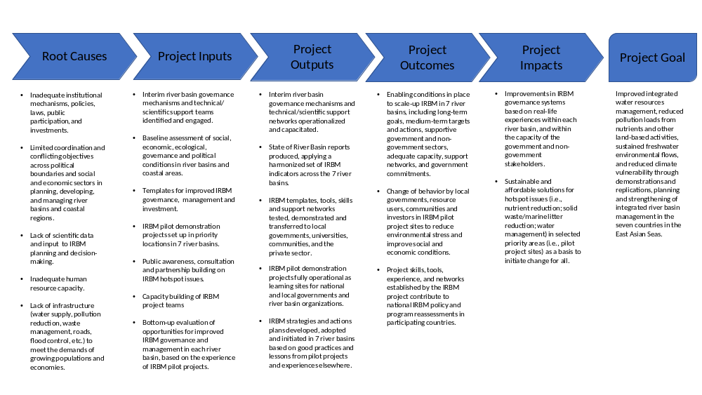
arrangements that are acceptable to and within the capacity of the private sector and local communities, and which will serve as a template for scaling up good practices in improved governance and management at the basin level and across river basins.
- Sharing knowledge and developing capacities in IRBM development and implementation within each river basin through training and hands-on experience, and establishing a regional knowledge platform to share experiences, tools and templates across sites in a coordinated action to improve source-to-sea sustainability through collaborative learning. In addition, each pilot project includes training, monitoring and evaluation, knowledge building, communication and information dissemination as an integral part of the pilot work to capacitate and inform local stakeholders.

A priority ingredient of the project strategy is the integration of developing and operating sectors in the river basins and coastal areas into an interconnected, cooperating network of stakeholders and decision-makers applying the IRBM and ICM methods under the “source-to-sea system” principle. A critical factor is effective river basin governance with appropriate representation from the different levels and sectors of
government, the scientific community, private sector/industry, women, community groups (e.g., farmers; fishers), and other relevant NGOs. These governance mechanisms need to be operationalized with the mandate and authority to ensure that environmental priorities and activities in each river basin and associated coastal area are not trailing behind or remaining independent of economic development plans and activities, but are in the mainstream of such plans and activities.

The project is firmly rooted in the GEF International Waters (IW) focal area. With respect to the GEF 6 IW Strategy, the project falls within the IW 2 focal area, “Catalyze investments to balance competing water uses in the management of transboundary surface and groundwater and enhance multi-state cooperation”, and specifically Program 4 “Water/Food/Energy/Ecosystem Security Nexus” and Program 5, “Reduce Ocean Hypoxia”. Garnering support for achieving enhanced governance and management of river basins and associated coastal and marine resources ultimately is dependent upon aligning LME and sub-regional sea area SAP objectives and priorities (Table 3) with IRBM strategies and action plans as well as national and local socio-economic development goals.

Over the past few years, valuable experiences have been gained in addressing environmental degradation and improving governance and management within source-to-sea systems, which support the project’s strategy. There have been several long-term initiatives to remedy downstream impacts of large-scale water diversion, to reduce pollutant loads, and to improve the planning of multiple activities in different regions of the world including the East Asia Seas region; the Bay of Bengal; the Danube River and the Black Sea; the Baltic Sea; the Caribbean; and the Colorado River, its delta and the Gulf of California. Some of these initiatives have been supported by the GEF, as summarized in the STAP Advisory Document.

In East Asia, Integrated Coastal Management (ICM) has been demonstrated by PEMSEA and other organizations to be an effective, multi-stakeholder approach in addressing multi-variate threats to coastal habitats and marine ecosystems, and the basis for laying out a roadmap for sustainable development across the region, i.e., Sustainable Development Strategy for the Seas of East Asia. This IRBM project builds on the lessons learned from the 15 to 20 years of ICM planning and implementation at sites located in Cambodia, Indonesia, Lao PDR, Malaysia, Philippines and Vietnam, as a means of leveraging structured and sustainable stakeholder buy-in to development and conservation priorities. In December 2017, it was estimated that countries have scaled up ICM programs to cover 18 percent of the coastline of the East Asia region’s 234,000 km coastline (PEMSEA Annual Report, 2017). This has been underpinned by the strengthening of institutional and individual capacity at the national and local levels, setting up an East Asian Seas Partnership Council comprised of 11 Country Partners and 21 Non-Country Partners to oversee and guide the implementation of the regional sustainable development strategy, organization of a regional network of more than 50 local governments sharing experiences in and promoting sustainable development of coastal and marine areas of the region through ICM, and establishment of 15 ICM Learning Centres in universities across the EAS region.

Different management approaches, such as IRBM, ICM and IWRM are often implemented jointly and PEMSEA’s demonstration project in Lao PDR provides a good example of this. The Sedone Integrated River Basin Management Project (SIRBMP) is the first project in southern Lao PDR that promotes an interprovincial and multisectoral approach to manage the resources in a river basin, as a collaborative effort among three provinces, the Department of Water Resources, and PEMSEA. The SIRBMP provides capacity development in rapid appraisal, river basin strategy and implementation plan development, project implementation, communication and awareness building, information management, and other activities.

The experience gained from these various S2S initiatives has confirmed the long-term commitment that is required to understand and begin to address source-to-sea system degradation. This is primarily a consequence of the complexity and scope of source-to-sea systems. It takes long periods of sustained effort and investment to achieve changes and then to mainstream practices that operationalize a source-to-sea approach through changed behavior.

Acknowledging that S2S implementation requires time and rigorous dialogue, the GEF 6 IW Strategy emphasizes foundational support for building the capacity of institutional structures. The strategy developed and applied in this project is consistent with the GEF 6 IW Strategy as well as the priorities and needs of the participating countries as identified during the Project Preparation Phase. By combining:
- efforts to improve understanding of various S2S governance, socioeconomic, ecological conditions, gaps and needs in the seven priority river basins and associated coastal areas; with
- pilot projects aimed at providing on-the-ground solutions to key issues;
- proven templates for further up-scaling and replication; and
- hands-on training, experience building and information sharing in participatory planning, development and implementation of IRBM governance and management solutions across the seven participating countries;

The project will meet the foundational objective of the GEF IW 6 Strategy to build the capacity of the river basin governance mechanisms, as well as the needs of countries to have working templates, tools and approaches that solve real problems in S2S systems and provide the means to scale-up and replicate elsewhere.

Results and Partnerships

Expected Results

Project Goal, Objective, Outcomes and Outputs/Activities

The project goal is to establish functional integrated river basin management mechanisms in priority river basins of 7 ASEAN countries for reducing pollution and sustaining freshwater environmental flows as well as adapting to climate change vulnerabilities.

The project objective is to improve governance and management responsiveness and capacities in integrated water resources management, pollution load reduction from nutrients and other land-based activities, protection and conservation of freshwater environmental flows, and alleviation of climate vulnerability through demonstrations, planning, and strengthening of integrated river basin management in selected countries in the East Asian Seas.

In order to achieve the above objective, the project’s intervention has been organized in three components.

Component 1: Baseline Assessment of Source to Sea Management Continuum
Component 2: IRBM Pilot Projects for Improved Governance and Management of River Basins/Sub-Basins and Associated Coastal Areas
Component 3: Knowledge Management, Capacity Development, and Monitoring and Evaluation

The expected outcomes under each of the three components, and the outputs and activities planned to achieve them, are described below.

Each country has selected a priority river basin for the project (see Annex K for details on the selection process). The criteria used in the selection of the priority river basins were developed and agreed to by the participating countries during the Project Preparation Phase and were stated in the form of 6 questions, namely:
- Is the candidate site identified as a priority river basin by the national government? Why?
- Is the receiving near coastal area and sea area identified as a priority coastal and marine area? Why?
- Is there an adequate foundation of information and knowledge of the candidate site?
- Are there previous or ongoing programs or projects at the candidate site covering governance and management?
- Are scientific data available for decision-making and planning in the source-to-sea system covering land resource and water system? Who has the data? How are the data shared and used?
- Is there investment by governments, donors, the private sector and others in river basin/coastal area planning and development. Who is investing and what are the investments for?

The countries agreed that if the answer was “NO” to three or more of the six questions, then the candidate site may not be appropriate site for the IRBM project, given its objectives, budget and limited duration. The final selections are summarized in Table 5.

River basin profiles were completed for the priority river basin by national Technical Working Groups and are included in the National IRBM Project Proposals (Annex K). The pre-project IRBM governance situation at the national and river basin levels in each country is summarized in Figure 2.

Table 5: Country Selection of Priority River Basins

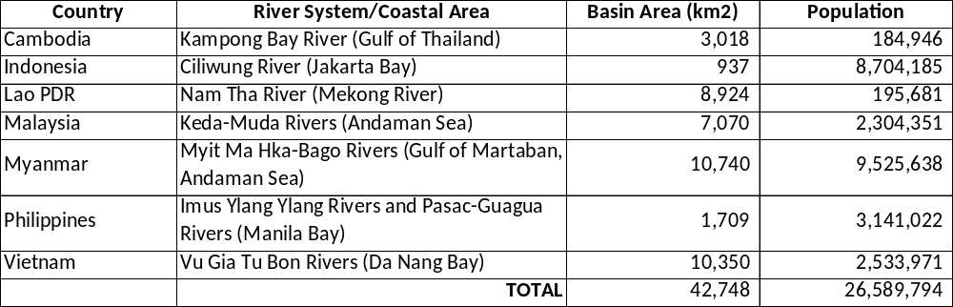

Figure 2: IRBM Governance at the National and River Basin Levels in Participating Countries
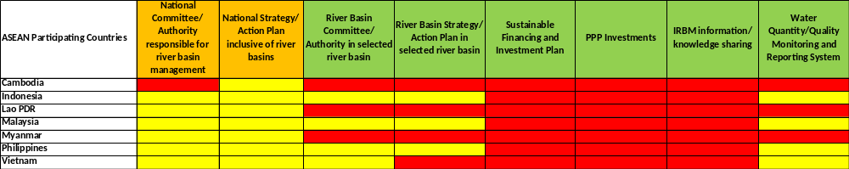

Component 1: Baseline Assessment of Source to Sea Management Continuum
The principal challenges to be addressed in this component are building awareness and consensus among the different government authorities, users and beneficiaries of the priority river basins on the need and benefits of a holistic and integrated approach for a source-to-sea management continuum. This will be achieved through: a) gathering and consolidation of available information and data from the many different sectors that have authority, responsibility and/or operate in the river basins and coastal areas, including national agencies responsible for agriculture, fisheries, mining, forestry, tourism, transportation, water resource management, environment, etc., as well as local governments, scientific institutions/universities, NGOs and communities (Outputs 1.1.1, 1.1.2, and 1.1.3); b) forecasting future growth and development and the potential benefits and impacts of such development (Outputs 1.1.4 and 1.1.5); and c) packaging, reviewing and validating the information in collaboration with the different government authorities, users and beneficiaries of the selected river basins and coastal areas to identify and confirm the needs and benefits of an IRBM approach for a source-to-sea management continuum (Output 1.1.6).

To ensure cross-site comparability, this Outcome will be linked with Outcome 3.1: A common set of IRBM indicators adopted and implemented by 7 countries for monitoring and evaluation of progress. The agreed indicators will be used in the preparation of a State of River Basin (SORB) report. The SORB report will be patterned after PEMSEA’s State of Coasts (SOC) reporting system or similar framework being planned or implemented in the ASEAN Region. The SORB reporting system will consolidate information coming from administrative, social, economic and environmental sectors for purposes of: (a) establishing baseline conditions in a river basin/associated coastal area prior to the startup of an IRBM program, including changes that are clime related; (b) assessing progress, achievements and shortcomings of ongoing IRBM programs by determining changing conditions with respect to governance and social and economic conditions, as well as trends and/or emerging environmental issues; and (c) developing recommendations for continual improvement of IRBM programs for consideration by national and local governments and other relevant stakeholders in each river basin/coastal area.

The anticipated benefits of the SORB reporting system include:
- SORB is a reporting and monitoring instrument designed for use at the river basin level. It will provide a systematic approach to organize and present multi-faceted information, facilitate multisectoral participation, interaction and awareness building in river basin and coastal area governance, and enhance local government and river basin organization leadership among its constituents.
- SORB will provide local governments and river basin organizations with information on changing social, economic and environmental conditions in the area, and outline the potential impacts and implications of such changes.
- SORB will spell out the issues and perspectives of the community, including women, on the benefits and challenges in sustainable river basin and coastal development, and the effectiveness of the IRBM program in deriving benefits.
- SORB will offer recommendations for consideration by local governments and river basin organizations to address unsustainable trends and emerging problems through improvements in IRBM programs.

The expected outcome of this effort is an enhanced level of awareness of the need for improved governance and management of the respective river basins and coastal areas among the general public and the principal users of the natural resources, and commitments to be part of the development and management processes.

The outcomes envisaged under Component 1 are described in more detail below.

Outcome 1.1: Improved understanding of governance, socioeconomic, ecological conditions, gaps and needs of priority river basins/Sub-Basins and Coastal Areas

Output 1.1.1 Bio-physical profiles prepared/updated covering: a) land uses in the watershed and coastal delta, including significant planned development; b) conjunctive uses of water; c) changes and trends in river water flows and quality over time (including groundwater if available); and d) other biophysical considerations.
Activities under Output 1.1.1 will build on and supplement information that has been collected during the project preparation phase (see river basin profiles in Annex K). While there has been a substantial amount of effort already made to develop baselines for the selected river basins and associated coastal areas in Indonesia, Malaysia and the Philippines, the information has not been collated and analyzed from a multi-sectoral/multi-stakeholder perspective, which is an essential aspect of IRBM and the SORB reporting system. Other selected river basins and coastal areas in Cambodia, Lao PDR, Myanmar and Vietnam have not previously undergone baseline assessment. A common set of process, stress reduction and impact indicators developed under Outcome 3.1 will be used by countries to prepare their respective SORB reports.

PEMSEA’s Integrated Information Management System (IIMS) (or similar database that may be available and functioning in a participating country) will be employed to store and analyze governance, demographic, socio-economic and environmental data for input to the SORB baseline assessment reports. These data will also serve as input into total pollutant loading and water use analyses (Activities 1.1.4 and 1.1.5). The two analyses will provide forecasts of water demand among sectors, as well as the potential impacts resulting from conflicting and competing uses of freshwater resources and receiving marine waters.

Activities for Output 1.1.1
Regional:
In collaboration with participating countries, river basin organizations and ongoing and planned projects and programs dealing with ICM, IWRM and IRBM:
1.1.1.1 Develop a State of River Basin (SORB) reporting template and process covering bio-physical, socio-economic, demographic, ecological, governance and management characteristics in the priority river basins, including climate-related issues.
1.1.1.2 From Outcome 3.1, incorporate a series of common indicators into the SORB template, including methodologies and metrics to be used to collect and analyze data and information for input to the SORB report. Indicators will be gender specific where relevant.
1.1.1.3 Prepare and disseminate a Guide for SORB Reporting to be used as a resource document for planning, implementing, consulting stakeholders, and preparing SORB baseline and SORB progress reports.
1.1.1.4 As may be required, refine PEMSEA’s River Basin-Integrated Information Management System (RB-IIMS) to serve as a data and information management and analysis support system in the 7 priority river basins, and particularly for the preparation of the SORB baseline and succeeding progress reports.
1.1.1.5 Prepare and disseminate a User’s Manual for the RB-IIMS software.
1.1.1.6 Organize and conduct regional and national training workshops on the development and application of the SORB reporting system and the transfer and application of the RB-IIMS software to local river basin organizations/Project Teams.

Participating Countries:

1.1.1.7 As directed and guided by the river basin organizations, and with the assistance of the Regional Project Management Unit (RPMU) hosted by PEMSEA Resource Facility (PRF), the local Project Teams will:
- prepare a work plan, schedule and budget for the development and implementation of the SORB baseline report and identify a multi-sectoral task team to coordinate, manage and implement the work plan.
- as confirmed in Activity 1.1.1.2, gather relevant and available secondary bio-physical data on the river basin and associated coastal region (e.g., land uses in the watershed and coastal delta, including significant planned development; b) conjunctive uses of water; c) changes and trends in river water flows and quality over the past 5 years (i.e., 2012-2017), other biophysical considerations and implications of forecast growth and development.
- upload the biophysical data and information into the RB -IIMS or equivalent GIS-based data management system for storage, accessibility and analysis.
- collate and analyze the biophysical data, information, trends and changes using the common set of indicators and metrics agreed to in Activity 1.1.1.2. and incorporate the information into the draft SORB report.

Output 1.1.2 Socio-economic and demographic profiles prepared/updated covering existing and forecast growth/development in the respective river basins/sub-basins and coastal areas.
Activities under Output 1.1.2 are designed to provide insights into existing conditions and potential changes due to economic and population growth in the selected river basins and associated coastal areas. All of the selected river basins in this project have been significantly pressured due to rapid economic growth and associated population growth, which eventually has put pressure on environmental flows of the river basin and coastal area due to pollutant loadings and/or changes in water quality or water quantity, as identified in Annex K. Output 1.1.2 will provide information on the changes and trends in socio-economic characteristics and demographics, disaggregated by gender, in the selected river basins and coastal areas over the years and their likely impact on environmental flows, as well as an analysis of the potential impact of future economic activities,population growth and climate-related hazards. This output will provide decision-makers and planners with material for prioritizing land- and water-use planning and management, as well as identify information gaps that need to be addressed through targeted research and/or monitoring and evaluation programs.

Activities for Output 1.1.2

Regional:
1.1.2.1 Develop/adapt the methodology and template for conducting a socio-economic survey in the selected river basins and coastal areas to gather primary data, disaggregated by gender, on community perspectives on socio-economic and environmental conditions in the river basin and coastal areas, the root causes, including climate-related hazards, and options for improving the situation, including participatory planning and implementation of IRBM programs and investments.
1.1.2.2 Organize and conduct a regional training workshop on the planning and implementation of the community-based survey, including the storage, collation and analysis of data and information gathered.

Participating Countries:
1.1.2.3 Using the socio-economic and demographic indicators and metrics confirmed in Activity 1.1.1.2, including gender disaggregated data and information as may be relevant, and with the assistance of the RPMU, the local Project Teams will facilitate:
- the development and/or updating of socio-economic and demographic profiles in each of the river basins and coastal areas, identifying documented changes and trends over the past 5 years (i.e., 2012-2017) and forecast growth/development in the respective river basins and coastal areas.
- the organization and conduct of interviews/surveys of communities/sectors of communities in the river basins and coastal areas, including women and indigenous populations, to determine the various perspectives on social, environmental and economic conditions and priorities as well as gaps and needs to improve the situation.
- incorporation of socio-economic and demographic data into the RB-IIMS system for storage and analysis.
- collation and analysis of socio-economic and demographic data, survey results and related information on trends and changes and incorporate the results into the draft SORB report.

Output 1.1.3: Governance and management systems assessed in each of the selected river basins/sub-basins and corresponding coastal areas, including IRBM and ICM institutional arrangements, policies, legislations/regulations, enforcement, stakeholder participation (including indigenous people, women and the youth), management, scientific and technical capacities, and current levels of financing for source to sea management.
Activities under Output 1.1.3 are intended to provide information on the pre-project governance and management systems across the 7 selected river basins. The key categories of information to be identified and assessed under this output include: institutional arrangements for river basin and coastal area management and their functionalities; national and local IRBM-related policies, strategies and action plans and the respective levels of implementation; legislation/regulations and enforcement processes; public awareness and participation in planning, implementation, monitoring and evaluation processes; enabling capacities and capacity development gaps and needs; and public and private sector investments and sustainable financing in support of IRBM programs. The information will be used to identify the status and gaps in sustainable governance of the priority river basins and associated coastal areas and identifying options for improving the situation.

Activities for Output 1.1.3

Participating Countries:
1.1.3.1 Using the governance and management indicators and metrics confirmed in Activity 1.1.1.2, including gender disaggregated data and information as may be relevant, local Project Teams will facilitate:
- the development and/or updating of governance and management profiles identifying changes and trends over the past 5 years (i.e., 2012-2017) and planned activities covering the following: IRBM institutional arrangements; national and local IRBM-related policies, strategies and action plans and the respective levels of implementation; legislation/regulations and enforcement processes; public awareness and participation in planning, implementation, monitoring and evaluation; enabling capacities and capacity development; and public and private sector investments and sustainable financing in support of IRBM implementation.
- incorporation of the governance and management information into the RB-IIMS system for storage and analysis.
- collation and analysis of the governance and management information, trends and changes and incorporate the information into the draft SORB report.

Output 1.1.4: Rapid assessment of land-based pollutant loadings and sources conducted using total pollutant loading models in 7 priority river basins/sub-basins; the impact of existing and planned developments and growth in the river basins assessed in the context of national and local policies and regulations as well as in the context of the corresponding TDAs and SAPs in the various LMEs, particularly with regard to the objectives and/or agreed reductions in nutrient and pollution loads from the rivers into the coastal waters and LMEs where available.
Activities under Output 1.1.4 focus on rapid assessment of major pollutant sources loadings in the selected river basins and coastal areas and their impacts on coastal and marine waters and resources. The rapid assessment is seen as an essential first step in identifying and confirming priorities and hotspot locations in each river basin, recognizing that there is currently a dearth of reliable surveillance monitoring data available. Total pollutant loading (TPL) models (as available in Indonesia, Malaysia, Philippines, Vietnam) will be applied to estimate organic and nutrient loadings (present and forecast) from domestic, industrial and agricultural point sources, as well as non-point sources of pollution including land run-off, atmospheric, as appropriate, to the coastal area and receiving marine waters. Where water quality monitoring data are available (e.g., Indonesia; Malaysia; Philippines; Vietnam), these data will be used to calibrate the TPL models and for cross-referencing and sharing across the 7 river basins. Forecasting of future pollutant loading scenarios will be conducted based on trends in socio-economic development and population growth.

Activities for Output 1.1.4
Regional:
1.1.4.1 Organize and conduct river basin-level training workshops on the application of TPL modeling (Cambodia, Lao PDR, and Myanmar), model validation and forecasting, and interpretation of results in the context of total pollutant loadings to coastal and marine waters and their potential impacts.
1.1.4.2 Provide technical assistance for the development and implementation of TPL modeling in the respective river basins and coastal areas.
1.1.4.3 Prepare and publish a summary report based on the information shared, discussions and outcomes of the TPL modeling, including lessons learned and good practices in the 7 river basins and in the context of nutrient and pollution loads from the 7 priority rivers into the coastal waters and LMEs.

Participating Countries:
1.1.4.4 The local Project Teams will facilitate:
- the organization and conduct river basin-level workshops on TPL modeling, data and information requirements and sources, delineation of hotspot issues and locations within the river basins and coastal areas, and pollutant loading impact analyses, with representation from relevant national and local government agencies, universities, scientific institutions and other projects and programs with available data, experience and/or capacity in the application of TPL models.
- coordinating the implementation of the TPL modeling/rapid appraisal including:
- developing the TOR and work plan and budget for the conduct of TPL modeling/rapid assessment of existing and forecast total pollutant loadings for the river basin and coastal area, hotspot locations/sources in the river basin, as well as scenario building to evaluate the impact of different pollutant load reduction options and their impact on the coastal and marine waters and ecosystem services;
- issuing a consultancy contract/subcontract for the TPL modeling/rapid appraisal;
- gathering data and information for input to the TPL model/rapid appraisal;
- organizing and conducting river basin-level consultations/workshops to review and validate the results of the draft TPL modeling/rapid appraisal, including pollutant loading sources and forecasts, hotspot issues and locations within the river basin, and scenarios for pollutant reduction and impacts in coastal and marine waters.
- preparation and dissemination of a final TPL/rapid appraisal report on the river basin and coastal area, including conclusions and recommendations on pollutant sources, hotspot issues and locations within the river basin and coastal area, and scenarios for pollution reduction/mitigating impacts in receiving coastal and marine waters.
- incorporation of the TPL/rapid appraisal information, forecast trends and changes into the draft SORB report using the common set of indicators and metrics agreed to in Activity 1.1.1.2.
Output 1.1.5: Competing uses and users of water analyzed to assess existing and future water uses and the implications on the applicable water/food/ energy/ecosystem security nexus at the basin/sub-basin level.
Output 1.1.5 is intended to provide a better understanding of conflicts in water resource management that occur in the selected river basins and coastal areas as a consequence of existing and future water uses and the implications on the applicable water/food/energy/ecosystem security nexus. The initial step towards a comprehensive assessment will be implemented during this foundational phase, namely: a) a review of available scientific research, environmental monitoring and reporting, projects and programs undertaken in the areas, including risk/vulnerability assessment related to climate change and other natural and man-made hazards; and b) stakeholder consultations/surveys to identify perspectives and anecdotal information on changes and trends that have evolved that are relevant to water/food/energy/ecosystem security nexus, as identified in Activities 1.1.2 through 1.1.4.

Leading institutional stakeholders within each of the participating countries will be engaged in jointly analyzing available information, summarizing key issues facing local users and policy makers, and preparing a template for identifying and assessing water/food/energy/ecosystem security nexus in river basins and coastal areas in the context of pollution and climate change disruptions.

Among the deliverables under this output, a guidance toolkit will be developed that, for example, identifies particular vulnerable areas and issues in river basins/coastal areas that could potentially impact the local economies, livelihoods of coastal communities, the ecosystem goods and services communities are reliant on, and the respective and collective roles of men and women. The indicators incorporated into the tool kit will be generated under Outcome 3.1.

The information generated in Output 1.1.5 will be incorporated into the SORB baseline report, including identification of information gaps and needs as well as conclusions and recommendations for follow-on targeted research and environmental monitoring and reporting over the longer term. The longer-term effort will be designed to provide governments and river basin organizations with comprehensive and ongoing feedback on changes and trends in environmental flows and the water/food/energy/ecosystem security nexus as a consequence of improved IRBM programs.

Activities for Output 1.1.5
Regional:
1.1.5.1 With participation by relevant national institutions, regional organizations and programs and S2S specialists, undertake a review of available scientific research, environmental monitoring and reporting, projects and programs undertaken in the ASEAN region and beyond that are relevant to water/food/energy/ecosystem security nexus, including climate change hazards.
1.1.5.2 Based on the results of Activity 1.1.5.1, complete a collaborative assessment of relevant issues and threats to existing and future water uses in each of the 7 river basins and coastal areas on environmental flows and the water/food/energy/ ecosystem security nexus.
1.1.5.3 Prepare summary reports on each selected river basin and coastal area and submit the reports to the river basin organizations in each participating country for review and incorporation into the SORB baseline reports.
1.1.5.4 Prepare a guidance toolkit, e.g., providing guidance to policy-makers and river basin organizations on identifying particular vulnerable areas and issues that could potentially impact the livelihoods of coastal communities and the ecosystem goods and services they are reliant on.

Output 1.1.6: Information and knowledge gained from the profiling and modeling activities consolidated into baseline assessments (SORB) for the 7 priority river basins and coastal areas, including existing and forecast conditions, gaps and needs in governance and management; baseline assessments disseminated to national and local governments and other concerned stakeholders in the respective countries for validation, awareness and consensus building.
Output 1.1.6 focuses on the preparation of a consolidated State of River Basin (SORB) report that incorporates the river basin profiling, modeling, stakeholder consultations and surveys, as well as the results of the regional collaboration on environmental flows and the water/food/energy/ecosystem security nexus. The SORB baseline reports will provide the foundation for IRBM program development, implementation, monitoring and evaluation, and updating and improving processes. A second SORB report will be prepared in Year 5 of the project to assess changes, progress and improvements that have occurred as a consequence of the project and to provide guidance further refinement and improvement of IRBM governance and management programs. The specific objectives of the SORB reporting system are as follows:

SORB Baseline Report (to be completed prior to IRBM program start-up)
- Gather comprehensive qualitative and quantitative baseline information on the demographic, socioeconomic, environmental status, as well as management actions in a given river basin and coastal area;
- Determine existing governance mechanisms and implementing arrangements that are in place;
- Determine and prioritize pertinent issues to be addressed in an IRBM program, including pollution reduction, environmental flows, water/food/energy/ecosystem security nexus and climate change;
- Establish the social, economic and environmental conditions/benchmarks, gender disaggregated as appropriate, as a basis for comparison in future SORB reports; and
- Identify critical information gaps that will be the subject of further research and/or future monitoring.

End-of-Project SORB Report (to be completed in Year 5 of IRBM program)
- Review the scope of the IRBM program and delineate the governance mechanisms and implementing arrangements that have been put in place;
- Assess the extent and effectiveness of IRBM program implementation;
- Identify trends or changes in the social, economic and environmental status of the area, gender disaggregated as appropriate, and determine the driving forces for change;
- Assess the implications of identified trends; and
- Promote adaptive management in IRBM program implementation, in response to changing conditions.

Activities for Output 1.1.6
Regional:
1.1.6.1 Assist Project Teams to prepare final versions of the SORB baseline reports for approval, publication and dissemination.
1.1.6.2 Facilitate the dissemination of the SORB Reports regionally and globally through regional and global knowledge sharing events and uploading on the regional knowledge platform (Component 3).

Participating Countries:
1.1.6.3 The Project Teams will facilitate:
- preparation of the first draft of a consolidated SORB baseline report in accordance with the IRBM template and indicators agreed to in Activities 1.1.1.1 and 1.1.1.2, using data and information gathered and analyzed under Outputs 1.1.1 to 1.1.5.
- organization and conduct of stakeholder consultations across the respective river basins and coastal areas, including national and local government leaders, communities, universities, private sector, NGOs and women’s groups, etc. to validate the information contained in the draft SORB baseline report, and to build consensus on the priority issues, impacts, gaps, needs and potential opportunities for improving governance and management through IRBM approaches.
- following the stakeholder’s consultations, revision and updating the draft SOC including conclusions and recommendations for specific actions to be included in the river basin implementation plans as well as incorporated into national and local government development planning and budgetary frameworks.
- publication and dissemination of the SORB baseline reports to the relevant national and local government agencies and stakeholder groups and issue supporting informative materials (e.g., brochures; media briefs; infographics) to facilitate improved awareness and understanding among government leaders, policymakers and the general public on the significance of the S2S continuum in the local and national context; dissemination of SORB reports regionally and globally through the regional knowledge platform and networks (Component 3)
- in the 5th year of the project, organize a stakeholder’s workshop to plan and develop a SORB Report on ongoing IRBM Programs implementation and assessment of progress, impacts, gaps and required improvements in governance and management.

Component 2: IRBM Pilot Projects for Improved Governance and Management of River Basins/Sub-Basins and Associated Coastal Areas
In this component of the project, the focus will be on improving governance and integrated planning, development and management of river basins and associated coastal areas through Integrated River Basin Management (IRBM) in order to:
- optimize efficient use of water resources while meeting the challenges of sustainable development in the respective river basins and coastal areas;
- reduce pollution discharges into the freshwater and ultimately into the marine environment of the East Asian Seas;
- improve integrated water resource management to preserve and enhance environmental flows and reduce climate vulnerability; and
- develop and demonstrate approaches/templates for overcoming key challenges to sustainable development and management of river basins/sub-basins and assosicated coastal areas.

Based on the river basin profiles and national proposals (Annex K), certain key issues are seen to be repeatedly occurring in the 7 river basins, namely: water pollution (organic, nutrients, toxic and hazardous waste); solid waste, plastics and litter; deforestation; biodiversity loss; erosion, siltation, flooding and landslides; water security/water quality (drinking water; recreation; aquaculture); competing uses/water quantity (dams; irrigation; urbanization, domestic and industrial use); and climate change.

These issues and their environmental and socio-economic negative effects are not beyond mitigation or elimination. It will take time, and certainly everything cannot be solved in this one project. The goal of Component 2 is to establish sustainable solution templates for the challenges identified, which can then be scaled-up and replicated within the IRBM area, province/state, country, and even transferred to other countries through south-south cooperation. The major thrust of this foundational project is to enable the development and demonstration of sustainable and replicable solutions within the timeframe and budget of the project, at appropriate scales and locations, covering key selected issues identified in each country.

The project strategy adopts a 4-tier approach:
- A regional tier, being the Project Board/Steering Committee, namely the ASEAN Working Group for Water Resources Management, to review and assess the performance of the project, appraise annual work plans and budgets, and facilitate knowledge sharing and opportunities for up-scaling IRBM project results and lessons learned to relevant audiences in ASEAN.
- A national tier that facilitates cooperation and involvement of central agencies in the planning and coordination of central agency support and advisory and knowledge sharing processes to the project, and reviewing and assessing outputs in the context of contributions to national policies and programs. The national tier will have representation/participation in the activities at the river basin and pilot project levels. National agency representatives can use the experience to catalyze the development or improvement of national IRBM policies, institutional mechanisms, laws, etc. It is recognized, however, that the development and improvement of national IRBM governance mechanisms and instruments will not be deliverables under the current project due to limited project duration and budget.
- A river basin tier that facilitates the planning, coordination, management and monitoring and evaluation of the project at the river basin level, within existing river basin organizations or interim mechanisms set up during the project. The river basin tier will be comprised of representatives from responsible national agencies, local governments, non-governmental organizations and other major stakeholders in the river basin. The river basin tier will have representation at the pilot project level, and will interact regularly with the Project Teams that develop and implement activities at the local levels.
- A pilot project tier is involved in the development, implementation, monitoring and reporting of solution- and impact-oriented IRBM demonstration projects at a hotspot location in each river basin. The IRBM pilot projects will focus on governance and management priorities such as water quality improvement, pollution reduction, waste management, reforestation, and water use and conservation management at the local level. The local tier Project Teams will be capacitated through formal training and working with technical experts and professionals contracted by the project, to develop, implement and demonstrate IRBM templates that result in real-life changes at the local scale. By the end of the project, the local tier Project Teams will be enabled to use proven tools and their experience to promote and facilitate scaling up and replicating good practices and lessons to the river basin tier. The pilot sites will serve as showcases and learning centers for IRBM governance and management, which will provide real impact in the local areas while also creating knowledge, capacity development and scaling-up/replication opportunities for the river basins.

Outcome 2.1: IRBM Pilot Projects Demonstrate Governance Mechanisms and Instruments for Improved Source to Sea Management in 7 Priority River Basins/Sub-Basins and Coastal Areas.
Outcome 2.1 provides river basin organizations with hands-on experience in coordinating, guiding and overseeing real-life projects that require intergovernmental (i.e., national and local governments), multi-sectoral and community participation and cooperation to reach no-regret solutions that are acceptable, affordable and sustainable. The term “no-regret” is used in this case in acknowledgement of the fact that comprehensive scientific studies and assessments of the river basins’ and associated coastal areas’ ecosystems and environmental flows require a longer-term effort that could take years to accomplish. In the interim, the pilot projects implemented under Component 2 will use best available scientific information and professional project preparation and advice to develop options and template solutions for each hotspot location. The options, including socio-economic and environmental implications and impacts as well as financing and partnership arrangements, will be presented to the national and local governments, river basin organizations, communities, business/private sector and other stakeholder groups, including women and indigenous groups, for feedback and consensus building. Ultimately, the final decision to move forward with the implementation of one or more of the template solutions will be the responsibility of the concerned national and local governments and river basin organizations following a fully transparent process that conforms to the rules and regulations in each country.

The capital financing for the pilot projects is beyond the available budget of this IRBM project. Thus, one of the major challenges that Outcome 2.1 will address is to determine the partnership and financing structure for the pilot projects. This, in fact, is the major stumbling block currently faced by local governments and river basin organizations. By walking local governments and river basin organizations through the process of project development, financing and sustainable implementation, a legacy of approaches, experiences and networking will be created. In particular, the project will facilitate the development and assessment of financing options (e.g., public, public-private, private) and partnership arrangements. One innovative financing option to be explored is referred to as a “PPP Inclusive Growth Fund”. This option will assess opportunities for an effective and equitable financing structure that facilitates pro-active participation of the private sector, the government and the community in the financing, ownership and operation of the pilot project.

Outcome 2.1 involves 2 major outputs (i.e., detailed baseline assessments/feasibility studies; and formal agreements with national and local governments to proceed with the pilot project implementation, including financing and investment arrangements for the pilot projects. These outputs entail local Project Teams working in close collaboration with a professional support group provided by the project, as and when required. The professional support group will include specialists with international and regional experience in IRBM, technology, financing, physical, biological and social sciences, investment, law, etc., who will provide tools and guidance in the development and implementation of activities at the river basin and pilot project tiers.

Output 2.1.1 Detailed baseline assessments and feasibility studies conducted at priority hotspot locations in 7 river basins/sub-basins and coastal areas.
Output 2.1.1 will assist national and local governments and river basin organizations and Project Teams to complete detailed baseline assessments and feasibility studies of selected hotspot locations in each river basin (Table 6). The first step involves putting together the local Project Teams, comprised of representatives from relevant national government agencies, local governments, universities, community groups and the business community to plan, develop and implement IRBM projects. The projects will be socially, environmentally and economically beneficial to the local communities and the river basin/coastal area, as well as financially sustainable within the context of the capacity and willingness-to-pay of users and beneficiaries of the required infrastructure and services.

Table 6: IRBM Pilot Sites and Priorty Issues
River Basin/Country | Pilot Project Sites | Priority Issues at the Pilot Sites
- Kampong Bay River Basin, Cambodia | Kampot City | Pollution reduction/nutrient management; water resource management (i.e., environmental flows from upstream hydroelectric dam operation)
- Ciliwung River Basin, Indonesia | Depok City | Pollution reduction/nutrient management; solid waste management/marine litter/plastics management
- Nam Tha River Basin,  Lao PDR | Loungnamtha Town Proper | Reforestation and sustainable management of forests; pollution reduction/nutrient management
- Kedah River Basin,  Malaysia | Alor Setar City | Pollution reduction/nutrient management; water resource management (i.e., environmental flows from upstream hydroelectric dam operation and agricultural irrigation)
- Myit Ma Hka-Bago River Basin, Myanmar | Bago City | Solid waste management/marine litter/plastics reduction; water resource management/water security (i.e., flooding and drought conditions)
- Imus-Ylang Ylang and Pasac-Guagua River Basins,  Philippines | General Trias City  Guagua Municipality | Pollution reduction/nutrient management; solid waste management/marine litter/plastics reduction; circular economy; water resource management (environmental flows; sustainable water supply)  Water resource management (environmental flows; sustainable water supply for domestic, agricultural and aquacultural purposes)
- Vu Gia Thu Bon River Basin, Vietnam | Quang Nam Province and  Da Nang City | Pollution reduction/nutrient management; solid waste management/marine litter/plastics reduction; circular economy; water resource management (environmental flows for salt water intrusion; hydroelectric dam operation; sustainable water use/security for domestic, agriculture and aquaculture purposes)

The baseline assessment will detail existing conditions at the hotspot site, including demographics, land use, socio-economic and environmental conditions, access to environmental services, existing and potential threats to socio-economic and environmental objectives, conflicts, gaps, perspectives and capacities, including climate-related hazards. The process for completion of the baseline assessment will be very much participatory, engaging the different levels of government, political jurisdictions, sectors of the economy, and community groups, including women and indigenous groups. This will not only facilitate a comprehensive baseline, but also build awareness building and engage sectors of the community in the planning and development process.

In recognition for the need for thorough consultations, the specific area for investment cannot be identified beforehand. Thus, the activities outlined below reflect this prior need as well as the generation of requisite information for preparing the feasbility studies and investment plans. Further, the project will support pilot project proponents in securing investments for implementation.

The feasibility studies and sustainable financing mechanisms will be prepared to identify different technical, financial, economic and management and operating options for the IRBM pilot project in each hotspot location. Each pilot project will target the integration of two to three priority issues at each hotspot location, including pollution reduction/nutrient management, marine litter/plastics reduction/waste management, sustainable reforestation, water supply protection, conservation and management, and/or reductions in vulnerability to extreme climate events. The feasibility studies will also explore opportunities for applying climate smart, low carbon, and resource and energy efficient technologies and processes as part of optimizing technical, financial and socio-economic aspects of the integrated solutions.

Activities for Output 2.1.1
Regional
In collaboration with national focal agencies, local government units and other major stakeholder groups in the 7 priority river basins/sub-basins and coastal areas:
2.1.1.1 Set-up an interim coordinating mechanism at the river basin level (e.g., Cambodia, Lao PDR, Myanmar) or confirm existing river basin coordinaiting mechanisms (e.g., Indonesia, Malysiam Philippines, Vietnam) to oversee and guide the IRBM project at the river basin level, with due consideration to gender perspectives and balance in the membership and the TOR for the mechanisms.
2.1.1.2 Confirm linkages of the IRBM project to national coordinating mechanisms in each to oversee and coordinate inputs and support from responsible national agencies to the IRBM project at the river basin level.
2.1.1.3 Establish a multi-sectoral, multi-disciplinary local Project Team to plan and co-ordinate the development and implementation of the IRBM project in each river basin/associated coastal area, including the planning and implementation of solution-oriented pilot projects at hot spot locations in each river basin covering priority issues such as water quality improvement, pollution reduction, waste management, enhanced water resource management and/or reduced climate vulnerability, with due consideration to gender perspectives and balance in the membership and the TOR for the local Project Team.
2.1.1.4 In collaboration with the river basin organizations and Project Teams in each river basin:
- develop the work plans and budgets for organizing and conducting the 7 pilot projects, including the detailed baseline studies of the hotspot locations, the identification of priority projects, the conduct of professional feasibility studies, the development of sustainable financing options, and the building of consensus among national and local governments, river basin organizations and other stakeholders on the preferred options, including benefits and opportunities for both men and women;
- overseeing the implementation of the TOR and work plan and budget for the pilot projects;
- maintaining quality control over all outputs and deliverables of the professional support group and the Project Teams.
2.1.1.5 Prepare generic solution templates for: identifying, developing and implementing IRBM pilot projects; partnership agreements for national and local governments to develop and implement the IRBM pilot projects; financing mechanisms and arrangements for the capital and operating costs of the pilot projects, including a public-private inclusive growth fund or PPIG; and contractual agreements with public and private sector partners for financing, constructing, mananging, operating and maintaining, and monitoring IRBM pilot projects. The generic solution templates will be used to guide the Project Teams in each river basin through a series of processes for the start-up, operation and monitoring and evaluation of the pilot projects.
2.1.1.6 Organize and conduct technical workshops in each river basin with the Project Teams and representatives from the hotspot locations to orient each group on the TOR, work plan and solution templates, and roles and responsibilities.
2.1.1.7 Set up and implement a monitoring and reporting system and schedule for each pilot project, with regular progress reporting on the pilot projects for dissemination to the concerned local governments and river basin organizations, UNDP and GEF.
2.1.1.8 Put in place a professional project support group to advise and provide technical support/assistance to river basin organizations and Project Teams in planning, developing, implementing and monitoring IRBM pilot projects in the 7 river basins/sub-basins and coastal areas, comprised of international and local consultants and experts with environmental, technical, legal, financing, investment and socio-economic expertise/experience (including gender issues).

Cambodia:
2.1.1.9 The River Basin Organization will confirm the selected hotspot location in the Kampong Bay River Basin, namely Kampot City, as the site to be developed as the pilot project for IRBM template solutions (Annex K).
2.1.1.10 With the support of a professional support group provided by the project, the local Project Teams will develop terms of reference and implement contracts to:
- prepare a focused baseline assessment of Kampot City in the context of socio-economic and environmental conditions in the city, including climate-related hazards, as well as resulting impacts on the river basin and coastal region in line with the SORB baseline report (Outcome 1) for the Kampong Bay River Basin and associated coastal and marine area.
- prepare a comprehensive feasibility study of priority environmental threats at the hotpspot (e.g., pollution reduction and environmental flows), covering legal, administrative, technical, financial, economic, social and environmental management options for the identified IRBM pilot project; including related environmental and social risks as well as risk mitigation measures (i.e., UNDP Environmental and Social Management Framework).
- identify and evaluate potential financing, investment and partnership mechanisms for the construction and operation of the pilot facility, including public sector, private sector, public-private partnership, and public-private-people inclusive growth partnership;
- organize and conduct public awareness/public consultations to inform, gather feedback and build consensus on preferred options.
- identify and finalize the preferred option for the IRBM pilot project.

Indonesia:
2.1.1.11 The River Basin Organization will confirm the selected hotspot location in the Ciliwung River Basin, namely Depok City, as the site to be developed as an IRBM pilot project demonstration and learning site for IRBM template solutions (Annex K).
2.1.1.12 With the support of the professional support group provided by the project, the local Project Team will develop terms of reference and implement contracts to:
- prepare a focused baseline assessment of Depok City in context in the context of socio-economic and environmental conditions in the city, including climate-related hazards, as well as existing and forecast impacts on the river basin and coastal region in line with the SORB baseline (Outcome 1) for the Ciliwing River Basin and coastal and marine area.
- analyze and prepare a detailed professional prefeasibility study, identifying options for “Leapfrog” and “Holistic Solutions” approach to solving multiple issues (i.e., polluton reduction; solid waste management/marine litter/plastics), inclusive of community-based solid waste management and small-scale industry wastewater treatment options; including related environmental and social risks as well as risk mitigation measures (i.e., UNDP Environmental and Social Management Framework).
- identify and evaluate potential financing, investment and partnership mechanisms for the construction and operation of the pilot facility, including public sector, private sector, public-private partnership, and public-private-people inclusive growth partnership.
- organize and conduct communication/public consultations to inform and build consensus on preferred option(s).
- identify preferred option(s) for the IRBM pilot project.

Lao PDR:
2.1.1.13 The Nam Tha River Basin Organization will confirm the selected hotspot location, Loungnamtha Town proper, as the site to be developed as an IRBM pilot project demonstration and learning site for IRBM template solutions (Annex K).
2.1.1.14 With the support of the professional support group provided by the project, the local Project Team will develop terms of reference and implement contracts to:
a. prepare focused baseline assessment in the context of socio-economic and environmental conditions in the hotspot location, including climate-related hazards, as well as existing and forecast impacts on the river basin and coastal region in line with the SORB baseline (Outcome 1) for the Nam Tha River Basin in line with the SORB baseline report (Outcome 1).
b. analyze and prepare a detailed professional prefeasibility study, identifying options for “Leapfrog” and “Holistic Solutions” approach to solving multiple issues (e.g., reforestation and sustainable management of forests; and wastewater treatment (with nutrient management) and solid waste management (with full recycling of plastics) in Loungnamtha Town proper); including related environmental and social risks as well as risk mitigation measures (i.e., UNDP Environmental and Social Management Framework).
- identify and evaluate potential financing, investment and partnership mechanisms for the construction and operation of the pilot facility, including public sector, private sector, public-private partnership, and public-private-people inclusive growth partnership.
- organize and conduct communication/public consultations to inform and build consensus on preferred option(s).
- identify preferred option(s) for the IRBM pilot project.

Malaysia:
2.1.1.15 The River Basin Organization will confirm the selected hotspot location in the Kedah River Basin, namely Alor Setar City, as the site to be developed as an IRBM pilot project demonstration and learning sites for IRBM template solutions (Annex K).
2.1.1.16 With the support of the professional support group provided by the project, the local Project Team will develop terms of reference and implement contracts to:
- prepare focused baseline assessment of Alor Setar City in the context of socio-economic and environmental conditions in the city, including climate-related hazards, as well as existing and forecast impacts on the river basin and coastal region in line with the SORB baseline (Outcome 1) for the Kedah River Basin and coastal region in line with the SORB baseline report (Outcome 1).
- analyze and prepare a detailed professional prefeasibility study, identifying options for “Leapfrog” and “Holistic Solutions” approach to solving multiple issues (e.g., pollution reduction and environmental flows); including related environmental and social risks as well as risk mitigation measures (i.e., UNDP Environmental and Social Management Framework).
- identify and evaluate potential financing, investment and partnership mechanisms for the construction and operation of the pilot facility, including public sector, private sector, public-private partnership, and public-private-people inclusive growth partnership;
- organize and conduct communication/public consultations to inform and build consensus on preferred option(s).
- identify preferred option(s) for the IRBM pilot project.

Myanmar:
2.1.1.17 The River Basin Organization will confirm the selected hotspot location in the Myit Ma Hka-Bago River Basin and the coastal region of the Gulf of Martaban, namely Bago City, as the site to be developed as an IRBM pilot project demonstration and learning sites for IRBM template solutions (Annex K).
2.1.1.18 With the support of the professional support group provided by the project, the local Project Team will develop terms of reference and implement contracts to:
- prepare focused baseline assessment of Bago City in the context of socio-economic and environmental conditions in the city, including climate-related hazards, as well as existing and forecast impacts on the river basin and coastal region in line with the SORB baseline (Outcome 1) for the Myit Ma Hka-Bago River Basin and the coastal region of the Gulf of Martaban in line with the SORB baseline report (Outcome 1).
- analyze and prepare a detailed professional prefeasibility study, identifying options for “Leapfrog” and “Holistic Solutions” approach to solving multiple issues (e.g., solid waste management/marine litter/plastics reduction; water resource use/security); including related environmental and social risks as well as risk mitigation measures (i.e., UNDP Environmental and Social Management Framework).
- identify and evaluate potential financing, investment and partnership mechanisms for the construction and operation of the pilot facility, including public sector, private sector, public-private partnership, and public-private-people inclusive growth partnership;
- organize and conduct communication/public consultations to inform and build consensus on preferred option(s).
- identify preferred option(s) for the IRBM pilot project.

Philippines:
2.1.1.19 The River Basin Organizations will confirm the selected hotspot locations in the Imus-Ylang Ylang and Pasac-Guagua River Basins and coastal areas, namely General Trias City and Guagua Municipality respectively, as the pilot sites to be developed as IRBM pilot project demonstration and learning sites for IRBM template solutions (Annex K).
2.1.1.20 With the support of the professional support group provided by the project, the local Project Teams will develop terms of reference and implement contracts to:
- prepare focused baseline assessments of General Trias City and Guagua Municipality in the context of socio-economic and environmental conditions in the two hotpsot locations, including climate-related hazards, as well as existing and forecast impacts on the respective river basins and coastal regions of Manila Bay in line with the SORB baseline (Outcome 1) for the Imus-Ylang Ylang and Pasac-Guagua River Basins and coastal regions in line with the SORB baseline reports (Outcome 1).
- analyze and prepare detailed professional prefeasibility studies, identifying options for “Leapfrog” and “Holistic Solutions” approach to solving multiple issues (e.g., pollution reduction/nutrient management; solid waste management/marine litter/plastics reduction; circular economy; environmental flows; sustainable water supply/quality for domestic, agricultural and aquacultural purposes); including related environmental and social risks as well as risk mitigation measures (i.e., UNDP Environmental and Social Management Framework).
- identify and evaluate potential financing, investment and partnership mechanisms for the construction and operation of the pilot facility, including public sector, private sector, public-private partnership, and public-private-people inclusive growth partnership;
- organize and conduct communication/public consultations to inform and build consensus on preferred option(s).
- identify preferred option(s) for the IRBM pilot projects.

Vietnam:
2.1.1.21 The River Basin Organization will confirm the selected hotspot locations in the Vu Gia Thu Bon River Basin and coastal area, namely Quang Nam Province and Danang City, as the pilot sites to be developed as IRBM pilot project demonstration and learning sites for IRBM template solutions (Annex K).
2.1.1.22 With the support of the professional support group provided by the project, the Project Team will develop terms of reference and implement contracts to:
- prepare focused baseline assessments of hotspots locations in Quang Nam Province and Danang City in the context of socio-economic and environmental conditions in the two hotpsot locations, including climate-related hazards, as well as existing and forecast impacts on the respective river basins and coastal regions in line with the SORB baseline (Outcome 1) for the Vu Gia Thu Bon River Basin and coastal region.
- analyze and prepare a detailed professional feasibility study, identifying options for “Leapfrog” and “Holistic Solutions” approach to solving multiple issues (e.g., pollution reduction/nutrient management; solid waste management/marine litter/plastics reduction; circular economy; environmental flows; sustainable water use/security for domestic, agriculture and aquaculture purposes); including related environmental and social risks as well as risk mitigation measures (i.e., UNDP Environmental and Social Management Framework).
- identify and evaluate potential financing, investment and partnership mechanisms for the construction and operation of the pilot facility, including public sector, private sector, public-private partnership, and public-private-people inclusive growth partnership;
- organize and conduct communication/public consultations to inform and build consensus on preferred option(s).
- identify preferred option(s) for the IRBM pilot project.

Output 2.1.2: Agreements signed and implemented with national agencies, local governments, private sector and other interested partners to finance, construct, operate, assess and report on IRBM pilot projects in 7 priority river basins/sub-basins and coastal areas in accordance with agreed indicators, monitoring programs, and metrics.
As confirmed in Output 2.1.1, an IRBM pilot project site has been identified in each of the 7 river basins and a preferred option for addressing one or more urgent IRBM challenges has been determined, following a comprehensive feasibility study, financial/investment analysis, and public consultation/consensus building process. The next step is to formalize the commitment(s) to implement the pilot project. This entails negotiating and signing a Memorandum of Agreement (MOA) with the local government that will host and co-finance the construction and operation of the pilot facility. Other signatories to the MOA will be determined as part of the financing and investment analysis in Output 2.1.1, with potential signatories being national government agencies, development banks, commercial banks, donors and private investors.

Participating Countries:
2.1.2.1 With the endorsement of the river basin organization and the local government(s) that will be hosting and cofinancing the pilot project, the Project Team in each river basin will facilitate the negotiation and signing of a Memorandum of Agreement with the local government(s) who will be hosting and co-financing the project, as well as other committed public and private sector investors to proceed with the financing and implementation of the IRBM pilot project.
2.1.2.2 With the support of the professional support group, the Project Teams will then:
- facilitate the tendering, bidding, negotiation and contacting process for the design, construction, financing and operation of the pilot facility in accordance with national and local policy, laws and regulations, and the agreement with relevant authorities.
- oversee the construction and commissioning process for the pilot facility.
- monitor, assess and report on the start-up and operation of the pilot facility and the impact and benefits derived.
- prepare knowledge products, such as case studies, policy briefs, good practices and lessons learned from the pilot project experience.

Outcome 2.2: Integrated river basin management strategies and action plans in 7 priority river basins/sub-basins and coastal aeas formulated/updated, adopted and initiated.
The river basin tier of IRBM governance is responsible for intergovernmental, interagency and multisectoral planning, coordination, monitoring and assessment across political, social, environmental and economic boundaries and sectors in the S2S continuum. River basin profiles (Annex K) indicate that there are common key barriers to effective IRBM goverance among the river basin organizations namely:
- limited ability and willingness to prioritize water resources management across the basin;
- low level of integration and harmonization of sectoral development/management plans;
- inadequate governance (policy, representative instituional mechanisms, laws, public participation/mobilization, capacity, human and financial resources) in place for sustainable land and water use management in watershed areas and coastal basins;
- limited enforcement of policy and regulatory frameworks to protect water resources and related ecosystems;
- insufficient investment to meet the specific need and conditions across the river and coastal basins; and
- lack of monitoring data and information on water quality, water quantity and water use across sectors and sources/loadings of land-based pollution.

Outcome 2.2 is designed as starting point to help mitigate IRBM governance challenges by engaging the existing and interim river basin organizations in assessing and refining existing goverance mechanisms and instruments based on the experiences of the pilot projects. The principal deliverable will be river basin strategies and actions plans, developed, adopted and initiated in all 7 river basins. Proposed improvements and changes in governance and management systems will be based on the real-life experiences within each river basin as a result of pilot project experiences (i.e., bottom up planning and development), rather than academic.

Output 2.2.1: Assessments and recommendations for improved interagency and multisectoral governance structures in priority river basins/sub-basins and coastal areas developed and disseminated.
Output 2.2.1 will provide river basin organizations in the 7 priorty rivers with insights into good practices and experiences in IRBM from across the region and internationally. The regional team will also work with river basin prganizations and local Project Teams to review and assess existing institutional arrangements and conditions in each river basin and develop options for improving the situation, based on pilot project experience. Options, strategies and recommended action will be summarized and undergo consultation with government and non-government stakeholders before finalization and dissemination.

Regional:
2.2.1.1 Prepare a Technical Report on Good Practices in Governance and Management of IWRM, IRBM and ICM Projects and Programs within the ASEAN region and other regions of the world, including innovations in insitutional arrangements, policies and strategies, legislation/regulations and their enforcement, economic and financial instruments, public awareness and participation, socio-economic and enviornmental resiliency to climate-related and other natural and man-made hazards, gender gaps and equity, knowledge management and capacity building, blue economy investments, and sustainable financing of IRBM programs.
2.2.1.2 Organize and conduct an ASEAN-wide regional forum on innovations in IRBM governance and management and blue economy development of river basins and coastal areas for national and local government policy-makers, planners and managers.
2.2.1.3 Based on the outcome of the regional forum, prepare and disseminate an IRBM Guide to Improved Governance and Management of River Basins and Coastal Areas in the ASEAN Region for use by national and local governments in planning, implementing, reviewing and continually improving governance and management of river basins and coastal areas.
2.2.1.4 Work with the river basin organizations and Project Teams to prepare the work plan and budget for reviewing and assessing, and developing recommendations for improving IRBM governance and management systems in the selected river basins and coastal areas using the IRBM Guide.

Cambodia:
2.2.1.5 Based on the experience of the IRBM pilot project and the IRBM Guide, the Project Team will facilitate:
- the review, evaluation and updating of the role, responsibilities and benefits of a Kampong River Basin Organization in line existing institutional mechanisms and laws.
- preparation of a draft technical report including options and proposed actions for improving the governance arrangements and mechanisms of the Kampong Bay River Basin and coastal area of Kampot City.
- organization and conduct public consultations on the draft report to gather feedback and refinements.
- finalization and dissemination of the report to the relevant government authorities, concerned stakeholders and the general public.

Indonesia:
2.2.1.6 Based on the experience of the IRBM pilot project and the IRBM Guide, the Project Team will facilitate:
- the review, evaluation and updating of the existing institutional mechanisms, management arrangements, provisions and operational practices of the river basin organization for the Ciliwung River Basin and the Jakarta Bay coastal area.
- preparation of a draft technical report including options and proposed actions for improving the governance arrangements and mechanisms of the Ciliwung River Basin and the Jakarta Bay coastal area.
- organization and conduct of public consultations on the draft report to gather feedback and refinements to the draft.
- finalization of the report to the relevant government authorities, concerned stakeholders and the general public.

Lao PDR:
2.2.1.7 Based on the experience of the IRBM pilot project and the IRBM Guide, the Project Team will facilitate:
- the review and evaluation of the role, responsibilities and benefits of a Nam Tha River Basin Organization in line existing institutional mechanisms and laws, as well as the governance and management experiences and operational practices of the interim Project Steering Committee for IRBM of the Nam Tha River Basin.
- preparation of a draft technical report including options for improving the governance of the Nam Tha River Basin.
- organization and conduct of public consultations on the draft report to gather feedback and refinements to the draft.
- finalization of the report and dissemination to the relevant government authorities, concerned stakeholders and the general public.

Malaysia:
2.2.1.8 Based on the experience of the IRBM pilot project and the IRBM Guide, the Project Team will facilitate:
- the review, evaluatation and updating of the existing institutional mechanisms, management arrangements, provisions and operational practices of the Coordination Committee for Integrated Management of the Kedah River Basin and the Coastal Region.
- preparation of a draft technical report including options for improving the governance of the Kedah River Basin and the Coastal Region.
- organization and conduct of public consultations on the draft report to gather feedback and refinements to the draft.
- finalization of the report and dissemination to the relevant government authorities, concerned stakeholders and the general public.

Myanmar:
2.2.1.9 Based on the experience of the IRBM pilot project and the IRBM Guide, the Project Team will facilitate:
- the review, evaluation and updating of the role, responsibilities and benefits of a Myit Ma Hka and Bago River Basin Organization in line existing institutional mechanisms and laws, as well as the governance and management experiences and operational practices of the interim Project Steering Committee for IRBM of the Myit Ma Hka and Bago River Basins and coastal region of Gulf of Martaban.
- preparation of a draft technical report including options for improving the governance of the Myit Ma Hka and Bago River Basin and Bay and coastal region of Gulf of Martaban.
- organization and and conduct of public consultations on the draft report to gather feedback and refinements to the draft.
- finalization of the report and dissemination to the relevant government authorities, concerned stakeholders and the general public.

Philippines:
2.2.1.10 Based on the experience of the IRBM pilot project and the IRBM Guide, the Project Team will facilitate:
- the review, evaluation and updating of the existing institutional mechanisms, management arrangements, provisions and operational practices of the Imus-Ylang Ylang-Rio Grande Water Quality Management Area and the Regional Development Council for Region III for the Pasac-Guagua River Basin for IRBM of the two river basins and coastal regions within the Manila Bay.
- preparation of draft technical reports including options for for improving the governance of the Imus-Ylang Ylang-Rio Grande Water Quality Management Area and the Regional Development Council for Region III for the Pasac-Guagua River Basin and their respective coastal areas within Manila Bay.
- organization and conduct of public consultations on the draft reports to gather feedback and refinements to the draft.
- finalization of the reports and dissemination to the relevant government authorities, concerned stakeholders and the general public.

Vietnam:
2.2.1.11 Based on the experience of the IRBM pilot project and the IRBM Guide, the Project Team will facilitate:
- the review, evaluation and updating of the existing institutional mechanisms, management arrangements, provisions and operational practices of the Coordination Committee for Integrated Management of the Vu Gia-Thu Bon River Basin and the Quang Nam - Da Nang Coastal Region.
- preparation of a draft technical report including options for improving the governance of the Coordination Committee for Integrated Management of the Vu Gia-Thu Bon River Basin and the Quang Nam - Da Nang Coastal Region.
- organization and conduct of public consultations on the draft report to gather feedback and refinements to the draft.
- finalization of the report and dissemination to the relevant government authorities, concerned stakeholders and the general public.

Output 2.2.2: Assessments and recommendations for improved IRBM policies, laws, financial and economic instruments, and support programs in priority river basins/sub-basins and coastal areas developed and disseminated.
Output 2.2.2 will entail review and assessment of good practices in integrated governance and management practices, within the ASEAN region and beyond. This will build on the lessons learned in the 7 priority river basins. Guidance will be available for Project Teams in the form of a technical report on good practices for, and a series of templates covering, IRBM policies, strategies, laws, economic and financial instruments and partnership arrangements for consideration in each participating river basin/sub-basin and coastal area. Each river basin Project Team will use this information in assessing and recommending options for strenthening IRBM governance and management in their respective location.

Regional:
2.2.2.1 Using the Technical Report on Good Practices in Governance and Management of IWRM, IRBM and ICM Projects and Programs prepared under Output 2.2.1, develop templates of IRBM policies, strategies, laws, economic and financial instruments and partnership arrangements taking into consideration the existing capacities in the various river basins, as well as national priorities and objectives and targets and objectives subscribed to by participating countries in international aggreements, including ASEAN policies and strategies, LME SAPs, the UN SDGs, UNFCCC, and so on.
2.2.2.2 Assist the river basin organizations and Project Teams to prepare the work plan and budget for reviewing and analyzing, and developing recommendations for improving policies and strategies, laws and regulations, economic and financial instruments and partnership arrangements within their respective river basins.
2.2.2.3 Work with the the river basin organizations and Project Teams to review and analyze policies and strategies, laws and regulations, economic and financial instruments and partnership arrangements and develop recommendations for improving these insttruments within their respective river basin.

Participating Countries:
2.2.2.4 Project Teams in each river basin will facilitate:
- review and analysis of national and local IRBM policies and strategies as well as related laws and regulations, economic and financial instruments and partnership arrangements using the refined templates.
- preparation of assessment reports on the results of the review and analysis process, including a provisonal agenda for developing and/or updating existing national and local policy, strategies, laws, instruments and partnerships.
- organization and conduct IRBM forums with the river basin organizations, relevant national agencies, local governments and other concerned stakeholders to review and validate the technical reports and build consensus on the provisional agenda for developing and/or updating existing river basin policy, strategies, laws, instruments and partnerships.
- publish the final assessment reports/provisional agenda and disseminate them to relevant government authorities at the national and local levels, stakeholders in the river basins and the general public.

Output 2.2.3: Seven IRBM strategies and action plans endorsed to the appropriate Heads of Government Agencies and Authorities for adoption and implementation of the plans.
Based on the experiences of the SORB reports, IRBM pilot projects, and the technical reports on improved governance, policy, regulations and programs, the major thrust of Output 2.2.3 will be preparation, consensus building, and endorsement of IRBM strategies and action plans by the respective river basin organizations and local governments to the responsible national Government Agencies or Authorities in each country for review, adoption and initiation. Due to the limited duration of the project, initiation of the action plans will specifically target commitments of adequate human and financial resources to scale-up or replicate at least one priority management intervention in each river basin.

Cambodia:
2.2.3.1 The Project Team will facilitate:
- the preparation of the Kampong Bay River Basin Framework Strategy and 10-year Action Plan covering improved governance and management system priorities, actions, capacities, gaps, and needs, including monitoring, evaluation and reporting.
- review existing medium-term development plans and planning processes at the national and local government levels, and identify opportunities for accessing resources to scale up or replicate at least one priority management intervention in the Kampong River Basin as an early initiative of the action plan.
- organize and conduct public consultations in collaboration with the river basin organization, local and national governments on the draft Framework Strategy and Action Plan to gather feedback and finalize the draft.
- submit the Kampong Bay River Basin Framework Strategy and 10-year Action Plan to the river basin organization for endorsement to the relevant government authorities for adoption and initiation of priority management interventions.

Indonesia:
2.2.3.2 The Project Team will facilitate:
- review of the Strategic Plan (Pola) of Ciliwung-Cisadane River Basin (per Decree of Minister of Public Works No. 26/KPTS/M/2015), propose refinements, and prepare a supporting 10-year Action Plan covering improved governance and management system arrangements, priorities, capacities, gaps, needs, and efficiencies, including a monitoring, evaluation and reporting.
- review existing medium-term development plans and planning processes at the national and local government levels, and identify opportunities for accessing resources to scale up or replicate at least one priority management intervention in the Ciliwung-Cisadane River Basin as an early initiative of the action plan.
- organize and conduct public consultations on the proposed refinements to Pola and 10-year Action Plan to gather feedback and finalize the draft
- submit the 10-year Action Plan to the river basin organization for endorsement to the relevant government authorities for adoption and initiation of at least one priority management intervention.

Lao PDR:
2.2.3.3 The Project Team will facilitate:
- the preparation of a Nam Tha River Basin Framework Strategy and 10-year Action Plan covering improved governance and management system priorities, actions, capacities, gaps, and needs, including monitoring, evaluation and reporting.
- review existing medium-term development plans and planning processes at the national and local government levels, and identify opportunities for accessing resources to scale up or replicate at least one priority management intervention in the Nam Tha River Basin as an early initiative of the action plan.
- organization and conduct of public consultations on the draft Framework Strategy and Action Plan to gather feedback and finalize the draft.
- submission of the revised Framework Strategy and 10-year Action Plan to the river basin organization for endorsement to the relevant government authorities for adoption and initiation of at least one priority management intervention.

Malaysia:
2.2.3.4 The Project Team will facilitate:
- the preparation of the Kedah River Basin Framework Strategy and 10-year Action Plan covering improved governance and management system priorities, actions, capacities, gaps, and needs, including monitoring, evaluation and reporting.
- review existing medium-term development plans and planning processes at the national and local government levels, and identify opportunities for accessing resources to scale up or replicate at least one priority management intervention in the Kedah River Basin as an early initiative of the action plan.
- organization and conduct of public consultations on the draft Framework Strategy and Action Plan to gather feedback and finalize the draft.
- submission of the revised Framework Strategy and 10-year Action Plan to the river basin organization for endorsement to the relevant government authorities for adoption and initiation of at least one priority management intervention.

Myanmar:
2.2.3.5 The Project Team will facilitate:
- the prepartion of Myit Ma Hka River and Bago River Basin Framework Strategy and 10-year Action Plan covering improved governance and management system priorities, actions, capacities, gaps, and needs, including monitoring, evaluation and reporting.
- review existing medium-term development plans and planning processes at the national and local government levels, and identify opportunities for accessing resources to scale up or replicate at least one priority management intervention in the Myit Ma Hka and Bago River Basin as an early initiative of the action plan.
- organization and conduct of public consultations on the draft Framework Strategy and Action Plan to gather feedback and finalize the draft.
- submission of the revised Framework Strategy and 10-year Action Plan to the river basin organization for endorsement to the relevant government authorities for adoption and initiation of at least one priority management intervention.

Philippines:
2.2.3.6 The Project Teams will facilitate:
- review and refinements to the 10-year Action Plan for Imus-Ylang Ylang-Rio Grande Water Quality Management Area.
- the preparation of a 10-year Action Plan for the Pasac-Guagua River Basin, covering improved governance and management system arrangements, priorities, capacities, gaps, needs, and efficiencies, including a monitoring, evaluation and reporting.
- review existing medium-term development plans and planning processes at the national and local government levels, and identify opportunities for accessing resources to scale up or replicate at least one priority management intervention in both the Imuss Ylang-Ylang River Basin and the Pasac-Guagua River Basin Nam Tha River Basin as an early initiative of the two action plans.
- organization and conduct of public consultations on the proposed refinements to the two 10-year Action Plans to gather feedback and finalize the drafts.
- submission of the two Framework Strategies and 10-year Action Plans to the respective river basin organizations for endorsement to the relevant government authorities for adoption and initiation of at least one priority management intervention in each river basin.

Vietnam:
2.2.3.7 The Project Team will facilitate:
- the preparation of the Vu Gia-Thu Bon River Basin and the Quang Nam - Da Nang Coastal Region Framework Strategy and 10-year Action Plan covering improved governance and management system priorities, actions, capacities, gaps, and needs, including monitoring, evaluation and reporting.
- review existing medium-term development plans and planning processes at the national and local government levels, and identify opportunities for accessing resources to scale up or replicate at least one priority management intervention in the Vu Gia-Thu Bon River Basin as an early initiative of the two action plans.
- organization and conduct of public consultations on the draft Framework Strategy and Action Plan to gather feedback and finalize the draft.
- submission of the Framework Strategy and 10-year Action Plan to the river basin organization for endorsement to the relevant government authorities for adoption and initiation of at least one priority management intervention.

Component 3: Knowledge Management, Capacity Development, and Monitoring and Evaluation
Outcome 3.1: Improved IRBM knowledge management and enabling capacities among participating countries, partners and networks.

Component 3 consists of five outputs for IRBM improved knowledge management and sharing within each participating country, across participating countries, as well as south-south and north-south collaborations.

Output 3.1.1: Technical report/guide for a harmonized set of IRBM governance and management indicators on inputs, process, socioeconomics, governance, stress reduction, and environmental status, among others, developed, published and disseminated.
Output 3.1.1 is focused on development and adoption of a common set of indicators for measuring the processes, stress reduction, achievements and impacts of IRBM governance and management programs, taking into account policies and measures for the multifunctional uses of rivers on a catchment scale and associated institutional changes. It will build on existing regional reporting systems and indicators, including the ASEAN IWRM Performance Indicators (2015) for six water management issues, namely: water supply management; irrigation management; stormwater management; flood management; water pollution management and sanitation management.

Regional:
3.1.1.1 Conduct a desk study of indicators and monitoring and evaluation reporting systems that are being applied at the national, regional and global levels to assess the progress, impacts and benefits derived from ICM, IWRM, IRBM projects and programs, such as the Mekong and Red Rivers, as well as ASEAN Strategies and Action Plans, PEMSEA’s SDS-SEA and other SAPs for LMEs/regional and sub-regional sea areas, and relevant international instruments, including the UN SDGs and international conventions and instruments such as UNFCCC, CBD and the Aichi Biodiversity Targets, and the Sendai Framework.
3.1.1.2 Prepare a technical report/guide based on the desk study, recommending a list of SMART indicators (e.g., socioeconomic, governance, stress reduction, environmental status, among others) to be used in monitoring, evaluating and improving IRBM planning and implementation. Indicators will be gender specific where appropriate. The listing will also include guidance on how the indicators can be used and by whom in developing, implementing and managing IRBM programs. Disseminate the draft report/guide to relevant organizations and individuals in participating countries and organizations for review and comment.
3.1.1.3 Revise the draft report/guide based on feedback; publish and disseminate it to national and local governments, river basin organizations and Project Teams for inclusion in baseline assessments of river basins and State of River Basin Reporting (Output 1.1).

Output 3.1.2: Improved IRBM water quality monitoring and reporting programs implemented in connection with IRBM pilot projects in 7 priority river basins/sub-basins and coastal areas.
Output 3.1.2 is aimed at mobilizing local capacity for integrated environmental monitoring with, as a minimum, basic capacities in water quality monitoring and reporting at the river basin level. The strategy is to incorporate environmental monitoring into the development, implementation, management and operation of the pilot projects in each river basin and coastal area. Thus, in addition to providing scientifically sound information on environmental conditions in the river basin, the monitoring programs will target trends and changes in water quality, environmental flows and ecosystem health as a consequence of the management interventions, which are captured into the end-of project SORB report in each river basin.

Regional:
3.1.2.1 Conduct a desk top review of objectives, approaches and methodologies employed in environmental monitoring of IRBM programs in the context of S2S continuum, environmental flows, water/food/energy/ecosystem security and climate change vulnerabilities.
3.1.2.2 Evaluate environmental monitoring capacities in the selected river basins and coastal areas and identify gaps and needs in relation to the desk top review.
3.1.2.3 Organize and conduct a reginal workshop involving national and local governments, Project Teams, universities and scientific institutions, regional organizations to build consensus on key parameters, metrics and methodologies for environmental monitoring of IRBM programs, including trends and changes as a consequence of management interventions.
3.1.2.4 Finalize, publish and disseminate a Guide to Environmental Monitoring in support of IRBM Program Development and Implementation.
3.1.2.5 Develop generic template solution for integrating environmental monitoring into the planning, development, financing, management and operation pilot projects in each river basin, for direction and use by the respective Project Team in each river basin.

Participating Countries:
3.1.2.6 In collaboration with national and local government monitoring agencies, and IRBM Learning Centers, and with reference to: a) the template solution for integrating environmental monitoring into the IRBM pilot projects; and b) the Guide for Environmental Monitoring in support of IRBM Program Development and Implementation, the Project Teams will facilitate:
- the development of a sustainable and scientifically sound environmental monitoring program in the selected river basin with a particular focus on assessing impacts and benefits associated with the IRBM pilot project operations;
- incorporation of the environmental monitoring program into the monitoring, evaluation and reporting requirements of the IRBM pilot project financing and investment arrangements.
c. as required, organizing training of laboratory personnel and/or facilitating access to such training to ensure capacity in scientifically sound environmental monitoring, analysis and reporting.
d. monitoring, assessing and reporting on the start-up and operation of the environmental monitoring program and the changes that occur in freshwater and marine water quality and environmental flows as a consequence of the management interventions.
e. incorporating the results of the environmental monitoring program into the SORB progress report in the final year of the project.

Output 3.1.3: Core capacities and skills in IRBM development and management transferred to Project Team members, managers and implementers of IRBM projects in 7 priority river basins/sub-basins and coastal areas.
Output 3.1.3 enables core groups within each country and river basin with the essential capacities and skills in IRBM development and management. Based on evaluations conducted during the project preparation phase, it is apparent that priority capacity development needs are IRBM and ICM development and implementation, and the application of supporting models and tools including SORB development and reporting, socio-economic assessment, total pollutant loading, water resource assessment and management. Special skills training/capacity transfer will also be developed and provided via hands-on experience and mentoring in the application of solution templates for sustainable development and management of river basins and coastal areas, the conduct of professional pre-feasibility/feasibility studies for the 7 pilot projects, and the implementation of IRBM water quality monitoring and surveillance programs. Priorities for capacity development and training will include managers, planners and implementers of IRBM programs at the national and local levels. The project will actively seek the participation of women in all capacity development and training activities. The implementation activities under Output 3.1.3 will also involve collaboration with selected partners to build and transfer capacities in environmental monitoring and assessment (e.g., ACB; MERIT; MSI; KIOST; JICA).

Regional:
3.1.3.1 Develop training modules in IRBM and ICM for orientation and awareness building, including gender aspects and risk identification, among national and local policy-makers and leaders as well as management and coordination of IRBM/ICM projects and programs for planners, managers and implementers of IRBM and ICM programs. The IRBM aspects will build on similar efforts already in place.
3.1.3.2 In collaboration with national and local governments and river basin organizations, identify universities and other scientific institutions in each participating country to serve as IRBM Learning Centers.
3.1.3.3 Organize and conduct regular regional “training-trainers” workshops with representatives from the IRBM Learning Centers, with an equal participation of women and men, to build a core group of IRBM/ICM trainers in each country.
3.1.3.4 Establish an IRBM learning network among the IRBM Learning Centers to build relationships and enhance capacities through experience, skills sharing, technical assistance and targeted research across the network.
3.1.3.5 Link the IRBM Learning Network with PEMSEA’s ICM Learning Network to improve linkages between and collaborative efforts among universities and scientific institutions in S2S development, training and targeted research, as well as ready access for technical and scientific assistance by national and local governments and other stakeholders.
3.1.3.6 As required, develop and organize IRBM special skills training programs in river basins/coastal areas, with an equal participation of women and men, on the use of relevant models and tools (e.g., TPL; socio-economic assessment; water use analysis and forecasting; prefeasibility/feasibility studies; etc.) based on available local capacities and needs.

Participating Countries:
3.1.3.7 The Project Teams will:
- organize IRBM orientation and awareness building seminars for national and local policymakers and leaders, communities and community groups, including women’s organizations, to enhance: a) understanding of the S2S continuum and environmental flows; b) the need for and benefits of integrated governance and management of river basins and coastal areas; and c) the policy, legal, planning and development, and institutional innovations that can provide social, economic and environmental benefits to communities, the environment and the economy as a whole.
- organize IRBM/ICM training workshops for Project Team members, managers and implementers of the IRBM projects in the selected river basins and coastal areas to enhance capacities in planning, implementation, monitoring and evaluation, and reviewing and improving IRBM projects and programs in line with the IRBM Guide (Outcome 1).
- organize special skills training workshops for Project Team members, managers and implementers of IRBM projects in the selected river basins and coastal areas, local universities and NGOs/community groups, as appropriate, covering SORB reporting, RB-IIMS, TPL; socio-economic assessment; water use analysis and forecasting; communication and public participation; community surveys; prefeasibility/feasibility studies; etc.).

Output 3.1.4: Regional IRBM knowledge and communication management platform operationalized including project M&E reporting.

Regional forums/events will be organized and conducted in collaboration with (a) the existing ASEAN governance framework, particularly the ASEAN Working Group on Water Resources Management (AWGWRM) and the ASEAN Senior Officers on the Environment (ASOEN) as applicable to accelerate adoption, uptake and upscaling; (b) other GEF-supported LME projects in the region, including SDS-SEA, Gulf of Thailand and South China Sea, Indonesian Seas, among others; (c) PEMSEA’s regional networks (e.g., local governments; universities).

To build IRBM knowledge management awareness and support in the ASEAN region, among ASEAN Member States and across the East Asian region, actions in Output 3.1.4 will focus on: a) building an e-portal that is readily accessible and proactive in communicating project findings and impacts to key regional bodies through face-to-face events organized by the project or co-organized with other organizations; b) producing and disseminating informative documents; and c) promoting the up-scaling and replication of knowledge products and services generated by the project.

Regional:
3.1.4.1 Gather, package, and disseminate knowledge products from the various project activities, events, and outputs, such as good practices, lessons learned, policy briefs, case studies, guidance documents, technical reports, etc., using various formats and content that are readily accessible and understandable by target audiences including political leaders, planners, IRBM managers and practitioners, investors, and the general public.
3.1.4.2 Prepare a template framework for an e-portal designed to provide ready access to knowledge products and informative materials developed during the preparation and implementation of the IRBM project to:
- strengthen awareness of the S2S continuum and environmental flows of priority rivers/coastal areas in the ASEAN region and support for scaling-up and replication of IRBM programs;
- facilitate the packaging and dissemination of knowledge products and services developed and during the preparation, implementation and monitoring and evaluation phases of the project;
- enhance capacities of, and services to national and local levels of government for developing, implementing and scaling-up IRBM projects;
- integrate bankable investment projects into improving water quality and environmental flows, reducing pollution, mitigating marine litter/plastics loadings to marine waters, enhancing water resource management/water security, and reducing climate change vulnerability; and
- engage domestic and foreign investors, donors and financial institutions in IRBM investment projects.
3..1.4.3 Launch the regional e-portal and, as may be required, assist the Project Teams and river basin organizations with the development, start-up and operation of their respective e-portals.
3.1.4.4 Establish linkages and exchanges of information, knowledge products and services with other IRBM-related KM platforms, at the national, regional and global levels.
3.1.4.5 Develop, monitor, and regularly update a Stakeholder Engagement and Communications Plan based on the regional and national actions, expected outputs and desired outcomes identified in the Project Document (more information on Stakeholder Engagement can be found in Part IV of the Project Document).
3.1.4.6 Communicate project progress and findings regularly at meetings of ASOEN, AWGWRM, AWGCRM, EAS Partnership Council, etc., including:
- Transferring findings and strategic directions of IRBM at each year’s AWGWRM and AWGCME meetings;
- Presenting briefings on outputs and outcomes/impacts that are strategic to the targets and objectives of ASOEN and EAS Partnership Council as well as LME projects and programs (e.g., South China Sea; Indonesian Seas; Bay of Bengal; and Coral Triangle Initiative (CTI), as well as networks of local governments, universities and private sector established under the various regional programs (e.g., PEMSEA; CTI; Mangroves for the Future; etc.).
- Where feasible, developing collaborative projects and capacity enhancement opportunities for IRBM up-scaling and replication with other regional programs, projects and networks.
- Disseminating quarterly and annual reports on technical and financial delivery of the project in accordance with the monitoring and reporting requirements identified in Part VII of the Project Document.
3.1.4.7 Organize and conduct Regional forums/events in collaboration with (a) the existing ASEAN governance framework, particularly the ASEAN Working Group on Water Resources Management (AWGWRM) and the ASEAN Senior Officers on the Environment (ASOEN), other GEF-supported LME projects in the region, including SDS-SEA, Gulf of Thailand and South China Sea, Indonesian Seas, among others, and PEMSEA’s regional networks (e.g., local governments; universities).
3.1.4.8 Organize study tours/learning exchanges among policy makers, local government leaders and managers of IRBM sites to provide opportunities for South-South and Triangular Cooperation, sharing of experiences, successes and shortcomings to accelerate IRBM implementation and up-scaling across the ASEAN region.

Participating Countries:
3.1.4.9 The Project Teams will:
- coordinate the implementation of Stakeholder Engagement and Communication Plans in their respective country, including the preparation and/or dissemination of informative materials via e-portal and social media to relevant national agencies and representatives to ASOEN, ASEAN Working Groups, and other international and regional organizations.
- prepare and submit timely quarterly and annual reports on technical and financial delivery of the project in their respective country in accordance with UNDP and GEF reporting requirements.
- participate in study tours/learning exchanges and networking among national policymakers, local government leaders and IRBM managers.

Output 3.1.5: One percent of the GEF grant allocated for participation in regional and global forums, preparation of experience notes, and organization and conduct of regional twinning activities in collaboration with GEF LME/IW Learn.
Emphasis in this Output will be on active learning across the IW portfolio and strengthening the dissemination of and access to informative materials, experts, networks and learning experiences in IRBM project development and implementation.

Regional:
3.1.5.1 Organize and conduct international workshops/forums to facilitate cross-region interaction and experience in S2S awareness and IRBM development and implementation.
3.1.5.2 Facilitate the participation of representatives from the ASEAN countries, river basin organizations and/or Project Team members to participate in IW conferences/events, sharing good practices and case studies in IRBM implementation.

Participating Countries:
3.1.5.3 Participate in international workshops/forums organized by the project and IW Learn to share project experiences and develop networking relationships with projects and programs in other regions of the world.

PARTNERSHIPS
The project will build on, complement and collaborate with a number of other initiatives in the region. Table 7 below shows the nature of the proposed coordination and expected results to be achieved by partners that contribute to the results of the IRBM project.

Table 7: Partners’ Contributions to Expected Project Outputs and Outcomes

Partners | Contributions to Expected Project Outputs and Outcomes
National Implementing Agencies | - Primary operational focal points in each participating country to coordinate, guide and facilitate project activities.
Other National level Ministries, Departments and Agencies (e.g., water resource/river basin management, coastal management, pollution control, environmental monitoring, public works, health, transport, fisheries, agriculture, forestry, finance, budget and development planning, etc.) | - Main points of contact for communications, coordination, capacity-building, policy and legislative development and implementation in relation to a) river basin and coastal development policies, b) aligning sectoral line agencies with IRBM and ICM, and c) mainstreaming IRBM and ICM with medium term development plans
Provincial/State Governments | - Provincial/state administration, legislation and regulation, river basin development planning and implementation. Leveraging participation of constituent districts, cities, municipalities, villages / townships related to site based IRBM implementation. Leadership and coordination for knowledge management and scaling up of good practices.
District, city, municipal, village / township level governments | - Coordination of legislation and regulation functions at localized levels. Front line leadership for development and implementation of IRBM programs. Sharing of knowledge with provincial and national governments.
River Basin Organizations | - Governance and management of river basins by planning, coordinating and managing strategies and action plans for sustainable development through IRBM.  - Identification of knowledge and capacity gaps and develop program to fill technical and scientific gaps through research, training, capacity building and other forms of support and technical assistance etc.  - Develop partnerships and leverage investments in project activities, facilities and services from public and private sectors, including: pollution reduction, waste management, sustainable fisheries/agriculture, sustainable livelihood development, water quality monitoring and development of laboratories, etc.  - Social marketing, community mobilization, and policy advocacy.
National and sub-national ministries, departments, agencies and bureaus related to integrated water resources management, waste management, sanitation and health | - Policy development and implementation, planning, coordinating and managing water use and conservation, reducing pollution at priority project sites, preserving and enhancing environmental flows, and mitigating climate change vulnerabilities by scaling up and replicating IRBM good practices at priority river basins in the country.
National and sub-national ministries, departments, agencies and bureaus related to integrated coastal management (ICM) and coastal resources management | - Policy development and implementation, planning, coordinating and managing ICM programs in the country including marine spatial planning and sustainable development and management of coastal and marine resources and ecosystem services.
National and sub-national ministries, departments, agencies and bureaus related to fisheries, wildlife, forestry, etc. | - Planning, coordinating and managing the conservation of fauna and flora.  - Coordinate project activities related to habitat preservation and restoration, sustainable fisheries management and related livelihood development at priority project sites
National and sub-national ministries, departments, agencies and bureaus related to climate change, disaster risk reduction and management, public works, engineering and infrastructure, port development, management and oversight | - Development and implementation of policies and laws related to climate change mitigation and adaptation, disaster and emergency response, compensation and liability, port development and oil spill response measures.  - Coordinate project activities related to increasing public and private preparedness and capacity to respond to natural and man-made disasters.  - Coordinate project activities to mainstream CCA/ DRR with other policies and legislation.  - Coordinate activities related to capacity-building for ports.
Private/business sector, industry, development banks, donors | - Support implementation of the IRBM project including investments in the pilot projects through the formulation of PPP arrangements and investment opportunities.  - Engage with other stakeholders in the conduct of “blue economy” business forums, etc.
Women’s groups, community organizations | - Primary resource users and beneficiaries of river basin and coastal and marine ecosystems and their traditional management.  - Participants in planning and co-management activities, as well as targeted beneficiaries of water quality and environmental flows improvements, sustainable fisheries/agriculture management, reforestation, pollution reduction, water use /conservation, livelihood support, strengthening of resilience to climate change, and other project interventions.
Universities, research and academic, scientific and technical institutions | - Project activities that require scientific and technical input and support, including environmental monitoring, water quality testing, pollutant load modeling, conduct of ecosystem assessments and valuations, gender assessments, capacity-building and skills development related to IRBM/ICM, etc.  - Involved in packaging of knowledge products which integrate science-based evidence into policy-making processes.
Law enforcement agencies, community-based monitors, metrology departments/ organizations and related networks | - Responsible for enforcement of relevant laws and regulations.  - Participate in relevant capacity building activities, including strengthening of monitoring, surveillance and enforcement, environmental monitoring and reporting , disaster response / implementation of early warning systems.
Scaling up the Implementation of the Sustainable Development Strategy for the Seas of East Asia | - Possible joint participation on Project Steering Committees  - Coordination/collaboration on pollution reduction in priority rivers and coastal areas in ASEAn Member States and PEMSEA Partner Countries  - Sharing of experiences, knowledge and good practices through regional networks including the PEMSEA Network of Learning centers and PEMSEA Network of Local Governments  - Co-organizing workshops/knowledge sharing events at regional forums including the EAS Congress  - Linking project portals/websites with PEMSEA’s SEA Knowledge Bank
Implementing the Strategic Action Programme for the South China Sea and Gulf of Thailand | - Possible joint participation on Project Steering Committees  - Coordination / collaboration on habitat restoration and management; disaster risk reduction in coastal areas; reducing land based sources of pollution, etc.  - Inclusion in selected knowledge management initiatives related to influencing policy adoption / implementation, increasing investments and sharing of information on good practices
Bay of Bengal LME Project | - Sharing of information and knowledge related to EAFM and sustainble livelihoods in selected areas of Indonesia and Myanmar  - Possible outreach services to other Bay of Bengal countries
Coral Triangle Initiative Regional Action Plan | - Integrating biodiversity conservation areas with IRBM/ICM, with emphasis on improving effectiveness in Indonesia, Malaysia and Philippines

RISKS AND ASSUMPTIONS
There are a number of risks associated with the assumptions made and according to various exogenous conditions. Identified project risks were assessed according to the guidelines outlined below in Figure 6.

 | Figure 6. Risk Assessment Guiding Matrix
 | Impact
Likelihood |  | Critical | High | Medium | Low | Negligible
Likelihood | Certain/Imminent | Critical | Critical | High | Medium | Low
Likelihood | Very Likely | Critical | High | High | Medium | Low
Likelihood | Likely | High | High | Medium | Low | Negligible
Likelihood | Moderately Likely | Medium | Medium | Low | Low | Negligible
Likelihood | Unlikely | Low | Low | Negligible | Negligible | Considered to pose no determinable risk

Risks were characterized according to the UNDP/GEF Risk Standard Categories, and mitigation measures are outlined below in Table 8.

Table 8: Project Risks Assessment and Mitigation Measures
Identified Risks | Impact | Likelihood | Risk Assessment | Mitigation Measures
Environmental  Impacts of pollution, land development, conflicting water uses and climate change in the selected river basins undermine the sustainability of S2S/ IRBM management, by adversely impacting environmental flows and biological processes that underpin provisioning, regulating and supporting ecosystem services. | High | Likely  (in the long term) | High | The risks associated with predicted pollution, land development, conflicting water uses and climate change impacts are complex and difficult to quantify. Substantive project funds are allocated toward increasing capacities, experience and knowledge base in each river basin regarding the reduction and mitigation of such impacts on environmental flows and the water/food/energy/ecosystem security nexus, and the associated consequences on local communities. The increased capabilities, experience and supporting networks resulting from these efforts will facilitate improvements in governance and management of the selected river basins as well as better informed strategies for scaling up and replicating good IRBM practices within and across priority river basins.
Financial  Financial sustainability of project activities is threatened by inadequate allocation of funding by governments. | High | Moderately Likely | Medium | The ratio of GEF funding to cofinancing is approximately 1:3, signifying a considerable level of commitment by governmental stakeholders for a foundational project. It is expected that during project implementation, additional cofinancing and investment capital will be identified. It is noted that the project aims to ensure financial sustainability of the river basin governance mechanisms, which will be agreed upon by the concerned national and local government authorities.
Operational  Performance of project activities is low due to inadequate coordination by national and local governments and river basin organizations. | High | Moderately Likely | Medium | National Implementing Agencies will be confirmed in each of the 7 beneficiary countries, with each reporting to the ASEAN Working Group on Water Resources Management as the regional Project Steering Committee and also with direct reporting line to the Regional IRBM Project Manager. The project will include an intergovernmental, multi-sectoral river basin organization in the selected river basin in each country to plan, coordinate and oversee project implementation, with a full-time coordinator hired to coordinate the implementation activities in the field.
Operational  Integrated approach and mechanisms lacking for river and coastal basin management | Medium | Moderately Likely | Low | The project will introduce integrated coastal area and river basin management or Source to Sea training and exchange of knowledge and lessons with the relevant sectors of government in cooperation with NGOs and community organizations. Involvement of the river basin organizations and local authorities will be essential as they are key IRBM stakeholders and water users. A more systematic approach to water and coastal management will be developed by all stakeholders and incorporated into national and basin-level policy. Capacity building in IWRM-ICM will be emphasized with government and NGO staff, and community representatives.
Organizational  Unclear mandates or conflicts among resource users, different sectors of governmental units, national and subnational stakeholders lead to delays in project implementation. | High | Moderately Likely | Medium | The national implementing agency in each of the 7 beneficiary countries will be tasked with facilitating cross-sectoral collaboration at the national level. The river basin organizations, comprised of national policymakers, local Chief Executives and representatives of concerned community groups, including women’s groups and other non-government organizations, will be tasked to facilitate broad stakeholder participation at the river basin level. Project Teams will be organized at the river basin level as well for additional coordination among managers, technical and scientific community, private/business sector, industry and non-government organizations, including women’s groups, to put in place pilot projects and to help develop and bridge improved IRBM governance and management systems in each river basin.
Organizational  There is insufficient capacity to support management changes proposed by the project, e.g. with regard to institutional and administrative support, and legislation/laws and enforcement. | Medium | Moderately Likely | Low | Capacity building is one of the primary focuses of the project, with the aim of training “change agents” in each of the 7 beneficiary countries. Local governments will be engaged in sharing management responsibilities, including planning, implementing, monitoring, and control and surveillance arrangements. Further areas for capacity building may be identified during project implementation.
Political  Lack of national and local political support and buy-in for implementation of IRBM | High | Moderately Likely | Medium | The selection of priority river basins and coastal areas for the project involved national and local governments, NGOs and scientific institutions in each country. This established ownership of the project in the two levels of government. During project development and implementation, the project will work from the bottom-up, working closely with local Chief Executives and decision-makers at hotspot locations within river basins/sub-basins, to provide on-the-ground solutions to hotspot issues. One of the criteria used in selecting a hotspot location for a pilot project is evidence of political will and commitment to invest in the project and to allocate the necessary resources to sustain the IRBM program. Lessons learned and good practices will then be shared and transferred to national levels for adaptation and use in national IRBM policy and programming.
Political  Change in key policy and/or decision makers or other events beyond the control of the project lead to changes in policies and/or support for the project. | High | Moderately Likely | Medium | A 5-year long project will inevitably operate across national and subnational election cycles. The project is designed to facilitate national responses to agreed regional action programs, including the ASEAN, SDS-SEA, SCS LME, BOB LME, CTI-CFF, etc., which are long-term commitments that are mostly unaffected by changes in national or local governments.
Regulatory  Enabling decisions required for implementation of some of the key project activities are delayed due to inefficiencies and/or lack of ownership by national and/or local government units. | High | Moderately Likely | Medium | A number of the planned project activities require high level enabling decisions, including commitments in support of pilot project investments, approval of river basin governance systems, strategies and action plans, and investment in action plan implementation and up-scaling. The River Basin Coordinating Committees are critical to this process, with membership from key national agencies, local governments with jurisdiction in the river basin and coastal areas, as well as community groups, universities/scientific and technical insitutions and the business sector. The project will provide hands-on experience in planning, consultation, negotiation, conflict resolution, etc. in developing and investing in pilot projects, and forging longer-term actions, to help overcome conflicts and to build mulit-sectoral ownership and commitment. com
Strategic  Complex water and land use policy and practice in river basins will impede adoption of integrated management approaches | High | Moderately Likely | Medium | Given the nature of the proposed project – oriented toward joint fact finding, consensus building, establishing processes, creating enabling political environments, it is envisaged that the integrated river basin management approach will facilitate the recognition of implications of upstream land use practices and water resources development projects on coastal water resources and communities living in the coastal margin. The project will emphasize active management of water quality that can obviate or reduce deleterious effects and yield enhanced opportunities for sustainable socio-economic advantage.
Strategic  Resource users including communities and private sector enterprises are reluctant to collaborate with the project. | Medium | Moderately Likely | Low | The integrated approaches supported by the project, including IRBM and ICM, are designed to deliver win-win solutions for resource users and managers. The IRBM pilot projects will enable local governments, local communities, private/ business sector, industry, etc., the opportunity to collaborate on the planning, implementation, management and operation of facilities and services that are designed to improve existing conditions that threaten the social and economic well-being of communities and community groups, while safeguarding water quality, environmental flows and ecosystem services.

STAKEHOLDER ENGAGEMENT PLAN
Stakeholder inclusion and participation is critical to ensuring successful implementation of the GEF project. As the water resources sector is complex and involved with disparate stakeholders, the project needs to be implemented in integrated and concerted manner, involving a broad spectrum of stakeholders. The participating seven (7) participating countries possess different levels of development and capacity in handling the water resources within the respective countries. This creates unique setting for the project to ensure the engagement of the various stakeholders available to solve complex and difficult issues along the priority river basins in the participating countries.

During the project development phase, relevant stakeholders were identified in each participating country to be involved in the project at each country. The detailed list of stakeholders is included in Annex F.

Regional coordination is an important aspect to share and synchronize the experiences and successes gained through the project implementation. The regional platform for the project will be provided by ASEAN. In particular, the ASEAN Working Group on Water Resources Management (AWGWRM) will lead the platform. Policy and high-level guidance will be provided by the ASEAN Senior Officials on the Environment Meeting (ASOEN) and the ASEAN Ministerial Meeting on Environment (AMME). Regionally, UNDP, UNEP, FAO, ESCAP, ACB, PEMSEA, COBSEA, MRC, World Bank, ADB, AIIB, GCF among others are recognized as important stakeholders and contributors to the project.

A regional platform for sharing the experiences and stakeholder involvement will be enhanced through the global and regional forums such as ASEAN Regional Forum (ARF) and EAS Congress. Locally, River Basin Coordinating Committees will be organized and/or strengthened to ensure inclusive representation of the various stakeholders. The River Basin Coordinating Committees will involve local government representatives and academic experts as well as civil society organizations, ensuring representation from local women’s groups. To facilitate the communication among the stakeholders, a web-based information system accessible to all parties will be established.

The project will organize a range of forums, networks and opportunities for stakeholder engagement, inclusion and participation including, but are not limited to:
- Ministerial Forums and meetings and other special events;
- Regional and National Project Boards;
- Project Teams;
- Policy forums;
- Expert/scientific advisory groups;
- Other communities of practice.

An adaptive management principle will be applied to stakeholder involvement plan (Annex I) which identifies new and necessary stakeholders continuously throughout the program cycle. As the project progresses from design to implementation and evaluation, additional stakeholders will be identified. Therefore, the Stakeholder Engagement Plan as attached in Annex F will remain framework plan and will be revisited throughout project implementation.

GENDER EQUALITY AND EMPOWERING WOMEN
To advance women’s equal participation with men as decision makers in the IRBM project work, a gender action plan (GAP) was developed based on research as well as the gender analysis conducted during the Project Preparation Phase (Annex G). Apart from the equitable representation of women in all aspects of project processes, meetings and activities, the GAP also seeks to promote gender mainstreaming in all project components, implementation of project activities and at all stakeholder levels. The IRBM project requires that project attention to gender perspectives is explicit and integrates gender-responsive budgeting into IRBM finance.

The GAP includes gender-related activities for all river basins to promote and facilitate gender balance, women’s participation and leadership, as well as special actions which systematically support women’s skills, livelihood development, and engagement in river basin management. Activities vary in terms of measurability, project effort and scope. Some activities will be supported by organizations that are already involved in related development work in the river basins or have local know how. The designed gender actions are not static, they will be completed and adapted with the ongoing project and the individual requirements of the hotspots.

Individual gender activities, including preliminary budgets, indicators, responsible and key actors as well as the overall gender requirements for the project are presented in the Annex G. Monitoring and evaluation data will be collected in support of social and gender indicators as proposed in the action plan and in the project document.

SOUTH-SOUTH AND TRIANGULAR COOPERATION (SSTRC)
The project will facilitate sustainability and expansion of South-South cooperation among ASEAN Member States that maximizes mutual benefits. To this end, the project will provide efficient and effective knowledge exchange that engages both government and non-government stakeholders. It will target three areas:
- knowledge on what has worked in the IRBM projects and what hasn’t, together with information on who is involved and what they can offer via national/regional e-portals, a regional knowledge platform, study tours, and technical and scientific networks;
- delineation of IRBM policies, legal frameworks and regulations, and provision of opportunities for South-South exchanges on best practices and harmonization across political boundaries;
- development of a State of River Basin reporting system with a harmonized set of indicators that will facilitate individual and collective trend analyses among ASEAN countries/river basins, as well as an assessment of impacts and benefits derived from a range of management interventions;
- identification of strategic funding and partnership approaches and technical cooperation to build the capacity of countries to implement South-South cooperation, manage the ‘start-up’ costs of collaboration and finance the scaling-up of promising ideas.

The project will be a builder of capacities and facilitator of exchanges, driven primarily by the ASEAN participating countries themselves, working with other interested stakeholders including UNDP, FAO, PEMSEA and non-state entities.

SUSTAINABILITY AND SCALING UP
The project aims to build awareness and capacity among ASEAN participating countries on the need for and benefits of improved governance and management of river basins and coastal areas in the context of a source-to-sea continuum. The project brings together 7 countries with differing political, social and economic characteristics but with common commitments on improvements in integrated water resource management (i.e., ASEAN Strategic Plan of Action on Water Resources Management; ASEAN Blueprint 2009-2015) and the protection and management of coastal and marine resources. This foundational project provides new innovative elements related to the developing and sustaining IRBM programs in participating countries as well as the opportunity to learn-by-doing.

Component 1 is designed to strengthen institutional framework and governance enabling conditions. The Project Board (i.e., ASEAN Working Group on Water Resources Management) and Regional Project Management Unit will provide 5 years of sustained regional governance and commitment. Broader stakeholder involvement, through the establishment and/or strengthening of river basin organizations will expand ownership to non-governmental beneficiaries, including women’s groups and the private sector, resulting in a more inclusive governance process. The project is also facilitating cross-sectoral coordination through the implementation of integrated approaches which require multi-sectoral involvement. These efforts will also enhance governance and institutional frameworks at the river basin level, e.g., through approval of IRBM strategies and action plans, ICM plans, IRBM learning centers, etc.

Institutional strengthening at the river basin level coupled with a strong resource mobilization strategy and establishment of financing mechanisms will contribute to the sustainability of the pilot project interventions and gradual rolling out of the river basin strategies and 10-year action plans (Component 2). A substantial proportion of the project budget is allocated for capacity and awareness building, aimed at empowering local resource beneficiaries and managers in becoming more involved with development, operation and ecosystem management decisions (Component 3). The project is also supporting the organization and conduct of regional and national forums targeting national policymakers and planners and local Chief Executives, along with key players in related global and regional programs and organizations, which will play important roles in building awareness and support for medium-term development and investment in IRBM scaling up and replication efforts among the beneficiary countries.

The ultimate success of project implementation will be measured by how priority actions are carried out at the local level. Providing scale-able frameworks, e.g., through pilot projects which ground-test IRBM strategies and action plans, will provide local stakeholders with a roadmap for integrating the socio-economic development priorities of their communities with the sustainable management and conservation of the ecosystem goods and services they are reliant on.

Although there are limited quantitative data available regarding gender-disaggregated labor, it is clear that women play important roles in freshwater and marine water resource use and sustainable development and management. By mainstreaming gender issues into the project design, considering local and traditional practices in the ASEAN region, there is an increased likelihood that gender involvement will be strengthened and sustained after project closure.

Capacity building and knowledge transfer through e-portals, study tours and regional and national networking supports the institutional arrangements for IRBM. These investments will also contribute to a broader appreciation and acceptance of the need for improved management and responsible IRBM practices at the national and regional levels, providing a basis for continued action and sustainability of project results after its completion. Collaboration with multilateral forums such as PEMSEA, ATSEA, CTI-CFF, SCS LME and BOBLME, in which participating countries are partners, is a major assuring factor for the sustainability of this project. These regional institutional arrangements will be enhanced by promoting both the synergies and the unique circumstances of the IRBM. The key project approach here is to strengthen the functions of such existing platforms rather than creating new ones.

The project will promote up-scaling and replicability by: (i) supporting establishment/strengthening of river basin management mechanism and institutional development; (ii) developing and implementing problem-solving pilot projects with templates that can be replicated and further developed in other situations in similar contexts; (iii) implementing State of River Basin reports with indicators and methodologies that will provide a means to monitor and evaluate project results with a high potential for replication throughout the countries and region; and (iv) developing and implementing methods for knowledge management that will benefit similar projects throughout the region.

Scaling up and replication opportunities include but are not limited to the following:
- SORB reporting system with a common set of agreed progress, impact and benefit indicators can be replicated to other areas within the littoral countries and in other parts of Southeast Asia;
- tried and tested solution templates for addressing pollution reduction (nutrient management, solid waste/marine litter (plastics recycling/circular economy), environmental flows and climate change impacts;
- innovative approaches to financing, investing in and sustaining essential critical facilities and services for protection and management of water quality, ecosystem services and environmental flows in rivers and coastal areas including PPP;
- IRBM and ICM action plans and interventions that can up-scaled in the selected river basin and to other river basins where they will be implemented, and also replicated in other areas;
- through the development and demonstration of PPP arrangements with existing national and local organizations, government agencies, NGOs and the private/business sector, projects results can be absorbed and utilized broadly not just in the participating countries but extending to East Asia and other regions.

Project Management

Cost efficiency and effectiveness: Based on the information gathered during the project preparation phase, it is apparent that previous and existing river basin projects have been structured and implemented with a focus on setting up governance and management mechanisms, developing action plans and initiating communication and awareness building activities. While there is value in such efforts, overall there has been limited progress in addressing real-life problems that are occurring in the river basins and mitigating their impacts on society. At the same time, in most of these priority river basins, economic development and operating activities have continued, and even accelerated, with little regard for priorities, strategies and action plans that are in place to protect and sustainably manage the freshwater and coastal and marine ecosystems and ecosystem services in these priority areas.

This project will tackle such limitations. Based on PEMSEA’s lessons learned and good practices in developing and up-scaling ICM as a systematic approach to sustainable development of coastal and marine areas in the East Asian Seas region, the project strategy for this IRBM foundational project is to:
- focus IRBM project activities on one or two key issues identified by stakeholders in each priority river basin in participating countries;
- develop/refine IRBM process and solution-oriented templates for the identified key issues and transfer the templates to Project Teams in each river basin;
- concentrate resources on professionally conducted and site specific analysis and baseline establishment in relation to the identified key issues and perform transparent project evaluations and consultations with concerned stakeholders to finally select the optimal project solutions for the identified issues;
- promote and facilitate government-business sector-community partnerships through a participatory process that facilitates co-development, co-ownership and co-operation in project planning, development, management and implementation, and catalyze increased investments from the public and private sectors; and
- facilitate knowledge sharing and the successful transfer of best practices, technologies and skills within each selected river basin/coastal area and participating country, as well as across ASEAN participating countries.

Considering the limited duration of the project and the resources available, the approach is deemed to be both cost efficient and effective, resulting in real-life solutions for a selected and defined area in the river basins and establishing a core group of stakeholders with a learning experience and skills which can be utlized to scale-up and replicate IRBM beyond the life of the projects.

Project management: The project will be implemented in selected river basins in 7 countries, namely: Cambodia (Kampong Bay River); Indonesia (Ciliwung River); Lao PDR (Nam Tha River); Malaysia (Keda-Muda Rivers); Myanmar (Myit Ma Hka-Bago Rivers); Philippines (Imus Ylang-Ylang Rivers and Pasac-Guagua Rivers); and Vietnam (Vu Gia-Thu Bon Rivers). The project will be managed according to the standard arrangements established for UNDP-GEF projects in the International Waters focal area, including the following:
- Implementing Agency (IA): UNDP;
- Executing Agency (EA) (UNDP Implementing Partner): PEMSEA Resource Facility (PRF), Manila, Philppines;
- Regional Project Board/Project Steering Committee: ASEAN Working Group for Water Resources Managemen, with representative (s) from the ASEAN Secretariat together with UNDP as a full member and PRF as the Secretariat, with Project Board meetings hosted on a rotating basis among participating countries;
- Regional Project Management Unit (RPMU): the RPMU will be hosted and supervised by the PRF in the PEMSEA Office, Manila, Philippines, including a Regional IRBM Project Manager, IRBM Project Officer/Moniotring and Evaluation Officer, Finance and Administration Officer, and specialists/consultants contracted by the EA/PRF;
- National Project Coordinating Unit (PCU): An national PCU will be identified within the offices of the National Implementing Partners in each of the seven beneficiary countries (i.e., Cambodia MOE; Indonesia MOEF; Laos DWR; Malaysia DID; Myanmar ECD; Philippines DENR; and Vietnam VEA). As a minimum, each PCU will include one staff of the National Implementing Partner, as part of the national co-financing commitment, who will serve as a member of the RBCC and coordinate national input into work planning and project implementation, review and assessment of project outputs in the context of national policy and programs, and participation in national knowledge sharing events and activities; and
- River Basin Coordinating Units (RBCU): Seven (7) RBCUs hosted by the lead local governments/agencies, with one in each of the selected river basins/coastal areas (Kampot Province, Cambodia; Depok City, Indonesia; Luang Nam Tha Province, Lao PDR; Alam Satar City, Malaysia; Bago District; Myanmar; Cavite Province, Philippines; Pampanga Province; Philippines; and Quang Nam Province; Vietnam) in accordance with co-financing commitments. RBCUs, as a minimum, will include two staff, namely an RBCU Coordinator and Technical Assistant, as well as short- to medium-term specialists/consultants contracted by the project as part of the Project Team (Component 2).

Agreement on Intellectual Property Rights and Use of Logo on the Project’s Deliverables and Disclosure of Information: To accord proper acknowledgement to the GEF for providing grant funding, the GEF logo will appear together with the UNDP logo on all promotional materials, other written materials like publications developed by the project, and project hardware. Any citation on publications regarding projects funded by the GEF will also accord proper acknowledgement to the GEF. Information will be disclosed in accordance with relevant policies notably the UNDP Disclosure Policy and the GEF policy on public involvement.

VI. Project Results Framework

This project will contribute to the following Sustainable Development Goal (s): 6/11/13/14/17
UNDAF/Country Programme Outcome:
Cambodia: By 2018, people living in Cambodia, in particular youth, women and vulnerable groups, are enabled to actively participate in and benefit equitably from growth and development that is sustainable and does not compromise the well – being or natural or cultural resources of future generation.

Indonesia: Strengthened climate change mitigation and adaptation and environmental sustainability measures in targeted vulnerable provinces, sectors and communities.
Lao PDR: Forests and other ecosystems are protected and enhanced, and people are less vulnerable to climate-related events and disasters.

Malaysia: Implementation of a national development agenda that enables green growth through climate - resilient measures, sustainable management of energy and natural resources, and improved risk governance.
Myanmar: By 2022, Myanmar becomes more resilient to climate and disaster risk with efficient environmental governance and sustainable use of natural resource.
Philippines: National and local government and key stakeholders ensure that urbanization, economic growth, and climate change actions are converging for a resilient, sustainable and equitable development path of communities.
Vietnam: By 2021, Viet Nam has accelerated its transition to low-carbon and green development, and enhanced its adaptation and resilience to climate change and natural disasters, with a focus on empowering the poor and vulnerable groups.
This project will be linked to the following output of the UNDP Strategic Plan: Output 1.3: Solutions scaled up for sustainable management of natural resources, including sustainable commodities and green and inclusive value chains.
 | Objective and Outcome Indicators | Baseline | Mid-term Target | End of Project Target | Data Collection Methods and Risks/Assumptions
Project Objective:  To improve integrated water resources management, reduce pollution loads from nutrients and other land-based activities, sustain freshwater environmental flows, and reduce climate vulnerability through demonstrations and replications, planning and strengthening of integrated river basin management in selected countries in the East Asian Seas. | 1. Natural resources that are managed under a sustainable use, conservation, access and benefit-sharing regime. | - 4 Large Marine Ecosystems (Bay of Bengal, South China Sea, Gulf of Thailand and Indonesia Sea) | - 4 Large Marine Ecosystems (Bay of Bengal, South China Sea, Gulf of Thailand and Indonesia Sea) | - 4 Large Marine Ecosystems (Bay of Bengal, South China Sea, Gulf of Thailand and Indonesia Sea) | Assumptions: Note that the project will contribute to reducing pollution loadings transported through national river systems feeding these 4 LMEs.
 | 2. Number of shared water ecosystems (fresh or marine) under cooperative management.

Outcome | Objective and Outcome Indicators | Baseline | Mid-term Target | End of Project Target | Data Collection Methods and Risks/Assumptions
 | 3. Number of women and men as direct beneficiaries of project activities | - 0 | - Direct beneficiaries of project IRBM/ICM and special skills training: women: 500, men: 500 | - Direct beneficiaries of the project IRBM investments at hotspot locations in 7 river basins/ coastal areas (e.g., pollution reduction waste management; water supply/ security; reduced vulnerability): Women: 1% of RB population;  Men: 1% of RB population. | - Baseline assessments/gender analysis  - Training workshop reports  - Monitoring reports on field interventions  - Case studies on investment projects
Risks: Resource users could be reluctant to participate in project activities.

Assumptions: Women’s and men’s participation is assumed consistent with findings of stakeholder consultations and general practice at the project sites.

Outcome | Objective and Outcome Indicators | Baseline | Mid-term Target | End of Project Target | Data Collection Methods and Risks/Assumptions
COMPONENT 1: BASELINE ASSESSMENT OF SOURCE TO SEA MANAGEMENT CONTINUUM
Outcome 1: Improved understanding of governance, socioeconomic, ecological conditions, gaps and needs of priority river basins/sub-basins and coastal areas. | Outputs:  1.1.1 Bio-physical profiles prepared/updated covering: a) land uses in the watershed and coastal delta, including significant planned development; b) conjunctive uses of water; c) changes and trends in river water flows and quality over time (including groundwater if available) and d) other biophysical considerations.  1.1.2 Socio-economic and demographic profiles prepared/updated covering existing and forecast growth/development in the respective river basins/sub-basins and coastal areas.  1.1.3 Governance and management systems assessed in each of the selected river basins/sub-basins and corresponding coastal areas, including IRBM and ICM institutional arrangements, policies, legislations/regulations, enforcement, stakeholder participation (including indigenous people, women, and the youth), management, scientific and technical capacities, and current levels of financing for source to sea management.  1.1.4 Rapid assessment of land-based pollutant loadings and sources conducted using total pollutant loading models; the impact of existing and planned developments and growth in the river basins assessed in the context of national and local policies and regulations as well as in the context of the corresponding TDAs and SAPs in the various LMEs, particularly regarding the objectives and/or agreed reductions in nutrient and pollution loads from the rivers into the coastal waters and LMEs where available.  1.1.5 Competing uses, and users of water analyzed to assess existing and future water uses and the implications on the applicable water/food/energy/ ecosystem security nexus at the basin/sub-basin level.  1.1.6 Information and knowledge gained from the profiling and modeling activities consolidated into baseline assessments for the 7 priority river basins and coastal areas, including existing and forecast conditions, gaps and needs in governance and management; baseline assessments disseminated to national and local governments and other concerned stakeholders in the respective countries for validation, awareness, and consensus building.
 | 4. Improved understanding of governance, socioeconomic, ecological conditions, gaps and needs of priority river basins/sub-basins and coastal areas. | - Absence of comprehensive bio-physical and socio-economic profiles of 7 selected river basins/sub-basins and coastal regions  - Existing IRBM governance mechanisms not functioning effectively (Indonesia, Malaysia, Philippines, Vietnam); or not yet established (Cambodia, Lao PDR, Myanmar).  - Lack of scientific data/monitoring information on pollutant sources and pollutants loadings in river basins and coastal regions.  - Competing uses of water resources evident across the different sectors, but not evaluated.  - Absence of comprehensive methodology, indicators, metrics or reporting system for assessing IRBM governance and management | - Bio-physical and socio-economic profiles completed for 7 river basins  - Existing river basin governance mechanisms/ institutional arrangements reviewed and evaluated; interim governance mechanisms set up in priority river basins in Cambodia, Lao PDR, and Myanmar.  - TPLs completed in 7 rivers basins and coastal areas as a rapid assessment of total pollutant loadings and primary sources of pollution in the river basins and coastal regions.  - Template process/survey conducted to identify and assess competing uses and users of water in priority hotspot demonstration sites in 7 rivers/ coastal marine waters.  - State of River Basin reporting system (SORB) developed; SORB baseline assessments reports completed in 7 river basins (linked to Outcome 3.1 on IRBM indicators). | - SORB Reports (end of project) completed and used by river basin organizations as input to planning and development of IRBM strategies and action plans in 7 river basins/sub-basins. | - Bio-physical and socio-economic profiles  - Technical reports on TPL and socio-economic surveys  - SORB (baseline) report  - SORB (end-of-project) report  - Project monitoring reports  - Project Board meetings
Risk:
- Lack of data on environmental flows, including water, sediment, pollutants, litter, etc., socio-economic, and demographic characteristics inhibits baseline profiles and SORB reporting.

Assumptions:
- National agencies and scientific institutions in each participating country are committed to provide available data to complete the profiles; pollutant loading modeling will facilitate rapid assessment of priority pollutant loadings and hotspot locations in each river basin; water use surveys provide qualitative information on water use conflicts and threats; environmental monitoring programs developed or improved and implemented during the project.

- TPL models are applied in cases where monitoring data are limited; environmental monitoring programs to be developed or improved and implemented during the project will be used to validate the models.

 | Objective and Outcome Indicators | Baseline | Mid-term Target | End of Project Target | Data Collection Methods and Risks/Assumptions
COMPONENT 2: IRBM PILOT PROJECTS FOR IMPROVED GOVERNANCE AND MANAGEMENT OF RIVER BASINS/SUB-BASINS
AND ASSOCIATED COASTAL AREAS
Outcome 2.1 IRBM pilot projects implemented to demonstrate governance mechanisms and instruments for improved source to sea management in 7 priority river basins/sub-basins and coastal areas. | Outputs:  2.1.1 Detailed baseline assessments and feasibility studies conducted at hotspot locations in 7 priority river basins/sub-basins and coastal areas.  2.1.2 Agreements signed and implemented with national agencies, local governments, private sector and other interested partners to finance, construct, operate, assess. and report on IRBM pilot projects in 7 priority river basins/sub-basins and coastal areas in accordance with agreed indicators, monitoring programs, and metrics.
 | 5. IRBM pilot projects providing measurable social, economic and environmental benefits to local hotspot locations as well as lessons and good practices for improved S2S management. | - 0 | - Detailed baseline assessments completed at 7 hotspot locations; priority issues/sources identified.  - Feasibility studies completed at 7 hotspot locations; public consultation and consensus building processes conducted.  - Technical and financing options for IRBM pilot projects agreed upon; agreements signed with responsible national and local governments to proceed with IRBM pilot demonstration projects. | - Subject to government approval and investment commitments, 7 IRBM pilot projects commissioned, operational and providing quality information on social, economic and environmental benefits and impacts for local communities and river basin hotspots, as well as lessons and good practices for improved S2S management. | - Public consultation proceedings/reports  - River basin coordinating committee meeting reports  - Project Board meeting reports  - Decisions of national and local government planning and development authorities
Risks:
- Insufficient capacity to develop bankable, sustainable investment projects that respond to public demand/priorities for required infrastructure and services
- National and local governments and river basin authorities are reluctant to commit to investments
- Delays caused by lack of adequate and acceptable financing

Assumptions:
- Baseline commitments of national and local governments and river basin authorities are satisfactory and representative.
- There is political and financial commitment at both levels of government.

Outcome | Objective and Outcome Indicators | Baseline |  | Mid-term Target |  | End of Project Target | Data Collection Methods and Risks/Assumptions
Outcome 2.2: Integrated river basin management strategies and action plans in 7 priority river basins/sub-basins formulated, adopted and initiated. | Outputs:  2.2.1 Assessments and recommendations for improved interagency and multisectoral governance structures in priority river basins/sub-basins and coastal areas developed and disseminated.  2.2.2 Assessments and recommendations for improved IRBM policies, laws, financial and economic instruments, and support programs in priority river basins/sub-basins and coastal areas developed and disseminated.  2.2.3 Seven IRBM strategies and action plans developed and endorsed to the appropriate Heads of Government Agencies and Authorities for adoption and implementation of the plans.
 | 6. No. of IRBM management strategies and action plans adopted and initiated with adequate human and financial resource commitments from national and local governments. | - River basin/sub-basin actions plans completed in the Philippines (Imus Ylang-Ylang River Basin) and Indonesia (Ciliwung-Cisadane River Basin). Human and financial resource commitments to action plan implementation are limited; no major environmental infrastructure in place. | - IRBM Guide to Improved Governance and Management of Rivers and Coastal Areas in the ASEAN Region published and disseminated.  - Assessment of IRBM institutional arrangements, polices, laws, economic instruments governance, action plans, capacities and financing mechanisms completed in 7 priority river basins/sub-basins and coastal areas; 7 assessment reports, including recommended improvements, published and disseminated. |  | - IRBM strategies and 10-year action plans endorsed with indicative commitments of adequate human and financial resources to initiate the action plans in 7 priority river basins/sub-basins and coastal areas. |  | - Technical reports  - IRBM strategies and action plans  - Decisions of national/local authorities for river basins/sub-basins  - Project Board meeting reports
Risk:
Enabling decisions required for adopting and initiating the strategies and action plans are delayed.

Assumption:
The time required for building awareness and consensus among decision-makers on the strategies and actions plans is sufficient.

Outcome | Objective and Outcome Indicators | Baseline |  | Mid-term Target | End of Project Target |  | Data Collection Methods and Risks/Assumptions
COMPONENT 3: KNOWLEDGE MANAGEMENT, CAPACITY DEVELOPMENT, AND MONITORING AND EVALUATION
Outcome 3: Improved IRBM knowledge management and enabling capacities among participating countries, partners and networks. | Outputs:  3.1.1 Technical report/guide for a harmonized set of IRBM governance and management indicators on inputs, process, socioeconomics, governance, stress reduction, and environmental status, among others, developed, published and disseminated.  3.1.2 Improved IRBM water quality monitoring and reporting programs implemented in connection with IRBM pilot projects in 7 priority river basins/sub-basins and coastal areas.  3.1.3 Core capacities and skills in IRBM development and management transferred to Project Team members, managers and implementers of IRBM projects in 7 priority river basins/sub-basins and coastal areas.  3.1.4: Regional IRBM knowledge and communication management platform operationalized, including project M&E reporting.  3.1.5: One percent of GEF grant allocated for participation in regional and global forums, preparation of experience notes, and organization and conduct of regional twinning activities in collaboration with GEF LME/IW Learn.
 | 7. Core groups of IRBM managers and implementers, universities, NGOs and the business sector enabled and supporting river basin organizations with the execution of IRBM strategies and action plans. | - Water quality monitoring being implemented in: Ciliwung River/ Jakarta Bay (Indonesia); Kedah River/Malacca Strait (Malaysia); Imus-Ylang Ylang and Pasac Guagua Rivers/ Manila Bay (Philippines); and Vu Gia – Thu Bon Rivers/ Da Nang Bay (Viet Nam).  - Limited capacity/skills and experience among IWRM and ICM programs in the region on S2S continuum, governance and management. Several national and regional knowledge sharing events are being organized each year by ASEAN, PEMSEA and GEF-supported LMEs, as well as other bilateral and multilateral donor- supported projects. S2S management and decision-support tools are not being addressed in an integrated manner thus far.  - National and sub-national water quantity and quality monitoring and reporting systems for priority rivers partially in place in 5 countries (Cambodia, Indonesia, Malaysia, Philippines, Vietnam).  - IW learn regional workshop conducted in April 2018 in Bangkok; development of regional IW/LME KM sharing platform explored; PEMSEA introduced its SEA Knowledge Bank platform. | - Harmonized set of IRBM governance and management indicators adopted and incorporated into SORB baseline reports across the 7 priority river basins/sub-basins and coastal areas.  - IRBM/ICM training and IRBM special skills training modules developed; regional and river basin IRBM training programs and schedules prepared and initiated, with at least 50% of the trainees being women.  - Completion of project mid-term review, submitted for review and approval by the Project Board and UNDP, and uploading to the regional knowledge platform.  - Timely delivery of quarterly and annual reports in accordance with GEF and UNDP M&E requirements.  - Water quantity and quality data collection, M&E mechanisms and capacities reviewed in 7 river basins/sub-basins.  - Participation in all GEF IW Conferences to held during implementation of the project to facilitate cross-regional collaboration and knowledge sharing on IRBM implementation by ASEAN Member States.  - Design and construction of a regional IRBM knowledge portal/website; initial set of IRBM knowledge products developed and disseminated (e.g., IRBM training modules; SORB guideline; RB-IIMS and TPL user manuals). |  |  | - End-of-project SORB reports provide policymakers, planners, managers and the general public with information on the impacts and benefits of IRBM pilot projects, as well as gaps, needs and priorities for up-scaling to the river basin/sub-basin and coastal area.  - River basin organizations and project teams in priority river basins/sub-basins and coastal areas capacitated and initiating IRBM strategy and action plans in 7 priority river basins/sub-basins and coastal areas; regional technical/scientific support networks set up to provide advice and assistance to river basin organizations and project teams.  - Completion of the project terminal evaluation for review and approval by the Project Board and UNDP, and uploading to the regional knowledge platform.  - Timely delivery of quarterly, annual reports and end-of-project report in accordance with GEF and UNDP M&E requirements.  - Scientifically sound water quantity and quality M&E mechanisms developed and initiated at hotspot locations and providing input to M&E reporting in accordance with common set of IRBM indicators.  - Regional IRBM knowledge-sharing platform fully functional, including access to knowledge products and support services produced by the project, as well as linkages to other related KM platforms, at the national, regional and global levels, including the IW/LME Learn platform and regional training and outreach program. |  | - Regional workshop report on identification and selection of IRBM stress indicators  - National and regional training workshop reports  - SORB (baseline and end-of-project) reports  - Project Board meeting reports  - GEF IW conference proceedings  - GEF regional workshop/knowledge sharing reports  - Quarterly and annual reports prepared by the Regional IRBM Project Manager and submitted to UNDP and the Project Board for review and approval.
Risks:
- Project implementation is taking place in 7 countries at national and sub-national levels concurrently. Varying capacities, skills, knowledge, access to resources, information and technologies constrain planning and development of IRBM at the national and river basin/sub-basin levels.

- Varying interests, capacities, skills, knowledge, access to resources, information and technologies constrain upscaling of IRBM across the priority river basins/sub-basins and coastal areas.

- Delays in submission of progress reports from 7 project sites could affect the timely delivery of the quarterly and annual reports.

Assumptions:
- Capacity building initiatives will address existing needs and gaps at national and local levels by: a) supporting cross-learning, region-wide knowledge sharing activities on IRBM development and implementation, as well as b) customized special skills training and hands-on experience at the river basin/sub-basin level, as required for project planning and implementation.

- National and local governments have indicated their interest and support for strengthening IRBM governance and management and the opportunity to set up IRBM pilot demonstration projects in the priority river basins and sub-basins and coastal areas.

- Project Teams and coordinating units are capable and fully recognize the objectives and benefits of timely and quality M&E reporting.

VII. Monitoring and Evaluation (M&E) Plan
The project results as outlined in the project results framework will be monitored annually and evaluated periodically during project implementation to ensure the project effectively achieves these results. Supported by Component/Outcome Three: Knowledge Management and M&E, the project monitoring and evaluation plan will also facilitate learning and ensure knowledge is shared and widely disseminated to support the scaling up and replication of project results.

Project-level monitoring and evaluation will be undertaken in compliance with UNDP requirements as outlined in the UNDP POPP and UNDP Evaluation Policy. The UNDP Country Office will work with the relevant project stakeholders to ensure UNDP M&E requirements are met in a timely fashion and to high quality standards. Additional mandatory GEF-specific M&E requirements (as outlined below) will be undertaken in accordance with the GEF M&E policy and other relevant GEF policies.

In addition to these mandatory UNDP and GEF M&E requirements, other M&E activities deemed necessary to support project-level adaptive management will be agreed during the Project Inception Workshop and will be detailed in the Inception Report. This will include the exact role of project target groups and other stakeholders in project M&E activities including the GEF Operational Focal Point and national/regional institutes assigned to undertake project monitoring. The GEF Operational Focal Point will strive to ensure consistency in the approach taken to the GEF-specific M&E requirements (notably the GEF Tracking Tools) across all GEF-financed projects in the country. This could be achieved for example by using one national institute to complete the GEF Tracking Tools for all GEF-financed projects in the country, including projects supported by other GEF Agencies.

M&E Oversight and monitoring responsibilities:

Regional IRBM Project Manager: The Regional IRBM Project Manager is responsible for day-to-day project management and regular monitoring of project results and risks, including social and environmental risks. The Regional IRBM Project Manager will ensure that all project staff maintain a high level of transparency, responsibility and accountability in M&E and reporting of project results. The Regional IRBM Project Manager will inform the Project Board, the UNDP Principal Project Regional Representative (PPRR) and the UNDP-GEF RTA of any delays or difficulties as they arise during implementation so that appropriate support and corrective measures can be adopted.

The Regional IRBM Project Manager will develop annual work plans based on the multi-year work plan included in Annex, including annual output targets to support the efficient implementation of the project. The Regional IRBM Project Manager will ensure that the standard UNDP and GEF M&E requirements are fulfilled to the highest quality. This includes, but is not limited to, ensuring the results framework indicators are monitored annually in time for evidence-based reporting in the GEF PIR, and that the monitoring of risks and the various plans/strategies developed to support project implementation (e.g. ESMP, gender action plan, stakeholder engagement plan etc..) occur on a regular basis.

Project Board (ASEAN Working Group for Water Resources Management): The Project Board will take corrective action as needed to ensure the project achieves the desired results. The Project Board will hold project reviews to assess the performance of the project and appraise the Annual Work Plan for the following year. In the project’s final year, the Project Board will hold an end-of-project review to capture lessons learned and discuss opportunities for scaling up and to highlight project results and lessons learned with relevant audiences. This final review meeting will also discuss the findings outlined in the project terminal evaluation report and the management response.

Project Implementing Partner (PEMSEA Resource Facility): The Project Implementing Partner is responsible for providing all required information and data necessary for timely, comprehensive and evidence-based project reporting, including results and financial data, as necessary. The Project Implementing Partner will strive to ensure project-level M&E is undertaken by national institutes, and is aligned with national systems so that the data used and generated by the project supports national systems.

UNDP PPRR: The UNDP PPRR will support the Regional IRBM Project Manager as needed, including through annual supervision missions. The annual supervision missions will take place according to the schedule outlined in the annual work plan. Supervision mission reports will be circulated to the Project Team and Project Board within one month of the mission. The UNDP PPRR will initiate and organize key GEF M&E activities including the annual GEF PIR, the independent mid-term review and the independent terminal evaluation. The UNDP PPRR will also ensure that the standard UNDP and GEF M&E requirements are fulfilled to the highest quality.

The UNDP PPRR is responsible for complying with all UNDP project-level M&E requirements as outlined in the UNDP POPP. This includes ensuring the UNDP Quality Assurance Assessment during implementation is undertaken annually; that annual targets at the output level are developed, and monitored and reported using UNDP corporate systems; the regular updating of the ATLAS risk log; and, the updating of the UNDP gender marker on an annual basis based on gender mainstreaming progress reported in the GEF PIR and the UNDP ROAR. Any quality concerns flagged during these M&E activities (e.g. annual GEF PIR quality assessment ratings) must be addressed by the UNDP PPRR and the Regional IRBM Project Manager.

The UNDP PPRR will retain all M&E records for this project for up to seven years after project financial closure to support ex-post evaluations undertaken by the UNDP Independent Evaluation Office (IEO) and/or the GEF Independent Evaluation Office (IEO).

UNDP-GEF Unit: Additional M&E and implementation quality assurance and troubleshooting support will be provided by the UNDP-GEF Regional Technical Advisor and the UNDP-GEF Directorate as needed.

Audit: The project will be audited as per UNDP Financial Regulations and Rules and applicable audit policies on NGO implemented projects.

Additional GEF monitoring and reporting requirements:

Inception Workshop and Report: A project inception workshop will be held within three months after the project document has been signed by all relevant parties to, amongst others:
- Re-orient project stakeholders to the project strategy and discuss any changes in the overall context that influence project strategy and implementation;
- Discuss the roles and responsibilities of the Project Team, including reporting and communication lines and conflict resolution mechanisms;
- Review the results framework and finalize the indicators, means of verification and monitoring plan;
- Discuss reporting, monitoring and evaluation roles and responsibilities and finalize the M&E budget; identify national/regional institutes to be involved in project-level M&E; discuss the role of the GEF OFP in M&E;
- Update and review responsibilities for monitoring the various project plans and strategies, including the risk log; SESP, Environmental and Social Management Plan and other safeguard requirements; project grievance mechanisms; the gender strategy; the knowledge management strategy, and other relevant strategies;
- Review financial reporting procedures and mandatory requirements, and agree on the arrangements for the annual audit; and
- Plan and schedule Project Board meetings and finalize the first year annual work plan.

The Regional IRBM Project Manager will prepare the inception report no later than one month after the inception workshop. The inception report will be cleared by the UNDP Country Office and the UNDP-GEF Regional Technical Adviser, and will be approved by the Project Board.

GEF Project Implementation Report (PIR): The Regional IRBM Project Manager, the UNDP PPRR, and the UNDP-GEF RTA will provide objective input to the annual GEF PIR covering the reporting period July (previous year) to June (current year) for each year of project implementation. The Regional IRBM Project Manager will ensure that the indicators included in the project results framework are monitored annually in advance of the PIR submission deadline so that progress can be reported in the PIR. Any environmental and social risks and related management plans will be monitored regularly, and progress will be reported in the PIR.

The PIR submitted to the GEF will be shared with the Project Board. The UNDP PPRR will coordinate the input of the GEF Operational Focal Point and other stakeholders to the PIR as appropriate. The quality rating of the previous year’s PIR will be used to inform the preparation of the subsequent PIR.

Lessons learned and knowledge generation: Results from the project will be disseminated within and beyond the project intervention area through existing information sharing networks and forums. The project will identify and participate, as relevant and appropriate, in scientific, policy-based and/or any other networks, which may be of benefit to the project. The project will identify, analyse and share lessons learned that might be beneficial to the design and implementation of similar projects and disseminate these lessons widely. There will be continuous information exchange between this project and other projects of similar focus in the same country, region and globally.

GEF Focal Area Tracking Tools: The Core Indicators will be used to monitor global environmental benefits: list the required GEF Tracking Tool(s), as agreed with the UNDP-GEF Regional Technical Advisor. The baseline/CEO Endorsement GEF Focal Area Tracking Tool(s) – submitted as Annex to this project document – will be updated by the Regional IRBM Project Manager/Team (not the evaluation consultants hired to undertake the MTR or the TE) and shared with the mid-term review consultants and terminal evaluation consultants before the required review/evaluation missions take place. The updated GEF Tracking Tool(s) will be submitted to the GEF along with the completed Mid-term Review report and Terminal Evaluation report.

Independent Mid-term Review (MTR): An independent mid-term review process will begin after the second PIR has been submitted to the GEF, and the MTR report will be submitted to the GEF in the same year as the 3rd PIR. The MTR findings and responses outlined in the management response will be incorporated as recommendations for enhanced implementation during the final half of the project’s duration. The terms of reference, the review process and the MTR report will follow the standard templates and guidance prepared by the UNDP IEO for GEF-financed projects available on the UNDP Evaluation Resource Center (ERC). As noted in this guidance, the evaluation will be ‘independent, impartial and rigorous’. The consultants that will be hired to undertake the assignment will be independent from organizations that were involved in designing, executing or advising on the project to be evaluated. The GEF Operational Focal Point and other stakeholders will be involved and consulted during the terminal evaluation process. Additional quality assurance support is available from the UNDP-GEF Directorate. The final MTR report will be available in English and will be cleared by the UNDP PPRR and the UNDP-GEF Regional Technical Adviser, and approved by the Project Board.

Terminal Evaluation (TE): An independent terminal evaluation (TE) will take place upon completion of all major project outputs and activities. The terminal evaluation process will begin three months before operational closure of the project allowing the evaluation mission to proceed while the Project Team is still in place, yet ensuring the project is close enough to completion for the evaluation team to reach conclusions on key aspects such as project sustainability. The Regional IRBM Project Manager will remain on contract until the TE report and management response have been finalized. The terms of reference, the evaluation process and the final TE report will follow the standard templates and guidance prepared by the UNDP IEO for GEF-financed projects available on the UNDP Evaluation Resource Center. As noted in this guidance, the evaluation will be ‘independent, impartial and rigorous’. The consultants that will be hired to undertake the assignment will be independent from organizations that were involved in designing, executing or advising on the project to be evaluated. The GEF Operational Focal Point and other stakeholders will be involved and consulted during the terminal evaluation process. Additional quality assurance support is available from the UNDP-GEF Directorate. The final TE report will be cleared by the UNDP PPRR and the UNDP-GEF Regional Technical Adviser, and will be approved by the Project Board. The TE report will be publicly available in English on the UNDP ERC.

The UNDP PPRR will include the planned project terminal evaluation in the UNDP PPRR evaluation plan, and will upload the final terminal evaluation report in English and the corresponding management response to the UNDP Evaluation Resource Centre (ERC). Once uploaded to the ERC, the UNDP IEO will undertake a quality assessment and validate the findings and ratings in the TE report, and rate the quality of the TE report. The UNDP IEO assessment report will be sent to the GEF IEO along with the project terminal evaluation report.

Final Report: The project’s terminal PIR along with the terminal evaluation (TE) report and corresponding management response will serve as the final project report package. The final project report package shall be discussed with the Project Board during an end-of-project review meeting to discuss lesson learned and opportunities for scaling up.

Mandatory GEF M&E Requirements and M&E Budget:

GEF M&E requirements | Primary responsibility | Indicative costs to be charged to the Project Budget (US$) |  | Time frame
GEF M&E requirements | Primary responsibility | GEF grant | Co-financing | Time frame
Inception Workshop | UNDP PPRR | USD 20,000 | None | Within three months of project document signature
Inception Report | Regional IRBM Project Manager | None | None | Within two weeks of inception workshop
Standard UNDP monitoring and reporting requirements as outlined in the UNDP POPP | UNDP PPRR | None | None | Quarterly, annually
Risk management | Regional IRBM Project Manager  UNDP PPRR | None | None | Quarterly, annually
Monitoring of indicators in project results framework | Regional IRBM Project Manager  National Coordinating Units  River Basin Coordinating Units | Per year: USD 10,000 | None | Annually before PIR
GEF Project Implementation Report (PIR) | Regional IRBM Project Manager  UNDP PPRR  UNDP-GEF RTA | None | None | Annually
NIM Audit as per UNDP audit policies | UNDP PPRR | Per year: USD 12,000 | None | Annually or other frequency as per UNDP Audit policies
Lessons learned and knowledge generation | Regional IRBM Project Manager | Per year: USD 1,000 | None | Annually
Monitoring of environmental and social risks, and corresponding management plans as relevant | Regional IRBM Project Manager  UNDP PPRR | Per year: USD 5,000 | None | On-going
Stakeholder Engagement Plan | Regional IRBM Project Manager  UNDP PPRR | Per year: USD 4,000 | None | On-going
Gender Action Plan | Regional IRBM Project Manager  UNDP PPRR  UNDP GEF RTA | Per year: USD 5,000 | None | On-going
Addressing environmental and social grievances | Regional IRBM Project Manager  UNDP PPRR | Per year: USD 1,000 | None | On-going
Project Board meetings | Project Board  UNDP PPRR  Regional IRBM Project Manager | Per year: USD 12,000 | None | At minimum annually
Supervision missions | UNDP PPRR | None | None | Annually
Oversight missions | UNDP-GEF team | None9 | None | Troubleshooting as needed
GEF Secretariat learning missions/site visits | UNDP PPRR  and Regional IRBM Project Manager and UNDP-GEF team | None | None | To be determined.
Mid-term GEF Tracking Tool to be updated by Regional IRBM Project Manager | Regional IRBM Project Manager | None | None | Before mid-term review mission takes place.
Independent Mid-term Review (MTR) and management response | UNDP PPRR  Project Team  UNDP-GEF RTA | USD 50,000 | None | Between 2nd and 3rd PIR.
Terminal GEF Tracking Tool to be updated by Regional IRBM Project Manager | Regional IRBM Project Manager | None | None | Before terminal evaluation mission takes place
Independent Terminal Evaluation (TE) included in UNDP evaluation plan, and management response | UNDP PPRR  Project Team  UNDP-GEF RTA | USD 75,000 | None | At least three months before operational closure
TOTAL INDICATIVE COST  Excluding Project Team staff time, and UNDP staff and travel expenses |  | USD 395,000 | None

VIII Governance and Management Arrangements

Roles and responsibilities of the project’s governance mechanism: The project will be implemented following NGO implementation modaility. PEMSEA Resource Facility (PRF) will be the Implementing Partner for the project, based on the standard Project Cooperation Agremeent to be signed between UNDP and PRF. This is also in accordance with the Standard Basic Assistance between UNDP and the Government of the Philippines and the Country Programme. The Implementing Partner is responsible and accountable for managing this project, including the monitoring and evaluation of project interventions, achieving project outcomes, and for the effective use of UNDP resources.

The Implementing Partner is responsible for:
- Approving and signing the multiyear workplan;
- Approving and signing the combined delivery report at the end of the year; and,
- Signing the financial report or the funding authorization and certificate of expenditures.

The project organisation structure is as follows:

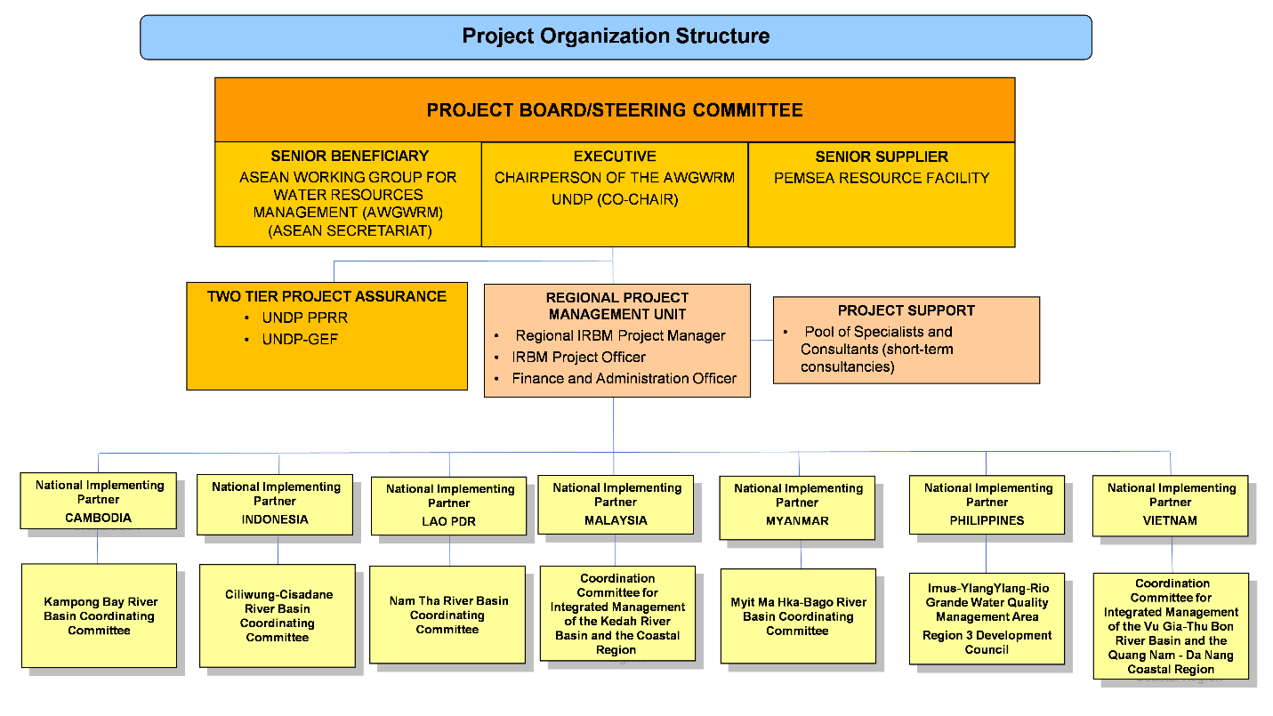

Project Board: The Project Board (also called Project Steering Committee) is responsible for making by consensus, management decisions when guidance is required by the Regional IRBM Project Manager, including recommendations for UNDP/Implementing Partner approval of project plans and revisions, and addressing any project level grievances. In order to ensure UNDP’s ultimate accountability, Project Board decisions should be made in accordance with standards that shall ensure management for development results, best value money, fairness, integrity, transparency and effective international competition. In case a consensus cannot be reached within the Board, final decision shall rest with the UNDP.

Specific responsibilities of the Project Board include:
- Provide overall guidance and direction to the project, ensuring it remains within any specified constraints;
- Address project issues as raised by the Regional IRBM Project Manager;
- Provide guidance on new project risks, and agree on possible countermeasures and management actions to address specific risks;
- Approve Annual Work Plans and Budgets;
- Agree on the Regional IRBM Project Manager’s tolerances as required;
- Review the project progress, and provide direction and recommendations to ensure that the agreed deliverables are produced satisfactorily according to plans;
- Appraise the annual project implementation report, including the quality assessment rating report; make recommendations for the workplan;
- Provide ad hoc direction and advice for exceptional situations when the Regional IRBM Project Manager’s tolerances are exceeded; and
- Assess and decide to proceed on project changes through appropriate revisions.

The composition of the Project Board will include the members of the AWGWRM, specifically those representing the 7 participating countries and representatives from UNDP, ASEAN Secretariat and PRF. Representatives from non-participating ASEAN Member States (Brunei, Singapore, Thailand) will be invited to participate in Project Board meetings as observers. They may also participate in other project activities at their own cost.

The Project Board will meet annually and preferably scheduled back-to-back with the meetings of the AWGWRM. Special meetings may be called as may be agreed by the Board. Further, decisions on urgent matters may rendered on a no-objection basis by electronic mail.

The ASEAN Secretariat’s Environment Division will serve as the interface between the project and ASEAN to ensure coordination of the work plans of the project with the activities of the AWGWRM and the broader ASEAN organization. The Division will also help facilitate knowledge sharing and opportunities for up-scaling IRBM project results and lessons learned to relevant audiences in ASEAN, as necessary.

Executive: The Executive is an individual who represents ownership of the project who will chair the Project Board. This role can be held by a representative from the Government Cooperating Agency or UNDP. The Executive is the Chairperson of the ASEAN Working Group for Water Resources Management.

The Executive is ultimately responsible for the project, supported by the Senior Beneficiary and Senior Supplier. The Executive’s role is to ensure that the project is focused throughout its life cycle on achieving its objectives and delivering outputs that will contribute to higher level outcomes. The Executive has to ensure that the project gives value for money, ensuring cost-conscious approach to the project, balancing the demands of beneficiary and suppler.

Specific Responsibilities: (as part of the above responsibilities for the Project Board)
- Ensure that there is a coherent project organization structure and logical set of plans;
- Set tolerances in the AWP and other plans as required for the Regional IRBM Project Manager;
- Monitor and control the progress of the project at a strategic level;
- Ensure that risks are being tracked and mitigated as effectively as possible;
- Brief relevant stakeholders about project progress;
- Organize and chair Project Board meetings.

Senior Supplier: The Senior Supplier is an individual or group representing the interests of the parties concerned which provide funding and/or technical expertise to the project (designing, developing, facilitating, procuring, implementing). The Senior Supplier’s primary function within the Board is to provide guidance regarding the technical feasibility of the project. The Senior Supplier role must have the authority to commit or acquire supplier resources required. If necessary, more than one person may be required for this role. Typically, the implementing partner, UNDP and/or donor(s) would be represented under this role. The Senior Suppler is: PEMSEA Resource Facility.

Specific Responsibilities (as part of the above responsibilities for the Project Board)
- Make sure that progress towards the outputs remains consistent from the supplier perspective;
- Promote and maintain focus on the expected project output(s) from the point of view of supplier management;
- Ensure that the supplier resources required for the project are made available;
- Contribute supplier opinions on Project Board decisions on whether to implement recommendations on proposed changes;
- Arbitrate on, and ensure resolution of, any supplier priority or resource conflicts.

Senior Beneficiary: The Senior Beneficiary is an individual or group of individuals representing the interests of those who will ultimately benefit from the project. The Senior Beneficiary’s primary function within the Board is to ensure the realization of project results from the perspective of project beneficiaries. The Senior Beneficiary role is held by a representative of the government or civil society. The Senior Beneficiary is: ASEAN Working Group on Water Resources Management.

The Senior Beneficiary is responsible for validating the needs and for monitoring that the solution will meet those needs within the constraints of the project. The Senior Beneficiary monitors progress against targets and quality criteria. This role may require more than one person to cover all the beneficiary interests. For the sake of effectiveness, the role should not be split between too many people.

Specific Responsibilities (as part of the above responsibilities for the Project Board)
- Prioritize and contribute beneficiaries’ opinions on Project Board decisions on whether to implement recommendations on proposed changes;
- Specification of the Beneficiary’s needs is accurate, complete and unambiguous;
- Implementation of activities at all stages is monitored to ensure that they will meet the beneficiary’s needs and are progressing towards that target;
- Impact of potential changes is evaluated from the beneficiary point of view;
- Risks to the beneficiaries are frequently monitored.

Regional IRBM Project Manager: The full-time Regional IRBM Project Manager has the authority to run the project on a day-to-day basis on behalf of the Project Board within the constraints laid down by the Board. The Regional IRBM Project Manager’s prime responsibility is to ensure that the project produces the results specified in the project document, to the required standard of quality and within the specified constraints of time and cost.
The Implementing Partner (PRF) hires the Regional IRBM Project Manager, who should be different from the Implementing Partner’s representative in the Project Board. The selection panel of the Regional IRBM Project Manager will include representatives from the UNDP, PRF the ASEAN Secretariat and a participating country, preferably the current chair of the AWGWRM will also be invited.
Specific responsibilities include:
- Provide direction and guidance to Project Team(s)/ responsible party (ies);
- Liaise with the Project Board to assure the overall direction and integrity of the project;
- Identify and obtain any support and advice required for the management, planning and control of the project;
- Manage project administration;
- Plan the activities of the project and monitor progress against the project results framework and the approved annual workplan;
- Mobilize personnel, goods and services, training and micro-capital grants to initiative activities, including drafting terms of reference and work specifications, and overseeing all contractors’ work;
- Monitor events as determined in the project monitoring schedule plan/timetable, and update the plan as required;
- Manage requests for the provision of financial resources by UNDP, through advance of funds, direct payments or reimbursement using the fund authorization and certificate of expenditures;
- Monitor financial resources and accounting to ensure the accuracy and reliability of financial reports;
- Manage the preparation and submission of financial reports to UNDP on a quarterly basis;
- Manage and monitor the project risks initially identified and submit new risks to the Project Board for consideration and decision on possible actions if required; update the status of these risks by maintaining the project risks log;
- Capture lessons learned during project implementation;
- Prepare the annual workplan for the following year; and update the Atlas Project Management module if external access is made available.
- Prepare the GEF PIR and submit the final report to the Project Board;
- Based on the GEF PIR and the Project Board review, prepare the AWP for the following year.
- Ensure the mid-term review process is undertaken as per the UNDP guidance, and submit the final MTR report to the Project Board.
- Identify follow-on actions and submit them for consideration to the Project Board;
- Ensure the terminal evaluation process is undertaken as per the UNDP guidance, and submit the final TE report to the Project Board;

Project Assurance: UNDP provides a three – tier supervision, oversight and quality assurance role – funded by the GEF agency fee – involving UNDP staff in Country Offices and at regional and headquarters levels. Project Assurance must be totally independent of the Project Management function. The quality assurance role supports the Project Board and Project Management Unit by carrying out objective and independent project oversight and monitoring functions. This role ensures appropriate project management milestones are managed and completed. The Project Board cannot delegate any of its quality assurance responsibilities to the Project Manager. This project oversight and quality assurance role is covered by the GEF Agency. Both UNDP PPRR and UNDP-GEF will dispense the functions.

Governance role for project target groups:

National Implementing Partner: In order to support the coordination of the project among national agencies and the fulfillment of national procedures associated with international donor funding, national project coordination will be undertaken by the National Implementing Partner. The National Implementing Partner will be represented in the River Basin Coordinating Committee to provide guidance and coordinate national input to the preparation, review and approval of the annual IRBM project work plan and budget. The National Implementing Partner will also have direct lines of communication with the regional Project Board/AWGWRM.

National Project Coordinating Unit (NPCU): NPCUs will be established within the office of the National Implementing Partner in each of the seven beneficiary countries, staffed by the National Implementing Partner in accordance with country co-financing commitments. NPCUs, as a minimum, should include one staff, namely a national project coordinating officer.

The NPCU will work in close collaboration with the respective River Basin Coordinating Committee and Project Team. The NPCU will be responsible for:
- Co-ordinating national agency input to the preparation of the annual work plans and budgets for project implementation at the river basin level;
- Overseeing and co-ordinating national agency input to the implementation of the approved IRBM work plans;
- Monitoring and reporting on the implementation of annual project work plans against agreed targets and quality criteria to the National Implementing Partner and other interested national agencies;
- Organizing the participation of representatives of national agencies in knowledge sharing and capacity development events organized by the project in the respective country and at the regional level.

River Basin Coordinating Committees (RBCC): RBCCs will be set up in Cambodia, Lao PDR, Malaysia, Myanmar and further operationalized in Indonesia, Philippines, Vietnam in the selected river basins/coastal areas. The RBCCs will include senior representatives from:
- National agencies responsible for water resource development and management
- Local governments within the river basin and associated coastal region
- Universities/scientific institutions within the river basin/coastal region
- Communities/community groups, including women’s organizations
- Private sector/business associations
- Other related projects.

The RBCCs will:
- Oversee and guide the IRBM project in the river basin, including the planning, development and implementation of pilot projects that target hot spot locations/issues within the river basin/coastal area;
- Review and endorse: annual work plans and budgets; technical reports; M&E reports; investments; financing and partnership arrangements; etc. associated with the river basin project to the National Project Boards;
- Establish a multi-disciplinary Project Team comprised of resource managers, scientific and technical experts, financial/investment specialists, legal experts, NGOs and community-based organizations to plan and develop annual work plans and budgets, coordinate the implementation of on-the-ground project activities in the river basin/coastal area, including: conduct of baseline assessments; implementation of (a) pilot project(s) covering hotspot locations/issues in the river basin; setting up a comprehensive, scientifically sound environmental monitoring and reporting system; organizing capacity building and knowledge sharing activities; and distillation of new and emerging risks, lessons learned and good practices to strengthen and scale up IRBM.
- Set up a River Basin Coordinating Unit (RBCU) to provide day-to-day guidance, coordination, monitoring and reporting of decisions and actions approved by the RBCC/Project Team.
- Staff the RBCU with local personnel in accordance with co-financing commitments of local governments. RBCUs should include at least three staff, namely:
- IRBM Manager/Coordinating Officer;
- IRBM Technical Assistant
- Administrative Assistant.

IX. Financial Planning and Management

The total cost of the project is USD 130,270,718. This is financed through a GEF grant of USD 8,479,123, and USD 121,791,595 in parallel co-financing. UNDP, as the GEF Implementing Agency, is responsible for the execution of the GEF resources only.

Parallel co-financing: The actual realization of project co-financing will be monitored during the mid-term review and terminal evaluation process and will be reported to the GEF. The planned parallel co-financing will be used as follows:

Co-financing source | Co-financing type | Co-financing amount | Planned Activities/Outputs | Risks | Risk Mitigation Measures
Cambodia Ministry of Environment | In kind | 4,085,337 | Provision of counterpart project staff, office space and facilities in Kampot Province, the site of the IRBM project; integration of IRBM project activities with existing and planned program commitments of Kampot Province. | Changes in government policy and priorities (national and local) could delay or reduce the co-financing commitment of Kampot Province. | Engage local Chief Executives and national government officials in the planning and development of the project. Establish an RB coordinating mechanism at the RB level to mainstream project activities into the government priorities, development plans and programs.
Indonesia Ministry of Public Works and Housing | In kind | 3,494,667 | Provision of counterpart project staff, office space and facilities of MPWH, including existing flood control and program initiatives in the Ciliwung River the site of the IRBM project; integration of IRBM project activities with existing and planned program of MPWH. | Changes in government policy and priorities (national and local) could delay or reduce the co-financing commitment of MPWH. | Integrate the RB project into the existing national coordinating mechanism/program for the Ciliwung River; mainstream project activities into the government priorities, development plans and programs.
City of Depok | In kind | 941,930 | Provision of counterpart project staff, office space and facilities in Depok City, the site of the IRBM pilot project; integration of IRBM project activities with existing and planned pollution reduction/waste management program commitments of Depok. | Changes in government policy and priorities could delay or reduce the co-financing commitment of Depok City. | Engage local the Chief Executive, planners and managers in the planning and development of the project. Establish an RB coordinating mechanism at the RB level to mainstream project activities into the government priorities, development plans and programs.
Lao PDR Ministry of Natural Resources and Environment | In kind | 958,056 | Provision of counterpart project staff, office space and facilities of MNRE, including existing program initiatives in the Nam Tha River Basin, the site of the IRBM project; integration of IRBM project activities into implementation of Lao’s National Water Resources Strategy from now until 2025  and Water Resources Action Plan for 2016-2020. | Changes in government policy and priorities (national and local) could delay or reduce the co-financing commitment of MNRE. | Promote and facilitate the integration the RB project into the existing national water resources strategy and action plan; mainstream project activities into the government priorities, development plans and programs.
Loang Namtha Province | In kind | 217,813 | Provision of counterpart project staff, office space and facilities in the three provinces which are located in the Nam Tha River Basin, the site of the IRBM pilot project; integration of IRBM project activities with existing and planned pollution reduction/waste management/water management program commitments of the three provinces. | Changes in government policy and priorities could delay or reduce the co-financing commitment of the three provinces. | Engage local the Chief Executives, planners and managers in the 3 provinces in the planning and development of the project. Establish an RB coordinating mechanism at the RB level to mainstream project activities into the government priorities, development plans and programs.
Bokeo Province | In kind | 1,029,363
Oudomxay Province | In kind | 993,050
Malaysia Ministry of Energy, Science, Technology, Environment and Climate Change | In kind | 74,000,000 | Provision of counterpart project staff, office space and facilities in Kedah. Collaborative implementation of three IRBM projects in the Kedah River Basin, namely: 1) National Water Balance Management System; 2) Implementation of the Kedah River/Anak Bukit River Flood Mitigation Plan; 3) Upgading of Main Canal and North Canal of Anak Bukit River | Changes in government policy and priorities (national and local) could delay or reduce the co-financing commitment of the MESTECC | Promote and facilitate the integration the RB project into the existing national water resources strategy and action plan; mainstream project activities into the government priorities, development plans and programs.
Myanmar Ministry of Natural Resource and Environmental Conservation | In kind | 14,909,000 | Provision of counterpart project staff, office space and facilities of MNREC and Bago City, the site of the IRBM pilot project, including existing flood control/dredging project and program initiatives in the Myit Ma Hka-Bago River Basin and coastal region of the Gulf of Martaban the site of the IRBM project. | Changes in government policy and priorities (national and local) could delay or reduce the co-financing commitment of MNREC. | Integrate the RB project into the MNREC program for the Myit Ma Hka-Bago River Basin and the coastal region of the Gulf of Martaban; mainstream project activities into the government priorities, development plans and programs.
Philippines | In kind | 5,918,123 | Implementation of river basin action plans in Imus Ylang Ylang and Pasac-Guagua River Basins as these relate to the rehabilitation of Manila Bay. | Changes in government policy and priorities (national and local) could delay or reduce the co-financing commitment of DENR agencies. | Integrate the RB project into the DENR-supported river basin programs for the two river basins; mainstream project activities into the government priorities, development plans and programs.
Province of Cavite, Philippines | In-kind | 389,766 | Provision of counterpart project staff, office space and facilities of the Province of Cavite, including existing program initiatives in the Imus-Ylang Ylang River Basin and the coastal area of Manila Bay. | Changes in government policy and priorities (national and local) could delay or reduce the co-financing commitment of the local government. | Engage the Governor of the Provnc,, planners and managers in the planning and development of the project; incorporate the project into the work program of the Province; mainstream project activities into the provincial priorities, development plans and programs.
City of General Trias, Cavite, Philippines | In-kind | 561,000 | Provision of counterpart project staff, office space and facilities of Genral Trias City, the site of the IRBM pilot project, including existing program initiatives in the Imus-Ylang Ylang River Basin and the coastal area of  Manila Bay. | Changes in government policy and priorities (national and local) could delay or reduce the co-financing commitment of the local government. | Engage local the Chief Executive, planners and managers in the planning and development of the project; incorporate the project into the work program of the City; mainstream project activities into the local government priorities, development plans and programs.
Vietnam Ministry of Natural Resources and Environment | In kind | 1,200,000 | Environmental monitoring and assessment program of MNRE in the Vu Gia - Thu Bon river basin and the coastal area of  Quang Nam - Da Nang | Changes in government policy and priorities (national and local) could delay or reduce the co-financing commitment of MNRE. | Integrate the M&E program of the MNRE into the project planning and implementation of the SORB, TPL and feasibility study; mainstream project activities into the government priorities, development plans and programs. Promote the project and build awareness among senior government officials at the National Council on Water Resources.
Quang Nam Province and Da Nang City | In kind | 8,000,000 | Provision of counterpart project staff, office space and facilities of Quang Nam Province and Da Nang City the site of the IRBM pilot project, including existing program initiatives in the Vu Gia - Thu Bon river basin and the coastal area of  Quang Nam - Da Nang. | Changes in government policy and priorities (national and local) could delay or reduce the co-financing commitment of the two local governments. | Engage local the Chief Executive, planners and managers in the planning and development of the project; incorporate the project into the work program of the Coordination Committee for Integrated Management of the Vu Gia-Thu Bon River Basin; mainstream project activities into the government priorities, development plans and programs.
UNDP | In kind | 197,403 | Collaboration on the implementation of related projects in each of the participating countries. | Cancellation or delays in project approvals and implementation. | Maintain communication and engage UNDP COs in the planning and development of the capacity strengthening/ knowledge management component of the project, including participation/ collaboration in training workshops and KM events.
Japan International Cooperation Agency, Vietnam | In kind | 4,600,000 | Collaboration on the implementation of the JICA project on Strengthening Capacity of Water Environmental Management in River Basins in Vietnam | Cancellation or delays in project approval and implementation | Maintain communication and engage JICA Viet Nam in the planning and development of the capacity strengthening/ knowledge management component of the project, including participation/ collaboration in training workshops and KM events.
PEMSEA | In kind | 296,087 | Provision of office space, utilities and equipment to house and operationalize the Regional IRBM Project Management Unit | PEMSEA is not selected as the regional Implementing Partner for the project. | Continue to work with UNDP, ASEAN and participating countries to plan and develop a quality project that fulfils the objectives of the partners; demonstrate PEMSEA’s capacity to effectively manage the implementation of the regional project.

UNDP Direct Project Services as requested by Implementing Partner (if any): The UNDP, as GEF Agency for this project, will provide project management cycle services for the project as defined by the GEF Council. In addition, the IP may request UNDP direct services for specific projects according to its policies and convenience. The UNDP and IP acknowledge and agree that those services are not mandatory and will be provided only upon request. If requested, the services would follow the UNDP policies on the recovery of direct costs. As is determined by the GEF Council requirements, these service costs will be assigned as Project Management Cost, duly identified in the project budget as Direct Project Costs. Eligible Direct Project Costs should not be charged as a flat percentage. They should be calculated on the basis of estimated actual or transaction based costs and should be charged to the direct project costs account codes: “64397- Services to Project– Staff” and “74596- Services to Project – General Operating Expenses (GOE)”.

Budget Revision and Tolerance: As per UNDP requirements outlined in the UNDP POPP, the regional Project Board will agree on a budget tolerance level for each plan under the overall annual work plan allowing the Regional IRBM Project Manager to expend up to the tolerance level beyond the approved project budget amount for the year without requiring a revision from the Project Board. Should the following deviations occur, the Regional IRBM Project Manager and UNDP PPRR will seek the approval of the UNDP-GEF team to ensure accurate reporting to the GEF: a) Budget re-allocations among components in the project with amounts involving 10% of the total project grant or more; b) Introduction of new budget items/or components that exceed 5% of original GEF allocation.

Any over expenditure incurred beyond the available GEF grant amount will be absorbed by non-GEF resources (e.g. UNDP TRAC or cash co-financing).

Flow of Funds: Funds transfer modality and reporting procedure shall be governed by UNDP rules and regulations for NGO implementation. The PRF will develop and sign a Memorandum of Agreement (MOA) with the National Implementing Partner in each paticipating country. The MOA will detail the roles and responsibilities of the PRF and the National Implementing Partner and the 5-year work plan and budget, among others. The MOA will specify that the funds will be allocated and downloaded in accordance with approved annual work plans and budgets, contracts/other agrements signed between the parties for specific work activities, and the completion and acceptance of project deliverables under the signed contracts/other agreements.

Refund to GEF: Should a refund of unspent funds to the GEF be necessary, this will be managed directly by the UNDP-GEF Unit in New York.

Project Closure: Project closure will be conducted as per UNDP requirements outlined in the UNDP POPP. On an exceptional basis only, a no-cost extension beyond the initial duration of the project will be sought from in-country UNDP colleagues and then the UNDP-GEF Executive Coordinator.

Operational completion: The project will be operationally completed when the last UNDP-financed inputs have been provided and the related activities have been completed. This includes the final clearance of the Terminal Evaluation Report (that will be available in English) and the corresponding management response, and the end-of-project review Project Board meeting. The Implementing Partner through a Project Board decision will notify the UNDP PPRR when operational closure has been completed. At this time, the relevant parties will have already agreed and confirmed in writing on the arrangements for the disposal of any equipment that is still the property of UNDP.

Transfer or disposal of assets: In consultation with the Implementing Partner and other parties of the project, UNDP PPRR is responsible for deciding on the transfer or other disposal of assets. Transfer or disposal of assets is recommended to be reviewed and endorsed by the Project Board following UNDP rules and regulations. Assets may be transferred to the government for project activities managed by a national institution at any time during the life of a project. In all cases of transfer, a transfer document must be prepared and kept on file.

Financial completion: The project will be financially closed when the following conditions have been met: a) The project is operationally completed or has been cancelled; b) The Implementing Partner has reported all financial transactions to UNDP; c) UNDP has closed the accounts for the project; d) UNDP and the Implementing Partner have certified a final Combined Delivery Report (which serves as final budget revision).

The project will be financially completed within 12 months of operational closure or after the date of cancellation. Between operational and financial closure, the implementing partner will identify and settle all financial obligations and prepare a final expenditure report. The UNDP PPRR will send the final signed closure documents including confirmation of final cumulative expenditure and unspent balance to the UNDP-GEF Unit for confirmation before the project will be financially closed in Atlas by the UNDP PPRR.

X. Total Budget and Work Plan

Total Budget and Work Plan
Atlas Proposal or Award ID: | 00104039 | Atlas Primary Output Project ID: | 00105778
Atlas Proposal or Award Title: | Reducing Pollution and Preserving Environmental Flows in the East Asian Seas through the Implementation of Integrated River Basin Management in ASEAN Countries
Atlas Business Unit | PHL 10
Atlas Primary Output Project Title | Reducing Pollution and Preserving Environmental Flows in the East Asian Seas through the Implementation of Integrated River Basin Management in ASEAN Countries
UNDP-GEF PIMS No. | 5635
Implementing Partner | PEMSEA

GEF Component/Atlas Activity | Responsible Party/  (Atlas Implementing Agent) | Fund ID | Donor Name | Atlas Budgetary Account Code | ATLAS Budget Description | Amount Year 1 (USD) | Amount Year 2 (USD) | Amount Year 3 (USD) | Amount Year 4 (USD) | Amount Year 5 (USD) | Total (USD) | See Budget Note:
COMPONENT 1: BASELINE ASSESSMENT OF SOURCE TO SEA MANAGEMENT CONTINUUM
Outcome 1: Improved understanding of governance, socioeconomic, ecological conditions, gaps and needs of priority river basins/sub-basins and coastal areas. | PEMSEA | 62000 | GEF | 71200 | International Consultants | 51,600 | 51,600 | 12,600 | 12,600 | 12,600 | 141,000 | 1
 |  |  |  | 71300 | Local Consultants | 131,700 | 25,500 | 10,500 | 10,500 | 10,500 | 188,700 | 2
 |  |  |  | 71400 | Contractual Services - Individ | 82,750 | 72,500 |  |  |  | 155,250 | 3
 |  |  |  | 71600 | Travel | 49,750 | 21,750 | 10,500 | 10,500 | 10,500 | 103,000 | 4
 |  |  |  | 72100 | Contractual Services-Companies | 452,250 | 140,000 | 35,000 | 239,302 | 35,000 | 901,552 | 5
 |  |  |  | 74500 | Miscellaneous Expenses | 6,760 | 8760 | 4,760 | 4,760 | 4,760 | 29,800 | 6
 |  |  |  |  | sub-total Outcome 1 | 774,810 | 320,110 | 73,360 | 277,662 | 73,360 | 1,519,302
 |  |  |  |  | Total Component 1 | 774,810 | 320,110 | 73,360 | 277,662 | 73,360 | 1,519,302
COMPONENT 2: IRBM PILOT PROJECTS FOR IMPROVED GOVERNANCE AND MANAGEMENT OF RIVER BASINS/SUB-BASINS AND ASSOCIATED COASTAL AREAS
Outcome 2.1 IRBM pilot projects implemented to demonstrate governance mechanisms and instruments for improved source to sea management in 7 priority river basins/sub-basins and coastal areas | PEMSEA | 62000 | GEF | 71200 | International Consultants | 279,000 | 105,000 | 21,000 | 25,200 | 42000 | 472,200 | 7
 |  |  |  | 71300 | Local Consultants | 105,000 | 147,000 | 105000 | 105,000 | 105,000 | 567,000 | 8
 |  |  |  | 71600 | Travel | 35,000 | 35,000 | 35,000 | 35,000 | 35,000 | 175,000 | 9
 |  |  |  | 72100 | Contractual Services-Companies | 927,500 | 759,500 | 70,000 | 70,000 | - | 1,827,000 | 10
 |  |  |  |  | sub-total Outcome 2.1 | 1,346,500 | 1,046,500 | 231,000 | 235,200 | 182,000 | 3,041,200
Outcome 2.2 Integrated river basin management strategies and action plans in 7 priority river basins/sub-basins formulated, adopted and initiated | PEMSEA | 62000 | GEF | 71300 | Local Consultants | - | - | - | 193,500 | 84000 | 277,500 | 11
 |  |  |  | 71400 | Contractual Services - Individ | - | - | - | - | 21,000 | 21,000 | 12
 |  |  |  | 72100 | Contractual Services-Companies | - | 70,000 | 245,000 | 505,000 | 200,000 | 1,020,000 | 13
 |  |  |  |  | sub-total Outcome 2.2 | - | 70,000 | 245,000 | 698,500 | 305,000 | 1,318,500
 |  |  |  |  | Total Component 2 | 1,346,500 | 1,116,500 | 476,000 | 933,700 | 487,000 | 4,359,700
COMPONENT 3: KNOWLEDGE MANAGEMENT, CAPACITY DEVELOPMENT, AND MONITORING AND EVALUATION
Outcome 3: Improved IRBM knowledge management and enabling capacities among participating countries, partners and networks | PEMSEA | 62000 | GEF | 71200 | International Consultants | 4,000 | 4,000 | 15,000 | 4,000 | 9,000 | 36,000 | 14
 |  |  |  | 71300 | Local Consultants | 143,800 | 115,300 | 112,300 | 112,300 | 112,300 | 596,000 | 15
 |  |  |  | 71400 | Contractual Services - Individ | 35,000 | 30,000 | 30,000 | 32,500 | 30,000 | 157,500 | 16
 |  |  |  | 72100 | Contractual Services-Companies | 286,200 | 176,200 | 231,200 | 358,700 | 353,700 | 1,406,000 | 17
 |  |  |  | 74500 | Miscellaneous Expenses | - | - | - | - | 1,498 | 1,498 | 18
 |  |  |  |  | sub-total Outcome 3 | 469,000 | 325,500 | 388,500 | 507,500 | 506,498 | 2,196,998
 |  |  |  |  | Total Component 3 | 469,000 | 325,500 | 388,500 | 507,500 | 506,498 | 2,196,998
PROJECT MANAGEMENT COST
Project Management | PEMSEA | 62000 | GEF | 71200 | International Consultants | 30,000 | 30,000 | 30,000 | 29,000 | 29,000 | 148,000 | 19
 |  |  |  | 71300 | Local Consultants | 43,000 | 43,000 | 43,000 | 43,000 | 43,000 | 215,000 | 20
 |  |  |  | 71600 | Travel | 1,500 | 1,500 | 1,500 | 1,500 | 1,500 | 7,500 | 21
 |  |  |  | 72500 | Office supplies | 2,500 | 2,500 | 2,500 | 2,500 | 2,500 | 12,500 | 22
 |  |  |  | 73400 | Purchase, Rental & Maint of Equip | 3,332 | 3,539 | 3,745 | 3,550 | 3,836 | 18,002 | 23
 |  |  |  | 74596 | Services to Project – General Operating Expenses (GOE) | 668 | 461 | 255 | 450 | 287 | 2,121 | 24
 |  |  |  |  | sub-total project management unit | 81,000 | 81,000 | 81,000 | 80,000 | 80,123 | 403,123
 |  |  |  |  | Total Project Management | 81,000 | 81,000 | 81,000 | 80,000 | 80,123 | 403,123
 |  |  |  | PROJECT TOTAL |  | 2,671,310 | 1,843,110 | 1,018,860 | 1,798,862 | 1,146,981 | 8,479,123

Summary of Funds:

Sources of Funds | Amount Year 1 | Amount Year 2 | Amount Year 3 | Amount Year 4 | Amount Year 5 | Total
GEF | 2,671,310 | 1,843,110 | 1,018,860 | 1,798,862 | 1,146,981 | 8,479,123
UNDP | 39,480 | 39,480 | 39,480 | 39,480 | 39,483 | 197,403
PEMSEA | 59,217 | 59,217 | 59,217 | 59,218 | 59,218 | 296,087
Cambodia Ministry of Environment | 817,067 | 817,067 | 817,067 | 817,067 | 817,069 | 4,085,337
Indonesia Ministry of Public Works and Housing | 698,993 | 698,993 | 698,993 | 698,993 | 698,695 | 3,494,667
City of Depok | 188,386 | 188,386 | 188,386 | 188,386 | 188,386 | 941,930
Lao PDR Ministry of Natural Resources and Environment | 191,611 | 191,611 | 191,611 | 191,611 | 191,612 | 958,056
Loang Namtha Province | 43,562 | 43,562 | 43,562 | 43,562 | 43,565 | 217,813
Bokeo Province | 205,872 | 205,872 | 205,872 | 205,872 | 205,875 | 1,029,363
Oudomxay Province | 198,610 | 198,610 | 198,610 | 198,610 | 198,610 | 993,050
Malaysia Ministry of Energy, Science, Technology, Environment and Climate Change | 14,800,000 | 14,800,000 | 14,800,000 | 14,800,000 | 14,800,000 | 74,000,000
Myanmar Ministry of Natural Resource and Environmental Conservation | 2,981,937 | 2,981,937 | 2,981,937 | 2,981,937 | 2,981,252 | 14,909,000
Philippines Department of Environment and Natural Resources | 1,183,624 | 1,183,624 | 1,183,625 | 1,183,625 | 1,183,625 | 5,918,123
Province of Cavite, Philippines | 77,953 | 77,953 | 77,954 | 77,953 | 77,953 | 389,766
City of General Trias, Philippines | 112,240 | 112,240 | 112,240 | 112,240 | 112,040 | 561,000
Vietnam Ministry of Natural Resources and Environment | 240,000 | 240,000 | 240,000 | 240,000 | 240,000 | 1,200,000
Quang Nam Province and Da Nang City | 1,600,000 | 1,600,000 | 1,600,000 | 1,600,000 | 1,600,000 | 8,000,000
Japan International Cooperation Agency, Vietnam | 920,000 | 920,000 | 920,000 | 920,000 | 920,000 | 4,600,000
TOTAL | 27,029,862 | 26,201,662 | 25,377,414 | 26,157,416 | 25,504,364 | 130,270,718

Budget Notes:

Outcome 1: Improved understanding of governance, socioeconomic, ecological conditions, gaps and needs of priority river basins.
- International consultants: USD 141,000 for 235 days at USD 600 per day over 5 years, including:
- setting up multi-sectoral coordinating mechanisms and Project Teams in each RB; preparing TOR, work plans and schedules in collaboration with Project Teams (20 days);
- planning, organizing and participating in IRBM orientation workshops and training workshops in 7 participating countries (30 days);
- participating in meetings of RB coordinating mechanisms; analyzing IRBM strategies, governance mechanisms and gaps, developing guidance toolkit (85 days);
- overseeing, guiding, reviewing and approving baseline and end-of-project SORB reports in 7 river basins (100 days).
- Local consultants: USD188,700 for 629 days at USD 300 per day over 5 years, including:
- preparing the SORB reporting template and Guide for SORB development and implementation (20 days);
- developing training programs and schedules and organizing regional training workshops for SORB and RB IIMS (15 days);
- organizing and conducting RB orientation workshops for the national and local RB coordinating mechanisms in each participating country (5days*7countries days);
- identifying and supporting the selection and start-up of the RB Project Teams (5days*7countries);
- developing socio-economic survey template and gender action plan (10 days);
- organizing and conducting socio-economic survey and regional gender action plan training workshop back-to-back with IIMS and SORB regional workshop (15 days);
- developing and organizing a TPL model training course and conducting regional training of Project Teams/universities from each RB (100 days);
- organizing and conducting training workshops for the RB Project teams in each country, including RB-IIMS, SORB, TPL, socio-economic assessment/gender action plan (7days*7 countries);
- facilitating the preparation, conduct and reporting of annual meetings of the RB coordinating mechanisms (5 days/year*7 countries for 5years);
- drafting and finalizing the baseline SORB report for each river basins (20days*7countries);
- conduct review and assessment of governance and management mechanisms for IRBM/ICM at the national and river basin levels in each country (5days*7 countries).
3. Service contracts: USD155,250 for:
- copyediting and laying out the RB IIMS manual, SORB Guide and Governance toolkit (4,750), year 1.
- developing, starting up and operating RB IIMS in each RB (20,000*7countries), year 1.
- editing and copyediting SORB reports in each river basin (1500*7countries), year 2.
4. Travel: USD103,000, assuming air travel cost of USD1,000 round trip and daily allowance/incidentals of $200 per day, for:
- international consultants for orientation meeting and annual meeting of RB coordinating committee in each country (orientation: 1750*3 pax*6countries; annual: 1800*1 pax*6 countries*4 years).
- local consultants/members of the project team from each country for regional training workshop on RBIIMS, SORB, socio-economic survey, and gender action plan (2,000*2pax/country*7countries), year 1.
5. Contractual services: USD901,552 for:
- one 5-day regional workshop/training course involving 14 participants from participating countries and 4 trainers/resources (RB-IIMS; baseline SORB, socio-economic survey, and gender action plan (20,000); one regional workshop on socio-economic assessment (4,750), year 1.
- one 5-day sub-regional workshop/hands-on training courses on total pollutant loading (TPL) model involving 30 participants from participating countries and 8 trainers/resource persons (25,000), year 1.
- subcontract universities to conduct river basin reviews on existing and future water uses and implications (7*5000), year 3.
- annual meetings of RB coordinating committees and regular meetings of Project Teams (5000/year*7 countries for 5years).
- Project Team, national universities and/or institutions in each country prepare the baseline SORB report (25,000*7countries); conduct the socio-economic survey (15,000*7 countries); implement the rapid appraisal/TPL modeling (10,000*7countries); TPL river basin workshop/data gathering (7*5000); SORB river basin validation workshop (7*7500), years 1 and 2; and organize and prepare the impact SORB report at the completion of the project (29,186*7countries), year 4.
6. Miscellaneous: USD29,800 spread across 59 workshops and participatory planning sessions in the 7 countries over 5 years to cover communication costs, signage and sundry items for each event.

Outcome 2.1: IRBM and ICM governance mechanisms and instruments result in improved source to sea management at the national and local levels in 7 priority river basins/sub-basins and coastal areas.
7. International consultants: USD472,200 for 787 days @ USD600 per day, including:
- IRBM/S2S specialists preparing generic templates for initiating/strengthening integrated IRBM governance and management in the selected river basins, working with RB organizations and Project Teams to prepare the strategies, work plan, budgets and schedules, delineating hotspot areas and issues in each RB, and identifying/confirming key individuals/institutions in each country for the RB Project Team (20days*7 countries) in year 1;
- Financial and investment specialists developing generic templates for PPP, PPIGF, blended financing (donor, government, private), public sector financing, etc. (40 days) in year 1;
- Technical/technology specialists developing generic templates for pollution reduction/nutrient management, waste management/plastics recycling, sustainable reforestation, renewable energy (40 days) in year 1;
- Technology and financial and investment specialists’ hands-on training to RB Project Teams in the 7 countries on the planning, development and initiation of pilot projects and the use of the developed templates (10days*7countries) in year 1;
- Technology and financial and investment specialists provide professional guidance, advice and support to RB Project Teams for the application of relevant templates/procedures in pilot project planning and implementation in hotspot areas, negotiating and signing agreements with national and local authorities, investors, business sector in support of pilot facilities/operations, overseeing construction and commissioning of pilot facilities; setting up M&E program to monitor and assess impact and benefits (71days*7 countries) in years 2 to 5.
8. Local consultants: USD567,000 for 1,890 days @ USD300 per day, including:
- organizing, coordinating, monitoring and reporting on IRBM activities at the river basin/pilot project levels in each country (50 days*7 countries*5 years)
- preparing legal agreement between PEMSEA and local government on pilot project development and financing (20days*7 countries) year 2
9. Travel: USD175,000, assuming air travel cost of USD1,000 round trip and daily allowance/incidentals of $200 per day, for:
- international consultants/specialists conducting 2 missions per year to each country to oversee and guide the Project Teams for the conduct of detailed baselines in hotspot location, conduct of feasibility studies, financial analyses, public consultations, negotiations/signing agreements with national and local government for pilot project implementation, procurement and contracting processes, overseeing construction, commissioning and start-up of pilot projects (2 missions/year @ 15 days/year*7 countries for 5 years).
10. Contractual Services: USD1,827,000 for:
- completing the detailed baseline assessments for identified hotspot area/location in each RB, including institutional and governance, demographic, socio-economic (with special consideration of women, children, indigenous people and the poor), environmental and political conditions and characteristics of the area, priority issues/threats to sustainable development and management of the RB/receiving coastal area, including pollution, waste management, environmental flows and climate change, as well as ongoing and proposed developments that will impact on the S2S continuum; conducted by the RB Project Team in each RB and/or subcontracted to a university/national institution (30,000*7 countries);
- conducting professional feasibility studies to identify and assess integrated management solutions for up to 3 priority threats in the identified hotspot area/location in each RB, including the delineation and evaluation of technical, management and operating options, capital and operating costs, partnership and financing approaches and sources of financing, including a public-private inclusive growth fund; subcontracted to a professional consultancy organization/firm (200,000*7countries);
- organizing and conducting public consultations/participatory processes in each RB to build awareness and consensus on the priority issues/threats in the hotspot area/location, the risks and impacts, the available options/solutions, the socio-economic and environmental impacts/implications, and support for preferred option(s) (11,000*7countries); conducted by the RB Project Team and/or subcontracted to a non-government organization with communications/awareness building expertise;
- developing and implementing a monitoring and evaluation program in the RB/hot spot location to measure the socio-economic and environmental impacts/benefits being derived from the pilot project facility, including benefits to people (men, women, children) and the economy of the location; subcontracted to a scientific institution/university in the RB area (20,000*7 countries) for inclusion in the SORB impact report, for years 4 and 5;

Outcome 2.2: Integrated River Basin Management Strategies and Action Plans in 7 priority river basins/sub-basins formulated, adopted and initiated.
11. Local consultants: US$277,500 for 925 days @ USD300 per day, including:
- reviewing and assessing RB organization and preparing an assessment report (80 days*300*7countries), year 4
- preparing a review and analysis of IRBM policies, laws, economic instruments; provisional agenda for each participating country to develop new or strengthen existing policies, regulations, institutional arrangements and mechanisms based on experiences of RB pilot projects; organize and conduct national IRBM forum (40 days*300*7countries), year 4;
- preparing technical report on IRBM good practices (30 days*300), year 4;
- preparing IRBM guide (20 days*300), year 4;
- assisting Project teams to develop approaches, work plans and budgets for review and assessment of RB governance instruments (5 days@300*7 countries).
12. Service contracts: USD21,000 for:
- copyediting and laying out the RB strategy and action plan in each country in local languages, as required, (3000*7 countries) year 4.
13. Contractual Services: USD1,020,000 for:
- developing templates for good practice in IRBM/ICM policies, strategies, laws, economic and financial instruments (25,000), year 4
- organizing and conducting a regional workshop on the application of the generic templates in the 7 selected river basins (25,000), year 4
- organizing and conducting an ASEAN workshop on improved IRBM governance and management based on the outcome of the project (25000), year 5
- organizing and conducting two (2) national IRBM forums in each country to build political awareness and support for scaling up and replication IRBM good practices, benefits and lessons learned from the IRBM pilot project, including RB strategy and 10-year action plan, as well as an agenda for action at the national level, involving 100 participants (2@25,000*7countries);
- conducting meetings/consultations in each country with stakeholder groups/organizations, including women’s organizations, to better engage/enhance participation and benefit in the planning, development and implementation of the pilot projects (20,000*7countries) for years 2 and 3, organized by RB Project teams;
- preparing an RB strategy and 10-year Action Plan for each RB, based on the experience, lessons learned and enabling mechanisms and activities undertaken during the RB project, including opportunities for incorporation of the action plan objectives and targets into the medium-term development plans at the local and national levels (25,000*7 countries), year 4;
- organizing and conducting public consultation/consensus building process for the RB strategy and 10-year Action Plan, including existing and potential implications and impacts, roles and responsibilities of government, business sector, and communities (25,000*7countries), conducted by the RB coordinating organization and RB Project Team, years 4 and 5;
- facilitating RB strategy and action plan adoption and initiation at the RB level, and incorporation of the action plan objectives and targets into the medium-term development and investment plans of local governments in the RB (15,000*7countries), conducted by the RB coordinating organization and the RB Project team, years 4 and 5.

Outcome 3: Improved IRBM knowledge management and enabling capacities among participating countries, partners and networks.
14. International consultants: USD36,000 for 60 days @ USD600 per day, including:
- preparing the template for river basin monitoring programs, connecting pilot project interventions with the assessment of impacts and benefits to local communities/environment and the river basin (10 days), year 3.
- M&E reporting (50 days), over 5 years.
15. Local consultants: USD596,000 for 1986 days@ USD300 per day for:
- IRBM Project Officer/M&E Officer coordinating, drafting and submitting quarterly and annual M&E reports, as required by GEF and UNDP, for review and endorsement by the Regional Project Manager to PEMSEA and UNDP (180 days), over 5 years.
- Finance and Administration Officer preparing and certifying quarterly and annual financial reports, as required by GEF and UNDP, for review and endorsement by the Regional Project Manager to PEMSEA and UNDP (137 days), over 5 years.
- conducting research on RB monitoring and evaluation reporting systems in the region and elsewhere, including indicators and metrics used in the systems, their application in the region and development of a proposed list of SMART indicators for use in monitoring, evaluating and improving IRBM planning and implementation; organizing a regional workshop to review, refine and finalize the proposed list of SMART indicators for application in the SORB baseline assessment (30 days), year 1.
- conducting research on gender issues in IRBM in the 7 RBs and identifying SMART gender-focused indicators to be incorporated into the SORB baseline assessment (20 days), year 1.
- reviewing and assessing existing capacities in environmental monitoring in each river basin (10 days), year 2.
- developing IRBM/ICM training modules for orientation, awareness and capacity building (100 days); organizing and participating in national/RB training workshops, year 1;
- developing gender and environmental and social risk identification (50 days) training modules; organizing and participating in national/RB training workshops, year 1;
- organizing and conducting a regional capacity development workshops for IRBM/ICM and special skills/tools in support of IRBM development and implementation, including RB-IIMS, SORB, developing and enabling a regional network of universities as IRBM learning and support centers for IRBM development and implementation in the respective countries/RBs (50 days*4 years), years 2 to 5;
- organizing, overseeing and assessing social and environmental screening procedures and plans, stakeholder engagement plans and gender analysis and action plans of projects in the participating countries and at the regional level, and providing input to the GEF and UNDP reporting/tracking procedures (50 days*4years), years 2 to 5
- designing a regional IRBM knowledge platform with links to national, regional and global e-platforms, to share knowledge and experience, tap expertise and advice, and promote South-South and Triangular Cooperation (SSTRC) (30 days), year 1.
- populating, maintaining and scaling up access to and use of the IRBM knowledge platform, including establishing and operationalizing of RB microsites for each of the RB projects linked to the regional platform (25 days*4 years), years 2 to 5.
- preparing knowledge products from RB projects to transfer/present to the AWGWRM, AWGCRM, ASOEN, EAS Partnership Council and other regional forums, networks of local governments, LMEs/regional seas programs, LME/IW Learn and other programs, projects and networks (8 days*7 countries for 5 years);
- developing and implementing communication and marketing plan for project activities, outcomes, outputs and knowledge products (60 days* 5 years)
- developing, implementing, monitoring and assessing gender action plan and environmental and social risk assessment at the river basin/pilot project levels (10 days per year*7 countries*5years).
16. Service contracts: USD 157,500 for:
- copyediting and laying out a Guide to Environmental Monitoring in support of IRBM Program Development and Implementation (2,500), year 4.
- developing, constructing, testing a guide for a harmonized set of IRBM governance and management indicators for inclusion in baseline assessment SORB reports. constructing and commissioning a regional e-portal/IRBM knowledge platform (20,000), completed by an IT firm in year 1.
- maintaining the security, integrity and facile operation of the e-portal/lRBM knowledge platform on an annual basis, including the incorporation of new functionalities and software applications, as may be requested by PEMSEA and the participating countries (15,000/year for 4 years, year 2 to year 5.
- NIM Audit as per UNDP audit policies (15,000 per year), 5 years.
17. Contractual Services: USD 1,406,000 for:
- preparing a guide for a harmonized set of IRBM indicators for inclusion in baseline SORB reports (25000), year 1.
- preparing a guide for environmental monitoring in the context of IRBM programs (20000), year 3.
- organizing conducting an ASEAN regional workshop on environmental monitoring in the context of IRBM programs (25000), year 4.
- organizing and conducting regional IRBM/ICM program development and implementation training and IRBM/ICM special skills training workshops for national program managers, RB Project Teams, IRBM managers, planners and practitioners, IRBM trainers/learning centers, and IRBM stakeholders, includin2000g women’s group (13workshops@20,000ea.) years 1 to 5.
- organizing and conducting study tours/learning exchanges for national IRBM program officers, local chief executives, planners and IRBM managers to provide opportunities for SSTRC and accelerating the up-scaling of IRBM programs (15,000/year for 3 years) years 3 to 5.
- organizing and conducting regional workshops in collaboration with GEF LME/IW Learn; co-organizing/participating in international workshops co-sponsored/hosted by IW LEARN to share outputs and outcomes from the IRBM project at the regional, national and local levels; preparing and packaging knowledge products for uploading to the LME/IW Learn knowledge platform; cross-regional exchanges with other LME programs/projects (80,000, 1% of the project budget).
- developing and implementing IRBM environmental monitoring program in 7 selected river basins (25000*7countries), years 4 and 5.
- organizing and conducting national IRBM orientation workshops for national agencies and local governments (7500*7 countries), year 1.
- organizing and conducting IIMS and SORB workshops for Project Teams in each river basin (7500*7 river basins), year 1.
- organizing and conducting IRBM/ICM and special skills training workshops for Project Teams in each river basin (5000 per workshop*6 workshops*7 river basins), years 1 to 5.
- implementing stakeholder engagement plans and communication plans in each river basin (6600*7 river basins*5years)
- regional project inception workshop (20000), year 1.
- annual PSC/Project Board meetings (15000*5 years).
- project mid-term review (40000), year 3.
- project terminal evaluation (60000), year 5.
18. Miscellaneous: USD1,498 for implementation of stakeholder participatory activities and events, to cover communication costs, signage and sundry items in the 7 countries.

Project Management Costs (PMC)
19. International consultant/Regional IRBM Project Manager: USD148,000 for 247 days @ USD600 per day including:
- managing and administering the regional project unit, officers and project consultants, developing and implementing annual work plans and budgets in accordance with the PRF; ensuring that the project produces the results specified in the project document, to the required standard of quality and within the specified constraints of time and cost; liaising with the respective National coordinating mechanisms/units, river basin coordinating mechanisms/units, Project Board/Project Steering Committee, UNDP PPRR, UNDP Country Offices and the UNDP Regional Hub (247 days), years 1 to 5.
20. Local consultants: USD215,000 for 717 days @ USD300 per day including:
- IRBM Project Officer providing technical backstopping to the Regional IRBM Project Manager as per TOR (Annex D) (360 days), years 1 to 5;
- Finance and Administration Officer providing financial management and accounting backstopping, as well as administrative support for procurement of goods and services for the project, as per TOR (Annex D) (357 days), years 1 to 5.
21. Travel: USD7,500, assuming air travel cost of USD1,000 round trip and daily allowance/incidentals of $200 per day, for:
- participating in the annual meetings of the Project Board (1,500*5 years).
22. Office supplies: USD12,500 for:
- purchasing of expendable office materials and supplies for project operations, Project Board meetings, regional workshops/events ($2,500/year).
23. Rental and maintenance of office equipment: USD18,002 for:
- rental of photocopier, server, UBIX telephone line, and maintenance of office furniture and equipment for five years
24. UNDP Direct Project Costs (DPC) - Services to Projects – General Operating Expenses (GOE): USD2,121.

PEMSEA Resource Facility as the executing agency will apply a 6% fee in each individual budget line. The execution fee will cover the costs incurred by PRF in the implementation of the project, that will include, among others, Executive Director’s time for oversight and project representation in regional and global advocacy fora, general project support in finance and accounting, communications and knowledge management, including web hosting and internet costs.

XI. Legal Context

This project forms part of an overall programmatic framework under which several separate associated country level activities will be implemented. When assistance and support services are provided from this Project to the associated country level activities, this document shall be the “Project Document” instrument referred to in: (i) the respective signed SBAAs for the specific countries; or (ii) in the Supplemental Provisions to the Project Document attached to the Project Document in cases where the recipient country has not signed an SBAA with UNDP, attached hereto and forming an integral part hereof. All references in the SBAA to “Executing Agency” shall be deemed to refer to “Implementing Partner.”

This project will be implemented by the PEMSEA Resource Facility (“Implementing Partner”) in accordance with its financial regulations, rules, practices and procedures only to the extent that they do not contravene the principles of the Financial Regulations and Rules of UNDP. Where the financial governance of an Implementing Partner does not provide the required guidance to ensure best value for money, fairness, integrity, transparency, and effective international competition, the financial governance of UNDP shall apply.

Any designations on maps or other references employed in this Project Document do not imply the expression of any opinion whatsoever on the part of UNDP concerning the legal status of any country, territory, city or area or its authorities, or concerning the delimitation of its frontiers or boundaries.

XII. Risk Management

Consistent with the Article III of the Supplemental Provisions to the Project Document, the responsibility for the safety and security of the Implementing Partner and its personnel and property, and of UNDP’s property in the Implementing Partner’s custody, rests with the Implementing Partner. To this end, the Implementing Partner shall:
- put in place an appropriate security plan and maintain the security plan, taking into account the security situation in the country where the project is being carried;
- assume all risks and liabilities related to the Implementing Partner’s security, and the full implementation of the security plan.
UNDP reserves the right to verify whether such a plan is in place, and to suggest modifications to the plan when necessary. Failure to maintain and implement an appropriate security plan as required hereunder shall be deemed a breach of the Implementing Partner’s obligations under this Project Document and the Project Cooperation Agreement between UNDP and the Implementing Partner.
The Implementing Partner agrees to undertake all reasonable efforts to ensure that no UNDP funds received pursuant to the Project Document are used to provide support to individuals or entities associated with terrorism and that the recipients of any amounts provided by UNDP hereunder do not appear on the list maintained by the Security Council Committee established pursuant to resolution 1267 (1999). The list can be accessed via http://www.un.org/sc/committees/1267/aq_sanctions_list.shtml.
Social and environmental sustainability will be enhanced through application of the UNDP Social and Environmental Standards (http://www.undp.org/ses) and related Accountability Mechanism (http://www.undp.org/secu-srm).
The Implementing Partner shall: (a) conduct project and programme-related activities in a manner consistent with the UNDP Social and Environmental Standards, (b) implement any management or mitigation plan prepared for the project or programme to comply with such standards, and (c) engage in a constructive and timely manner to address any concerns and complaints raised through the Accountability Mechanism. UNDP will seek to ensure that communities and other project stakeholders are informed of and have access to the Accountability Mechanism.
All signatories to the Project Document shall cooperate in good faith with any exercise to evaluate any programme or project-related commitments or compliance with the UNDP Social and Environmental Standards. This includes providing access to project sites, relevant personnel, information, and documentation.
The Implementing Partner will take appropriate steps to prevent misuse of funds, fraud or corruption, by its officials, consultants, responsible parties, subcontractors and sub-recipients in implementing the project or using the UNDP funds. The Implementing Partner will ensure that its financial management, anti-corruption and anti-fraud policies are in place and enforced for all funding received from or through UNDP.
The requirements of the following documents, then in force at the time of signature of the Project Document, apply to the Implementing Partner: (a) UNDP Policy on Fraud and other Corrupt Practices and (b) UNDP Office of Audit and Investigations Investigation Guidelines. The Implementing Partner agrees to the requirements of the above documents, which are an integral part of this Project Document and are available online at www.undp.org.

In the event that an investigation is required, UNDP has the obligation to conduct investigations relating to any aspect of UNDP programmes and projects. The Implementing Partner shall provide its full cooperation, including making available personnel, relevant documentation, and granting access to the Implementing Partner’s (and its consultants’, responsible parties’, subcontractors ‘and sub-recipients’) premises, for such purposes at reasonable times and on reasonable conditions as may be required for the purpose of an investigation. Should there be a limitation in meeting this obligation, UNDP shall consult with the Implementing Partner to find a solution.

The Implementing Partner will promptly inform UNDP in case of any incidence of inappropriate use of funds, or credible allegation of fraud or corruption with due confidentiality.

Where the Implementing Partner becomes aware that a UNDP project or activity, in whole or in part, is the focus of investigation for alleged fraud/corruption, the Implementing Partner will inform the UNDP PPRR /Head of Office, who will promptly inform UNDP’s Office of Audit and Investigations (OAI). The Implementing Partner shall provide regular updates to the head of UNDP in the country and OAI of the status of, and actions relating to, such investigation.

UNDP shall be entitled to a refund from the Implementing Partner of any funds provided that have been used inappropriately, including through fraud or corruption, or otherwise paid other than in accordance with the terms and conditions of the Project Document. Such amount may be deducted by UNDP from any payment due to the Implementing Partner under this or any other agreement.

Where such funds have not been refunded to UNDP, the Implementing Partner agrees that donors to UNDP (including the Government) whose funding is the source, in whole or in part, of the funds for the activities under this Project Document, may seek recourse to the Implementing Partner for the recovery of any funds determined by UNDP to have been used inappropriately, including through fraud or corruption, or otherwise paid other than in accordance with the terms and conditions of the Project Document.

Note: The term “Project Document” as used in this clause shall be deemed to include any relevant subsidiary agreement further to the Project Document, including those with the Implementing Partner, responsible parties, subcontractors and sub-recipients.

Each contract issued by the Implementing Partner in connection with this Project Document shall include a provision representing that no fees, gratuities, rebates, gifts, commissions or other payments, other than those shown in the proposal, have been given, received, or promised in connection with the selection process or in contract execution, and that the recipient of funds from the Implementing Partner shall cooperate with any and all investigations and post-payment audits.

Should UNDP refer to the relevant national authorities for appropriate legal action any alleged wrongdoing relating to the project, the Government will ensure that the relevant national authorities shall actively investigate the same and take appropriate legal action against all individuals found to have participated in the wrongdoing, recover and return any recovered funds to UNDP.

The Implementing Partner shall ensure that all of its obligations set forth under this section entitled “Risk Management Standard Clauses” are passed on to each responsible party, subcontractor and sub-recipient and that all the clauses under this section entitled “Risk Management” are included, mutatis mutandis, in all sub-contracts or sub-agreements entered into further to this Project Document.

XIII. Mandatory Annexes

Annex A: Multi Year Work Plan
Annex B: GEF Core Indicators at Baseline
Annex C: Overview of Technical Consultancies
Annex D: Terms of Reference
Annex E: UNDP Social and Environmental Screening Procedure and Plans as needed
Annex F: Stakeholder Engagement Plan
Annex G: Gender Analysis and Action Plan
Annex H: UNDP Risk Log
Annex I: Results of the capacity assessment of the project implementing partner and HACT micro assessment
Annex J: Additional agreements
Annex K: National IRBM Pilot Project Proposals

Annex A: Multi Year Work Plan
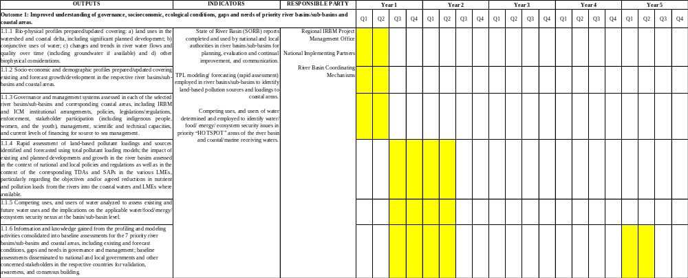

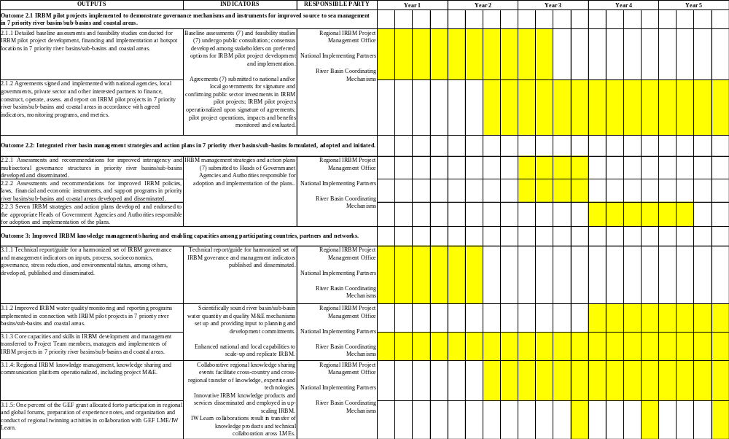

Annex B: GEF Core Indicators (at baseline)

Core Indicator 7: Number of shared water ecosystems (fresh or marine) under new or improved cooperative management
Number (expected at PIF) | Number (expected at CEO Endorsement) | Number (achieved at MTR) | Number (achieved at TE)
3 | 3

7.1 Level of Transboundary Diagnostic Analysis and Strategic Action Program formulation and implementation
Shared Water Ecosystem (name) | Rating (entered at PIF) | Rating (entered at CEO Endorsement) | Rating (entered at MTR) | Rating (entered at TE)
1. Bay of Bengal:  Myit Ma Hka-Bago River - Gulf of Martaban (Myanmar)  Keda-Muda Rivers/Andaman Sea (Malaysia)  2. Indonesian Seas:  Ciliwung River – Jakarta Bay (Indonesia)  3. South China Sea and Gulf of Thailand:  Kampong Bay River – Gulf of Thailand (Cambodia)  Nam Tha River-Mekong River (Lao PDR)  Imus Ylang Ylang Rivers and Pasac Guagua Rivers – Manila Bay (Philippines)  Vu Gia -Thu Bon Rivers – Da Nang Bay (Viet Nam) | 3 = SAP ministerially endorsed  1 = No TDA/SAP  4 = SAP under implementation | 3 = SAP ministerially endorsed  1 = No TDA/SAP  4 = SAP under implementation

7.2 Level of regional legal agreements and regional management institution(s) to support its implementation
Shared Water Ecosystem (name) | Rating (entered at PIF) | Rating (entered at CEO Endorsement) | Rating (entered at MTR) | Rating (entered at TE)

7.3 Level of national/local reforms and active participation of Inter-Ministerial Committees
Shared Water Ecosystem (name) | Rating (entered at PIF) | Rating (entered at CEO Endorsement) | Rating (entered at MTR) | Rating (entered at TE)
1. Bay of Bengal:  Myit Ma Hka-Bago River - Gulf of Martaban (Myanmar)  Keda-Muda Rivers/Andaman Sea (Malaysia)  2. Indonesian Seas:  Ciliwung River – Jakarta Bay (Indonesia)  3. South China Sea and Gulf of Thailand:  Kampong Bay River – Gulf of Thailand (Cambodia)  Nam Tha River-Mekong River (Lao PDR)  Imus Ylang Ylang Rivers and Pasac Guagua Rivers – Manila Bay (Philippines)  Vu Gia -Thu Bon Rivers – Da Nang Bay (Viet Nam) | 2 = National/local reforms in preparation, IMCs functional  2 = National/local reforms in preparation, IMCs functional  2 = National/local reforms in preparation, IMCs functional  2 = National/local reforms in preparation, IMCs functional  2 = National/local reforms in preparation, IMCs functional  2 = National/local reforms in preparation, IMCs functional  2 = National/local reforms in preparation, IMCs functional | 2 = National/local reforms in preparation, IMCs functional  2 = National/local reforms in preparation, IMCs functional  2 = National/local reforms in preparation, IMCs functional  2 = National/local reforms in preparation, IMCs functional  2 = National/local reforms in preparation, IMCs functional  2 = National/local reforms in preparation, IMCs functional  2 = National/local reforms in preparation, IMCs functional

7.4 Level of engagement in IW:LEARN through participation and delivery of key products
Shared Water Ecosystem (name) | Rating (entered at PIF) | Rating (entered at CEO Endorsement) | Rating (entered at MTR) | Rating (entered at TE)
1. Bay of Bengal  2. Indonesian Seas  3. South China Sea and Gulf of Thailand | 4 = As above, plus active participation of project staff and country representatives at  International Waters conferences and the provision of spatial data and other data  points via project website  2 = Website in line with IW:LEARN guidance active  4 = As above, plus active participation of project staff and country representatives at  International Waters conferences and the provision of spatial data and other data  points via project website | 4 = As above, plus active participation of project staff and country representatives at  International Waters conferences and the provision of spatial data and other data  points via project website  2 = Website in line with IW:LEARN guidance active  4 = As above, plus active participation of project staff and country representatives at  International Waters conferences and the provision of spatial data and other data  points via project website

Core Indicator 11: Number of direct beneficiaries disaggregated by gender as co-benefit of GEF investment
 | Total number (expected at PIF) | Total number (expected at CEO Endorsement) | Total number (achieved at MTR) | Total number (achieved at TE)
Women | 132,948 | 132,948
Men | 132,948 | 132,948
Total | 265,896 | 265,896

Annex C: Overview of Technical Consultancies

Consultant | Time Input | Tasks, Inputs and Outputs
For Project Management / Monitoring & Evaluation
International / Regional and Global Contracting
Regional IRBM Project Manager | Full-time | Under the supervision of the Executing Director of PEMSEA, the Regional IRBM Project Manager (RPM) has the responsibility to manage the project planning, implementation, monitoring and reporting. The RPM’s primary responsibility is to ensure that the project produces the results specified in the project document, to the required standard of quality and within the specified constraints of time and cost.  See the full TOR for details.
National Contracting
IRBM Project Officer/ M&E Officer | Full-time | Under the supervision of the Regional IRBM Project Manager (RPM), the IRBM Project and M&E Officer (PO) has the responsibility for overall technical backstopping and management support to the RPM, including monitoring the progress of the project implementation with quality and transparency in accordance with the Project Document. The PO’s primary responsibility is to support the RPM by coordinating with international and national consultants and National PCU staff in the timely delivery of quality project activities and outputs and M&E reports as stipulated in the Project Document.  See the full TOR for details.
Finance and Administration Officer | Full-time | Under the supervision of the Regional IRBM Project Manager (RPM), the Finance and Administration Officer (FAO) is responsible for the efficient and effective procurement of goods and services, the execution of financial services and processes, and the transparent utilization of financial resources of the IRBM project. The FAO promotes a client-oriented approach consistent with the prevailing rules and regulations of UNDP and PEMSEA. The FAO will guide all National PCUs in the preparation budgets in accordance with the Project Document, ensuring that all funds are spent in line with approved work plans. Other key tasks include overseeing the administration and procurement processes of the RPO, the reporting of project expenses, preparing for financial audits, dealing with cash advance requests, and generally ensuring solid fiduciary management of the project.  See full TOR for details
For Technical Advice and Assistance
Local / National contracting
IRBM Project Officer  Rate: $300 per day | 300 days over 5 years | Under the supervision of the RPM, the PO will work with the National Coordinating Units, River Basin Organizations and the RB Coordinating Unit in each country for:  - coordinating IRBM project planning and preparation work for project initiatives at the regional, national and local levels;  - overseeing and monitoring the preparation and status of project proposals, work plans and budgets, and receiving relevant documentation for review and approval;  - compiling, summarizing, and presenting information/data on specific project and related topics or issues including: SORB template, SORB Guide, technical report on good practices, IRBM Guide, review of mnitoring program in each RB, capacity assessment in each RB, drafting and finalization of SORB reports (baseline; progress), RB governance and management review, etc.
Local consultant: Social/Environmental Specialist  Rate: $300/day | 300 days over 5 years | Under the supervision of the RPM, the social/environmental specialist will work with the National Coordinating Units, River Basin Organizations and the RB Coordinating Unit in each country for:  - developing and implementing socio-economic surevy/assessment in each RB  - organizing and conducting regional training on socio-economic assessment and gender sensistivity  - researching and faciliting the application of SMART indicators for gender assessment/analysis in SORB reporting  - developing, assessing, reporting and updating Gender Action Plans, Stakeholder Engagement Plans and Social/EnvironmentalScreening in each RB
Local consultant: RB IIMS and TPL Specialist  Rate: $300/day | 100 days over 2 years (years 1 and 2) | Under the supervision of the RPM, the RB IIMS/PPL specialist will work with the National Coordinating Units, River Basin Organizations and the RB Coordinating Unit in each country for:  - organizing and conducting regional training of RB teams in RB IIMS and TPL modeling  - overseeing outputs from each river basin  - guiding and coordinating TPL modeling and assisting in report preparation  - organizing regional knowledge sharing event (year 2) and preparing a summary report on RB IIMS and TPL application in the 7 countries
Local consultant: Capacity Development/ Knowledge Management Specialist  Rate: $300/day | 300 days over 5 years | Under the supervision of the RPM, the capacity development/KM specialist will work with the National Coordinating Units, River Basin Organizations and the RB Coordinating Unit in each country for:  - organizing and conducting regional and national training workshops for SORB, RB IIMS, socio-economic assessment and gender action plan implementation, including program, schedule, participants and resource persons  - coordinating and overseeing the development of IRBM/ICM, socio-economic assessment, gender action plan implementation, TPL and other IRBM special skills training modules  - developing and strengthening a network of universities in the participating countries to serve as training centers and technical support/assistance in IRBM project implementation in the 7 RBs.
Local consultant: RB PCO Co-ordinators  Rate: $300/day | 300 days per country over 5 years | Under the supervision of the River Basin Organization in each country and in close collaboration with the RPMU and the RB Project Team, the RB PCU Coordinator will be responsible for:  - planning and developing annual project work plans and budgets for submission to RB coordinating mechanism in the respective country  - coordinating the implementation of work plans and budgets as approved by the RB coordinating mechanism and National Coordinating Committee  - monitoring and evaluating progress and preparing quarterly and annual reports to the RB coordinating mechanism and National Coordinating Committee  - building awareness and promoting stakeholder participation in IRBM governance and management activities and events at the RB level  - organizing and facilitating regular meetings of the RB coordinating mechanism.
Local consultant: Communications specialist  Rate $300 per day | 300 days over 5 years | Under the supervision of the RPM, the communications specialist will work with the National Coordinating Units, River Basin Organizations and the RB Coordinating Unit in each country for developing and implementing a communications plan to promote and facilitate the transfer of information, experience and good practices developed during the project.
Local consultant: IT specialist  Rate $300 per day | 100 days over 4 years | Under the supervision of the RPM, the IT specialist will work with the PO, River Basin Organizations and the RB Coordinating Unit in each country for designing, constructing, maintaining and continually improving a regional e-portal/knowledge sharing platform for IRBM, linked to global, regional and national platforms(30 days @ 300).
Local consultant: Legal specialists  Rate $300 per day | 20 days per country (year 2) | Under the supervision of the RPM, the legal specialist will work with the National Coordinating Units, River Basin Organizations, RB Coordinating Unit and responsible local governments in each country for negotiating and preparing a legal agreement for the national and local governments/RB authority to develop, implement, finance and invest in an approved pilot project facility.
Local consultant: Governance specialists  Rate $300 per day | 120 days per country over 2 years (years 4 and 5) | Under the supervision of the RPM, the legal specialist will work with the National Coordinating Units, River Basin Organizations, RB Coordinating Unit and responsible local governments in each country for:  - reviewing, evaluating, updating and refining RB governance and coordinating mechanisms at the local RB level  - preparing a 10-year draft IRBM action plan at the local RB level  - reviewing and analyzing IRBM national policies, laws, instruments in each participating country  - preparing technical reports and provisional agenda for developing/strengthening national IRBM policy and institutional mechanisms in each participating country at the national government level
Local consultant: RB Social/Environmental Screening/Stakeholder Engagement Plan and Gender Action Plan Co-ordinators  Rate $300 per day | 50 days per country over 5 years | Under the supervision of the River Basin Organization in each country and in close collaboration with the RPMU and the regional Environmental/Social Specialist, the RB Environmental/Social Coordinator will be responsible for:  - implementing socio-economic survey/assessment in the RB (year 1)  - organizing and conducting RB training on socio-economic assessment and gender sensitivity (years 1 and 2)  - collecting and inputing gender assessment/analysis in SORB reporting process (years 1 and 2)  - assessing, reporting and updating Gender Action Plans, Stakeholder Engagement Plans and Social/EnvironmentalScreening in the RB (years 2 to 5)
International / Regional contracting
Regional Project Manager/IRBM Specialist  Rate: $600 per day | 260 days over 2 years (years 1 and 2)  390 days over 3 years (years 3 to 5)  20 days for 5 years | The Regional IRBM Project Manager (RPM) as an IRBM specialist will provide international perspective, strategic guidance and technical inputs to the implementation of activities under including the following:  Under Outputs 1.1 to 1.6:  - overseeing the development of the strategy. procedures, indicators and metrics for conducting baseline assessments in each country river basin  - coordinating the preparation of a guidance toolkit for policy makers and RB organizations on the process of developing, implementing and sustaining IRBM programs in the respective RBs  - overseeing the preparation of and participating in IRBM orientation workshops and IRBM/ICM training workshops at the regional and national/RB levels as a trainer/resource person  - overseeing the preparation and finalization of SORB reports in the 7 RBs  Under Outputs 2.1 to 2.3  - developing the strategy and procedures for evaluating, updating and drafting 10-year IRBM action plans in the 7 RBs of the project  - overseeing/guiding the formulation and consensus building process for improved IRBM governance strategies and mechanisms in each RB, including the preparation and adoption of 10-year IRBM action plans  - overseeing/guiding the preparation and consensus building process for national IRBM agenda to strengthen IRBM governance, management and investment in the 7 participating countries.  Under Outputs 3.1 to 3.4  - serving as a resource person in regional IRBM/ICM and special skills training workshops  - developing/overseeing/providing input to knowledge products for uploading to e-portal and dissemination
Financial and Investment Specialists  Rate: $600/day | 200 days over 5 years  20 days over 5 years | In close coordination with the Regional IRBM Project Manager (RPM), other project specialists and the RB Project Teams, the Financial and Investment Specialists will provide international perspective, strategic guidance and technical inputs to the implementation of activities including the following:  Under Outputs 2.1 to 2.3:  - developing generic templates for innovative, balanced and sustainable financing and investment mechanisms and procedures for affordable, equitable and sustainable financing of IRBM pilot projects in the 7 river basins, including PPP; public-private inclusive growth fund (PPIGF); public sector financing; and private sector operation and management)  - facilitating the development and use of the templates in each RB/hotspot location in support of the RB Project Teams  - overseeing and guiding the Project Teams in each country with the conduct of detailed baseline, feasibility study, financial analysis, public consultations, negotiation with local government, procurement and contracting process, commissioning, start-up/operation, and M&E  - consensus building among government and stakeholders  - negotiation of agreements for pilot project implementation and financing with national and local governments, RB coordinating mechanisms, etc.  - assisting in the procurement and contracting process, pilot project commissioning, start-up, operation, and M&E development and implementation.  Under Outputs 3.1 to 3.4  - serve as a resource person in regional IRBM/ICM and special skills training workshops  - develop/oversee/provide input to knowledge products for uploading to e-portal and dissemination
Pollution Reduction/Waste Management/Reforestation/Climate Specialists  Rate: $600/day | 169 days over 5 years  20 days over 5 years | In close coordination with the Regional IRBM Project Manager (RPM) and the Financial and Investment Specialists, the Pollution Reduction/Waste Management/Reforestation/Climate Specialists will provide international perspective, strategic guidance and technical inputs to the implementation of activities under including the following:  Under Outputs 2.1 to 2.3:  - developing generic templates for innovative technologies, mechanisms and approaches to solving priority challenges to sustainable IRBM development and management in hotspot locations in the 7 RBs  - facilitating the development and use of the templates in each RB/hotspot location in support of the RB Project Teams  - overseeing and guiding the Project Teams in each country with the conduct of detailed baseline, feasibility study, financial analysis, public consultations  - consensus building among government and stakeholders  - negotiation of agreements for pilot project implementation and financing with national and local governments, RB coordinating mechanisms, etc.  - assisting in the procurement and contracting process, pilot project commissioning, start-up, operation, and M&E.  Under Outputs 3.1 to 3.4  - serve as a resource person in regional IRBM/ICM and special skills training workshops  - develop/oversee/provide input to knowledge products for uploading to e-portal and dissemination

Annex D: Terms of Reference

1) PROJECT BOARD/PROJECT STEERING COMMITTEE
The Project Board/Project Steering Committee (PB/PSC) will serve as the project’s decision-making body. It will meet according to necessity, at least once each year, to review project progress, approve project work plans and approve major project deliverables. The PB/PSC is responsible for providing the strategic guidance and oversight to project implementation to ensure that it meets the requirements of the approved Project Document and achieves the stated outcomes. The PB/PSC’s role will include:
- Provide strategic guidance to project implementation;
- Ensure coordination between various donor funded and government funded projects and programmes;
- Ensure coordination with various government agencies and their participation in project activities;
- Approve annual project work plans and budgets, at the proposal of the Project Manager;
- Approve any major changes in project plans or programmes;
- Oversee monitoring, evaluation and reporting in line with GEF requirements;
- Ensure commitment of human resources to support project implementation, arbitrating any issues within the project;
- Negotiate solutions between the project and any parties beyond the scope of the project;
- Ensure that UNDP Social and Environmental Safeguards Policy is applied throughout project implementation; and, address related grievances as necessary.

These terms of reference of the PB/PSC will be finalized during the Project Inception Workshop.

2) REGIONAL IRBM PROJECT MANAGER (RPM) (International)

- Organizational Context
Under the supervision of the Executing Director of PEMSEA, the Regional IRBM Project Manager (RPM) has the responsibility to manage the project planning and implementation. The RPM’s primary responsibility is to ensure that the project produces the results specified in the project document, to the required standard of quality and within the specified constraints of time and cost.

- Key Functions / Key Results
The RPM’s key functions and results are to:
- Co-ordinate the implementation of the work plan and budget of the IRBM Project based on the approved UNDP Project Document;
- Liaise directly with the IRBM project proponents, the country representatives, the river basin organizations, and other donors as appropriate, in order to coordinate the annual work plan for the project;
- Provide overall supervision for all project staff in the Regional Project Management Unit (RPMU) and National Project Coordinating Units (NPCUs) as well as guide and supervise all project partners responsible for executing different components of the project as well as external policy relations;
- Consult and coordinate closely with the Project Board/Project Steering Committee, National Focal Agencies, River Basin Coordinating Committees, Project Teams, other regional project partners, and the respective GEF IW project officers in all regions;
- Manage the realization of project outputs through activities as described in the Project Document;
- Identify and obtain any support and advice required for the management, planning and control of the project;
- Plan the activities of the project and monitor progress against the initial quality criteria;
- Monitor events as determined in the Monitoring & Communication Plan, and update the plan as required;
- Manage requests for the provision of financial resources, using advance of funds, direct payments, or reimbursement;
- Monitor financial resources and accounting to ensure accuracy and reliability of financial reports;
- Manage and monitor the project risks as initially identified in the Project Document, submit new risks to the PB/PSC for consideration and decision on possible actions if required and update the status of the risks by maintaining the Project Risk Log;
- Prepare the Project Quarterly Progress Report (progress against planned activities, update on Risks and Issues, expenditures) and submit the report to the PB/PSC and Project Assurance;
- Prepare the Annual Review Report, and submit the report to the PB/PSC and the National Focal Agencies;
- Based on the review, prepare the Annual Work Plan for the following year, as well as Quarterly Plans if required.
- Prepare Final Project Review Reports to be submitted to the PB/PSC and the National focal agencies;
- Identify follow-on actions and submit them for consideration to the PB/PSC;
- Manage the transfer of project deliverables, documents, files, equipment and materials to national beneficiaries; and
- Prepare the final Regional Delivery Report for signature by UNDP.

Technical Advise/Coordination Function:
- Apply expertise in Integrated Coastal Management (ICM), Integrated Water Resources Management (IWRM), Integrated River Basin Management (IRBM), information technology, structured learning, and project management to maintain the project’s overall integrity and coherence;
- Supervise and provide technical expertise to all IRBM project activities;
- Ensure project progress and impact through liaisons with stakeholders’ participation and quality delivery of activity deliverables, according to project work plans and budget;
- Liaise, consult and network with appropriate regional and global partner organizations, other relevant IW-related environmental and/or sustainable development programs; and
- Ensure consistency between the various project elements and related activities provided or funded by other donor organizations.

Project Management Function:
- Under PEMSEA’s rules and regulations and in coordination with UNDP policies, identify requirements for equipment and travel related to the project implementation;
- Provide direction and guidance to Regional PMO, National PCUs and other project stakeholders;
- Manage the project, its staff, cross-component coordination, deliveries and budget;
- Prepare the annual work plan based on the Project Document, in close consultation and coordination with the PB/PSC, regional and national project partners and relevant donors;
- Organize and supervise all reporting activities to UNDP (Implementing Agency), PEMSEA (Executing Agency), PB/PSC, ensuring adherence to GEF Agencies’ administrative, financial and technical reporting requirements;
- Mobilize goods and services for project activities, including preparing and overseeing the development of Terms of Reference for consultants and contractors; and
- Oversee the development and management of all M&E requirements.

- Qualifications and Skills Required
Education:
- At least a master’s degree in River-basin Management, Water Resources Management, Coastal Resources Management , Environmental or Marine Science, or Engineering.
Experience:
- At least ten years of development work experience at the management level, preferably in the ASEAN region. Practical experience in water and coastal resources management is essential. Familiarity with the environmental policies, programs and operating modalities of local and national governments of the seven (7) participating ASEAN countries is required.
Languages:
- Fluency in the English language, with effective oral and written communication skills. Familiarity with languages of participating countries is an asset.
IT Skills:
- Proficiency in the use of various software applications (MS Word, MS Excel, MS Project, and Financial Systems) and adequate knowledge and practical experience in handling web- based management systems.

3) IRBM PROJECT AND M&E OFFICER (National)

- Organizational Context
Under the supervision of the Regional IRBM Project Manager (RPM), the IRBM Project and M&E Officer (PO) has the responsibility for overall technical backstopping and management support to the RPM, including monitoring the progress of the project implementation with quality and transparency in accordance with the Project Document. The PO’s primary responsibility is to support the RPM by coordinating with international and national consultants and National PCU staff in the timely delivery of quality project activities and outputs and M&E reports as stipulated in the Project Document.

- Key Functions / Key Results
Key Functions of the PO include:
- Coordinating IRBM project planning and preparation work for project initiatives at the regional, national and local levels;
- Overseeing and monitoring the preparation and status of project proposals, work plans and budgets, and receiving relevant documentation for review and approval;
- Compiling, summarizing, and presenting information/data on specific project and related topics or issues;
- Reviewing project documents for completeness and compliance with relevant rules and procedures prior to submission for final approval and signature;
- Implementing evaluation policies and strategies of the IRBM Project;
- Updating as necessary Monitoring and Evaluation plans, consistent with the national M&E framework, in consultation with the participating countries;
- Facilitating review of progress on a quarterly basis and ensure problem solving through remedial actions;
- Assisting National PCUs in the identification of potential implementation problems and bottlenecks and recommend appropriate strategies to address them;
- Preparing quarterly and annual programmatic progress updates on the project in accordance with the Project Document.

Corporate Competencies:
- Demonstrate integrity by modeling the PEMSEA’s and UNDP’s values and ethical standards;
- Promote the vision, mission, and strategic goals of PEMSEA and UNDP;
- Display cultural, gender, religion, race, nationality and age sensitivity and adaptability; and
- Treat all people fairly without favoritism.

Functional Competencies:
- Promote knowledge management in PEMSEA and a learning environment in the office through leadership and personal example;
- Actively work towards continuing personal learning and development in one or more Practice Areas, acts on learning plan and applies newly acquired skills;
- Ability to lead strategic planning, results-based management and reporting;
- Ability to lead formulation and monitoring of management projects;
- Build strong relationships with clients, focuses on impact and result for the client and respond positively to feedback;
- Consistently approach work with energy and a positive, constructive attitude;
- Demonstrate good oral and written communication skills;
- Demonstrate openness to change and ability to manage complexities;
- Lead teams effectively and shows mentoring as well as conflict resolution skills;
- Demonstrate strong oral and written communication skills;
- Remain calm, in control and good humored even under pressure; and
- Ability to work in a team.

- Qualifications and Skills Required
Education:
- At least a master’s degree in water or coastal resources management, river-basin management, environmental or marine sciences or engineering.
Experience:
- At least 5 years of related experience in the field of water and/or coastal resources management, river-basin management, environmental management, preferably in ASEAN region;
- Extensive knowledge of monitoring and evaluation methodologies i.e. both quantitative and qualitative data collection, processing and analysis;
- A strong background in river-basin and/or ICM management programs, having managed projects wherein systematic input, output and process data were collected and used to guide programming;
- Knowledge of sampling and questionnaire design;
- Experience in designing and implementing country level projects and M&E processes;
- Experience working with and maintaining good relations with international, as well as counterparts and beneficiaries (e.g. national and local governments, NGOs, consultants, and private sector);
- Solid experience in the management of people and systems in high-pressure environments.
Languages:
- Fluency in the English language, with effective oral and written communication skills. Ability to speak local languages of 7 participating ASEAN countries would be an asset.
IT Skills:
- Proficiency in the use of various software applications (MS Word, MS Excel, MS Project, and Financial Systems) and adequate knowledge and practical experience in handling web- based management systems.

3) FINANCE AND ADMINISTRATION OFFICER (National)

- Organizational Context
Under the supervision of the Regional IRBM Project Manager (RPM), the Finance and Administration Officer (FAO) is responsible for the efficient and effective procurement of goods and services, the execution of financial services and processes, and the transparent utilization of financial resources of the IRBM project. The FAO promotes a client-oriented approach consistent with the prevailing rules and regulations of UNDP and PEMSEA. The FAO will guide all National PCUs in the preparation budgets in accordance with the Project Document, ensuring that all funds are spent in line with approved work plans. Other key tasks include overseeing the administration and procurement processes of the RPO, the reporting of project expenses, preparing for financial audits, dealing with cash advance requests, and generally ensuring solid fiduciary management of the project.

- Key Functions / Key Results
Summary of key functions:
- Implement operational strategies;
- Install the project’s financial systems and procedures, in accordance with UNDP’s existing guidelines and national execution;
- Orient project staff on the use of the project’s financial systems and procedures;
- Manage cash advance requests, including budget preparation and approval, and liaise both with National PMO and external party to ensure timely cash disbursement and accurate recording of all cash advance requests;
- Responsible for accuracy of funding requests and expenditures, completeness of documentation and availability of funding resources;
- Monitor cash advance settlement to ensure smooth operations of cash advance request;
- Manage petty cash to ensure adequate cash for day-to-day operations;
- Provide accounting and administrative support to Regional and National PMOs;
- Manage day to day operation of the project’s finance affairs and associated functions to ensure smooth running operation of the project’s finance aspects;
- Closely monitor the operation of the projects budget and maintain project accounts with current information while ensuring that the budget is used in accordance with the approved Work Plans and budgets;
- Monitor projects expenditure (commitment and disbursement) based on project records;
- Ensure full compliance with the prevailing rules and regulations of financial processes, financial records and reports and audit follow up, including implementation of an effective internal control framework;
- Maintain solid understanding of Accounting Principles and Audit Procedures to ensure that all financial transactions are in line with the UNDP and PEMSEA guidelines;
- Review and clarify cash advance request budget before being approved by Regional Project Manager;
- Process cash advance request in a timely manner including liaising with National PMO and external party to solve any issues hindering the cash disbursement;
- Maintain proper control of the supporting documents for payments and financial reports for IRBM Project, including the preparation of all types of vouchers;
- Maintain the internal expenditures control system which ensures that vouchers processed are matched and completed, transactions are correctly recorded, travel claims, other entitlements are duly processed;
- Assist Regional PMO with financial reporting and other tasks as required.

- Qualifications and Skills Required
Education:
- Bachelor Degree in Finance, Business or Public Administration. Specialized certification in Accounting and Finance is required.
Experience:
- At least 5 years of progressively responsible finance experience is required at the national and international levels.
Languages:
- Fluency in written and spoken English a must;
- Ability to speak one of seven participating ASEAN countries would be an asset.
Other Requirements:
- Demonstrated strong familiarity with PEMSEA and UNDP development projects;
- Knowledge of and experience in administration, finance and purchasing of development projects will be highly desirable;
- Strong knowledge and solid experience in coordination of project management support are essential as well as ability to draft high quality correspondence on budget-related issues, briefing notes, graphic and statistical summaries, accounting spreadsheets, etc.;
- Good inter-personal and team building skills.
IT Skills:
- Proficiency in the use of various software applications (MS Word, MS Excel, MS Project, and Financial Management Systems) and adequate knowledge and practical experience in handling web- based management systems.

***

Annex E. Social and Environmental Screening Procedure and Plans as needed
Project Information

Project Information
- Project Title | Reducing Pollution and Preserving Environmental Flows in the East Asian Seas through the Implementation of Integrated River Basin Management in ASEAN Countries
- Project Number | 9654
- Location (Global/Region/Country) | 7 ASEAN Countries including Cambodia; Indonesia; Lao PDR; Malaysia; Myanmar; Philippines; Vietnam

Part A. Integrating Overarching Principles to Strengthen Social and Environmental Sustainability

QUESTION 1: How Does the Project Integrate the Overarching Principles in order to Strengthen Social and Environmental Sustainability?
Briefly describe in the space below how the Project mainstreams the human-rights based approach
The concept of Integrated River Basin Management (IRBM) applied in the project is inherently designed to include the human-rights based approach. As the water resources sector affects various other sectors and social groups, the inclusion of marginalized groups, namely women, ethnic minorities, the poor, and indigenous/local groups, among others, will be ensured through stakeholder analysis and consultative/participatory meetings at the onset of the project. In particular, a river basin profile and socio-economic survey will be organized and conducted during the inception phase of the project, including the identification and assessment of marginalized stakeholders among the project proponents in the priority river basins/sub-basins and related coastal areas of the participating countries.
In conducting capacity building and community-based activities, special attention will be paid to the inclusion of marginalized sectors of the river basin societies. During the inception phase of the project where primary socio-economic data will be gathered in river basin and coastal communities, local civil society organizations will be engaged in the process to facilitate access to and feedback from marginalized groups as input to project planning, implementation and assessment.
The Gender Specialist, Knowledge Management/Capacity Development Specialist, and the Communications/Marketing Specialist of the Regional Project Management Unit will ensure that the human-rights based approach is incorporated into all project activities. The Regional Project Manager and Monitoring and Evaluation Specialist will monitor and assess the effectiveness and progress of the project activities in this aspect.
Briefly describe in the space below how the Project is likely to improve gender equality and women’s empowerment
Gender equality and women’s empowerment is an important consideration in the project design. As many reports have confirmed, the water sector has a significant effect on women’s welfare. the Project is geared toward the improving gender equality and empowering women in the implementation of the IRBM project. The detailed plan for gender and women’s empowerment is laid out in the Gender Action Plan (GAP) as attached in Annex G of this document. The following highlights of the GAP are specifically designed to improve gender equality and women’s empowerment:
- Skills development (e.g. IRBM/ICM management; pollution reduction/waste management, water use/conservation; sustainable reforestation);
- Strengthening of women’s involvement in planning and decision making at national and subnational levels (e.g. equal participation, strengthening women`s empowerment);
- Implementation of women-specific livelihood activities associated benefits (e.g., recycling; product development and marketing); and
- Participation of women as agents of economic, social and political change at community level (e.g., project planning and development, awareness building, monitoring and evaluation).
The Project will hire a Gender Specialist to ensure the implementation of the GAP, monitor and evaluate its effectiveness, and make recommendations for improvements where necessary. The Regional Project Manager will ensure that GAP assessments and recommendations are continually updated and incorporated into annual work plans and annual progress reports.
Briefly describe in the space below how the Project mainstreams environmental sustainability
The major thrust of this foundational project is to enable the development and demonstration of sustainable and replicable environmental solutions using the IRBM approach within the timeframe and budget of the project, at appropriate scales and locations, covering key selected issues identified in each country. The project strategy adopts a 4-tiered approach to facilitate up-scaling and replication of improved IRBM governance and management practices among the 7 participating countries:
- A regional tier, being the Project Board/Project Steering Committee, namely the ASEAN Working Group for Water Resources Management, among other duties, will facilitate knowledge sharing and opportunities for up-scaling IRBM project results and lessons learned to relevant audiences in ASEAN.
- A national tier will facilitate cooperation and involvement of national agencies in planning and coordination, advisory, and knowledge sharing processes, as well as reviewing and assessing outputs in the context of contributions to national policies and programs. The national tier will have representation/participation in the activities at the river basin and pilot project levels (see below). National agency representatives will use the experience to catalyze the development or improvement of national IRBM policies, institutional mechanisms, laws, etc., thereby mainstreaming IRBM environmental sustainability into programs and investments at the national level.
- A river basin tier will be responsible for the planning, coordination, management and monitoring and evaluation of the project at the river basin level, within existing river basin organizations or interim mechanisms set up during the project. The river basin tier will be comprised of representatives from responsible national agencies, local governments, non-governmental organizations and other major stakeholders in the river basin. The river basin tier will use the outputs of the project, including the tools, networks and skills generated during the project, to develop, adopt and initiate river basin strategies and 10-year action plans aimed at scaling-up and replicating good practices and lessons learned in water use/conservation, pollution reduction/waste management; sustainable reforestation, etc.
- A pilot project tier will be involved in the development, implementation, monitoring and reporting of solution- and impact-oriented IRBM demonstration projects at a hotspot location in each river basin. The IRBM pilot projects will focus on governance and management priorities such as water quality improvement, pollution reduction, waste management, reforestation, and water use and conservation management at the local level. The local tier Project Teams will be capacitated through formal training and working with technical experts and professionals contracted by the project. By the end of the project, the local tier Project Teams will be enabled to promote and facilitate scaling up and replicating good practices and lessons to the river basin tier and the development and initiation of the 10-year action plans.

Part B. Identifying and Managing Social and Environmental Risks

QUESTION 2: What are the Potential Social and Environmental Risks?  Note: Describe briefly potential social and environmental risks identified in Attachment 1 – Risk Screening Checklist (based on any “Yes” responses). If no risks have been identified in Attachment 1 then note “No Risks Identified” and skip to Question 4 and Select “Low Risk”. Questions 5 and 6 not required for Low Risk Projects. | QUESTION 3: What is the level of significance of the potential social and environmental risks?  Note: Respond to Questions 4 and 5 below before proceeding to Question 6 |  |  |  | QUESTION 6: What social and environmental assessment and management measures have been conducted and/or are required to address potential risks (for Risks with Moderate and High Significance)?
Risk Description | Impact and Probability (1-5) | Significance  (Low, Moderate, High) | Comments |  | Description of assessment and management measures as reflected in the Project design. If ESIA or SESA is required note that the assessment should consider all potential impacts and risks.
The Project might have inequitable or discriminatory adverse impacts on affected populations, particularly people living in poverty or marginalized or excluded individuals or groups. | I=3  P=3 | Moderate | The IRBM Strategies and Action Plans being developed for the 7 river basins and coastal areas might benefit only those organizations and sectors of the economy that are directly engaged in the project. Marginalized sectors of communities, particularly people living in poverty might be excluded in some instances. |  | During the development of the project, a Stakeholder Analysis was undertaken, and a Stakeholder Engagement Plan was prepared based on consultations during the Project Preparation Phase, as well as desk-top research. The Plan, which is annexed to the ProDoc, outlines the management measures that will be undertaken to address this risk and leverage it for multiple benefits. The project will ensure that representatives of the marginalized sectors of the population will be engaged in capacity building and learning activities of the project, and enabled to participate and contribute to planning, development and implementation of their respective river basin projects and programs. The project will give a voice to the marginalized sectors by establishing and strengthening participatory processes in the governance and management of the 7 priority river basins and coastal areas. For full details of the proposed capacity development and enabling action plans, please see Annex F of the ProDoc.
The Project might have restrict availability, quality of and access to resources or basic services, in particular to marginalized individuals or groups. | I=3  P=2 | Low | Even with a Stakeholder Engagement Plan, there is a risk of excluding marginalized individuals or groups in project activities in some instances.
The Project might exclude any potentially affected stakeholders, in particular marginalized groups, from fully participating in decisions that may affect them. | I=3  P=2 | Low | The Project Board of the IRBM Project might fail to invite all the stakeholders especially representatives of marginalized groups to their Board Meetings in deciding important matters relating to the project implementation. The Stakeholder Engagement Plan should be strictly implemented and carefully monitored for compliance.
The Project might reproduce discriminations against women based on gender, especially regarding participation in design and implementation or access to opportunities and benefits. | I=3  P=3 | Moderate | The project activities may be mainly carried out by directly engaged personnel disregarding gender equality despite the Gender Action Plan developed for this project. The project will strictly implement the GAP and encourages the participation of women and girls in project planning, development, implementation and assessment; capacity building activities are designed to enable the participation of women and girls in the project. |  | During the development of the project, a Gender Analysis was undertaken, and a Gender Action Plan (GAP) was prepared based on consultations during the Project Preparation Phase, as well as desk-top research. The GAP, which is annexed to the ProDoc, outlines the management measures that will be undertaken to address this risk and leverage it for multiple benefits. The project will ensure that women and women’s groups will be engaged in capacity building and learning activities of the project, and enabled to participate and contribute to planning, development and implementation of their respective river basin projects and programs. For full details of the proposed capacity development and enabling action plans, please see Annex G of the ProDoc.
Women’s groups/leaders raised gender equality concerns regarding the Project during the stakeholder engagement process and this has been included in the overall Project proposal and in the risk assessment. | I=2  P=3 | Low | Women’s groups were consulted during the stakeholder’s consultation phase. Specific concerns were raised regarding livelihoods and improved living conditions particularly for women working in the informal waste management sector. Women’s issues have been included in the gender analysis on a country-by-country basis in the ProDoc. The Gender Action Plan highlights 5 key actions that are focused on gender equity and empowerment of women.
The Project may be involved in reforestation. | I=2  P=3 | Low | Some of the river basin sites may be reforested in order to restore the pristine natural forest which was converted to commercial plantations such as rubber or banana. Reforestation will be restoration purposes for enhancing biodiversity.
The Project might involve support for employment or livelihoods that may fail to comply with national and international labor standards (i.e. principles and standards of ILO fundamental conventions)? | I=3  P=2 | Low | The project will be dealing with individuals in the informal work sector, particularly waste pickers and waste handlers working at dump sites and waste recycling facilities in the river basin communities. Existing conditions in most cases are high human health risk and poor working conditions, which are not in accordance with national and international environmental health, safety and labor standards. The project will focus on developing and investing in facilities and services that meet national and ILO standards, provide regular and equitable employment and salaries for the informal workers, generate new livelihood opportunities, and improve the quality of life.
The Project might involve temporary or permanent and full or partial physical displacement. | I=3  P=2 | Low | Informal work sector, particularly waste pickers and waste handlers work and sometimes live at dump sites and waste recycling facilities in the river basin communities. In the case of existing dump site closure, families living/working in the site might be displaced. In such cases, a resettlement plan will be developed and implemented.
The Project might lead to forced evictions. | I=3  P=2 | Low | As previously stated.
 | QUESTION 4: What is the overall Project risk categorization?
 | Select one (see SESP for guidance) |  |  |  |  | Comments
 | Low Risk |  |  | ☐
 | Moderate Risk |  |  | X |  | Management of river basins of the ASEAN region involve various stakeholders including poor and marginalized groups of people. Also, the role of managing water is critical to equality of gender especially to girls and women. The Project possesses risks of carrying out the activities excluding the poor and marginalized groups of people or disregarding the sensitivity of gender. Through the development of Gender Action Plan and Stakeholder Engagement Plan, the project is designed to reduce the risks identified in the check list.
 | High Risk |  |  | ☐
 | QUESTION 5: Based on the identified risks and risk categorization, what requirements of the SES are relevant?
 | Check all that apply |  |  |  |  | Comments
 | Principle 1: Human Rights |  |  | X |  | The poor and marginalized groups of people need to be identified, organized and engaged in the capacity building, planning and implementation activities of the project. This has been included in the Stakeholder Engagement Plan in the Annex F.
 | Principle 2: Gender Equality and Women’s Empowerment |  |  | X |  | The role of women in the water and waste sectors is well recognized. Project activities will need to focus on identifying, organizing (if not already existing) and engaging women in the 7 river basins on social, economic and ecological issues, gaps and needs. Socio-economic surveys and gender equity and sensitivity mapping will be conducted as a first step in project implementation in order to strengthen the Gender Action Plan (Annex G) in each river basin. Even with Gender Action Plan, it is easy to disregard its importance. The project will need to be implemented strictly in compliance with the GAP.
 | 1. Biodiversity Conservation and Natural Resource Management |  |  | X |  | Some of sites of the project may undergo the reforestation activity in order to restore the biodiversity and reduce pollution from pesticide and solid waste generation. Reforestation, if any, should be carefully conducted in compliance with regulation and guideline set forth by the government and in full consultation and collaboration with local communities.
 | 2. Climate Change Mitigation and Adaptation |  |  | ☐
 | 3. Community Health, Safety and Working Conditions |  |  | X |  | Individuals in the informal work sector, particularly waste pickers and waste handlers working at dump sites and waste recycling facilities in the river basin communities are highly vulnerable under current health, safety and working conditions. The project will plan, develop and strictly enforce improved health, safety and working conditions that are in accordance with national and international standards.
 | 4. Cultural Heritage |  |  | ☐
 | 5. Displacement and Resettlement |  |  | ☐
 | 6. Indigenous Peoples |  |  | ☐
 | 7. Pollution Prevention and Resource Efficiency |  |  | ☐

Final Sign Off

Signature | Date | Description
QA Assessor |  | UNDP staff member responsible for the Project, typically a UNDP Programme Officer. Final signature confirms they have “checked” to ensure that the SESP is adequately conducted.
QA Approver |  | UNDP senior manager, typically the UNDP Deputy Country Director (DCD), Country Director (CD), Deputy Resident Representative (DRR), or Resident Representative (RR). The QA Approver cannot also be the QA Assessor. Final signature confirms they have “cleared” the SESP prior to submittal to the PAC.
PAC Chair |  | UNDP chair of the PAC. In some cases PAC Chair may also be the QA Approver. Final signature confirms that the SESP was considered as part of the project appraisal and considered in recommendations of the PAC.

SESP Attachment 1. Social and Environmental Risk Screening Checklist
Answer all questions in the checklist as if mitigation measures are not in place, so as to ensure that all potential risks are identified.

Checklist Potential Social and Environmental Risks |  | Note
Principles 1: Human Rights | Answer  (Yes/No)
1. Could the Project lead to adverse impacts on enjoyment of the human rights (civil, political, economic, social or cultural) of the affected population and particularly of marginalized groups? | No | The project is actually enhancing the human rights through sustainable resources and environmental management.
2. Is there a likelihood that the Project would have inequitable or discriminatory adverse impacts on affected populations, particularly people living in poverty or marginalized or excluded individuals or groups? | Yes | The river basin strategies and action plans being developed under the project might benefit only those sectors of government and communities who have the capacity and voice to participate, and might exclude marginalized groups of people. The project will ensure that representatives of the marginalized groups of people will be engaged at the orientation stage of the project to identify, organize and enable their participation in the project through capacity building and other planned experiences. The project will also strengthen existing participatory processes in governance and management of river basins and coastal areas to provide marginalized sectors of communities with a “seat at the table”.
3. Could the Project potentially restrict availability, quality of and access to resources or basic services, in particular to marginalized individuals or groups? | YES | See rationale above The project is intended to enhance availability, quality of and access to basic services and resources of the people.
4. Is there a likelihood that the Project would exclude any potentially affected stakeholders, in particular marginalized groups, from fully participating in decisions that may affect them? | Yes | See rationale above The project is enhancing the participation of all stakeholders in the selected river basins and coastal areas including marginalized groups.
5. Is there a risk that duty-bearers do not have the capacity to meet their obligations in the Project? | No | The project is intended to augment the capacity of local government officials and planners, river basin managers, community groups, academe and business sector.
6. Is there a risk that rights-holders do not have the capacity to claim their rights? | No | The project does not have any activities which will infringe any rights of the rights-holders.
7. Have local communities or individuals, given the opportunity, raised human rights concerns regarding the Project during the stakeholder engagement process? | No | During the stakeholders’ consultation phase, local communities and advocacy groups were engaged and supported the project objectives and activities.
8. Is there a risk that the Project would exacerbate conflicts among and/or the risk of violence to project-affected communities and individuals? | No | The project is intended to solve conflict between resource users.
Principle 2: Gender Equality and Women’s Empowerment
1. Is there a likelihood that the proposed Project would have adverse impacts on gender equality and/or the situation of women and girls? | No | The project will assess/survey current socio-economic and environmental conditions as a first step, before proceeding with planning and development. The project is intended to enhance gender equality through a gender-balanced participatory approach and with the full implementation of the Gender Action Plan.
2. Would the Project potentially reproduce discriminations against women based on gender, especially regarding participation in design and implementation or access to opportunities and benefits? | Yes | The project activities may be mainly carried out by personnel disregarding gender equality despite the Gender Action Plan developed for this project. The project will strictly implement the GAP and encourages the participation of women and girls in project planning, development, implementation and assessment; capacity building activities are designed to enable the participation of women and girls in the project development, management and implementation, as well as facilitation of improved livelihoods.
3. Have women’s groups/leaders raised gender equality concerns regarding the Project during the stakeholder engagement process and has this been included in the overall Project proposal and in the risk assessment? | Yes | Women’s groups were consulted during the stakeholder’s consultation phase. Specific concerns were raised regarding livelihoods and improved living conditions particularly for women working in the informal waste management sector. Women’s issues have been included in the gender analysis on a country-by-country basis in the ProDoc. The Gender Action Plan highlights 5 key actions that are focused on gender equity and empowerment of women.
4. Would the Project potentially limit women’s ability to use, develop and protect natural resources, taking into account different roles and positions of women and men in accessing environmental goods and services? | No | The project is intended to enhance the protection and sustainable management of natural resources and the environment. Pilot projects will be planned and implemented as part of the project, which will identify, promote and establish improved access, management, sharing and use of resources and resource benefits, equally to women and men.
Principle 3: Environmental Sustainability: Screening questions regarding environmental risks are encompassed by the specific Standard-related questions below
Standard 1: Biodiversity Conservation and Sustainable Natural Resource Management
1.1 Would the Project potentially cause adverse impacts to habitats (e.g. modified, natural, and critical habitats) and/or ecosystems and ecosystem services? | No | The project is intended to enhance ecosystem services and habitats by reducing pollution loads, improving water quality, and strengthening water conservation and management efforts in selected river basins/coastal areas.
1.2 Are any Project activities proposed within or adjacent to critical habitats and/or environmentally sensitive areas, including legally protected areas (e.g. nature reserve, national park), areas proposed for protection, or recognized as such by authoritative sources and/or indigenous peoples or local communities? | No | Project activities are designed to be implemented in populated areas where pollution is the heaviest.
1.3 Does the Project involve changes to the use of lands and resources that may have adverse impacts on habitats, ecosystems, and/or livelihoods? | No | The project is intended to enhance ecosystem services of the river basin.
1.4 Would Project activities pose risks to endangered species? | No | The project would enhance species conservation and protection.
1.5 Would the Project pose a risk of introducing invasive alien species? | No | N/A
1.6 Does the Project involve harvesting of natural forests, plantation development, or reforestation? | Yes | Some of the river basin sites may be reforested in order to restore the natural forest which was converted to commercial plantations such as rubber or banana. The project will focus on sustainable reforestation, with clear ecological and socio-economic targets. An inclusive growth model will be introduced to ensure that local communities are part of the investment and management process, have ownership, and derive benefit, while enhancing biodiversity and protecting water quality and environmental flows.
1.7 Does the Project involve the production and/or harvesting of fish populations or other aquatic species? | No | The project is intended to protect fisheries resources through integrated freshwater and marine water management.
1.8 Does the Project involve significant extraction, diversion or containment of surface or ground water? | No | The project is intended to protect, conserve and sustain water resources through IRBM in selected river basins/coastal areas.
1.9 Does the Project involve utilization of genetic resources? (e.g. collection and/or harvesting, commercial development) | No | N/A
1.10 Would the Project generate potential adverse transboundary or global environmental concerns? | No | N/A
1.11 Would the Project result in secondary or consequential development activities which could lead to adverse social and environmental effects, or would it generate cumulative impacts with other known existing or planned activities in the area? | No | The project is intended to conserve and protect the ecosystem services of the river basins thus suppressing the secondary or consequential developments.
Standard 2: Climate Change Mitigation and Adaptation
2.1 Will the proposed Project result in significant greenhouse gas emissions or may exacerbate climate change? | No | The project will reduce greenhouse gas discharge through conservation of forest resources/reforestation where applicable.
2.2 Would the potential outcomes of the Project be sensitive or vulnerable to potential impacts of climate change? | No | One of the outcomes of the project will be enhanced resiliency of the river basin communities to climate change.
2.3 Is the proposed Project likely to directly or indirectly increase social and environmental vulnerability to climate change now or in the future (also known as maladaptive practices)? | No | The project will reduce social and environmental vulnerability, as identified during the inception phase, through improved IRBM management in 7 river basins/coastal areas.
Standard 3: Community Health, Safety and Working Conditions
3.1 Would elements of Project construction, operation, or decommissioning pose potential safety risks to local communities? | No | N/A
3.2 Would the Project pose potential risks to community health and safety due to the transport, storage, and use and/or disposal of hazardous or dangerous materials (e.g. explosives, fuel and other chemicals during construction and operation)? | No | N/A
3.3 Does the Project involve large-scale infrastructure development (e.g. dams, roads, buildings)? | No | N/A
3.4 Would failure of structural elements of the Project pose risks to communities? (e.g. collapse of buildings or infrastructure) | No | N/A
3.5 Would the proposed Project be susceptible to or lead to increased vulnerability to earthquakes, subsidence, landslides, erosion, flooding or extreme climatic conditions? | No | N/A
3.6 Would the Project result in potential increased health risks (e.g. from water-borne or other vector-borne diseases or communicable infections such as HIV/AIDS)? | No | The project will alleviate health risks from water-borne and/or other vector-borne diseases by reducing pollution loading to the river basins.
3.7 Does the Project pose potential risks and vulnerabilities related to occupational health and safety due to physical, chemical, biological, and radiological hazards during Project construction, operation, or decommissioning? | No | N/A
3.8 Does the Project involve support for employment or livelihoods that may fail to comply with national and international labor standards (i.e. principles and standards of ILO fundamental conventions)? | YES | The project will be dealing with individuals in the informal work sector, particularly waste pickers and waste handlers working at dump sites and waste recycling facilities in the river basin communities. Existing conditions in most cases are high human health risk and poor working conditions, which are not in accordance with national and international environmental health, safety and labor standards. The project will focus on developing and investing in facilities and services that meet national and ILO standards, provide regular and equitable employment and salaries for the informal workers, generate new livelihood opportunities, and improve the quality of life.
3.9 Does the Project engage security personnel that may pose a potential risk to health and safety of communities and/or individuals (e.g. due to a lack of adequate training or accountability)? | No | N/A
Standard 4: Cultural Heritage
4.1 Will the proposed Project result in interventions that would potentially adversely impact sites, structures, or objects with historical, cultural, artistic, traditional or religious values or intangible forms of culture (e.g. knowledge, innovations, practices)? | No | N/A
4.2 Does the Project propose utilizing tangible and/or intangible forms of cultural heritage for commercial or other purposes? | No | N/A
Standard 5: Displacement and Resettlement
5.1 Would the Project potentially involve temporary or permanent and full or partial physical displacement? | No | N/A
5.2 Would the Project possibly result in economic displacement (e.g. loss of assets or access to resources due to land acquisition or access restrictions – even in the absence of physical relocation)? | No | N/A
5.3 Is there a risk that the Project would lead to forced evictions? | No | N/A
5.4 Would the proposed Project possibly affect land tenure arrangements and/or community based property rights/customary rights to land, territories and/or resources? | No | N/A
Standard 6: Indigenous Peoples
6.1 Are indigenous peoples present in the Project area (including Project area of influence)? | No | The project will be focusing on urban areas in the 7 river basins.
6.2 Is it likely that the Project or portions of the Project will be located on lands and territories claimed by indigenous peoples? | No | The project will be implemented in urban areas where there are no land disputes.
6.3 Would the proposed Project potentially affect the human rights, lands, natural resources, territories, and traditional livelihoods of indigenous peoples (regardless of whether indigenous peoples possess the legal titles to such areas, whether the Project is located within or outside of the lands and territories inhabited by the affected peoples, or whether the indigenous peoples are recognized as indigenous peoples by the country in question)? | No | N/A
6.4 Has there been an absence of culturally appropriate consultations carried out with the objective of achieving FPIC on matters that may affect the rights and interests, lands, resources, territories and traditional livelihoods of the indigenous peoples concerned? | No | The project was developed in consultation with all the stakeholders involved including rights-holders and indigenous peoples.
6.5 Does the proposed Project involve the utilization and/or commercial development of natural resources on lands and territories claimed by indigenous peoples? | No | N/A
6.6 Is there a potential for forced eviction or the whole or partial physical or economic displacement of indigenous peoples, including through access restrictions to lands, territories, and resources? | No | N/A
6.7 Would the Project adversely affect the development priorities of indigenous peoples as defined by them? | No | N/A
6.8 Would the Project potentially affect the physical and cultural survival of indigenous peoples? | No | N/A
6.9 Would the Project potentially affect the Cultural Heritage of indigenous peoples, including through the commercialization or use of their traditional knowledge and practices? | No | N/A
Standard 7: Pollution Prevention and Resource Efficiency
7.1 Would the Project potentially result in the release of pollutants to the environment due to routine or non-routine circumstances with the potential for adverse local, regional, and/or transboundary impacts? | No | The project is intended to reduce pollution and improve environmental flows in the river basins.
7.2 Would the proposed Project potentially result in the generation of waste (both hazardous and non-hazardous)? | No | The project is intended to reduce the generation of wastes through pollution reduction and integrated solid waste management in the river basins.
7.3 Will the proposed Project potentially involve the manufacture, trade, release, and/or use of hazardous chemicals and/or materials? Does the Project propose use of chemicals or materials subject to international bans or phase-outs? | No | N/A
7.4 Will the proposed Project involve the application of pesticides that may have a negative effect on the environment or human health? | No | N/A
7.5 Does the Project include activities that require significant consumption of raw materials, energy, and/or water? | No | The project is intended to conserve and protect the natural resources including water, mineral and forest.

Final Sign Off

Signature | Date | Description
QA Assessor
QA Approver
PAC Chair

Annex F. Stakeholder Engagement Plan

Introduction
As water resources at the river basins have various users, the IRBM project involves various levels of stakeholders. The multiple use conflicts on water resources are rather common these days around the global community due to water scarcity exacerbated by climate change and pollution. In this line, the objectives of the IRBM Project are to improve environmental flow and reduce pollution in the river basins of the seven participating countries of ASEAN Member States. In order to achieve the objectives, involving key stakeholders at regional, national and river basin/local levels are important. The concept of integrated water resource management (IWRM) and the source to sea continuum approach have culminated in the Integrated River Basin Management (IRBM) concept. In the IRBM, augmenting the governance mechanisms for water resources management is the key to the success of the IRBM Project.

There are a number of barriers hindering the goal of ensuring conservation and sustainable use of water resources in the region. Benefits of sharing the limited resources are often ignored in decision making and planning. An additional barrier, nearly universal across the ASEAN region is the insufficient recognition of the sustainable practices and the traditional knowledge that they develop at the local sites. There is also an inherent difficulty in sharing traditional knowledge. While some useful attempts are being made, private sector involvement in the reducing pollution and enhancing environmental flow is also limited.

The coverage of IRBM project is wide in that source to sea continuum considers the water resources management from upstream to downstream at coastal areas. This means that there are wide arrays of stakeholders exist along the river basins and coastal areas regardless of the developmental status of the countries. In analysing stakeholders of the IRBM project, three levels of stakeholders are considered, namely: regional stakeholders, national stakeholders and river basin/local stakeholders.

Regional stakeholders include International Organizations including ASEAN, UNDP, UNEP, International Funding Agencies such as ADB, AIIB, GCF etc, Regional Organizations such as ACB, PEMSEA, MRC etc, International NGOs such as WWF, IUCN etc. These regional stakeholders are instrumental in providing inputs to the project activities in achieving shared visions such as SDGs. National stakeholders play key roles in directing the project activities by facilitating cooperation and involvement of central agencies in the planning and coordination of central agency input, support, and advisory and knowledge sharing processes, through existing mechanisms such as the National Committee on River Basin Management. River basin/local stakeholders involve in the planning, coordination, management and monitoring and evaluation of the IRBM project in the priority river basins of the seven participating countries through the Local Committee on River Basin Management. In the priority river basin, pilot projects are being implemented and the River Basin Management Committee will oversee the day-to-day development, implementation, monitoring and reporting of the project activities on water quality improvement, pollution reduction, waste management, and enhanced water resource management.

Stakeholder Analysis
Table 1 shows the relevant stakeholders of IRBM Project at regional, national and river basin/local levels which serves as the platform for the stakeholder analysis for the IRBM Project.
Attachment A provides the list of stakeholders of the seven (7) participating countries of the IRBM project among ASEAN Member States. During the Project design stage, the stakeholders were engaged following highly participatory and inclusive processes, in line with UNDP and GEF requirements. The processes include consultations relating to:

- The identification and prioritization of demonstration sites and replication sites for priority river basins of the countries;
- Baseline assessments and the development of State of River Basin Reports covering physical, chemical, biological aspects of environmental flows, as well as socio-economic, demographic and governance and management conditions in the river basins and coastal regions;
- Capacity needs and gap analysis of stakeholders in IRBM;
- Governance system analysis for the sustainable management of the priority river basins with linkages to national, regional and global priorities, targets and commitments including the SDGs, climate change, biodiversity conservation, pollution reduction, and waste management;
- Gender inequities relating to water resources management;
- Broader social inclusion at the community level in relation to decision-making around the use of water resources;
- National consultations relating to planning, activity design, setting of targets/indicators, monitoring and evaluation, and consolidation of outputs, among other things;
- Scaling up and replication of good practices in IRBM at the river basin and national levels.

Table 1. Relevant Stakeholders of IRBM at Regional, National and River Basin Levels
 | Public stakeholders | Civil sector stakeholders | Private Sector stakeholders
Regional | International Organizations (UNDP, UNEP, MRC, ACB, PEMSEA, COBSEA, ADB, AIIB)  ASEAN Ministerial Meeting on Environment (AMME)  AWGWRM  ASOEN  Regional Project Board | International NGOs (IUCN, WWF etc.) | Multilateral Corporations with CSR programs
National | National governments agencies  National Project Board | National Academic Institutes  National Research Institutes  National Financial Institutes  Professional Associations | Leading Companies with CSR program  Private Funding Institutes  Environmental Infrastructure Developers
River basin/Local | Local government agencies  River Basin Organizations  River Basin Coordinating Committee  TWGs | Local Academic Institutes  Local Research Institutes  Community groups  Women’s group  Religious group | Local Companies with CSR program  Environmental Infrastructure Developers  Local Funding Companies

Approach to Stakeholder Participation
The IRBM project is an endeavour to realize environmental sustainability by addressing the issues at the priority river basins such as environmental flow and pollution with a three-fold approach: Component 1. Baseline Assessment of Source to Sea Management Continuum; Component 2. Governance and Improved IRBM; and Component 3. Knowledge Management and Learning. It focuses on improving the environmental flow and reducing the pollution through enhancing capacity of management mechanism and the decision makers.

The Component 3 is mainly devoted to capacity building of the stakeholders in managing the priority river basins for environmental sustainability. Capacity building is required for IRBM project to fuel the project activity implementation in a holistic manner since the subject matters of the project are highly technical in nature and stakeholders are multi-sectoral in character. In fact, people’s skill in coordination of a multipronged project is a key to success of the project. Knowledge management is another important aspect of the project in replicating the successes and lessons learned of the stakeholders through the project implementation. Information and data generated from the project should be properly stored and managed and knowledge products should be effectively disseminated to the stakeholders nationally and regionally.

The project is also aimed to improving linkages with industry, civil society including private sector and NGOs and communities as well as development partners. Continued consultations with stakeholder groups throughout project design and implementation stages are also important. As an effective communication tools for the stakeholders of the project, Regional Project Management Unit at PEMSEA will establish an IRBM Website to serve as knowledge sharing platform and information depository for IRBM.

Stakeholder Engagement Plan
The goal of this Stakeholder Engagement Plan is to involve all stakeholders of the project, including project-affected groups, indigenous peoples and local NGOs, as early as possible in the implementation process and throughout project duration, and to ensure that their views and concerns are made known and considered. The plan will also help the project in implementing effective communication channels and working relationships. The Regional and National Project Team will continue to hold consultations throughout project implementation as deemed necessary.

The Stakeholder Engagement Plan is a framework and the detailed plan will be subsequently developed on the onset of the project to reflect the changing situations at the project pilot sites and in-depth analysis by the National Project Officer to be established at the priority river basins. The Stakeholder Engagement Plan will be implemented in tandem with the Gender Action Plan that provides more detailed guidance on helping to ensuring gender equity in the project.

The project is composed of three components for improving environmental flow and reducing pollution at the priority river basins at participating sites. Across the river basins, the following activities for stakeholder engagement will be conducted for each component:

Component 1. Baseline Assessment of Source to Sea Management Continuum
Baseline assessment will be conducted by the experts of the Project Team in collaboration with the local NGOs, indigenous and marginalized groups. At the river basins, local knowledge and experiences will be utilized through engaging the relevant stakeholders including women’s group for data gathering and information culling. Important stakeholder groups in this component are the Core Team/Technical Working Group (TWG) composed of national and international experts, local NGOs and civil/marginalized groups. In order to conduct the baseline assessment of the priority river basins and pilot project sites, the Core Team/TWG will require special trainings including:
- Rapid assessment of the River Basin
- State of the River Basin Report
- RB-IIMS
- Total Pollutant Loading/Water quality and water use

Through the baseline assessment, the project is designed to determine the feasible pilot investment project through the pre-feasibility study. The main tasks of the Core Team/TWG at the pre-feasibility study stage include:
- Detailed data collection and measurement program
- Technical, legal, investment structure and environmental component planning
- Financial structure study
- Project option development
- Stakeholder consultation and consensus building
- Conducting national workshop for recommendation

After the recommendation of the national workshop for feasible pilot project, a full-scale feasibility study will be initiated. During the feasibility study stage, the Core Team/TWG will conduct the following activities:
- Detailed and professional project feasibility study
- Detailed legal and financial structure study
- Receiving approval by the government on the feasible options for investment projects

Component 2. IRBM Pilot Projects for Improved Governance and Management of River Basins/Sub-Basins and Associated Coastal Areas
Enhancing governance for the sustainable management of the priority river basins is one of the key targets of the project. Important stakeholders in this component are national and local governments, private sector investment group, local NGOs and marginalized groups which will be mobilized for the project activity implementation. At the onset of the project, a region-wide IRBM orientation workshop will be organized for policy makers and TWG in order to understand the project concept and mechanism required for enhancing governance mechanism at the priority river basins. The national and local governments will be organizing the National River Basin Management Committee and River Basin Coordinating Committee at a regular basis as a part of the commitment for enhancing stakeholder engagement to management.

Since the component 2 will entail the implementation of the pilot investment projects, the Project Team will mobilize a team of investment experts for packaging investment projects who will conduct:
- Feasibility studies
- Training national experts on investment projects through learning by doing

In Component 2, learning by doing methods will be utilized by national/international experts on environmental investment project for stakeholders at national and river basin/local levels. This opens an opportunity to transfer the capacity and knowledge of public and private partnership (PPP) modality in environmental investment to the river basins.

Component 3. Knowledge Management, Capacity Development and M&E: National and river basin/local stakeholders of the project will be benefitted from the activities of the Component 3 which is mainly for capacity building and knowledge management for the stakeholders of the project. Stakeholders of the priority river basins at the seven participating ASEAN countries will be invited to participate the following knowledge sharing opportunities:
- PEMSEA EAS Congress 2021
- GEF IW Conference
- ASEAN ASOEN/AWGWRM
- Other national and regional forums/conferences/workshops
- Cross-country study tours

For Component 3, stakeholders can enjoy the innovative IRBM knowledge products and services of the project in
- Knowledge products such as IRBM training modules, SORB Report guidelines
- RB-IIMS and TPL user manuals
- Case studies and lessons learned
- Investment templates for environmental infrastructure development

Stakeholders will be informed of the recent development at the GEF International Waters efforts through linking IRBM platform to IW:Learn platform and GEF IW Conference participation.

The detailed work plan, activities and budget for the three components are presented in Annex A of the Project Document. The Stakeholder Engagement Plan will be implemented in accordance with the project activities.

Major Stakeholders’ Engagement
The following table is a summary of the engagement of project’s major stakeholders.

Table 2. Summary of Engagement of Major Stakeholders
Stakeholder | Engagement methods/Means | Engagement Activities | Timeline | Required resources
Component 1. Baseline Assessment of Source to Sea Management Continuum
Core Team/TWG | Trainings and meetings | A range of technical trainings will be organized in the following areas:  - rapid assessment of the river basins  - State of the River Basin Report  - RB-IIMS  - Total Pollutant Loading/Water quality and water use  Conducting rapid assessment of the river basins.  Conducting pre-feasibility and feasibility studies. | 1st year of the project | Personnel time, meeting venue, travel, catering, materials
Local NGOs and marginalized groups | Training and survey | A training will be organized for rapid assessment of the river basins.  Survey of river basin will be conducted. | 1st year of the project | Personnel time, meeting venue, travel, catering, materials, equipment
National government | Meeting | National River Basin Committee will be formed.  Pre-feasibility study results will be reviewed and approved. | 1st year of the project | Personnel time, meeting venue, travel
Local government | Meeting | River Basin Coordinating Committee will be formed.  National Project Unit will be established | 1st year of the project | Personnel time, meeting venue, travel, materials
PEMSEA | Meeting and workshop | Regional Project Unit will be established. | 1st year of the project | Personnel time, meeting venue
AWGWRM | Meeting | Report to AWGWRM meeting on the IRBM project development | 1st year of the project | Personnel time, meeting venue
Component 2. Governance and Improved IRBM
Core Team/TWG | Meeting and publication | River basin strategy and 10-year action plan will be developed. | 3rd year of the project | Personnel time, meeting venue, travel
Local NGOs and marginalized groups | Meeting and publication | Involved in the development of the River basin strategy and 10-year action plan | 3rd year of the project | Personnel time, travel
National government | Meeting | Organize the National River Basin Management Committee meetings | Entire project duration | Personnel time, travel, venue
Local government | Meeting | Organize the River Basin Coordinating Committee meetings | Entire project duration | Personnel time, travel, venue
PEMSEA | Meeting/technical assistance | Organize annual Regional Project Board meetings.  A team of international investment experts will be mobilized to conduct the feasibility study for investment projects.  Organize an orientation workshop for national and local governments. | As planned | Personnel time, travel, venue, material
ACB | Meeting/technical advice | Participate in regional meetings organized by the project; provide expertise/information on biodiversity conservation strategies, plans and approaches in the 7 countries/river basins in support of enhanced environmental flows and biodiversity conservation and management and their linkage to targets and initiatives within the NBSAPs of the respective countries. | 3rd and 4th year of the project | Personnel time, travel, material
AWGWRM | Meeting | AWGWRM meeting to report the project progress | Entire duration of the project | Personnel time, travel, venue
Investment Sector | Meeting | Invited to solicited project proposal for environmental infrastructure development project as PPP mechanism | 4th - 5th year of the project | Personnel time, travel
Component 3. Knowledge Management and Learning
Core Team/TWG | Meeting and Publication | A range of knowledge products will be published:  - IRBM training modules, SORB Report guidelines  - RB-IIMS and TPL user manuals  - Case studies and lessons learned  - Investment templates for environmental infrastructure development  Attends at various meetings including:  - PEMSEA EAS Congress 2021  - GEF IW Conference  - ASEAN ASOEN/AWGWRM  - Other national and regional forums/conferences/workshops  - Cross-country study tours | Entire duration of the project | Personnel time, travel
Local NGOs and marginalized groups | Meeting | Attends at various meetings including:  - PEMSEA EAS Congress 2021  - GEF IW Conference  - ASEAN ASOEN/AWGWRM  - Other national and regional forums/conferences/workshops  - Cross-country study tours | Entire duration of the project | Personnel time, travel
National government | Meeting | Attends at various meetings including:  - PEMSEA EAS Congress 2021  - GEF IW Conference  - ASEAN ASOEN/AWGWRM  - Other national and regional forums/conferences/workshops  - Cross-country study tours | Entire duration of the project | Personnel time, travel
Local government | Meeting | Attends at various meetings including:  - PEMSEA EAS Congress 2021  - GEF IW Conference  - ASEAN ASOEN/AWGWRM  - Other national and regional forums/conferences/workshops  - Cross-country study tours | Entire duration of the project | Personnel time, travel
PEMSEA | Meeting | Organize the EAS Congress 2021.  Mobilizing the international experts for environmental infrastructure development.  Coordinate with IW:Learn for knowledge sharing platform.  Establish IRBM website. | As planned | Personnel time, travel, material, equipment
ACB | Regional workshop/consultation | Participate in regional workshop for selection of IRBM indicators and metrics for SORB baseline reports | 1st year | Personnel time, material, equipment
AWGWRM | Meeting | Organize ASEAN ASOEN | As scheduled | Personnel time, travel, material
Investment Sector | Meeting | Provide funding for environmental infrastructure projects as PPP mechanism | 5th year of the project | Personnel time, travel, material

Monitoring and Reporting

The Regional Project Manager and IRBM Project Officer are responsible for the review and monitoring of the project activities to ensure the stakeholder engagement plan is effectively reflected in all project activities as planned. The project’s progress will be reported to the annual Regional Project Board Meetings. Updates will also be made available to the AWGWRM meetings and River Basin Forums, as well as the IRBM website to be established by the Regional Project Management Unit. Project progress will also be shared at various forums and workshops at national and regional level during the course of project implementation.

Attachment A: Stakeholder Analysis
Cambodia
Priority River Basin: Kampong Bay River Basin
Involvement Level | Stakeholders | Roles | Possible Activities
National | Ministry Water Resource and Meteorology | Competent agency for water resources management  Chair of the National River Basin Management Committee  Member of the TWG | National River Basin Management Committee meetings  TWG activities  Approving pilot projects  Capacity building activities  Stakeholder consultation
National | Ministry of Environment | GEF project focal agency  Member of the National River Basin Management Committee  Leader of the TWG  National Project Unit | National River Basin Management Committee meetings  Secretariat for the TWG  Capacity building activities  Stakeholder consultation  AWGWRM meetings
National | Ministry of Interior  Ministry of Public Works and Transportation  Ministry of Council of Ministers  Ministry of Economy and Finance  Ministry of Agriculture Forestry and Fishery  Ministry of Industry and Handicraft  Ministry of Energy and Mine  Ministry of Rural Development  Ministry of Tourism  Ministry of Land Management Urban Planning and Construction  Ministry of Planning  Ministry of Culture and Fine Arts  Ministry of Health  Mekong River Committee | Members of the National River Basin Management Committee  Members of the TWG | National River Basin Management Committee meetings  TWG activities  Capacity Building activities
Local/River Basin | Provincial Governments  Provincial Department of Water Resource and Meteorology  Provincial Department of Environment  Provincial Department of Agriculture  Provincial Department of Public Works and Transportation  Provincial Department of Industry and Handicraft  Provincial Department of Mine and Energy  Provincial Department of Rural Development  Provincial Department of Tourism  Provincial Department of Land Management Urban Planning and Construction  Provincial Department of Economy and Finance  Provincial Department of Planning  Provincial Forestry Administration  Provincial Fishery Administration | Members of the River Basin Management Committee  Members of the TWG | River Basin Management Committee meetings  As the members of the TWG, the following will be conducted:  - rapid assessment of the river basins  - State of the River Basin Report  - RB-IIMS  - Total Pollutant Loading/Water quality and water use  - Conducting pre-feasibility and feasibility studies  - River basin strategy and 10 year action plan  As the members of the TWG, a range of knowledge products will be published:  - IRBM training modules, SORB Report guidelines  - RB-IIMS and TPL user manuals  - Case studies and lessons learned  - Investment templates for environmental infrastructure development  As the members of the TWG, attends at various meetings including:  - PEMSEA EAS Congress 2021  - GEF IW Conference  - ASEAN ASOEN/AWGWRM  - Other national and regional forums/conferences/workshops  - Cross-country study tours
Civil/NGOs | FACT  Corin  IUCN  IRRC/UNSCAP  UNDP  FAO  CWDCC  AFIDA  ATSA  DANIDA  PEMSEA | Members of the River Basin Management Committee | Supports the activities of the TWG  Attends the meetings including:  - PEMSEA EAS Congress 2021  - GEF IW Conference  - ASEAN ASOEN/AWGWRM  - Other national and regional forums/conferences/workshops

Indonesia
Priority River Basin: Ciliwung River Basin
Involvement Level | Stakeholders | Roles | Possible Activities
National | Directorate General for Water Resources (DGWR) of Public Works and Housings | Competent authority for interagency coordinating mechanism/body for river basin development and management  Chair of the National River Basin Management Committee  Leader of the TWG  National Project Unit | National River Basin Management Committee meetings  TWG activities  Approving pilot projects  Capacity building activities  Stakeholder consultation  AWGWRM meetings  TWG activities
 | Ministry of Environment and Forestry | GEF focal agency and co-competent authority for the IRBM project  Member of the National River Basin Management Committee  Member of the TWG | National River Basin Management Committee meetings  Secretariat for the TWG  Capacity building activities  Stakeholder consultation  TWG activities
 | Ministry of Maritime Affairs and Fisheries | Competent authority for coastal and marine area management  Member of National River Basin Management Committee  Member of the TWG | National River Basin Committee meetings  Capacity building activities  Stakeholder consultation  TWG activities
River Basin/Local | BBWS Ciliwung-Cisadane  Jasa Tirta II Public Corporation  Municipality Water Resources  Mining in Provincial/Municipalities Level  Planning Board in Provincial/Municipalities Level  Municipality Spatial Planning  Water Utilities  Municipality Forestry  Regional Environmental Agency | Members of the River Basin Management Committee  Members of the TWG | River Basin Management Committee meetings  As the members of the TWG, the following will be conducted:  - rapid assessment of the river basins  - State of the River Basin Report  - RB-IIMS  - Total Pollutant Loading/Water quality and water use  - Conducting pre-feasibility and feasibility studies  - River basin strategy and 10 year action plan  As the members of the TWG, a range of knowledge products will be published:  - IRBM training modules, SORB Report guidelines  - RB-IIMS and TPL user manuals  - Case studies and lessons learned  - Investment templates for environmental infrastructure development  As the members of the TWG, attends at various meetings including:  - PEMSEA EAS Congress 2021  - GEF IW Conference  - ASEAN ASOEN/AWGWRM  - Other national and regional forums/conferences/workshops  - Cross-country study tours
Civil/NGOs | Institute for Social and Economic Research  Education & Information (LP3ES)  Pantura Communication Community  Green Community Forum Multiparty Care of Ciliwung-Cisadane River Basin  Lembaga Alam Tropika Indonesia (LATIN)  The Indonesian Water Supply Association (PERPAMSI)  Education Development and Quality Assurance Agency (LP3EM) Rahmatan Lil Alamin  Center for Information and Environmental Management Indonesia (LSM PIPLI)  Mitra Kita Foundation.  Sapulidi.  Action Research Centre for Watershed Management.  Green Depok Community.  Kasih dan Peduli Foundation.  Action Forum/ Forum Lintas Pelaku.  Crescent.  Foundation of the Association for Research and Development (HP2M).  Caring Community NGO.  Bogor Development and Environmental Researcher (PPLHB) | Members of the River Basin Management Committee | Supports the activities of the TWG  Attends the meetings including:  - PEMSEA EAS Congress 2021  - GEF IW Conference  - ASEAN ASOEN/AWGWRM  - Other national and regional forums/conferences/workshops

Lao PDR
Priority River Basin: Nam Tha River Basin
Level of Involvement | Stakeholder | Role | Possible Activities
National | Department of Water Resources (DWR), Ministry of Natural Resources and Environment (MONRE), | Competent authority for water resources management  Chair of the National River Basin Management Committee  Leader of the TWG  National Project Unit | National River Basin Management Committee meetings  Approving pilot projects  Secretariat for the TWG  Capacity building activities  Stakeholder consultation  AWGWRM meetings  TWG activities
 | Ministry of Agriculture and forestry Department (MAFO)  Ministry of Energy and Mine Department (MOEM)  Ministry of Public work and transport (MPWT)  Ministry of Industry and Commerce Department (MICO)  National Mekong River Secretariat | Members of the National River Basin Management Committee  Members of the TWG | National River Basin Management Committee meetings  TWG activities  Capacity Building activities
River Basin/Local | Provincial Natural Resources and Environment Department (PONRE)  Provincial Agriculture and forestry Department (PAFO)  Provincial Energy and Mine Department (POEM)  Provincial Public work and transport (PPWT)  Provincial Industry and Commerce Department (PICO) | Members of River Basin Management Committee  Members of the TWG | River Basin Management Committee meetings  As the members of the TWG, the following will be conducted:  - rapid assessment of the river basins  - State of the River Basin Report  - RB-IIMS  - Total Pollutant Loading/Water quality and water use  - Conducting pre-feasibility and feasibility studies  - River basin strategy and 10 year action plan  As the members of the TWG, a range of knowledge products will be published:  - IRBM training modules, SORB Report guidelines  - RB-IIMS and TPL user manuals  - Case studies and lessons learned  - Investment templates for environmental infrastructure development  As the members of the TWG, attends at various meetings including:  - PEMSEA EAS Congress 2021  - GEF IW Conference  - ASEAN ASOEN/AWGWRM  - Other national and regional forums/conferences/workshops  - Cross-country study tours
Civil/NGOs | -

Malaysia
Priority River Basin: Kedah-Muda River Basin
Level of Involvement | Stakeholder | Role | Possible Activities
National | Department of Irrigation and Drainage, Ministry of Environment and Natural Resources | Competent authority for water resources management  Leader of the TWG  Chair of the National River Basin Management Committee  National Project Unit | National River Basin Management Committee meetings  Secretariat for the TWG  Approving pilot projects  Capacity building activities  Stakeholder consultation  AWGWRM meetings
 | Ministry of Agriculture (MOA) | Member of the TWG | National River Basin Management Committee meetings  TWG activities  Capacity Building activities
River Basin/Local | Department of Drainage and Irrigation (DID)/DID Kedah State  Muda Agricultural Development Authority (MADA)  Darul Aman Water Company (SADA)  Department of Statistics Kedah State  Department of Agriculture Kedah State  PLAN MALAYSIA Kedah  DID Drainage and Agricultural Irrigation  Department of Environment Kedah State  Indah Water Konsortium Sdn. Bhd. (IWK)  Department of Mineral and Geoscience Malaysia  National Hydraulic Research Institute Malaysia  Department of Meteorology  Tenaga Nasional Berhad (TNB)  Department of Survey and Mapping Malaysia (JUPEM) | Members of the River Basin Management Committee  Members of the TWG | River Basin Management Committee meetings  As the members of the TWG, the following will be conducted:  - rapid assessment of the river basins  - State of the River Basin Report  - RB-IIMS  - Total Pollutant Loading/Water quality and water use  - Conducting pre-feasibility and feasibility studies  - River basin strategy and 10 year action plan  As the members of the TWG, a range of knowledge products will be published:  - IRBM training modules, SORB Report guidelines  - RB-IIMS and TPL user manuals  - Case studies and lessons learned  - Investment templates for environmental infrastructure development  As the members of the TWG, attends at various meetings including:  - PEMSEA EAS Congress 2021  - GEF IW Conference  - ASEAN ASOEN/AWGWRM  - Other national and regional forums/conferences/workshops  - Cross-country study tours
Civil/NGOs | -

Myanmar
Priority River Basin: Myit Ma Hka-Bago River Basin
Level of Involvement | Stakeholder | Role | Possible Activities
National | Department of Meteorology and Hydrology (DMH), Ministry of Transport and Communications | Lead agency for IRBM project  Chair of the National River Basin Management Committee  National Project Unit  Leader of the TWG | National River Basin Management Committee meetings  Secretariat for the TWG  Approving pilot projects  Capacity building activities  Stakeholder consultation  AWGWRM meetings  TWG activities
 | Department of Human Settlement and Housing Department, Ministry of Construction  Fisheries Department, Ministry of Agriculture, Livestock and Irrigation  Technology University, Ministry of Education  Department of Health (DoH), Ministry of Health  Ministry of Industry  Department of Hydroelectric Power (DHP), Ministry of Electricity and Energy | Members of National River Basin Management Committee  Members of the TWG | National River Basin Management Committee meetings  TWG activities  Capacity Building activities
River Basin/Local | Yangon/Mandalay/Nay Pyi Taw City Development Committee  Myanmar Port Authority,  Department of Marine Administration, Environmental Conservation Department (ECD),  Local Authorities,  YCDC, Supervisors of Industrial Zone | Members of the River B Management Committee  Members of the TWG | River Basin Management Committee meetings  As the members of the TWG, the following will be conducted:  - rapid assessment of the river basins  - State of the River Basin Report  - RB-IIMS  - Total Pollutant Loading/Water quality and water use  - Conducting pre-feasibility and feasibility studies  - River basin strategy and 10 year action plan  As the members of the TWG, a range of knowledge products will be published:  - IRBM training modules, SORB Report guidelines  - RB-IIMS and TPL user manuals  - Case studies and lessons learned  - Investment templates for environmental infrastructure development  As the members of the TWG, attends at various meetings including:  - PEMSEA EAS Congress 2021  - GEF IW Conference  - ASEAN ASOEN/AWGWRM  - Other national and regional forums/conferences/workshops  - Cross-country study tours
Civil/NGOs | Biodiversity and Nature Conservation Association (BANCA)  Ecology and Economic Development Company (EcoDev)  Forest Resource Environment Development and Conservation Association (FREDA)  Ecosystem Conservation and Community Development Initiative (ECCDI)  The Myanmar Healthy Rivers Initiative  The Green Motherland Development Association  Network Activity Group (NAG) | Members of the TWG | Supports the activities of the TWG  Attends the meetings including:  - PEMSEA EAS Congress 2021  - GEF IW Conference  - ASEAN ASOEN/AWGWRM  - Other national and regional forums/conferences/workshops

Philippines
Priority River Basins: Imus Ylang River Basin and Pasac-Guagua River Basin
Level of Involvement | Stakeholder | Role | Possible Activities
National | NWRB  DENR  DILG  DPWH | National authorities for water resources management  Chairs of the River Basin Management Committees  National Implementing Partner | National River Basin Management Committee meetings  Secretariat for the TWG  Approving pilot projects  Capacity building activities  Stakeholder consultation  AWGWRM meetings  TWG activities
 | RBCO-DENR  MBCO-DENR  DPWH  NEDA  DA  DOE  DOST  LLDA-DENR | Members of River Basin Management Committee  Members of the TWG | National River Basin Management Committee meetings  TWG activities  Capacity Building activities
River Basin/Local | PG-ENRO, Cavite  PG-AO, Cavite  PG-PWH, Cavite  WQMA Board  Water Concessionaires  Regional Development Council Region III | Members of the WQMA Board  Members of the TWG | WQMA Board/RDC meetings  As the members of the TWG, the following will be conducted:  - rapid assessment of the river basins  - State of the River Basin Report  - RB-IIMS  - Total Pollutant Loading/Water quality and water use  - Conducting pre-feasibility and feasibility studies  - River basin strategy and 10 year action plan  As the members of the TWG, a range of knowledge products will be published:  - IRBM training modules, SORB Report guidelines  - RB-IIMS and TPL user manuals  - Case studies and lessons learned  - Investment templates for environmental infrastructure development  As the members of the TWG, attends at various meetings including:  - PEMSEA EAS Congress 2021  - GEF IW Conference  - ASEAN ASOEN/AWGWRM  - Other national and regional forums/conferences/workshops  - Cross-country study tours
Civil/NGOs | Asosasyon Ng Mga Ulirang Ina Sa Cavite  Empowered, Trained, Indigenous Birth Attendants of Cavite (Etibac)  Provincial Agriculture and Fishery Council (Pafc)  Guardians Bonafide For Hope Foundation Inc. | Members of the TWG  Members of the WQMA Board | Supports the activities of the TWG  Attends the meetings including:  - PEMSEA EAS Congress 2021  - GEF IW Conference  - ASEAN ASOEN/AWGWRM  - Other national and regional forums/conferences/workshops

Vietnam
Priority River Basin: Vu Gia - Thu Bon River Basin
Level of Involvement | Stakeholder | Role | Possible Activities
National | Ministry of Natural Resources and Environment (Department of Water Resources Management / Vietnam Environmental Administration) | Competent authority for water resources management  Chair of the National River Basin Management Committee  Leader of the TWG | National River Basin Management Committee meetings  Secretariat for the TWG  Approving pilot projects  Capacity building activities  Stakeholder consultation  AWGWRM meetings  TWG activities
 | Ministry of Agriculture and Rural Development  Ministry of Construction  Ministry of Industry and Trade  Ministry of the Communications and Transport  Ministry of Health  Ministry of Science and Technology | Members of the National River Basin Management Committee  Members of the TWG | National River Basin Management Committee meetings  TWG activities  Capacity Building activities
River Basin/Local | Department of Natural Resources and Environment  Department of Agriculture and Rural Development  Department of Construction  Department of Industry and Trade  Department of the Communications and Transport  Department of Health  Department of Science and Technology | Members of the River Basin Management Committee  Members of the TWG | River Basin Management Committee meetings  As the members of the TWG, the following will be conducted:  - rapid assessment of the river basins  - State of the River Basin Report  - RB-IIMS  - Total Pollutant Loading/Water quality and water use  - Conducting pre-feasibility and feasibility studies  - River basin strategy and 10 year action plan  As the members of the TWG, a range of knowledge products will be published:  - IRBM training modules, SORB Report guidelines  - RB-IIMS and TPL user manuals  - Case studies and lessons learned  - Investment templates for environmental infrastructure development  As the members of the TWG, attends at various meetings including:  - PEMSEA EAS Congress 2021  - GEF IW Conference  - ASEAN ASOEN/AWGWRM  - Other national and regional forums/conferences/workshops  - Cross-country study tours
Civil/NGOs | Fatherland Front and mass organizations (Women's Union, Farmers' Association, Veterans Association etc.)  Ho Chi Minh Communist Youth Union  Quang Nam Tourism Association  Da Nang Tourism Association | Members of the TWG  Members of the River Basin Management Committee | Supports the activities of the TWG  Attends the meetings including:  - PEMSEA EAS Congress 2021  - GEF IW Conference  - ASEAN ASOEN/AWGWRM  - Other national and regional forums/conferences/workshops

***

Annex G: Gender Analysis and Action Plan

Table of Contents
1 Introduction
  - General project description
  - Objectives of this document
  - Constitutional protections on nondiscrimination and gender-based legal differences

- Methodology and Material

- Summary of main gender issues facing the project
  - Cambodia
  - Indonesia
  - Lao PDR
  - Malaysia
  - Myanmar
  - Philippines
  - Vietnam

- Project strategies and recommendations
  - Engagement of men and women in activities
  - Project selection process for women s activities
  - Project Design: Targeted women s activities for the project
  - Monitoring and evaluation
  - Implementation arrangements

References
Gender Action Plan

1 Introduction
This Gender and social inclusion report is an integral activity within the UNDP-GEF project ‘Integrated River Basin Management - Reducing Pollution and Preserving Environmental Flows in the East Asian Seas through the Implementation of Integrated River Basin Management in ASEAN Countries”.
The need to maintain certain environmental flows (quality, quantity and timing of water flows) to sustain aquatic ecosystem function has become well-recognized. However, despite the obvious hydrological connection between land, rivers and sea, challenges still remain when it comes to effectively accounting for larger ecosystem linkages. There are numerous examples of the importance of considering these “source to sea” linkages in the management of LMEs, such as those in the Asia-Pacific region. It is expected that unless land-based pollution through the various East Asian national river systems is effectively addressed, it is bound to worsen. The drivers of pollution in the ASEAN (Association of Southeast Asian Nations) region are quite strong. It is home to about 617 million people the majority of whom live on major rivers and lakes, floodplains, and low-lying coastal areas. The people and economies of the region depend strongly on agriculture and ecosystem services which are directly and indirectly related to water resources.
The countries face vast challenges in implementing IWRM, which include the need for strengthening of policy and institutional framework, improving compliance and enforcement capabilities, statistically sound monitoring designs, long term data storage facilities and standardized reporting systems, and developing public participation. In order to achieve sustainable utilization of freshwater resources without compromising the economic viability of the coastal areas, new approaches to water and river basin management (i.e., active management of water quality in river basins and coastal waters) are required.
The proposed project “Reducing Pollution and Preserving Environmental Flows in the East Asian Seas through the Implementation of Integrated River Basin Management in ASEAN Countries” supports the water/food/energy/ecosystem nexus and application of the Source-to-Sea approach and seeks to expand the GEF investment in scaling up ICM in East Asia via the piloting and upscaling of IWRM in national river basins which transport upstream and downstream pollutants affecting coastal ecosystems and resources of the receiving seas and oceans. The project builds on the experiences and lessons learned from relevant GEF-financed initiatives on IWRM and ICM within and beyond the SEA region. It is the first SEA regional initiative to address common IWRM-ICM water issues at the basin and sub-basin level.
For the Project Preparation Phase, UNDP contracted PEMSEA to prepare the GEF/UNDP Project Document for endorsement by participating countries and UNDP, and submission to GEF Secretariat in August 2018. This present gender transboundary diagnostic analysis assesses risks and potentials for gender mainstreaming within the defined action areas of the adjusted project proposal in line with the gender equality and social inclusion strategies, guidance and standards of both UNDP and GEF. The participation of women and men equal voice will be integral to the design of this project.

1.1 General Project Description
The project “Reducing Pollution and Preserving Environmental Flows in the East Asian Seas through the Implementation of Integrated River Basin Management in ASEAN Countries” aims to improve integrated water resources management, reduce pollution loads from nutrients and other land-based activities, sustain freshwater environmental flows and reduce climate vulnerability through demonstrations and replications, planning and strengthening of integrated river basin management in selected countries in the East Asian Seas. National and local government and key stakeholders ensure that urbanization, economic growth, and climate change actions are converging for a resilient, sustainable, and equitable development path of communities.
The GEF-UNDP IRBM Regional Project on Reducing Pollution and Preserving Environmental Flows in the East Asian Seas through the Implementation of Integrated River Basin Management (IRBM) will be implemented in seven (7) ASEAN Member States (AMS), namely Cambodia, Indonesia, Malaysia, Myanmar, Philippines, Lao PDR, and Vietnam. The project is designed to improve integrated water resources management, reduce pollution loads from nutrients and other land-based activities, sustain freshwater environmental flows and reduce climate vulnerability through demonstrations and replications, planning and strengthening of integrated river basin management in the participating countries. National pilot projects will be implemented in selected river basins in each participating country as IRBM learning sites for scaling up and replicating good practices, tools and lessons learned from the national pilot sites to other river basins within each participating country and across the ASEAN region
The project will be implemented in seven ASEAN Member States (AMS), namely Cambodia, Indonesia, Malaysia, Myanmar, Philippines, Lao PDR, and Vietnam. The river basins/coastal areas designated by the national Technical Working Groups are as follows:
- Cambodia: Kampong Bay
- Indonesia: Ciliwung
- Lao PDR: Nam Tha
- Malaysia: Kedah
- Myanmar: Myit Ma Hka – Bago
- Philippines: Imus Ylang-Yland and Pasac-Guagua
- Vietnam: Vu Gia-Thu Bon
The proposed project realizes the potential of IRBM based on stakeholder visions and experiences. Recognizing innovative approaches to sustainable water and coastal management would create a long-term vision for policy reform and participatory planning at both national and basin level, the project will make steps to contribute to improved process to mainstream gender in water and coastal management activities and improved collaboration between researchers, managers and practitioners with gender and water experts to find practical and realistic approaches to gender mainstreaming. At the basin level, in particular, the project would support mechanisms to engage all stakeholders in implementation by working collaboratively and collectively through a strong networking arrangement with project partners in raising awareness amongst decision makers and policy developers on the potential of bottom-up strategies for negotiated integrated management of river basin ecosystems, based on participatory decision-making and the equitable distribution of responsibilities, burdens and benefits between women and men as well as their equal participation in dialogue and decision-making in the development and management of sustainable water resources.

  - Objectives
This document guides PEMSEAs approach to gender mainstreaming within the IRBM project “Reducing Pollution and Preserving Environmental Flows in the East Asian Seas through the Implementation of Integrated River Basin Management in ASEAN Countries”, to ensure that women and men benefit equally from project activities in Cambodia, Indonesia, LAO PDR, Malaysia, Myanmar, the Philippines and Indonesia. The policy framework gives recommendations for gender integration in the project design and its components for successful promotion of gender equality in river basin management and provides input on how the project can integrate gender considerations in a practical and strategic manner.
The rationale and expected outcome behind the gender mainstreaming approaches is two-fold:
- Provide insight to project staff, implementers and stakeholders on how to mainstream the work considering the project components and the cycle including planning, implementation, monitoring and evaluation;
- Provide insight on how planned activities can be carried out in a results-oriented manner by ensuring all stakeholders’ ideas and capacities are considered and made use of
Chapter 1 presents a general analysis of constitutional protections on nondiscrimination and gender-based legal differences, giving hints on existing gaps in policies for gender equality and gender mainstreaming. Chapter 2 describes the methods for identifying entry points for mainstreaming in the project. A country level situational analysis and gender indexes are provided in chapter 3. These gender profiles serve relevant country background information on main social, economic, gender issues and identifying contextual challenges per country. Chapter 4 illuminates potential gender actions for the project outputs, that have potential to reduce gender disparity by providing ways in which women gain more secure tenure to water and marine resources for women’s empowerment. These recommended actions are developed into a gender action plan in chapter 5. The action plan includes an assessment of potential impact for each activity, as well as an indication of needed resources. Many actions involve no cost but require different procedures or work methods; some will require an additional effort and funds.

  - Constitutional protections on nondiscrimination and gender-based legal differences
People in East Asia are heavily reliant on rivers for their livelihoods. Women in particular play an important role in water usage and management within their households. They collect and carry water to the home, perform cleaning and washing duties at the river and participate in agricultural activities that are water-dependent. The degree to which women are able to participate in and influence water governance decision-making processes must be understood in the broader political and legal context in their countries. Legal gender differences affect women’s economic prospects in owning property, opening bank accounts or starting businesses.

a) Accessing institutions and credits
Important for gender equality is the constitutional protections on nondiscrimination and on the assumption that customary and personal laws might include gender-based legal differences. Each project relevant country has a constitution on equality and five of the seven countries include a clause on nondiscrimination. Gender is explicit mentioned in Cambodia, Malaysia, Myanmar and in the Philippines.

Data source: World Bank Group Business and the Law 2016: Getting to Equal.
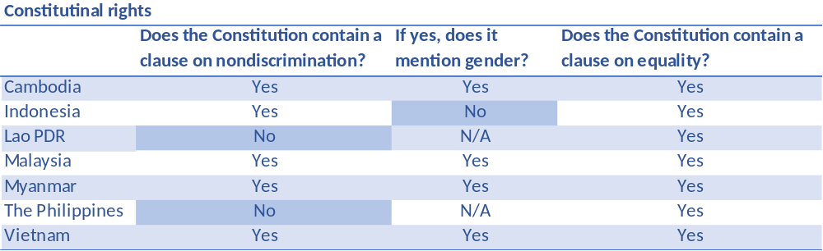

The ability for women to do business, dealing with private providers of goods and services, such as landlords and lenders, requires extensive freedom of movement, prove of identity and full contractual capability. Laws in Indonesia, Malaysia, Myanmar and in the Philippines restrict in particular married women from interacting easily with public authorities, the private sector or banks. Women in these countries face either constraints in applying for ID cards, choosing where to live, conferring citizenship to children, or being the legal head of a household.
Women make up a large share on loans from micro-finance institutions, but they are often lacking on traditional banking relationships. The Philippines and Vietnam prohibited discrimination in access to credit and Vietnam bolstered women’s access by programs targeting women entrepreneurs.
Quotas on reserved seats and party list for parliaments and local governments or corporate boards increases women’s representation in important decision-making processes. The use of quotas to determine the minimum number of women is widespread. In the project considered countries only Indonesia (30% women in local government and candidate lists for parliament) and the Philippines (2% women in local government) use the instrument to reserve seats on candidate lists for the parliament or local government. To increase women’s representation in managerial and board positions, Malaysia instituted a 30% target for women in decision-making positions in the corporate sector.

b) Using property
Women’s land rights are of particular relevance for example to hydropower development, given the sector’s impact on land. In Vietnam and LAO PDR exist legislation that says that land acquired by a woman and man during their marriage is a shared asset, and that land titles or certificates for these assets must include the names of both the wife and husband. In Laos, the Property Law 1990 and Land Law 2003 are the relevant pieces of legislation. In Vietnam, the Law on Marriage and Family (1986, revised in 2000) and the Land Law (2013) are the relevant legislation. (Christina Hill et all, 2017)
Moreover, in Malaysia and Indonesia female surviving spouses do not have the same inheritance rights as their male counterparts. That affects women`s access to assets such as properties and decreases their financial security and limits often investments in the daughters’ education.
More widespread than the land or job restrictions are tax benefits gender differences. Five of seven project countries either grant men an explicit tax deduction/credit, or an implicit tax deduction/credit is granted to the male head of household. In Cambodia, Indonesia, the Lao PDR, Malaysia and the Philippines, tax provisions directly favor men and disadvantage married women.

Data source: World Bank Group Business and the Law 2016: Getting to Equal.
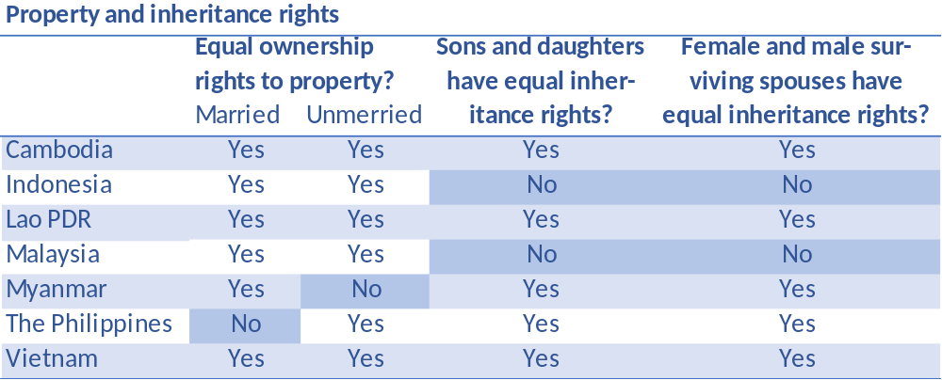

Source: World Bank Group, Atlas of Sustainable Development Goals 2017: World Development Indicators: Number of employment and entrepreneurship related laws differentiating between women and men

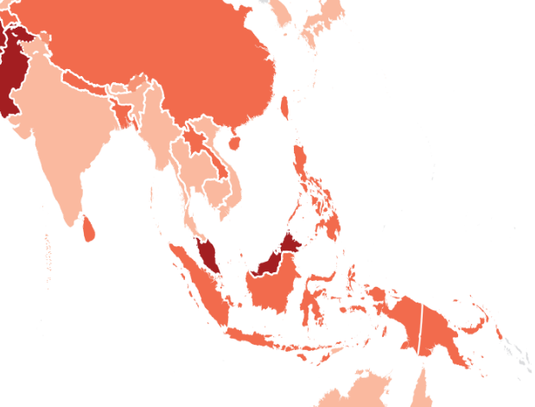
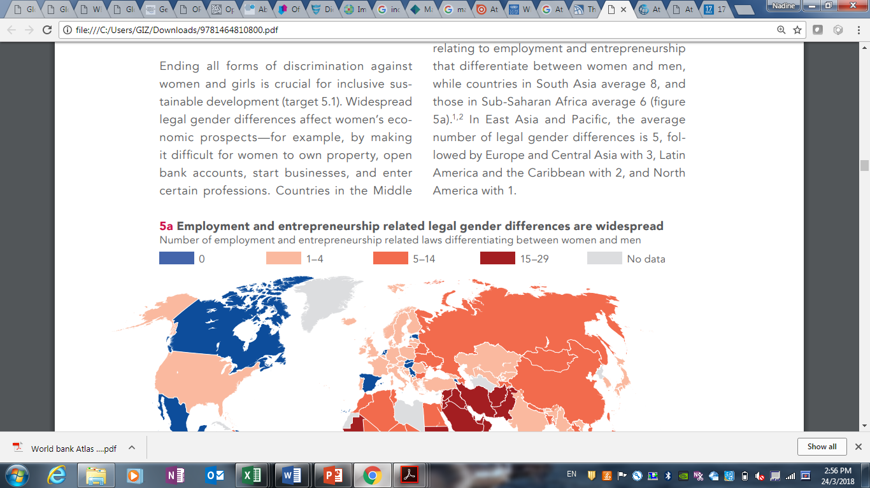
c) Getting a Job
Legal gender differences can affect a woman’s ability to get the job of her choice and also might limit her earning potential. All countries in East-Asia have laws impeding women’s economic opportunities. The World Bank study “Women, Business and the Law 2016” measured among other things barrier for women seeking opportunities that does not exist for men. Four of the seven in the project covered countries, Malaysia, Indonesia, the Philippines and Lao PDR are suited in the last third of that study. Malaysia has more than 15 legal differences in how the law treats women and men and ranks on place 159 of 173 covered countries and economies, followed by Indonesia (rank 139), the Philippines (rank 138), Lao PDR (rank 128). Vietnam and Cambodia have less than five barriers and rank on place 86 and 61 and Myanmar has the lowest legal gender difference and is suited on rank 32.
Opportunities for women are not equal where legal gender differences are prevalent, in most of the countries, labor codes do not guarantee mothers an equivalent position after maternity leave. Women in Malaysia and Vietnam but also in Myanmar, still face gender-based job restrictions. These prohibited jobs are often in well paid industries, such as mining, metalworking, constructing or manufacturing. The inequality in job opportunities can force women into low-paying sectors.

Data source: World Bank Group Business and the Law 2016: Getting to Equal.
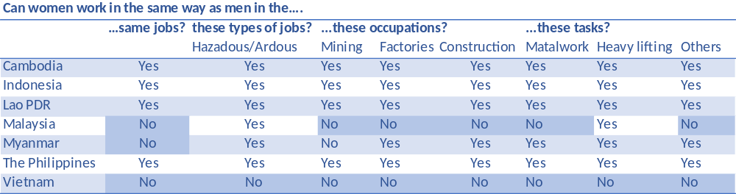

d) Violence
All seven project countries have legal protections either against sexual harassment or family occurred domestic violence. Myanmar is the only country that has no law on domestic violence against women. None of the seven countries covers legislations on all forms of domestic violence, including physical, sexual, emotional and economic violence. Moreover, Myanmar and Vietnam have no clear penalties for domestic violence.

Data source: World Bank Group Business and the Law 2016: Getting to Equal.
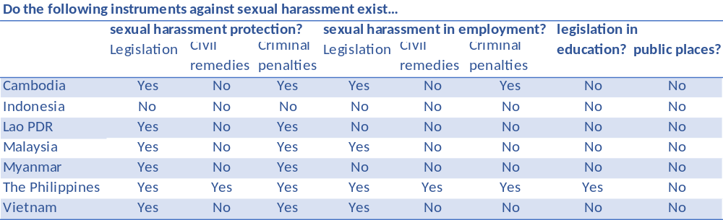

Aside from its obvious negative psychological and social effects, marital rape undermines a woman’s autonomy and well-being. Marital rape is not explicitly criminalized in some of the countries (Indonesia, Malaysia) or allow perpetrators to escape prosecution if they marry the victim (e.g. Philippines). In Myanmar, only rape of minors under the age of 14 is recognized as a criminal offence. Furthermore, women in Lao PDR, Malaysia and Myanmar are barred from filing criminal complaints against their husbands for rape. In these countries husbands are also exempt from facing criminal penalties for rape (known as the marital rape exemption).

- Methodology and Materials

PEMSEAs IRBM approach targets its interventions on the regional, national and local level within the three selected components: 1. Baseline Assessment of Source to Sea Management Continuum; 2. Governance for Improved IRBM and 3. Knowledge Management and Learning. All program interventions are aligned with the UNDP Social and Environmental Standards objectives to achieve a gender-sensitive approach. Gender mainstreaming is one of the underlying principles of the IRBM project for sustainable development. The recommendations highlighted in this report will be mainstreamed into all country project activities, provided in the project document and the relevant Technical Annexes.

The gender assessment is based on secondary data from international organizations and comprehensive reginal and national literature review of pertinent documents as well as on a combination on secondary and primary data specific to the pilot areas selected for implementation. Information were collected from site visits, discussions and interviews with PEMSEAs country managers, stakeholders working on gender issues, communities, donors, country partners and organizations such as GIZ or UNDP. Interview partners consulted throughout the design development are mentioned in the Stakeholder Engagement Strategy.

Gender indexes, country rankings and results on national gender gaps on economic, political, educational and health criteria are provided by several prominent international organizations and their data portals. For example, the OECD Gender Initiative offers results and indexes in the report “The Social Institution and Gender Index for East Asia and the Pacific” and The World Economic Forum (WEF) provides inter alia the Gender Gap Index 2016 for countries in the WEF Global Gender Gap Report 2016, whereas The World Bank provides tools for separate analyses to be carried out for sectors or countries on its data topics webpage. The present work applies, indexes and dashboards from “The Human Development Report 2016: Human Development for Everyone, launched by UNDP on March 2017. Based on the great clarity and the given sweeping overview, the World Bank paper “Women, Business and the Law 2016: Getting to Equal” as well as the “Atlas of Sustainable Development Goals 2017: World Development Indicators” were mainly used for the genders analysis on constitutional protections on nondiscrimination and gender-based legal differences. This document does not repeat all the country specific details provided in the reports but attempts to summarize the key facts and present the main transboundary and national concerns.

National gender assessments and analysis helped to understand the gender country challenges such as USAID: Cambodia Gender Assessment, 2016; GIZ: Gender Analysis: Identification of poor households in Cambodia, 2015; ADB &World Bank: Country Gender Assessment for LAO PDR - Reducing Vulnerability and Increasing Opportunity, 2012; ADB & UNDP: Gender Equality and Women`s Rights in Myanmar – A situation Analysis, 2016; Philippine Institute for Development Studies: How Does the Philippines Fare on Gender Equality?, 2017; UN Women: Transforming Our World: Vietnam - Women towards 2030, 2016, ADB: Gender Statistics - The Pacific and Timor-Leste, 2016

Further data collection is recommended regarding the lack of data specific to gender and waste management or river basin management in the country relevant hotspots. Baseline data need to be completed in all hotspots taking part in project activities. Monitoring and evaluation data should be collected in support of social and gender indicators as proposed in the action plan and in the project document.

3 Summary of Main Gender Issues Facing the Project
Addressing gender inequality and ensuring equal participation and opportunities for women and girls in Asia is central to achieving progress on the 2030 Agenda for Sustainable Development. Gender has been a part of ASEAN’s agenda since the 1988 Declaration of the Advancement of Women in the ASEAN Region. East Asia countries have contributed to narrowing of gender gaps in several areas, particular in education. Discriminatory attitudes that justify preference in education remain in some countries. For example, in Malaysia 43% of people believe that university is more important for boys than girls, and in the Philippines, 39% of people agree with that statement. There remain gender gaps in secondary education e.g. Lao PDR and in tertiary education in Viet Nam (World Bank, 2015). Gender-based inequalities challenges in some countries such as maternal mortality (Cambodia, Indonesia, LAO PDR, Myanmar) or access to basic education remain high. Women still have fewer income generation opportunities and systematically earn less than men for similar work in all project considered economies. This can result in occupational segregation along gender lines, with women concentrated in low-paying sectors, in the informal sector or as unpaid family labor. Women still own less productive assets or land and have disadvantages in access to business. And violence against women is reportedly high. For women, inadequate water supplies pose additional burdens. In Vietnam, some poor, remote, or migrant communities are unable to access clean water, exposing women and girls to increased risk of gynecological diseases. Although women are still the major users of water, they are less likely to participate in decision making on either domestic or public water supply
The 2016 Human Development Report, released on 21 March 2017, offers concrete and clear indicators and ranks for the project countries that are used in the following to point out main gender issued facing the project:

HDI: The Human Development Index (188 countries), is a summary measure for assessing progress in three basic dimensions of human development: a long and healthy life, access to knowledge and a decent standard of living.
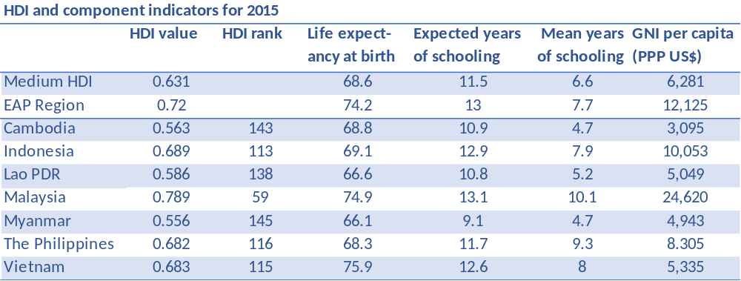

GDI: The Gender Development Index (160 countries), is based on the sex-disaggregated Human Development Index, defined as a ratio of the female to the male HDI. The Gender Development Index groups, divides countries into five groups by absolute deviation from gender parity in HDI values: while group 1 comprises countries with high equality in HDI achievements between women and men (absolute deviation of less than 2.5 percent) group 5 on the other hand comprises countries with low equality in HDI achievements between women and men (absolute deviation from gender parity of more than 10 percent).

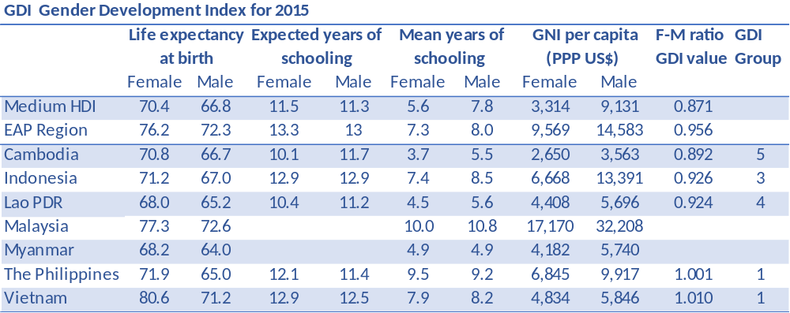
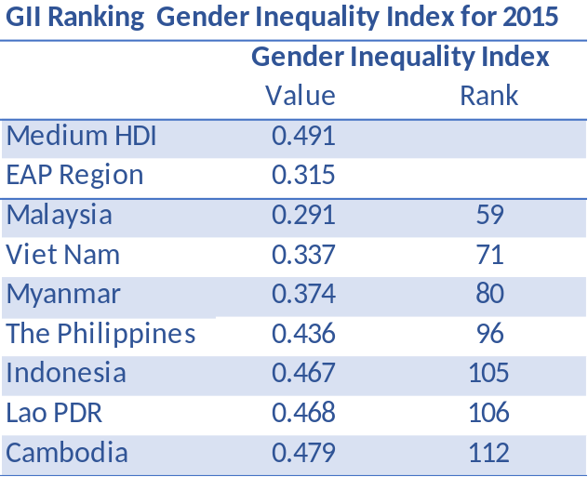
GII: The Gender Inequality Index (159 countries), reflects and ranks gender-based inequalities in three dimensions – reproductive health, empowerment, and economic activity and can be interpreted as the loss in human development due to inequality between female and male achievements in the three GII dimensions.

Most of the GII dimensions are also pictured in the “Life-course gender gap dashboard”, which benchmarks achievements on gender equality and the empowerment of girls and women. The indicators presenting gender gaps over the life course—childhood and youth, adulthood and older age. Three-color coding visualizes partial grouping of countries by indicator: the top third (dark green), the middle third and the bottom third.

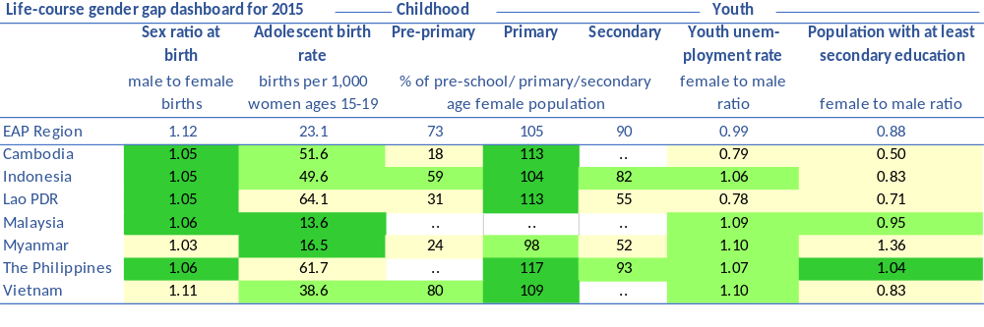

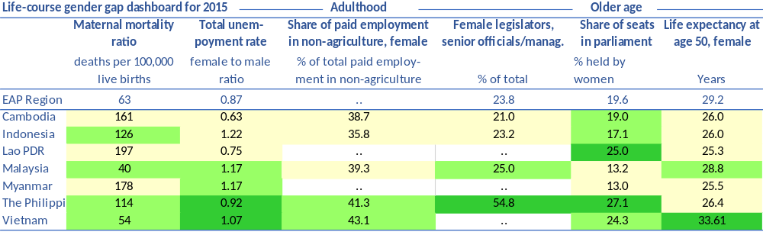
Cambodia
(UNDP Country report and USAID) Between 1990 and 2015, Cambodia’s HDI value increased 58% from 0.357 to 0.563. The country made progress in closing the gender gap in terms of political, economic, health, and education measures. The female HDI value for Cambodia is 0.529 in contrast with 0.592 for males, resulting in a GDI value of 0.892, which places the country into Group 5. Cambodia has a GII value of 0.479, ranking it 112 out of 159 countries in the 2015 index. More women now occupy political positions and are leaders in civil society organizations and movements, 19% of parliamentary seats are held by women.
Cambodia has essentially eliminated the gender gap in enrollment at the primary and lower secondary levels of education, although gaps persist at higher levels. 13% percent of adult women have reached at least a secondary level of education compared to 26% percent of their male counterparts. In practice, however, traditional norms and low levels of education and literacy still limit girls’ and women’s choices and options. Cambodia remains a hierarchical society with strong ideas about power and status. Women are considered to be of lower status than men, although status is also determined by age and other socioeconomic characteristics, especially wealth. For women, marriage and children additionally determine status. In general, attitudes toward gender roles still emphasize the woman as household manager and the man as provider. Women are also severely underrepresented in decision-making processes outside the household. ADB 2012
Maternal and child health indicators have improved significantly in recent years, including tremendous reductions in maternal and infant mortality, and more women have access to skilled birth attendants. But still for every 100,000 live births, 161 women die from pregnancy related causes; and the adolescent birth rate is 51.6 births per 1,000 women of ages 15-19. There has also been a noteworthy reduction in HIV/AIDS prevalence. Women are disproportionately affected by poor water access in Cambodia, given their responsibilities in the home to provide nutrition and maintain the health of children and family members. In Kampong Cham and Kampong Thom, research respondents indicated that at least 30 percent of all the households in their villages had no access to toilet facilities. (USAID)
Women continue to have a high rate of participation in the formal labor force and participate with 76% labor market compared to 87% for men, although the vulnerable employment rate (own-account and unpaid family labor) is high for both men and (disproportionately high) for women.
Gender equality commitments are embedded in Royal Government of Cambodia overall strategic plans such as the Rectangular Strategy for Growth, Employment, Equity, and Efficiency Phase III (2013-18); the National Strategic Development Plan NSDP 2014-18; Neary Rattanak IV (2014-18); and the second National Action Plan to Prevent Violence Against Women (NAPVAW II). Also, line ministries have Gender Mainstreaming Action Plans and organize Gender Mainstreaming Action Groups (GMAGs). The Ministry of Women’s Affairs (MOWA) is responsible for deeper examinations on gender equality and identifies gaps such as that women in politics are highly concentrated in lower levels of government and in government sectors traditionally associated with women, such as women’s issues or education. MOWA also points out, that the various action plans contain numerous unfunded commitments or weaknesses in conducting monitoring and evaluation. (USAID 2016)

Indonesia
Indonesia’s HDI value for 2015 is 0.689— which puts the country in the medium human development category—ranking it at 113 out of 188 countries and territories. Between 1990 and 2015, Indonesia’s HDI value increased from 0.528 to 0.689, an increase of 31%. Indonesia’s 2015 HDI of 0.689 is above the average of 0.631 for countries in the medium human development group and below the average of 0.720 for countries in East Asia and the Pacific. The female HDI (GDI) value for Indonesia is 0.660 in contrast with 0.712 for males, resulting in a GDI value of 0.926, which places the country into Group 3.

Gender inequalities are also found in access to education, health services, development utilities, and public infrastructure development. Indonesia has a GII value of 0.467, ranking it 105 out of 159 countries in the 2015 index. There are areas requiring progress for future success in women’s equality. Women make up less than 20% of parliamentary, and 43% of adult women have reached at least a secondary level of education compared to 52% of their male counterparts. For every 100,000 live births, 126 women die from pregnancy related causes; and the adolescent birth rate is 49.6 births per 1,000 women of ages 15-19. Education development has increased secondary education for female, however, it has not correlated in the same way to its participation in labor force. Female participation in the labor market is still low with 51% compared to 84% for men and the average female salary is less than half the average male salary. Comparative to the low rates of female political participation in parliament and local jobs is the quote of 22% of women in firms whose ownership includes women and firms whose top management includes women.

Indonesia has a large Muslim population where religious restriction impedes women’s mobility outside the house. Women participate in neighborhood or religious groups, but these groups have less or no influence on economically or business decisions. Education may be insufficient to change deeply rooted societal attitudes so that it may not improve outcomes that require transformations of gender relations such as decision-making authority, asset ownership, and community participation. Many parts of Indonesia are still governed by traditional law or local norms, which may give husbands rights to ask their wives to be housewives or to make household decisions by themselves. Moreover, patrilineal kinship in Indonesia often requires women to move into the homes of their husbands after marriage and give them limited inheritance rights. (WB Education 2015)

Violence against women in Indonesia is still a widespread problem throughout the country. The United Nations Population Fund (UNPF) conducted a survey in early 2017 and preliminary findings released in March revealed two in every five Indonesian women have experienced at least one of the four types of violence (physical, sexual, emotional, or economic) in their lifetime. The Pilot “Safe Cities” in Jakarta Province, supported by UN Women, provides technical advice on evidence-based policy advocacy, innovative ways to improve government response on domestic violence as well as prevention strategies.

The Ministry of Women’s Empowerment and Child Protection promotes mainstreaming of gender in in several programs. This is further supported by a Ministry of Finance regulation on planning and budgeting of gender considerations in national and local governments. Framed by the Convention on the Elimination of All Forms of Discrimination against Women (CEDAW), the government and UN Women supports the development of stronger legislative frameworks to remove discrimination against women and secure their rights, making Government policies and budgets more accountable to women. Activities are also taken to improve women's access to justice in plural legal systems through evidence-based policy advocacy and capacity building.

Lao PDR
Lao People's Democratic Republic’s HDI value for 2015 is 0.586— which put the country in the medium human development category—positioning it at 138 out of 188 countries and territories. Between 1990 and 2015, Lao People's Democratic Republic’s HDI value increased from 0.397 to 0.586, an increase of 48%. Lao People's Democratic Republic’s 2015 HDI of 0.586 is below the average of 0.631 for countries in the medium human development group and below the average of 0.720 for countries in East Asia and the Pacific. The female HDI value for Lao People's Democratic Republic is 0.560 in contrast to 0.607 for males, resulting in a GDI value of 0.924, which places the country into Group 4.
Lao People's Democratic Republic has a GII value of 0.468, ranking it 106 out of 159 countries in the 2015 index. In Lao People's Democratic Republic, 25% of parliamentary seats are held by women. The gender equality gap has narrowed in all levels of education enrolment, with gender parity at both primary and secondary levels. At tertiary level, the gender equality gap is still below parity and 30% of adult women have reached at least a secondary level of education compared to 43% of their male counterparts. For every 100,000 live births, 197 women die from pregnancy related causes; and the adolescent birth rate is 64 births per 1,000 women of ages 15-19. Also, national targets for under-five and infant mortality (set respectively at 70 and 45 per thousand live births) are still not achieved. Mortality rates are much higher among children from the poorest households and communities. Reasons for low maternal and child health services often are inadequate water and sanitation facilities and poor hygiene practices. In 2015, 76% of the population are estimated to have access to improved sources of drinking water and 71% have access to improved sanitation. However, the high prevalence of open defecation with estimated 23% is still a concern. There are high differences between rural and urban areas. For example, Saravane and Phongsaly have very high rates of open defecation between 78% and 62% respectively.
Female participation in the labor market is 78% compared to 77% for men. Although an equal share of men and women make up the working population, women are more excluded from formal sectors and the social protection that this entails. They generally occupy the lower rungs of the labor market, in the vulnerable informal sectors such as unpaid family workers. Men account for the majority of civil servants, professionals, technicians and other sectors. While Lao PDR has one of the highest proportions of women in national parliaments, the proportion of women is still very low in other decision-making positions in government institutions. At local level, 98% of village chiefs are men, although the Lao Women’s Union (LWU) is represented in village councils.
Lao PDR has achieved the MDG target 7C on safe water and sanitation, although the high prevalence of open defecation is still a concern.
The primary challenges to gender equality are in enabling equal access for women and girls to opportunities and resources, particularly for rural and marginalized women. Illiteracy, poor reproductive and basic health, food insecurity and economic disenfranchisement rank high among development priorities for women. The National Committee for the Advancement of Women, Mothers and Children (NCAWMC) as well as the Lao Women’s Union (LWU) have the mandates to promote gender equality and women’s empowerment. The operational capacities and budget of both institutions are limited and need to be enhanced at all levels.

Malaysia
Although Malaysia is the country with the most legal gender differences of the considered countries, it offers the best values for the HDI as well as for the GII in that group and ranks as the only country in the “high human development” category at position 59 out of 188 countries. Malaysia’s HDI value with 0.789, is above the average of 0.746 for countries in the high human development group and above the average of 0.720 for countries in East Asia and the Pacific. Between 1990 and 2015, Malaysia’s HDI value increased of 23% from 0.643 to 0.789. Due to a lack of relevant data, the GDI has not been calculated for Malaysia.
The country has a GII value of 0.291, ranking it 59 out of 159 countries in the 2015 index. For every 100,000 live births, 40 women die from pregnancy related causes; and the adolescent birth rate is 14 births per 1,000 women of ages 15-19. Just 13% of parliamentary seats are held by women. The Constitution provides for Sharia law and at least two women have been appointed to the Sharia judicial bench in Malaysia. But women are well represented in local and regional associations dedicated to enterprises, although their leadership roles and visibility in private-sector associations diminishes at the national level.
75% of adult women have reached at least a secondary level of education compared to 79% of their male counterparts. Sex-disaggregated data, including on the percentage and number of male and female workers in different categories are provided and maintained by the Malaysia’s Department of Statistics. Female participation in the labor market is 49% compared to 78% for men. Figures show, for example, that women are strongly represented in health-related sectors such as pharmacy (73%) and nursing (60%), and to some extent in medicine (47%), yet they only make up 11% of professional engineers (OECD 2016). But girls represent already more than one in three students enrolled in engineering programs and one in two researchers in science is a woman.
Efforts to more bring women into the formal economy are notable. In Malaysia, Women’s Service Centers at the state and district level provide business-related training and counseling. Furthermore, Malaysia is strengthening women’s role in business by implementing public sector policies. For example, the National Agricultural Policy set forth strategies to enhance women’s participation in agriculture and rural development. The government practices some affirmative action with respect to the entrepreneurial development of women, reaching out to women and providing incentives for them to start businesses. The government has also sponsored gender sensitization courses for policymakers, program implementers, and community leaders, and has strongly encouraged women’s access to technical inputs and tools.

Myanmar
Myanmar figures among the medium human development countries, ranking 145th of 188 countries. Several factors have hindered its socioeconomic development, including 60 years of isolation, Western economic sanctions between 1997 and 2012, a central command economy and unequal ownership and distribution of resources. The HDI of 0.556 is below the average of 0.631 for countries in the medium human development group and below the average of 0.720 for countries in East Asia and the Pacific.
Myanmar has a GII value of 0.374, ranking it 80 out of 159 countries in the 2015 index. Primary school enrollment has increased and gender parity has been achieved at both primary and secondary school levels and 27.1% of adult women have reached at least a secondary level of education compared to 20.0 % of their male counterparts. But there are continuing concerns about retention rates and the performance levels of certain categories of boys and girls (especially in secondary school), the quality of education (including the gender sensitivity of curricula), or concentration of girls in “female-oriented” educational streams.
Women’s participation in government and public administration increases slowly: 13% of Union Parliament seats are held by women. Despite some progress in the economy, gendered occupational segmentation and women’s concentration in the informal sector sustain concerns about job stereotyping, job quality, and sustainability. Female participation in the labor market is 75.1% compared to 81.1 for men. Women bear the responsibility for unpaid care work in addition to their paid jobs, while men are typically household heads.
The maternal mortality ratio consequently fell from 230 deaths per 100,000 live births in 2005 to 178 deaths in 2010 and the adolescent birth rate is 17% births per 1,000 women of ages 15-19. Women in the childbearing age group have been the focus of health attention in Myanmar. Women’s general health, in particular health concerns associated with violence against women and girls will need future attention. Conflict and recurring natural disasters have hit women hardest and violence against women and girls in every form is widespread. The number of females living with HIV was estimated at 70,000. Improvements have been registered in the quality of water and sanitation, 69% have access to improved drinking water and 79% of the population have access to sanitation.
Almost a third of the population of Myanmar do not have a form of identity document, 54% of those who do not have identity cards are women. In this sense, a common goal of the Norwegian Refugee Council (NRC), the United Nations High Commissioner for Refugees (UNHCR), and UN Women is to improve the protection of women in Myanmar through the recognition of legal identity rights, including access to civil documents and citizenship, and thus improving access to the services that are dependent on a secure legal identity.
The Ministry of Social Welfare, Relief and Resettlement promotes the implementation of commitments to gender equality and women’s empowerment. The Department of Social Welfare, acts as the government focal point on gender equality and women’s rights and the Myanmar National Committee for Women’s Affairs, is focused on the implementation of the Convention on the Elimination of All Forms of Discrimination against Women (CEDAW) and the Beijing Platform for Action supported by the Myanmar Women’s Affairs Federation and the Myanmar Maternal and Child Welfare Association. To ensure gender equality and women’s rights the Department of Social Welfare with support from the UN Gender Theme Group and the Gender Equality Network developed the National Strategic Plan for the Advancement of Women (2013–2022).

Philippines
The Philippines has made significant progress in enhancing the opportunities and welfare of its women and men. Its HDI value for 2015 is 0.682, positioning the country at 116 out of 188 countries and territories. This value is above the average of 0.631 for countries in the medium human development group and below the average of 0.720 for countries in East Asia and the Pacific.
The female HDI value is 0.682 in contrast with 0.681 for males, resulting in a GDI value of 1.001, which places the country into Group 1. The Philippines is the only country in the region to have fully closed the gender gap in both education and health. 73% of adult women have reached at least a secondary level of education compared to 70.3 percent of their male counterparts. The government continues focusing on promoting gender-fair participation, retention and achievement in education. One indicator for still existing discrepancies is for example that more boys than girls drop out from school because they need to work to augment the family income. (UNICEF)
Philippines has a GII value of 0.436, ranking it 96 out of 159 countries in the 2015 index. While 27% percent of parliamentary seats are held by women, the representation of women in elected positions across all offices has been an area of modest development, they are vast underrepresented: in 2016, 78% of the elected positions were occupied by men.
Maternal and child health services have improved with more children living beyond infancy, a higher number of women delivering at health facilities and more births being attended by professional service providers. For every 100,000 live births, 114 women die from pregnancy related causes; and the adolescent birth rate is 61.7 births per 1,000 women of ages 15-19. Maternal and neonatal tetanus has been eliminated in all regions of the country except the Autonomous Region of Muslim Mindanao.
Despite diminishing gender disparities in education outcomes and achievements, women continue to join the labor market less, and when they do, they tend to be paid less than men for similar work. Current female participation in the labor market is 50% compared to 79% for men. The trend since 2006 has been stagnant, with barely a 1-percentage point increase for females and a 2-percentage point decrease for males. Across most of Asia-Pacific countries with available data, women and girls tend to bear the larger burden of unpaid care and domestic work, which includes cooking and cleaning in the household's dwelling, person‐to‐person care activities, as well as transporting water (if unavailable on the household premises) from safe sources to the home (Hirway, 2016). The range of household, child and elderly care (and unpaid work in farms) done especially by women that goes unremunerated in society is undoubtedly a compelling reason why many women are invisible and excluded from their local and national economies.
The Philippines government with support from UNFPA, forces its engagement in preventing and responding to violence against women and children in both development and humanitarian settings. Even with great strides over the years in legislation to protect women and children against violence, there has been limited improvement in reported experiences of women. Compared to 20.1% of women in 2008 aged 15-49 years old reporting having ever experienced physical violence at aged 15, in 2013 the proportion stayed at 19.6%. Moreover, the Philippines have - compared to neighboring ASEAN countries - one of the highest trafficking incidences and the fastest growing. In 2011 it is estimated that 537 people are trafficked per 100,000 population, it climbed to 1,083 in 2014, 78% are women and girls.
The Magna Carta of Women sets out the State’s obligations in promoting and protecting gender equality, women’s rights, and the promotion of female empowerment across all sectors of society. The formulation of Women’s programs and plans is led by the Philippine Commission on Women (PCW).

Viet Nam
Viet Nam’s HDI value for 2015 is 0.683— which put the country in the medium human development category—positioning it at 115 out of 188 countries and territories. Between 1990 and 2015, Viet Nam’s HDI value increased of 43% from 0.477 to 0.683. The HDI of 0.683 is above the average of 0.631 for countries in the medium human development group and below the average of 0.720 for countries in East Asia and the Pacific. The female HDI value is 0.687 in contrast with 0.681 for males, resulting in a GDI value of 1.010, which places the country into Group 1.
Viet Nam has made strong progress on a solid legal foundation for gender equality and has a GII value of 0.337, ranking it 71 out of 159 countries in the 2015 index. 64% of adult women have reached at least a secondary level of education compared to 77% of their male counterparts. Gender gaps in educational enrollment, have been more or less closed. But gender stereotyping is still noticeable, women account for a small percent of students enrolled in engineering and applied technologies programs at Vietnam’s vocational colleges, where leadership and managerial positions are still dominated by men. Furthermore, women and girls of ethnic minority groups and poor households have fewer opportunities and have higher rates for school dropout and illiteracy.

One in ten women in Viet Nam still marry before their 18th birthday, mostly in remote ethnic minority areas. For every 100,000 live births, 54 women die from pregnancy related causes; and the adolescent birth rate is 38.6 births per 1,000 women of ages 15-19. Women continue to face risks from having unprotected sex with their partners. Nearly 54% of HIV infections among all women in Viet Nam result from risks taken by their male sexual partners. More than a third of young people lack access to contraception, as well as appropriate information. Access to family planning services remains limited, particularly for young unmarried women, migrant women, and women in remote and mountainous regions. Poor sanitation is a growing problem in urban areas, especially for female migrants. In schools, the absence of separate toilets for girls has contributed to high absenteeism among girls, limiting access to education and leading to poorer health outcomes, especially for ethnic minority girls.

24% of parliamentary seats are held by women and also the rates of female labor force participation are relatively high with 74% compared to 83% for men. Significant disparities still remain in the workplace and household, especially at a subnational level and in rural and remote areas. Women continue to earn less money than men, face entrenched cultural barriers and discrimination. For example, more than two-thirds of waste workers in Viet Nam are women, who earn less than men working in the waste sector, and 9 percent of waste pickers are children. These groups tend to be socially marginalized. They frequently live on or near garbage disposal sites, and thus are exposed to environmental and safety hazards. A few efforts have been carried out to provide micro-credit to female waste pickers, and to reduce the number of children working at waste dumps. However, there is much to be done to support the informal women sector.

The national Chamber of Commerce and Industry, comprised of all registered enterprises and with several branches, has a very active Women’s Entrepreneurs Council. Established in 2001, the council supplements the services provided to all businesses and has a training program for female entrepreneurs. The council participates in studies of women’s economic participation; collaborates with ministries, business associations, and international organizations on training, marketing, and business support programs; promotes the well-being of women through their participation in the economy; and collaborates with the Vietnam Women’s Union (VWU) and other socioeconomic organizations to support women’s participation in the economy, to upgrade their status in family and community life, and to contribute to job creation and poverty reduction. Currently, the Asian Foundation is working with the Vietnam Women Entrepreneurs Council to accelerate the growth of women-owned SMEs. The Higher Engineering Education Alliance Program (HEEAP) provides capacity building for women engineering professors and promoted women’s enrollment in technical fields and the Social Work Education Enhancement Program (SWEEP) trains female social work education administrators to become a more empowered and effective cohort of leaders in social work academia.

4 Project Strategies and Recommendations

The IRBM project is promoting gender equality and gender will be mainstreamed and integrated into all stages of the project cycle – from design and implementation through to monitoring and evaluation. The UNDP “Gender mainstreaming tool: Gender Mainstreaming Checklist for Project or Policy Documents” serves as a guideline to finalize the plan of action and the project document.

- Goals: The goal of the proposed intervention reflects the needs of both men and women. The goal seeks to correct gender imbalances through addressing practical needs of men and women.
- Target beneficiaries: There is gender balance within the target beneficiary group.
- Objectives: The intervention objectives address needs of both men and women.
- Activities: The planned activities involve both men and women. Activities are included to ensure that a gender perspective is made explicit.
- Indicators: Indicators are developed to measure progress towards the fulfilment of the objectives. These indicators measure the gender aspects of each objective and are gender disaggregated. Targets are set to guarantee a sufficient level of gender balance in activities.
- Implementation: Implementing partners and responsibilities for the planned intervention are listed in the Gender Action Plan. Men and women participate equally in the implementation activities.
- Monitoring and Evaluation: The monitoring and evaluation strategy include a gender perspective. It will examine both substantive (content) and administrative (process) aspects of the intervention.
- Risks: The greater context of gender roles and relations within society and potentially negative impact of the intervention has been considered.
- Budget: Financial inputs have been assessed to ensure that both men and women will benefit from the planned intervention. The need of gender sensitivity training and short-term gender experts have been factored into the budget.
- Annexes: A reference list with relevant research papers is included as annexes.
- Communication Strategy: A communication strategy has been developed to inform the public about the existence, progress, and results of the project from a gender perspective and is included in the project communication strategy.

Gender integration refers to the process of identifying and addressing gender and its impact on development outcomes as an integral part of the various project phases and components. Regarding the big scope of the project, it will be strived for reducing the complexity and the costs and to ensure the quality of gender activities by standardizing (general activities) as much as possible and individualizing where necessary (specific activities). Therefore, a kind of modular construction system will be developed – the gender action plan, that serves as a support structure for project involved actors.

4.1 Engagement of Men and Women in Activities
The following recommendations for all project components and countries, including the hotspots areas, are made to promote opportunities, drivers of change and positive gender dynamics as well as to manage and mitigate potential adverse risks over the duration of the project:
- Presence of gender equality goals, outcomes and outputs are reflected in each project component
- The project components include knowledge and realistic estimations about time, budget and supportive project management from ministries, communities, agencies, committees and technically project stuff, including data requirements
- Indicators and monitoring targets are set in terms of the gender objectives of reducing gender gaps, including sex-disaggregated monitoring indicators
- Support and control mechanism, such as reports or gender focal points are defined
- Potentially negative impacts or risks regarding the greater context of gender roles and relations within society are considered
- Commitments and inputs from the relevant ministries, communities, agencies or organizations are provided and responsibilities are defined in the Gender Action Plan
- Expenditures for gender capacity building and activities are allocated in each component and calculated in the project budget
- Participatory monitoring and evaluation processes are captured, reflecting gender beneficiaries and monitoring improvement for women’s welfare and status
Moreover, project specific and general gender activities that are summarized in the gender action plan (GAP) include targets, quotas, gender design features and quantifiable performance indicators to ensure women’s participation and benefits in the IRBM project. The GAP forms the basis for operationalizing the results and recommendations of the gender analysis, and contains specific gender elements to be considered in the project design and during the implementation of project measures and activities.

4.2 Project Selection Process for Women`s Activities
Gender-specific actions help to redress gender-based inequalities or discrimination against women or men in project activities. Some of the IRBM activities have been developed as specific activities to ensure that the project promotes equal opportunities and treatment through its activities. Although priorities, capacities, needs and gaps in IRBM vary from country to country, and from river basin/coastal area to river basin/coastal area, a common set of key project challenges have emerged across the countries, including:
- lack of effective/functional national and river basin-level coordinating mechanisms;
- low level of integration and harmonization of key sectors in the river basins (e.g., hydroelectric, agriculture, forestry, urban, port/navigation, fishing, aquaculture, tourism), resulting in competing (e.g., dams/irrigation), and conflicting uses (water for domestic use/untreated wastewater discharges);
- absence of overall strategy and action plan for the river basin development and management; in cases where strategies and action plans are in place there is a lack of effective implementation and enabling framework;
- identified management challenges include: deteriorating water quality; pollution (nutrients); solid waste (plastics); nutrient management; flooding; seasonal low water flow; competing uses; deforestation; erosion/sedimentation; environmental flows (e.g., dams/water management);
- insufficient capacity and know-how to develop investment projects to tackle identified management challenges;
- lack of financial commitment by the public sector for investment in facilities and services;
- lack of experience and know-how to develop public-private partnerships to leverage greater investment by the private/business sector;
- insufficient management and scientific capacity/experience to develop, implement and evaluate a science-based comprehensive IRBM program in the designated river basin/coastal area;
- lack of comprehensive environmental monitoring and evaluation program and database in the designated river basin/coastal area;
- lack of knowledge platform/information-sharing network to access new and innovative approaches to IRBM that have proven successful in ASEAN countries and across the region.
A main purpose of PEMSEA is to introduce gender activities in line with partners, ministries and communities. Following discussions and consultations, including gender issues among concerned national agencies, national water resource management and coordinating mechanisms, river basin authorities, local governments, resource managers, business/private sector, and community-based NGOs, a consensus emerged on the strategy to be developed and employed in the national IRBM pilot projects.
Key principles to be followed in the development of the national pilot projects and women activities, as well as the regional component of the project for knowledge management and capacity development, include:
- build on the commitments and momentum of the national governments, river basin authorities, local governments, NGOs, and donors in IRBM and ICM program in the designated river basins/coastal areas;
- utilize and build the capacity and talent at the central and local government levels for IRBM and ICM implementation;
- develop IRBM capacities through training and hands-on application and demonstration of best practices, technologies and professional skills, with the view to stimulate improved legal, policy, and institutional reforms at the national and local levels;
- promote government-business sector-community partnerships through a participatory process that facilitates co-development, co-ownership and co-operation in project development, management and implementation across sectors, and catalyze increased investments from the public and private sectors;
- work towards full and advanced integration in the designated river basin and coastal area – it will take time; collaborate/integrate with other relevant projects, structures, mechanisms and programs, including where optimal, activities undertaken by other donors and organizations; and
- facilitate knowledge sharing and the successful transfer of best practices, technologies and skills within each participating country and with other ASEAN participating countries and other stakeholders.
From these key principal topics for specific women activities were derived for the project and discussed to address gender disparities include employment and other economic opportunities accessible to men and women, gender-inclusive training activities, and measures to facilitate inclusion in decision-making by women. Measures will be designed to eliminate prevailing gender inequalities and inequities.
- Implementation of women-specific livelihood activities and associated benefits (e.g. inclusive growth, livelihoods along the recycling systems)
- Skills development (e.g. sewerage treatment facility, solar-pump-hydro hybrid,
- reforestation)
- Strengthening of women’s involvement in planning and decision making at national and subnational level (e.g. equal participation, strengthening women`s empowerment)
- Participation of women as agents of economic, social and political change at community level (e.g. waste awareness, waste reduction, handling waste).
Important discussed and proposed actions include also communication of gender related information to staff and partners, training and skill development on gender related issues, monitoring and reporting on mainstreaming within the project and supporting knowledge development activities by training and capacity-building.

4.3 Project Design: Targeted Women`s Activities for IRBM
The following special gender activities support systematically women’s skills and livelihood development and their engagement in the IRBM project work on selected sites. The project-specific actions ensure “gender mainstreaming” is tangible and explicitly visible in project design and implementation.

 | Proposed Intervention | Allocated Budget
1 | IRBM orientation and skills development | 45,000
2 | Empowered women through inclusive growth | 45,000
3 | Enhanced livelihood through sustainable reforestation | 45,000
4 | Integrating women/child waste pickers into a safe working and living environment and new livelihoods | 60,000
 |  | 195,000
Risk Identification
Given the situation described above, the IRBM project holds risks and opportunities for gender mainstreaming within the river basin, solid waste and thematically related hygiene aspects. Most crucially, discrimination of and violence against women at national level persists.
A number of risks exist, and many of them are project-specific (further specified in national pilot project proposals, Annex K). However, the enhancement of enabling capacities, development of a social protection floor for women and other measures, including better employment options for those that currently make their living this way, has been identified as the key risks. A holistic approach and more hotspot specific knowledge are needed to safeguard innovative concepts.

The following activities have been designed to complement the IRBM approach during the implementation of this project:

- Gendered norms in the complex water governance sector
Problem identification and rationale: River basins are dynamic over space and time, and any single management intervention has implications for the system as a whole. Lasting challenges for women in the IRBM sector in Asia are the gendered norms and inequalities that prevent women’s meaningful participation and leadership in water governance sectors and decision-making. Water and energy sectors and agencies are still male-dominated, and have limited focus or expertise in gender and social issues. The changing investments and plans in energy and infrastructure in the region have implications for transboundary water governance and for gender relations and women’s opportunities. Strategic decision-making at the river basin scale, active participation by relevant, well-informed stakeholders and a solid foundation of knowledge of the river basin and the natural and socio-economic forces that influence it are key elements to a successful IRBM initiative.

Proposed intervention: IRBM orientation and skills development
The proposed intervention is designed for professionals dealing with river basin management including: river basin organizations; regional or national governments involved in planning, water resource management, forestry, agricultural, and economic aspects of IRBM; nongovernmental organizations; companies; and universities. The training will have a minimum participation of 50% women, mobilizing and enabling them to participate actively in the decision-making process and to have better career options in the river basin management institutions or related businesses.
The capacity-building component will improve knowledge and skills of the participants in management of river systems and the long-term impacts for communities and people. Useful methods, experiences and tools for supporting IRBM will be discussed. Regional case studies will be used throughout the training to enable participants to learn the subject within an international setting. Women and men will get guidelines to organize planning, analysis and operational management. This activity will be organized by high-professional male and female trainers and offered in all participating river basins.

- Under representation of women in economic decision-making
Problem identification and rationale: Economic crises deepen pre-existing gender inequalities, including the under-representation of women at all levels of economic decision making and their over-representation in informal, vulnerable, and casual employment. At global, national, and household levels processes set in place economic crisis, affect people’s interactions with the environment, and exploitation of water for productive activities, domestic use, consumption, and sanitation.

Proposed intervention: Empowered women through inclusive growth
The proposed intervention will promote women in business undertaking activities across the waste value chain, including collection of waste, sorting and segregation, treatment or recycling and disposal of waste. Enterprises can address the gaps in the waste management system and build sustainability through efficiencies. These small enterprises might also engage in public-private partnerships with government departments and provide consulting services or providing information and data through online platforms and information analytics. Waste management enterprises typically have multiple revenue streams as they offer a range of services. These include waste collection fees from households, commercial enterprises and institutions, and proceeds from the production and sale of products sourced from waste materials, such as gift and utility items, biogas, and compost.

- Over-exploited resources and impacts on standard of living
Problem identification and rationale: Soil and water pollution, the over-extraction of water and alteration of vast tracts of land mass have contributed to the depletion of water and other natural resources. Both men and women are involved in reducing the environment’s sustainability, but their contributions differ in proportion to their power and influence, and their means to access and control natural resources. Local forests, which protect watersheds, are lost due to urban sprawl, cut for firewood and housing materials. Hence, the water supply and cleaning function of the forested areas are lost, further aggravating the urban water gap. Job losses, and the rising costs of food and fuel have increased inequalities and lowered standards of living for the most vulnerable whose livelihoods are dependent on their natural environment, in particular women and children. Consequently, the poor are forced to adopt coping strategies that overexploit the environment (for e.g. overfishing in protected waters, unsustainable cropping practices that lead to soil erosion, cutting trees for fuel wood). Reforestation, if several indigenous tree species are used, can provide benefits in addition to financial returns, including restoration of the soil, rejuvenation of local flora and fauna, and the capturing and sequestering of 38 tons of carbon dioxide per hectare per year. A tree-planting program could enhance the local climate, lower the sediment runoff volume into the river channel, remove threats from destroyed aquifers and guide away from monoculture plantations.

Proposed intervention: Enhanced livelihood through sustainable reforestation
The proposed intervention will raise the capacity of women and men equally in sustainable reforestation and income sources in selected hotspots in the participating river basins. In addition to income generation, sustainable reforestation projects will also be designed to reduce soil erosion, enhance wildlife habitat, produce high-quality trees for timber or special wood products, provide revegetated buffers along streams to protect water quality, increase species diversity and resiliency, and result in a more valuable, sustainable estate for future generations. This will be achieved through training in methods of establishing sustainable wooded areas and hands-on implementation in the development of a sustainable reforestation operation. The capacity development will support the equal participation of men and women to analyze the planting site, select appropriate tree species, prepare the site and the planting process, and to manage the site as a sustainable operation.

- Unsafe working conditions in the informal waste collection and recycling sector
Problem identification and rationale: The informal sector of existing waste management systems involves scavengers or waste pickers, waste collectors and waste agents. Informal workers provide waste collection and waste recycling services as a livelihood, while delivering a vital public service to local governments. Waste pickers fill a gap by reclaiming recyclables and providing inputs of raw material into the formal recycling chain. In this way, they are also acting as economic agents in the local recycling industry. (WIEGO 2016)

Project sites in Cambodia, Indonesia, Philippines and Vietnam have informal workers in their waste management systems, most of whom are women and, in some cases, children. For example, in Vietnam more than two-thirds of waste workers are women and 9% of waste pickers are children. (WIEGO 2015) Women working in the informal sector are likely to be marginalized when the informal activities become formalized. In the informal sector, men usually take control over waste materials with higher value for recycling. It is also common to find that men mainly collect waste and sell the segregated materials, while women segregate the collected waste items at home and are responsible for disposing of those with no value. Such a division of labor makes women’s work invisible or less valued, resulting in a lack of recognition of the economic contributions by women and inclusion in public policies. Consequently, when waste-picking activities become legitimized, women tend to be excluded or do not enjoy the same opportunities as men. (2015 UNEP In addition, under existing, waste pickers and waste handlers are continually exposed to environmental and safety hazards Waste pickers in particular are at a high level of health risk due to their proximity to unseparated discards, which often include infectious and toxic materials, as well as the unsanitary and hazardous conditions under which they work. Waste pickers are exposed to a cocktail of toxic fumes and other chemicals, including open burning, at the dump sites where they work. Risks also come from direct contact with waste materials such as broken glass, fecal matter, containers and packaging contaminated with residues from chemicals and pesticides, and medical wastes such as used needles and bandages from hospitals, etc.

Proposed intervention: Integrating women/children waste pickers into a safe working and living environment and new livelihoods
The proposed intervention aims to decrease the exposure of informal waste pickers and poor people dealing with waste in their daily activities. Job and livelihood opportunities will be developed in collaboration with the informal sector for a centralized waste segregation, recycling and production facility in selected hotspots in the participating river basins. Training and capacity development in segregating and safe handling waste will be provided to both men and women, with a least 50% of the participants being women waste pickers. The training will be promoted as part of the planning and commissioning of the centralized facilities, along with the identification and promotion of opportunities for employment, the development of sustainable small businesses that are aligned with the waste management system, and ready access to child care and education facilities.

4.4 Monitoring and evaluation
In order to understand the impact of the project efforts on gender and to ensure that gender is not “mainstreamed away”, monitoring and evaluation mechanisms are defined, including indicators, that will assess the project’s progress and achievements on promoting gender equality. The described gender indicators will be built into the monitoring system of the IRBM project. The progress and performance of the activities will be periodically assessed as part of the project overall monitoring.

- The project monitoring system includes indicators that measure gender differences in outputs, results and outcomes, the progress will be tracked on impact, outcomes and output indicators
- Project database includes sex-disaggregated and gender related information (e.g. number or proportion of women and men trained, employed or in management positions)
- Achievements in gender equality and women`s empowerment will be measured on the defined targets and by progress on implementing the plan’s
- Country-specific evaluations on development effectiveness, and long-term aggregate gender indicators will be made (e.g., amount of waste reduced in households, number of trees planted)
- Project addressing gender issues that arise during or from its implementation

Gender-specific target indicators are included in the Gender Action Plan (GAP) these have to be frequently revised and adjusted.

4.5 Implementing arrangements
Implementation will proceed in collaboration with the relevant line Ministries in each country. Primary
responsibility for implementation of gender activities remains with the Regional Project Management
and the National Coordination Units set for the purpose of this project, and the relevant personnel.

Bibliography
ADB. “Cambodia: Country gender analysis”. Asian Development Bank, Mandaluyong City, Philippines: Asian Development Bank, 2012. Publication Stock No. RPS114210
ADB. “Gender Equality and Women’s Rights in Myanmar, A Situation Analysis”, Asian Development Bank
ADB. “Gender and Urban Poverty in South Asia—Proceedings Report of the 2012 Subregional Workshop”, Asian Development Bank, Mandaluyong City, Philippines: Asian Development Bank, 2013.
Arlene Nietes Satapornvanit, Yuan Derunt, Nikita Gopal, Gladys Villacorta. ” NACA/USAID - Thematic Studies on Gender in Aquaculture in Cambodia, Lao PDR, Thailand and Vietnam”, 2016, The Journal of the Asian Fisheries Society
CIDA-AIT Partnership. “Gender Mainstreaming in Urban Environmental Management Projects: Lessons Learned from Southeast Asia Urban Environmental Management Applications (SEA-UEMA) Project” 2010
Clarissa C. David, Jose Ramon G. Albert and Jana Flor V. Vizmanos, Sustainable Development Goal 5: How Does the Philippines Fare on Gender Equality? Discussion Paper Series No. 2017-45, Philippine Institute for Development Studies
Sonia Maria Dias, Waste pickers and cities, Environment & Urbanization, 2016 International Institute for Environment and Development (IIED), Vol 28(2): 375–390
Faramand T, Ivankovich M, Holtemeyer J. 2017. „A Guide to Integrating Gender in Improvement”. Published by the USAID Applying Science to Strengthen and Improve Systems (ASSIST) Project. Chevy Chase MD: University Research Co., LLC.
Christina Hill, Phan Thi Ngoc Thuy, Jacqueline Storey & Silavanh Vongphosy, 2017, Gender & Development: Lessons learnt from gender impact assessments of hydropower projects in Laos and Vietnam
Herminia Ibarra, 2017, “Why strategic networking is harder for women”, World Economic Forum, www.weforum.org
Iffat Chowdhury, Hillary Johnson, Aneesh Mannava and Elizaveta Perova. “Gender streaming in Vietnam,
ILO. “Good Practices in Promoting Gender Equality in ILO Technical Cooperation Projects”, Bureau for International Labour Organization 2007
Leahy, C., Lunel, J., Grant, M., and Willetts, J., (2017), “Women in WASH Enterprises: Learning from female entrepreneurship in Cambodia, Indonesia and Lao PDR”, Enterprise in WASH – Working Paper 6, Institute for Sustainable Futures, University of Technology Sydney
Maria Rebecca Valenzuela, Wing-Keung Wong, and Zhu Zhen Zhen, “Income and Consumption Inequality in the Philippines”, 2017, Asian Development Bank Institute
Mitsunori Odagiri, Zainal Muhammad, Aidan A. Cronin, Michael E. Gnilo, Aldy K. Mardikanto, Khaerul Umam and Yameha T. Asamou, “Enabling Factors for Sustaining Open Defecation-Free Communities in Rural Indonesia: A Cross-Sectional Study”, International Journal of Environmental Research and Public Health 2017
National Economic and Development Authority Philippine Commission on Women Official Development Assistance Gender and Development Network, “Harmonized Gender and Development Guidelines for Project Development, Implementation, Management, Monitoring and Evaluation, 3. Edition, 2016
OECD, SIGI - Social Institution and Gender Index 2014 results for East Asia and the Pacific
Philippine Commission on Women, “Women`s Empowerment, Development and Gender Equality Plan, 2013 – 2016, funded by UNWOMEN
Philippine Statistic Authority, “2017 Gender Statistics on Labor and Employment”, 2018
Sarah Harper, Charlotte Grubb, Margot Stiles & Ussif Rashid Sumaila, 16 Feb 2017 “Contributions by Women to Fisheries Economies: Insights from Five Maritime Countries”, Journal Coastal Management Volume 45, 2017 - Issue 2 Pages 91-106
UN. “The Millennium Development Goals Report 2015”
UNDP & APTN. “Legal Gender Recognition: A Multi-Country Legal and Policy Review in Asia”, 2017
UNDP. “Human Development Report 2016: Human Development for Everyone”, United Nations Development Programme, One United Nations Plaza New York, NY 10017
UNDP. “Social and Environmental Screening Procedure”, 2016
UNDP. “Organizing Informal Workers: Benefits, Challenges and Successes”, 2015, United Nations Development Programme, 1 UN Plaza, New York, NY 10017, USA
UNDP. “UNDP’s Social and Environmental Standards (SES)”, 2014
UNDP, “Gender Mainstreaming in Practice – A Toolkit”, Regional Programme of the United Nations Development Programme’s, Regional Bureau for Europe and the CIS (UNDP RBEC), 3rd Edition 2007
UNDP. “Gender Mainstreaming – Training Manual”, 2007
UNEP. “Gender and Waste Management - Did you know…?”, IETC v.1.0
UNESCAPE, ADB, UNDP.” Making it Happen – Technology, Fianance and Statistics for Sustainable Development in Asai and the Pacific - Asia-Pacific Regional MDGs Report 2014/15
UN-Habitat. “World Cities Report 2016, Urbanization and Development: Emerging Futures”, 2016, United Nations Human Settlements Programme
UNICEF. “Strategy for Water, Sanitation and Hygiene 2016–2030”, 2016, Water, Sanitation and Hygiene (WASH) Section, Programme Division, UNICEF New York
City of Hobart Public Toilet Strategy 2015 - 2025
UNICEF. “Progress on Drinking Water, Sanitation and Hygiene - Update and SDG Baselines”, 2017, Water, Sanitation and Hygiene (WASH) Section, Programme Division, UNICEF New York
UNICEF. “Annual Results Report 2016 Water, Sanitation and Hygiene”. 2016
UNICEF. “Philippine Country Situation Update- WASH”, June 2017
UNICEF. “Opportunities - Supporting the Rights of Girls and Women through Menstrual Hygiene Management (MHM) in the East Asia and Pacific Region”, 2018
UNICEF. “Meeting the Humanitarian Needs of Children in Myanmar 2015 - Providing Equitable and Sustainable Water, Sanitation and Hygiene Services to Conflict-Affected Persons in Rakhine, Kachin and Northern Shan States”, WASH
UNWOMEN. Monitoring Gender Equality and The Empowerment of Women and Girls in the 2030 Agenda for Sustainable Development: Opportunities and Challenges
UNWOMEN. “CEDAW and women’s human rights – Asia and the Pacific”, 2018 http://asiapacific.unwomen.org/en/focus-areas/cedaw-human-rights
USAID. “A Guide to Integrating Gender in Improvement”, 2017
USAID. “Cambodia, Gender Assessment”, 2016
USAID. “Vietnam - Gender Analysis”, 2012
USAID. “GENDER Regional Agricultural Trade Environment (RATE) - Feed the Future”, 2013
WaterAid. “Water, Sanitation and Hygiene (WASH) situation and issues for urban poor people and vulnerable groups, Cambodia”
WEDC, The Water, Engineering and Development Centre, Synthesis Note No. 5, Recognising gender issues in the management of urban waste, 1998
WEF. “The Global Gender Gap Report 2016”, World Economic Forum.
WHO. “PHILIPPINES–WHO Country Cooperation Strategy 2017–2022”, 2017
WHO, WSP and UNICEF. “Universal Sanitation in East Asia Mission Possible?”, 2016
WHO. “Sanitation and Hygiene in East Asia”, 2010
WIEGO. “Informal Employment, Poverty and Gender”, 2016
WIEGO: Women in Informal Employment: ARB: Fighting for an Inclusive Model for Recycling in Bogotá1, 2015
WIEGO “Waste pickers and cities”, Vol 28 No 2, 2016
WIEGO. “From Theory to Action: Gender and Waste Recycling” A Toolkit for Teachers, Researchers and Practitioners, Book 3, 2015
WECF. “Women and Chemicals - The impact of hazardous chemicals on women”, 2016Women in Europe for a Common Future
Kitack Lim, 2017, Women in Maritime Philippines, 10th Anniversary
World Bank. 2017. Atlas of Sustainable Development Goals 2017: World Development Indicators. Washington, DC: World Bank. doi:10.1596/978-1-4648-1080-0. License: Creative Commons Attribution CC BY 3.0 IGO
World Bank. 2017. Improving Service Levels and Impact on the Poor : A Diagnostic of Water Supply, Sanitation, Hygiene, and Poverty in Indonesia. WASH Poverty Diagnostic;. World Bank, Washington, DC. © World Bank. https://openknowledge.worldbank.org/handle/10986/28505 License: CC BY 3.0 IGO.
World Bank. Annual Report 2017. worldbank.org/annualreport
World Bank Group. “Vietnam - World Bank Group Country Survey 2017”, Public Opinion Research Group - The World Bank Group, Report generated on: May 16, 2017
World Bank Group. “Women, Business and the Law 2016: Getting to Equal. Washington” 2015, DC: World Bank. doi:10.1596/978-1-4648-0677-3. License: Creative Commons Attribution CC BY 3.0 IGO
World Bank Group. “World Development Indicators 2016”
World Bank Group. “BUILDING SUSTAINABILITY IN AN URBANIZING WORLD” 2013
World Vision. “Global Annual Report WASH”, October 2016 through September 2017, Prepared January 2018
WaterAid. “Gender Equality and Disability Inclusion within water, sanitation and hygiene - Exploring integrated approaches to addressing inequality”
Yeny Dhokhikah, Yulinah Trihadiningrum “SolidWaste Management in Asian Developing Countries: Challenges and Opportunities”, Journal of Applied Environmental and Biological Sciences, 2012

Appendix A: Gender Activity Plan (GAP)
This project-specific gender action plan is a tool to ensure “gender mainstreaming” is tangible and explicitly visible in the IRBM project design and implementation. The project GAP is an integral part of the project design and mirrors the project outputs and ensures women’s participation and benefits in the project. The GAP includes general activities, required for all country sites and special activities which will support systematically women’s skills and livelihood development and their engagement in the project work on river basin management on selected sites. Some of the special activities will be supported by organizations that are already involved in related development work or have local know how. The items displayed in the following table are not static, they have to be completed and adapted with the ongoing project and the individual requirements of the hotspots.

Title | Target group | Output |  | Activity | Indicator |  | Budget |  | In Charge
GENERAL ACTIVITIES
Commitments of the implementer | Project management | Promoting gender awareness in project leadership and boards |  | Project managers, decision makers and board members, commit to gender equality and have gender expertise or conducted gender trainings and workshops to ensure gender mainstreaming in the project. They mobilize adequate resources to support gender issues and to set gender equality goals. | - Project contracts or commitments reflect relevant gender and development concerns  - Gender back round or conducted workshop or trainings  - Midterm interviews evaluated |  | No additional cost |  | UNDP/ PEMSEA
Commitments of the project team | Project team, monitoring and evaluation teams and consultants | Promoting gender awareness in the project team |  | Commitment and technical competence of the project staff, including monitoring and evaluation teams or consultants to undertake and implement the project’s gender equality strategy | - Trainings and workshops conducted  - Clause in the contract signed  - Midterm interviews evaluated |  | No additional cost |  | Project leader
Commitments government agency and partners | Implementing government agency and partners | Promoting gender awareness of partners and implementing agencies |  | Implementing agencies and partners commit to gender mainstreaming, attend gender training sessions and utilized the knowledge to conduct a gender analysis in their activities and encourage women’s leadership roles in the project. | - Number of committee members conducted gender trainings or workshops + number of committee members with gender back round/Number of committee members = 1  - Clause in the contract signed  - Midterm interviews evaluated |  | No additional cost |  | Activity leader
Presence of women in the project team | project team | Advancing equal employment opportunities in the project team |  | Equal employment and payment opportunities in the project for men and women advocated. Efforts made to employ more women through flexible or part-time jobs, taking into account that women are often responsible for household and children | - Number of employed women in the project team/Number of employed men in the project team  - Women salary in the project team/ men salary in the project team  - Number of hired female consultants/ Number of hired male consultants  - Payment of hired female consultants/ Payment of hired male consultants  - Number of part-time or time flexible contracts/Number of contracts |  | No additional cost |  | Project leader
Presence of women in the leadership |  | Improving  women’s role in management and leadership in the project |  | The representation of women in the project boards or committee should be equal, and women should get encouraged take a greater role in decision boards | - Number of women in the project board/Number of men in the project board = 1  - Number of women in leadership in the project /Number of men in leadership in the project |  | No additional cost |  | UNDP and Project leader
Presence of women in activities | Implementing team and participants of project activities | Enable women for active participation in project activities |  | Enforcement of procedures and processes that promote women’s participation and their systematic involvement in the planning and implementation of all activities and in consultation forums | - Number of women in an activity/ Number of men in an activity  - Number of women taking a visible coordinating role/ Number of men taking a visible coordinating role  - Number of women getting payed in an activity/ Number of men getting payed in an activity |  | No additional cost |  | Activity leader and gender expert
Women-only meetings | Project team, implementing government agency and partners | Enable women for active participation and decision-making processes |  | Separate, informal meetings organized for women to enable them to participate better in discussion and to take actively part in planning processes and decision-making | - Number of women-only meeting  - Number of women taking a visible coordinating role/ Number of men taking a visible coordinating role (same indicator as in presence of women in activities) |  | No additional cost |  | Activity leader and gender expert
Capacity building and awareness-training | Project team, implementing government agency and partners | Enhance gender expertise |  | Capacity building and awareness-raising trainings and workshops to clarify key gender concepts, under-standing the role of gender analysis and providing practical guidance on how to undertake gender planning for project and program activities throughout the project cycle. These gender sessions are included in all workshops and training programs to maximize knowledge on gender analysis and to strengthen the ability to identify problems in gender-responsiveness in the activities | - All project team members trained  - Number of project engaged people from implementing government agency trained (or gender back-round)/ Number of projects engaged people from implementing government agency  - Number of project engaged people from implementing partners trained (or gender back-round)/ Number of projects engaged people from implementing partners |  | USD 10,000 development cost, budget for the trainings are included in the components |  | Activity leader and project team
Technical support for partners and agencies | All project participants | Increasing gender awareness |  | Material and recommendations about the project activities, including gender equality, gender mainstream and gender-relevant activities at field level will be provided in the relevant languages and are online available. The common platform also supports sustain dialogue between the partners on gender equality. | - Materials developed,  - translated and  - online available |  | No additional cost
Mentoring mechanism | All project participants | Increasing gender expertise |  | Local gender focal points installed to each country to provide on-site technical support when needed. These focal points are connected for further follow up with the centralized project gender expert | - Contract with local gender focal points in each country  - Training provided  - Meeting/Workshop/Conference between local focal points and centralized project gender expert per country |  | No additional cost |  | Project management and gender expert
Collecting sex-disaggregated data |  | Strengthening gender gap identify-cation and progress in women’s welfare |  | Continuing efforts are made to collect sex-disaggregated data to monitor project achievements on women’s welfare and measure if gender equality has been increased. Baseline data will be developed for each activity and missing data need to be evaluated in studies or interviews. | - Indicator and kind of sex-disaggregated data will be developed and set for each activity responsible person and adjusted, harmonized and evaluated by the project gender expert |  | No additional cost |  | Activity leader and gender officer
Integrated monitoring and evaluation |  | Strengthening project management awareness |  | Gender Activity Plan and its indicators are fully integrated in regular project monitoring cycle and in the evaluation and reporting process to ensure management attention. | - Indicators integrated in M&E |  | No additional cost |  | M&E team
SPECIFIC WOMEN ACTIVITIES
IRBM orientation and skills development | Professionals dealing with river basin management from river basin organizations, governments involved in planning, water resources, forestry, agricultural, economic aspects of IRBM, nongovernment organizations, companies and universities |  | Sustainable development and management of river basins and coastal areas and improved gender equity and women’s empowerment in transboundary water governance. | The capacity-building component will improve knowledge and skills in IRBM and the impacts for communities and people. Useful methods, experiences and tools for supporting IRBM will be discussed. Regional case studies will be used throughout the training to enable participants to learn the subject within an international setting. Women and men will get guidelines to organize planning, analysis and operational management. This activity will be organized by high-professional male and female trainers and offered to all hotspots. |  | - Number of trained women and men (minimum 50% women participation)  - Number of hired female/male trainers for IRBM orientation and skill development  - Trainer salary women/men |  | 45,000 | Project Manager, professional trainers, gender officer
Empowered women through inclusive growth | Women in river basin communities |  | Capacity of communities through women in managing their own business | The proposed intervention will promote in particular women in business undertaking activities across the waste value chain, including collection of waste, sorting and segregation, treatment or recycling and disposal of waste. Women will have interval trainings in developing and managing small scale businesses to generate income. |  | - Number of trained women  - Number of women generated business ideas  - Number of women starting a business  - Amount of generated income from the new business per women/per activity |  | 45,000 | Activity leader, trainer for business development, gender officer
Enhanced livelihood through reforestation | Women and men in communities |  | Capacity development on reforestation and new income sources | The proposed intervention will train men and women equal in reforestation to improve soil erosion control, wildlife habitat, high-quality trees for timber or special wood products, revegetated buffers along streams to protect water quality, increased species diversity and resiliency, and a more valuable estate for future generations. The capacity development will support in particular women to analyze the planting site and select appropriate tree species, to prepare the site and the planting process and to maintain the seedlings as they mature. |  | - Number of trained women and men (minimum 50% women participation)  - Number of hired women for reforestation/Number of hired men  - Women salary in reforestation/ men salary  - Number of planted trees (indicator set by implementation of activity) |  | 45,000 | Activity leader, government agency for forest management, trainer for  Reforestation or PPP, gender officer and focal points
Enhanced livelihood through sustainable reforestation | Women in river basin communities |  | Capacity of communities through women in developing and implementing sustainable reforestation | The proposed intervention will train women and men equally in reforestation as a sustainable business and livelihood, as well as a means to improve soil erosion control, wildlife habitat, high-quality trees for timber or special wood products, revegetated buffers along streams to protect water quality, increased species diversity and resiliency, and a more valuable estate for future generations. The capacity development will support participants to analyze the planting site, select appropriate tree species, prepare the site and the planting process, and manage the site as a sustainable operation. |  | - Number of trained women and men (minimum 50% women participation)  - Number of hired women for reforestation/Number of hired men  - Women salary in reforestation/ men salary  - Number of planted trees (indicator set by implementation of activity) |  | 45,000 | Activity leader, professional trainer for  sustainable reforestation, gender officer
Integrating women/children waste pickers into a safe working and living environment and new livelihoods | Women waste pickers |  | Improving waste pickers and working conditions, and provide improved living environment for women and children | The proposed intervention aims to decrease the exposure of informal waste pickers and poor people dealing with waste in their daily activities. Job and livelihood opportunities will be developed in collaboration with the informal sector for a centralized waste segregation, recycling and production facility in selected hotspots in the participating river basins. Training and capacity development in segregating and safe handling waste will be provided to both men and women, with a least 50% of the participants being women waste pickers. The training will be promoted as part of the planning and commissioning of the centralized facilities, along with the identification and promotion of opportunities for employment, the development of sustainable small businesses that are aligned with the waste management system, and ready access to child care and education facilities. |  | - Number/percentage of trained women and men (minimum 50% women participation)  - Number/percentage of hired women/men in the formal waste management sector  - Women/men salaries in the formal waste management sector  - Increase in number of children attending school or daycare |  | USD 60,000 | Activity leader, professional trainer for  sustainable reforestation, gender officer

Annex H: UNDP Risk Log

# | Description |  | Date Identified |  | Type | Impact &  Probability |  | Counter measures / Mngt response | Owner | Submitted, updated by | Last Update | Status
1 | Impacts of pollution, land development, conflicting water uses and climate change in the selected river basins undermine the sustainability of S2S/ IRBM management, by adversely impacting environmental flows and biological processes that underpin provisioning, regulating and supporting ecosystem services. |  | 29 May 2018 |  | Environmental | The project is designed to minimize the impacts of issues created by pollution, resource sharing and environmental flow at the river basins. If the project activities are to be slowed, the risk might be taking effect.  P = 2  I = 5 |  | The risks associated with predicted pollution, land development, conflicting water uses and climate change impacts are complex and difficult to quantify. Substantive project funds are allocated toward increasing capacities, experience and knowledge base in each river basin regarding the reduction and mitigation of such impacts on environmental flows and the water/food/energy/ ecosystem security nexus, and the associated consequences on local communities. The increased capabilities, experience and supporting networks resulting from these efforts will facilitate improvements in governance and management of the selected river basins as well as better informed strategies for scaling up and replicating good IRBM practices within and across priority river basins. | Regional PMO  National PMO
2 | Financial sustainability of project activities is threatened by inadequate allocation of funding by governments. |  | 29 May 2018 |  | Financial | This risk is not likely to take effect since the government counterpart budget has been already identified. However, in rare cases of the political or institutional changes happening at the river basins, the risk might be taking effect.  P = 2  I = 5 |  | The ratio of GEF funding to co-financing is approximately 1:3, signifying a considerable level of commitment by governmental stakeholders for a foundational project.  It is expected that during project implementation, additional co-financing and investment capital will be identified. Also, the project aims to ensure financial sustainability of the river basin governance mechanisms, which will be agreed upon by the concerned national and local government authorities. | Regional PMO  National and local govern-ments
3 | Performance of project activities is low due to inadequate coordination by national and local governments and river basin organizations. |  | 29 May 2018 |  | Operational | Effective coordination is one of the keys to the success of the multi-country projects. The project has identified various stakeholders at the local, national and regional levels. This risk is not likely happening as the project is designed to coordinate to coordination the project activities at three levels. If the changes of political and institutional situations at the local and central levels, the risk will impact the overall delivery of the project activities. However, the impact will be limited to the affected countries.  P = 2  I = 5 |  | National Implementing Agencies will be confirmed in each of the 7 beneficiary countries, with each reporting to the ASEAN Working Group on Water Resources Management as the regional Project Steering Committee and also with direct reporting line to the regional project manager. The project will include an intergovernmental, multi-sectoral river basin organization in the selected river basin in each country to plan, coordinate and oversee project implementation, with a full-time coordinator hired to coordinate the implementation activities in the field. | Regional PMO  National PMO  Stakeholders at the river basins
4 | Unclear mandates or conflicts among resource users, different sectors of governmental units, national and subnational stakeholders lead to delays in project implementation. |  | 29 May 2018 |  | Organizational | This risk might be taking effect since legal and policy arrangements and mandates on water and natural resources are still not quite clear among the stakeholders in ASEAN countries. This risk will affect the speed of the project activities implementation at the river basins.  P = 3  I = 5 |  | The national implementing agency in each of the 7 beneficiary countries will be tasked with facilitating cross-sectoral collaboration at the national level. The river basin organizations, comprised of national policymakers, local Chief Executives and representatives of concerned community groups, including women’s groups and other non-government organizations, will be tasked to facilitate broad stakeholder participation at the river basin level. Technical working groups will be organized at the river basin level as well for additional coordination among managers, technical and scientific community, private/business sector, industry and non-government organizations, including women’s groups, to put in place pilot projects and to help develop and bridge improved IRBM governance and management systems in each river basin. | Regional PMO  National PMO  National and local govern-ments
5 | There is insufficient capacity to support management changes proposed by the project, e.g. with regard to institutional and administrative support, and legislation/laws and enforcement. |  | 29 May 2018 |  | Organizational | This risk may take effect if the project failed to capacitate the stakeholders at the river basins. In this case, the project outputs and outcomes would be compromised due to poor and ineffective handling of the project activities.  P = 2  I = 3 |  | Capacity building is one of the primary focuses of the project, with the aim of training “change agents” in each of the 7 beneficiary countries on state-of-the-art integrated approaches to IRBM. Local governments will be engaged in sharing management responsibilities, including monitoring, control, and surveillance arrangements. Further areas for capacity building may be identified during project implementation. | Regional PMO  National PMO
6 | Change in key policy and/or decision makers or other events beyond the control of the project lead to changes in policies and/or support for the project. |  | 29 May 2018 |  | Political | This risk is rather common among ASEAN countries due to frequent political and institutional changes. This risk will hamper the effective and efficient delivery of the project activities at the central or local levels, in particular, at the river basins.  P = 3  I = 5 |  | A 5-year long project will inevitably operate across national and subnational election cycles. The project is designed to facilitate national responses to agreed regional action programs, including the ASEAN, SDS-SEA, SCS LME, BOB LME, CTI-CFF, etc., which are long-term commitments that are mostly unaffected by changes in national or local governments. | Regional PMO  National PMO  National and local governments
7 | Enabling decisions required for implementation of some of the key project activities are delayed due to inefficiencies and/or lack of ownership by national and/or local government units. |  | 29 May 2018 |  | Regulatory | This risk will take effect when the stakeholders of national and local levels are not fully understood or aware of the project objectives, outputs and activities. In this case, the delivery of the project activities might be slowed down due to lengthy consultation between stakeholders at the river basins.  P = 2  I = 3 |  | A number of the planned project activities require high level enabling decisions, including commitments in support of pilot project investments, approval of river basin governance systems, strategies and action plans, and incorporation of IRBM scaling-up and replication program into medium-term development and investment plans at the national and local levels. The regional project manager and the National Implementing Agencies will be proactive in project advocacy, including regular communication with existing cross-sectoral coordination structures, such as national inter-ministerial committees and the national planning processes. | National PMO  National and local govern-ments
8 | Resource users including communities and private sector enterprises are reluctant to collaborate with the project. | 29 May 2018 |  | Strategic |  |  | This risk will take effect when resource users and private sectors are not fully aware of the project activities. In such case, the project implementation might be slowed due to possible issues raised by resource users and private sectors at the river basins.  P = 2  I = 3 | There are several key stakeholders in the project including local and private partners. It is essential to collaborate with resource users and relevant stakeholders at the river basins. This risk is not likely to happen but it would affect the implementability and efficiency of the project activities if happens in moderate scale.  The integrated approaches supported by the project, including IRBM and ICM, are designed to deliver win-win solutions for resource users and managers. The IRBM pilot projects will enable local governments, local communities, private/ business sector, industry, etc., the opportunity to collaborate on the planning, implementation, management and operation of facilities and services that are designed to improve existing conditions that threaten the social and economic well-being of communities and community groups, while safeguarding water quality, environmental flows and ecosystem services. | Regional PMO  National PMO  Local governments
9 | The project activities would have adverse impacts on gender equality and/or the situation of women and girls |  | 29 May 2018 |  | Others (Gender) | This risk will take effect when project design and activities are not considering the gender sensitivity. In this case, the women’s group or local advocacy groups might raise the question about the project activities.  P= 2  I = 3 |  | Gender equality and sensitivity is an important consideration of the project design. Project activities should be implemented in view of enhancing gender equality and empowering the marginalized groups.  The Gender Action Plan has been developed in accordance with the UNDP Gender Guidelines. The project’s current Gender Marking is GEN2 as the project include specific activities for gender equality and women, in particular, for enhancing women’s capacity. In this way, gender equality and sensitivity will be ensured throughout the project activity implementation. | Regional PMO  National PMO  UNDP

Annex I: Results of the capacity assessment of the project implementing partner and HACT micro assessment (Annex I is packaged in a separate document)

Annex J: Additional Agreements

CAMBODIA

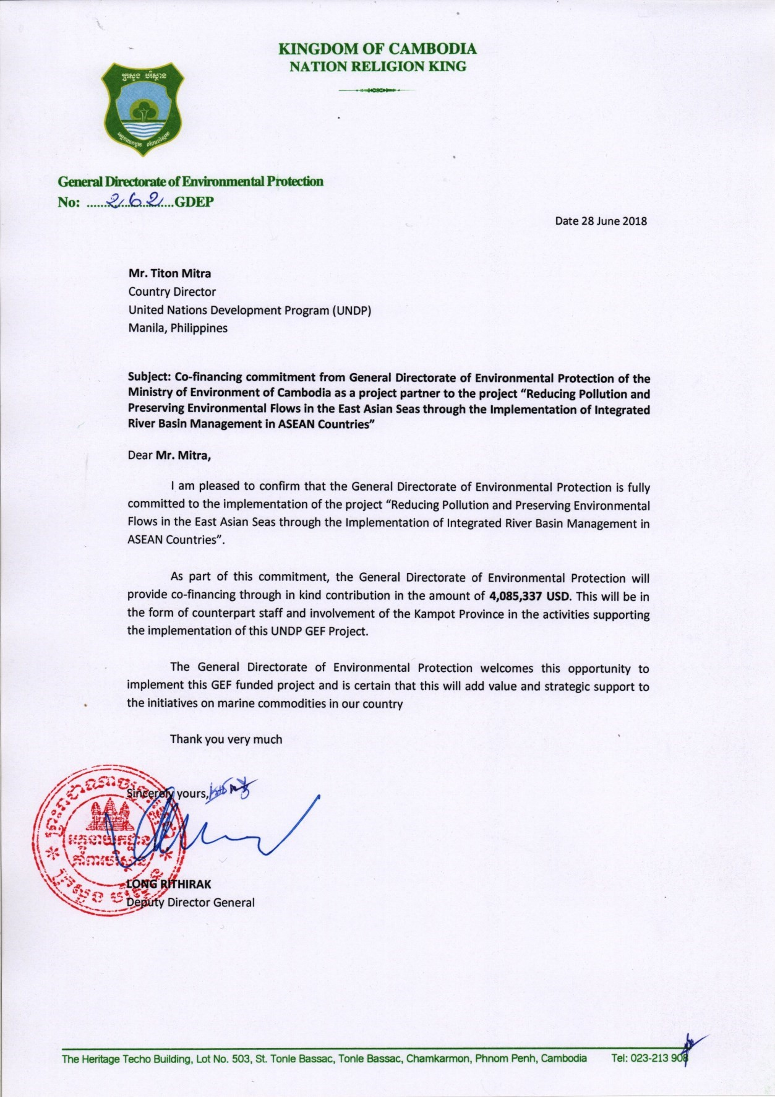

INDONESIA

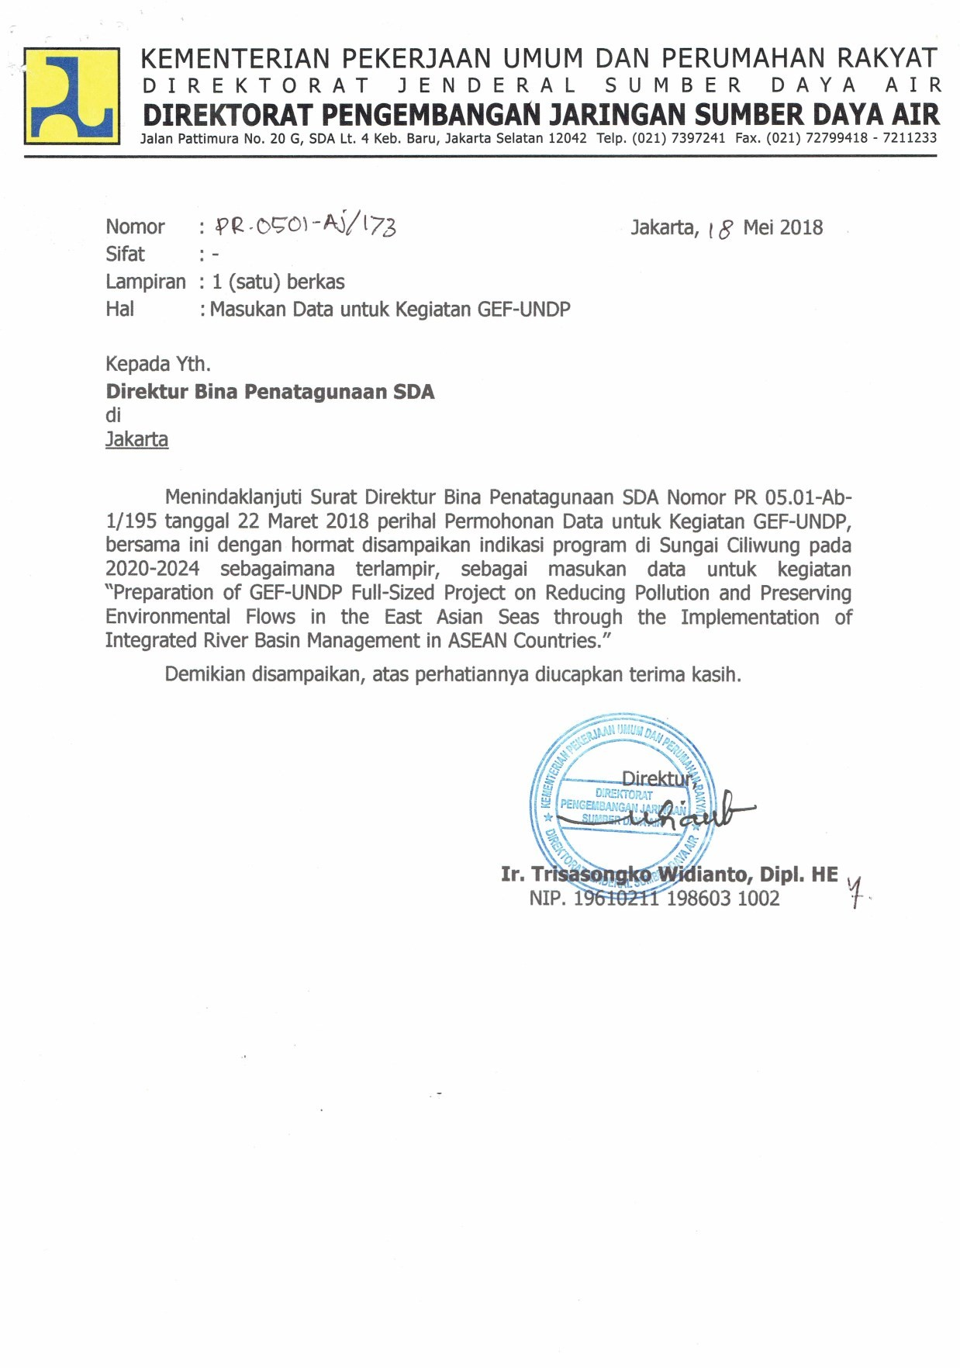
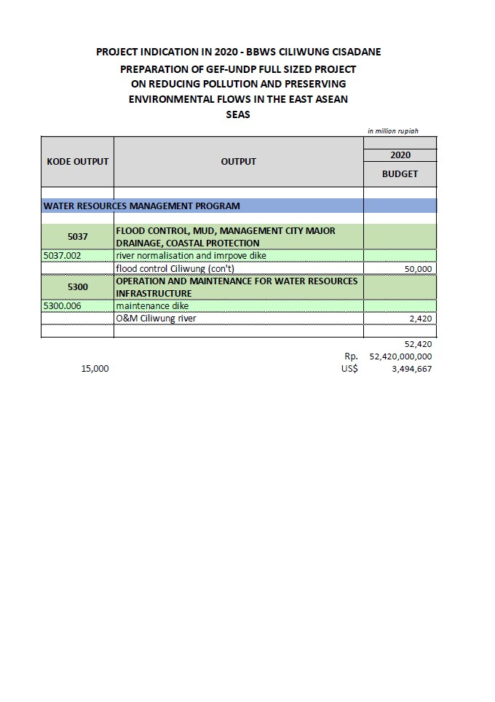
DEPOK CITY, INDONESIA

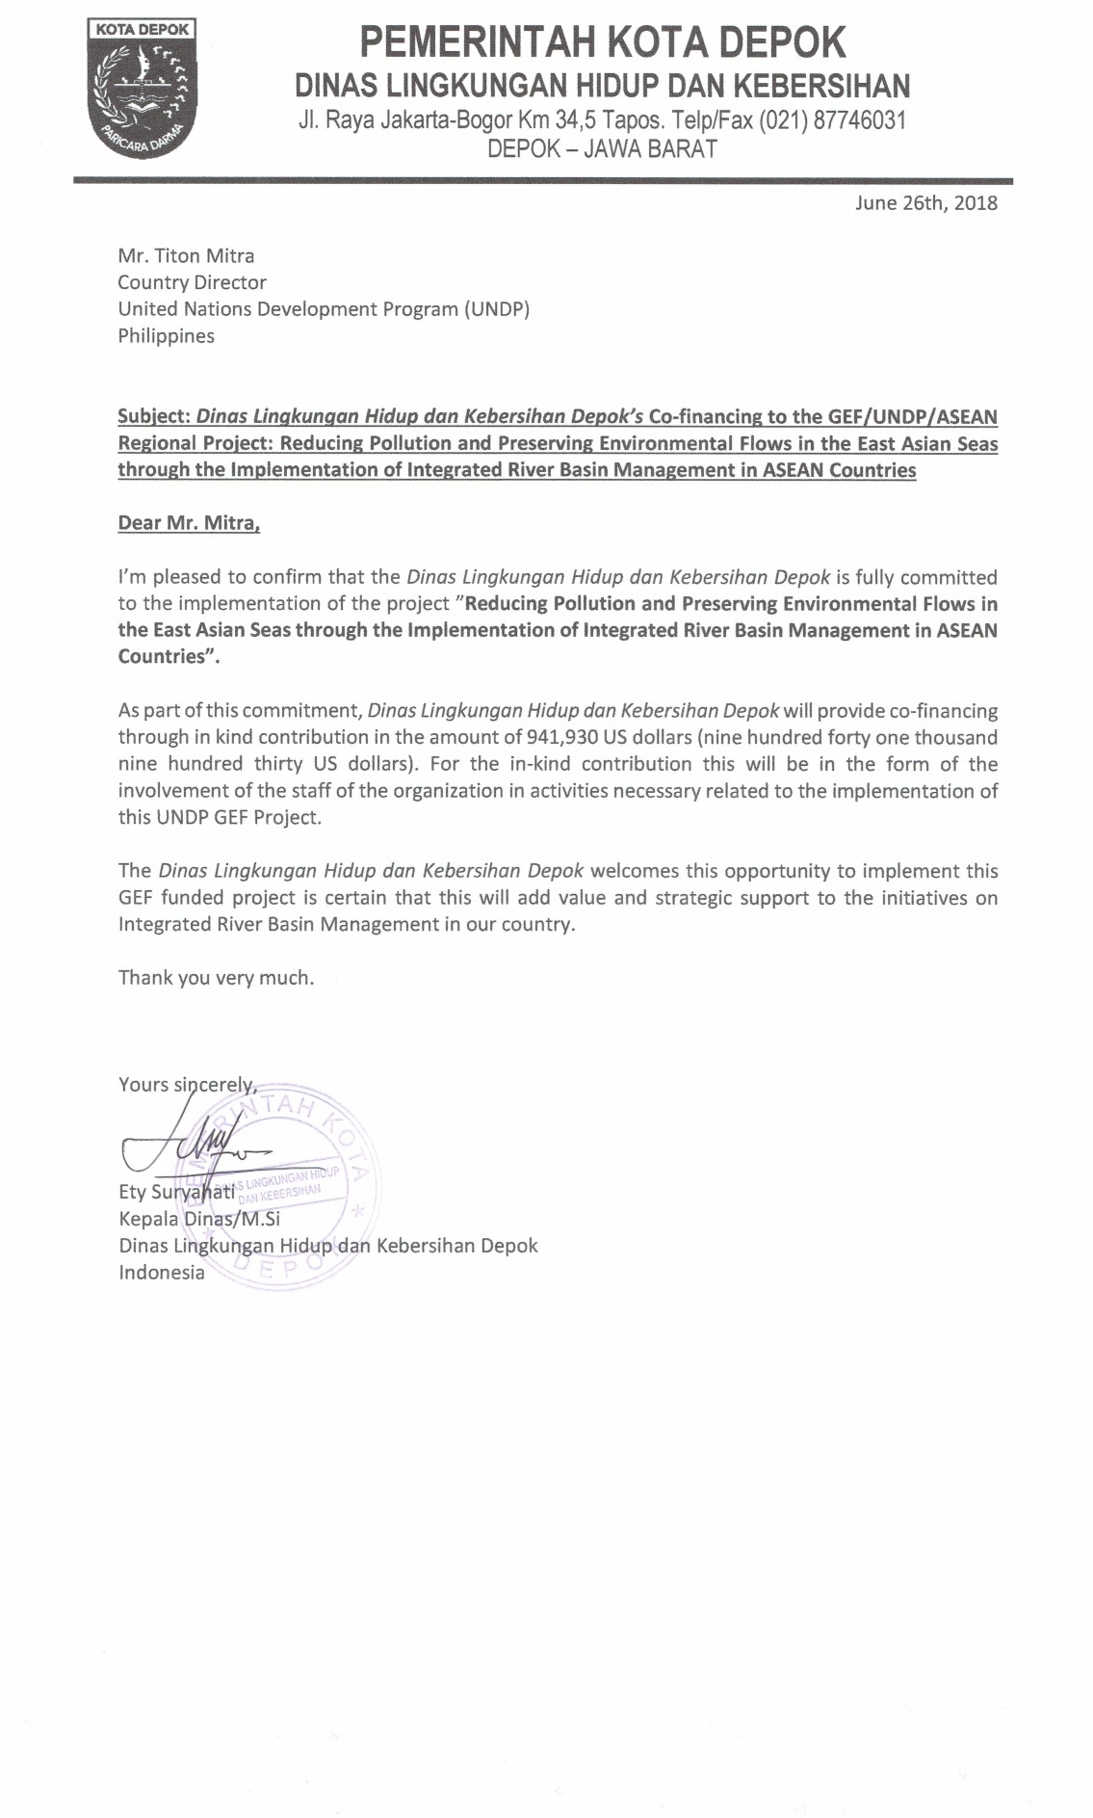

LAO DPR

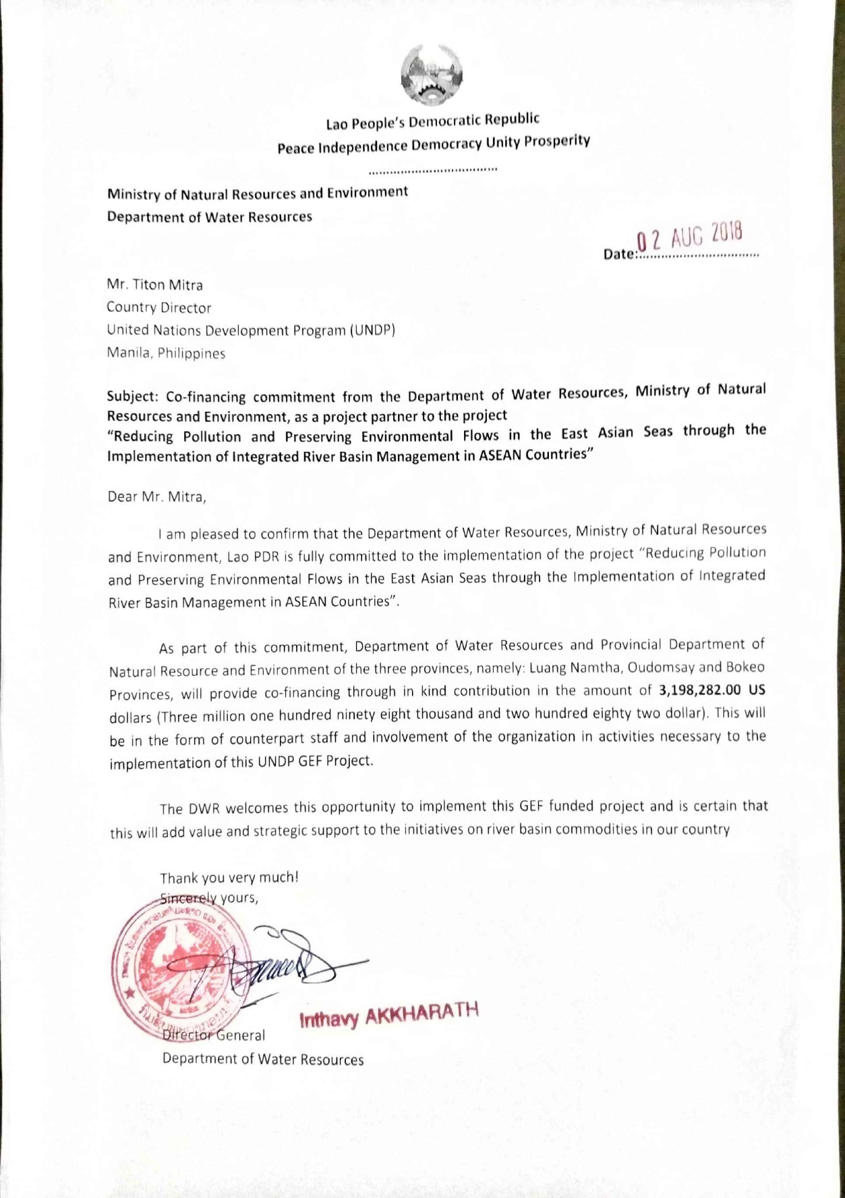

MALAYSIA

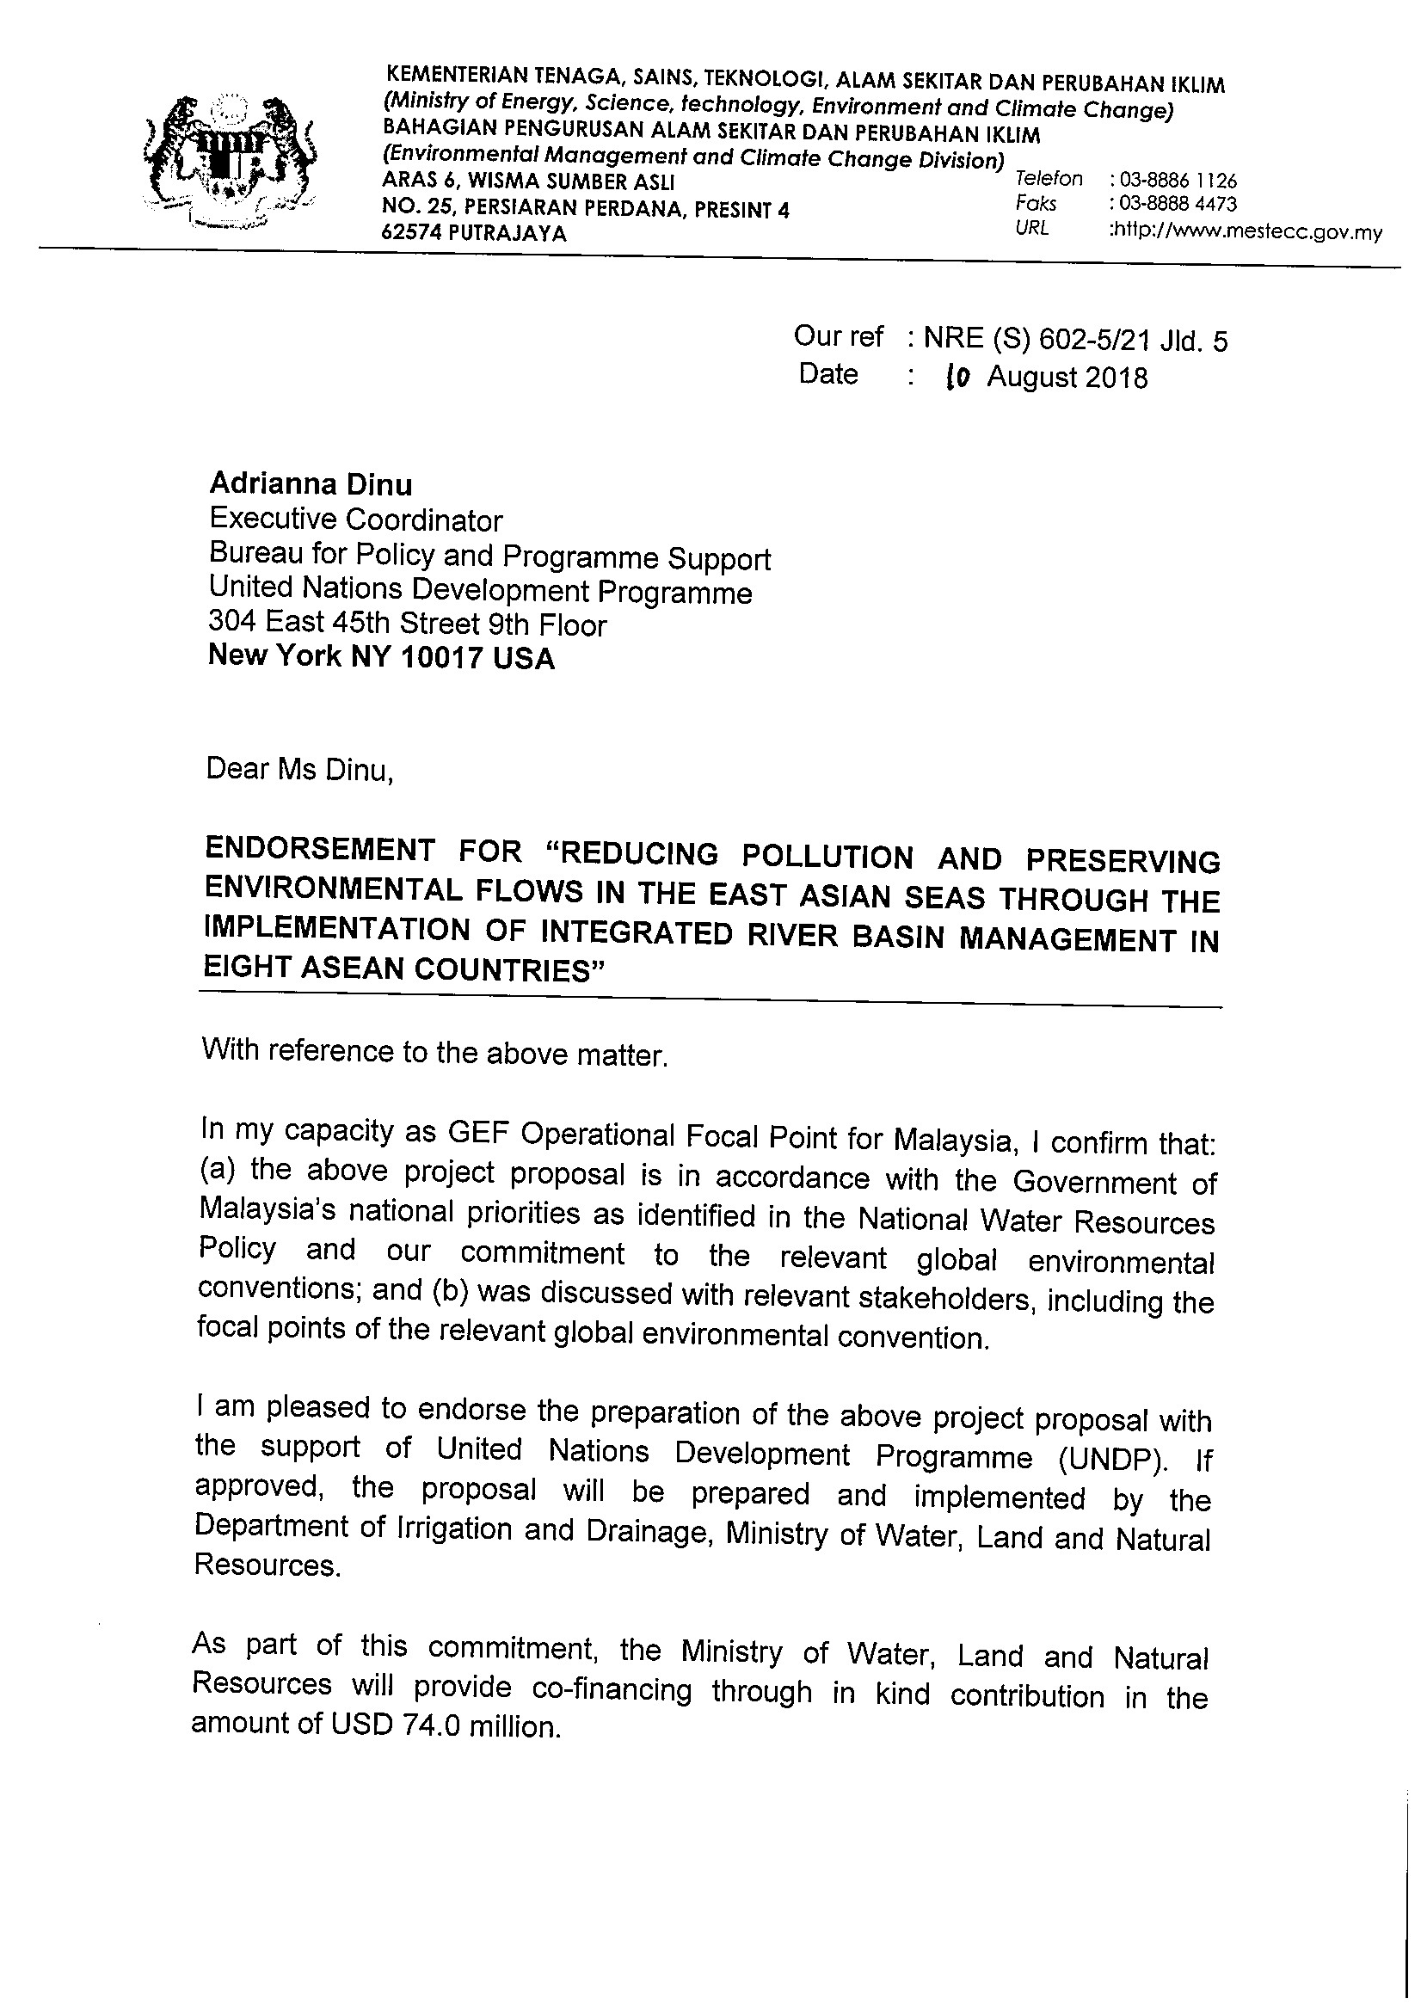
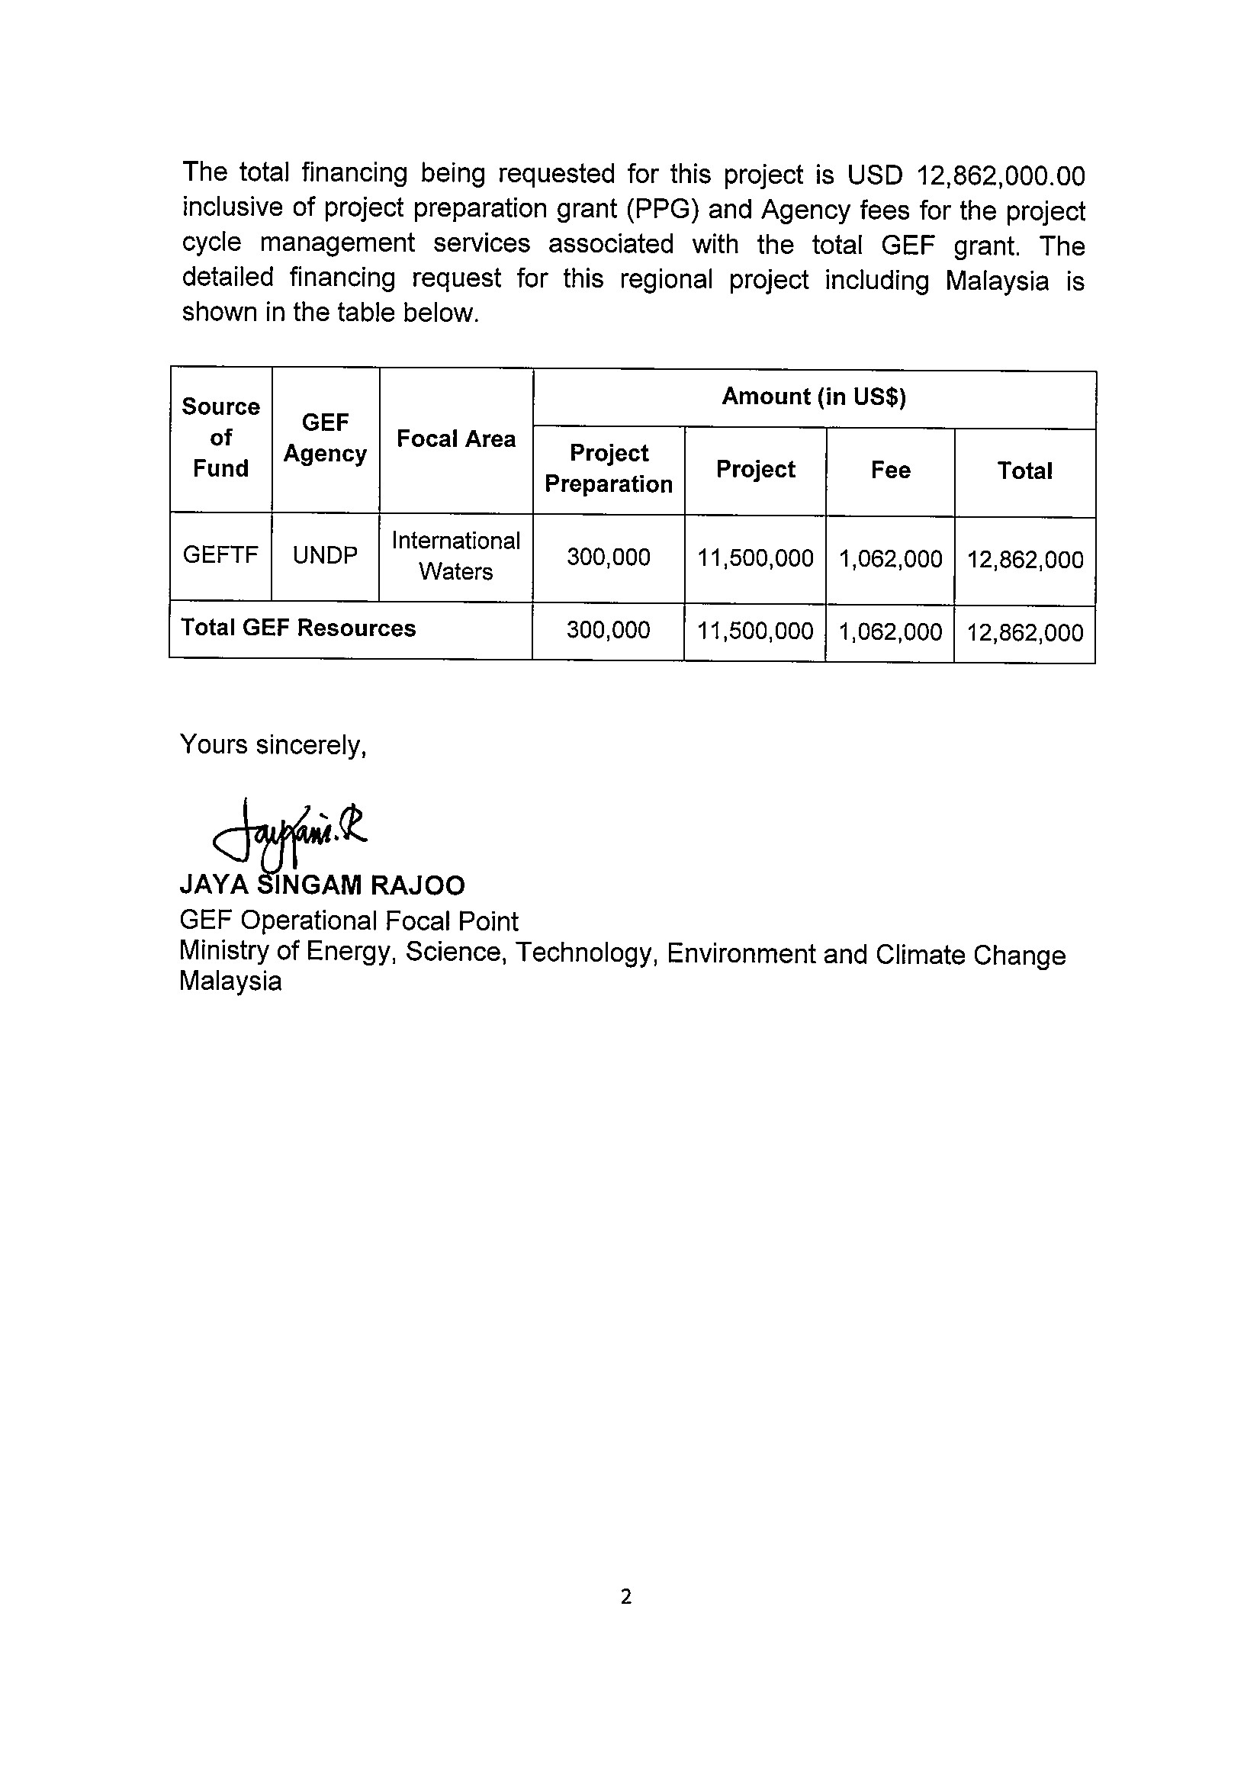

MYANMAR

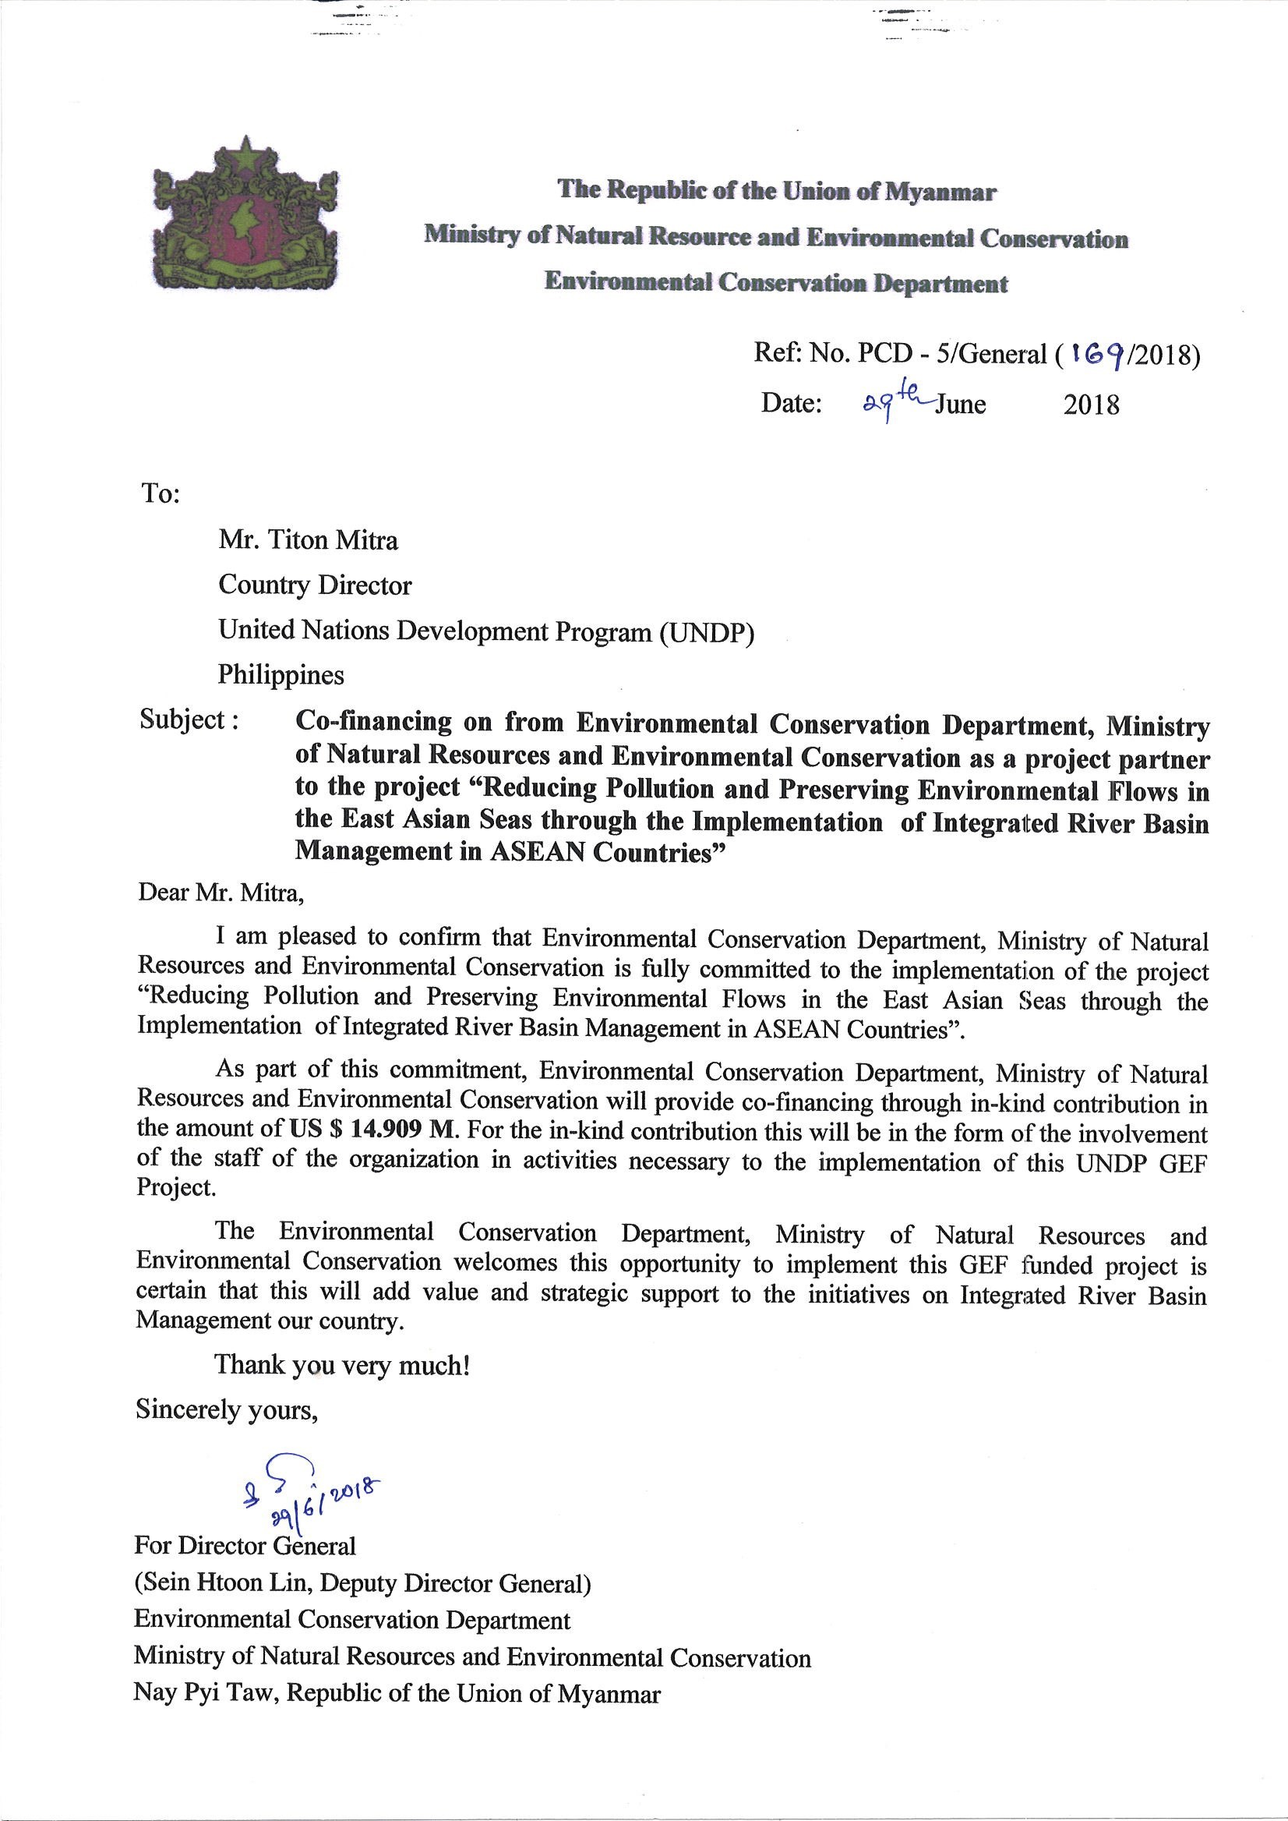

PHILIPPINES

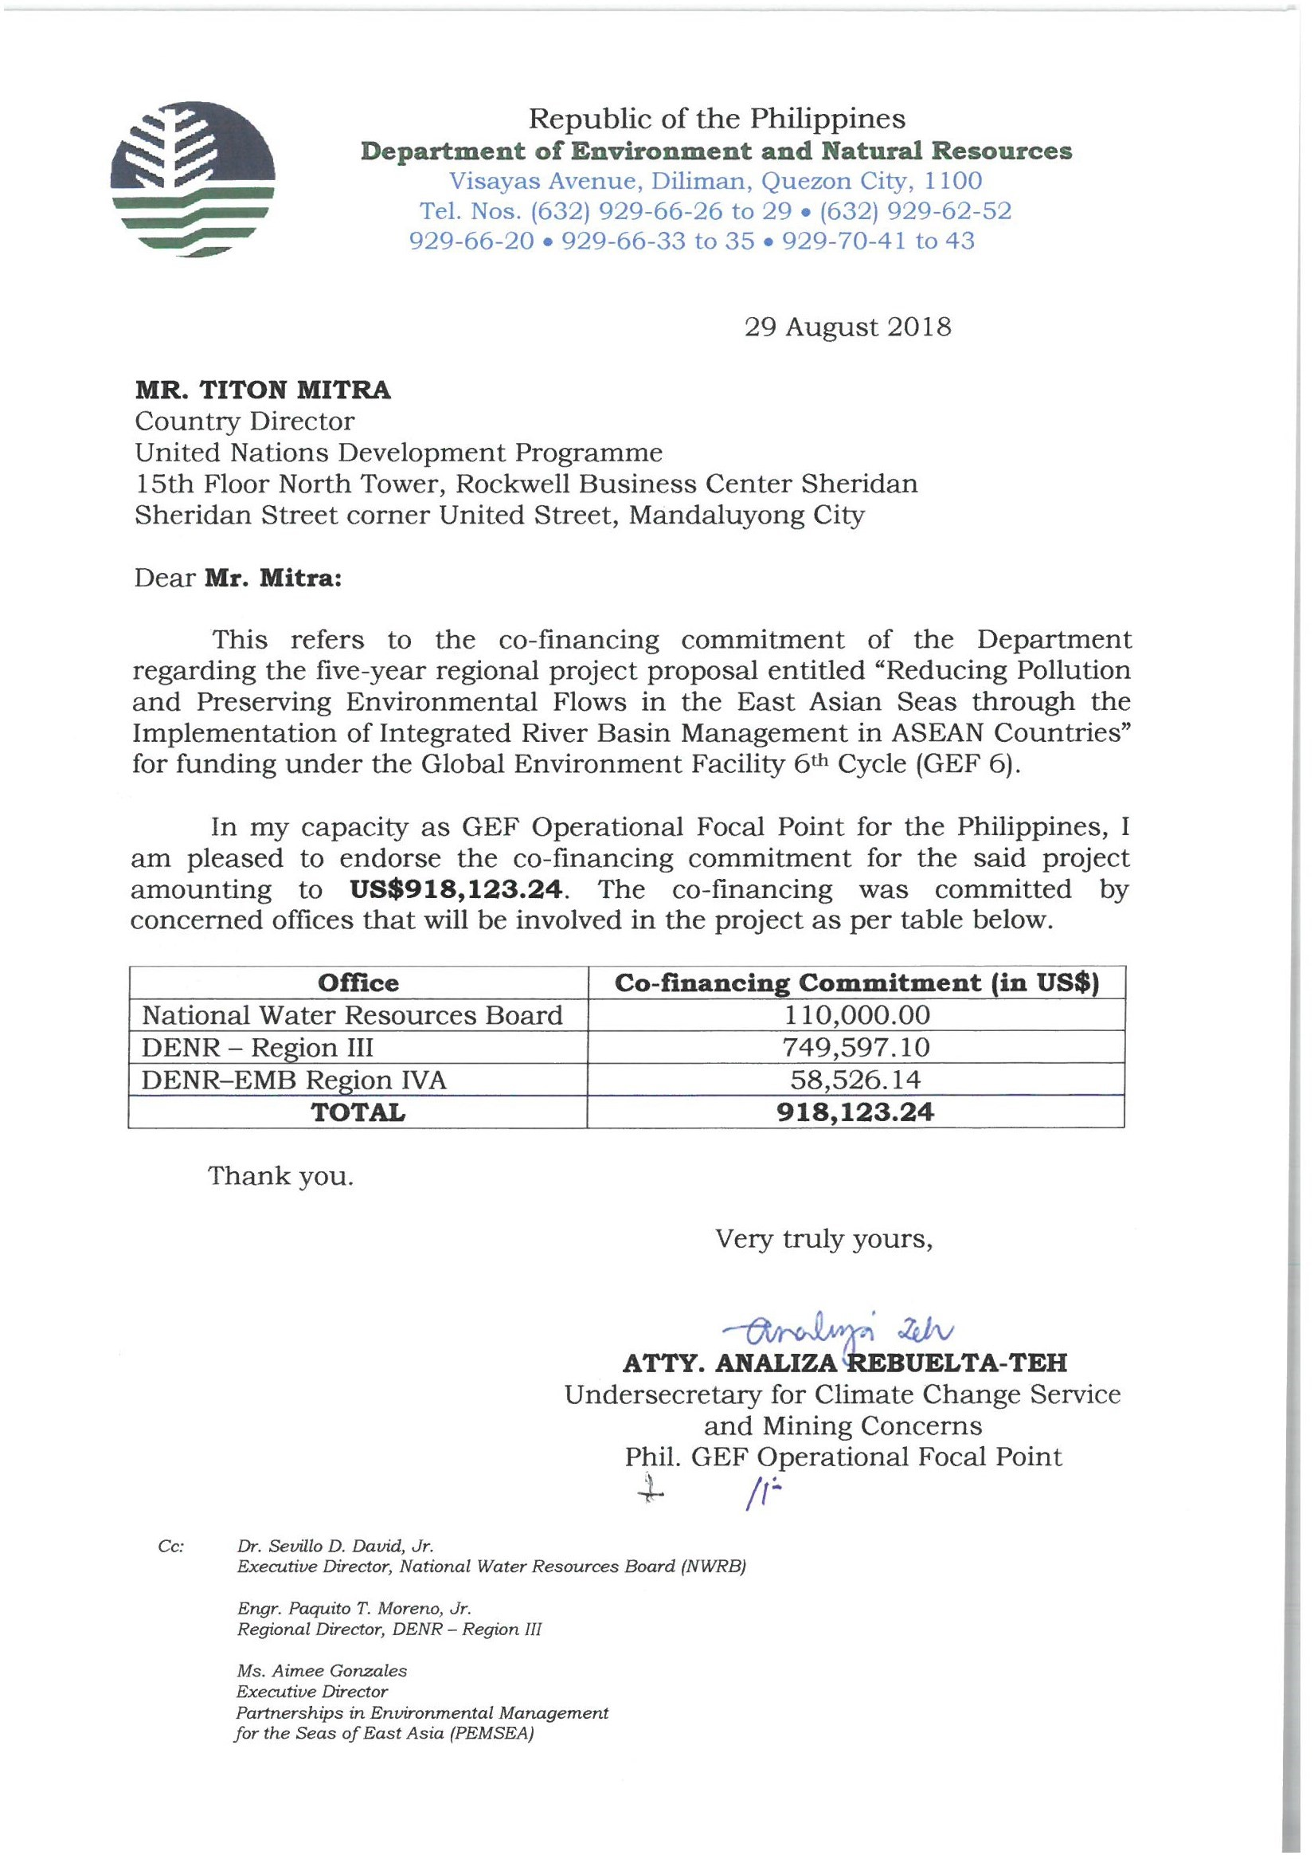

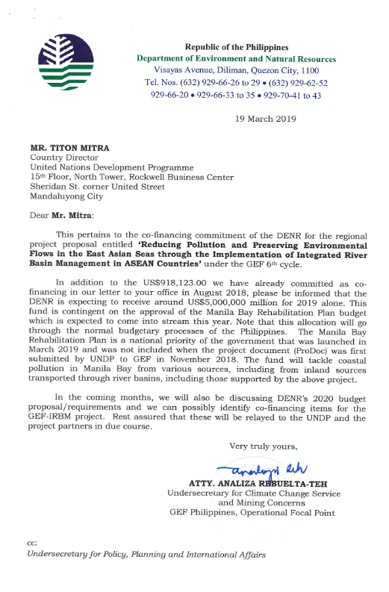

CITY OF GENERAL TRIAS, PHILIPPINES

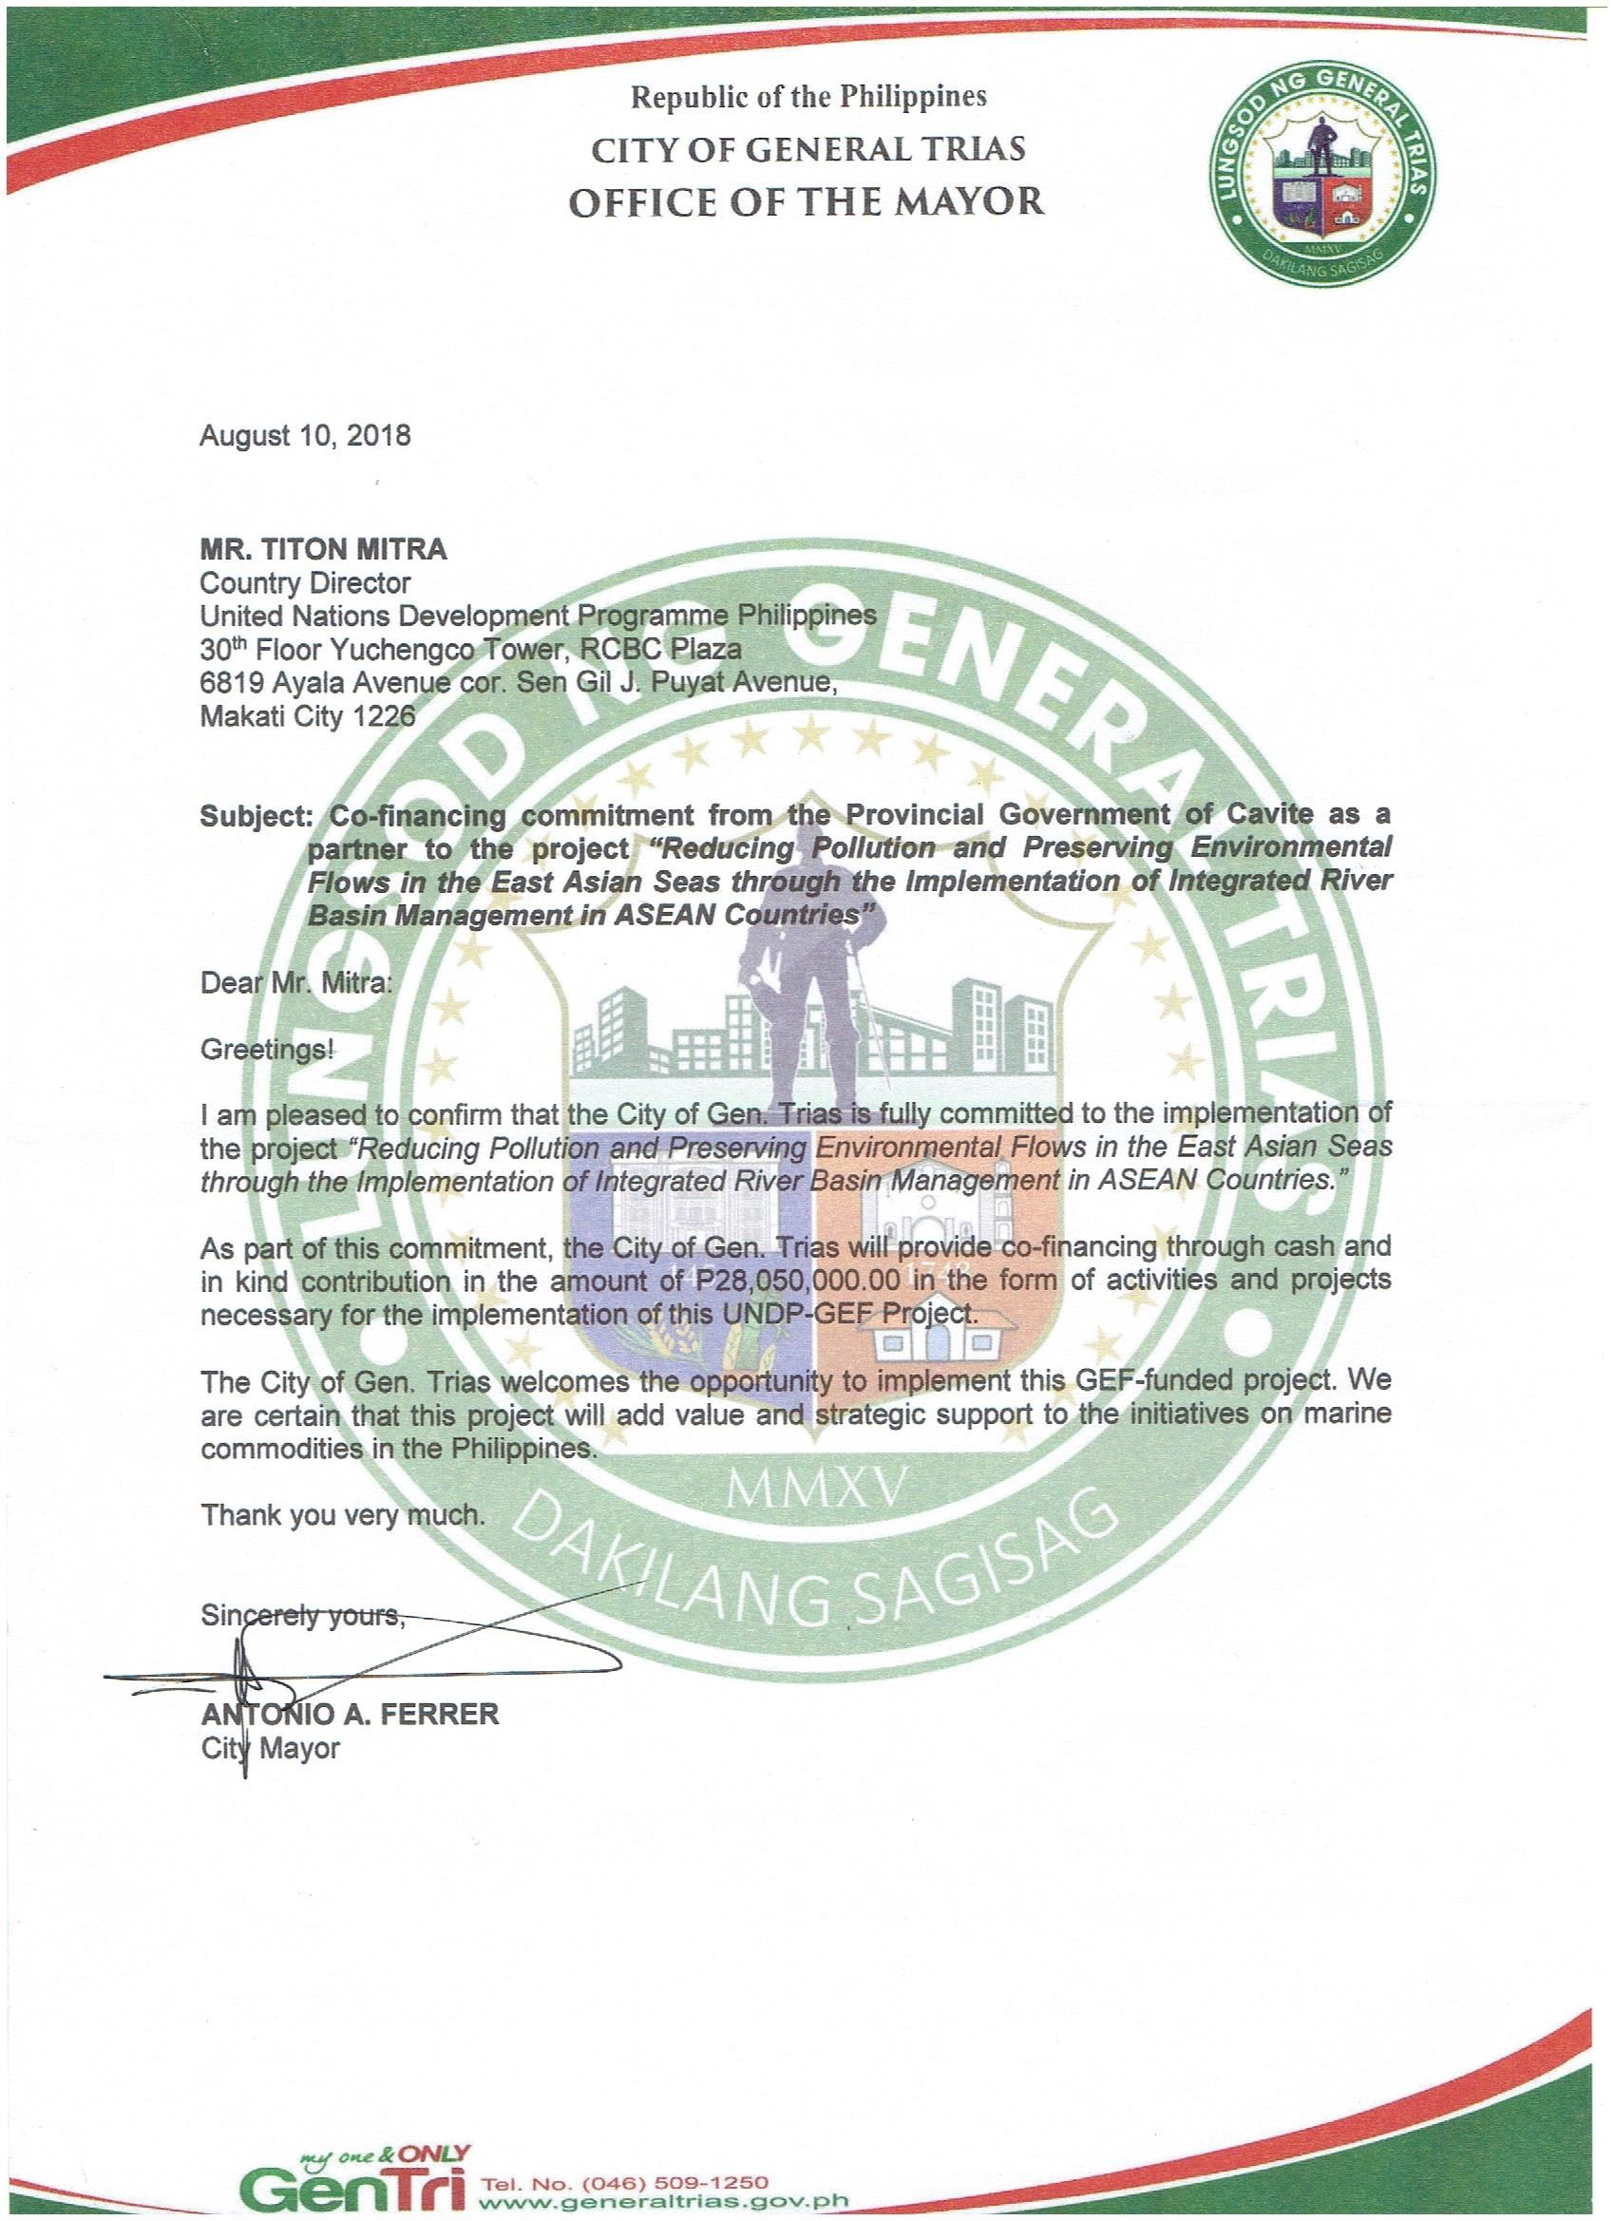
KOREA
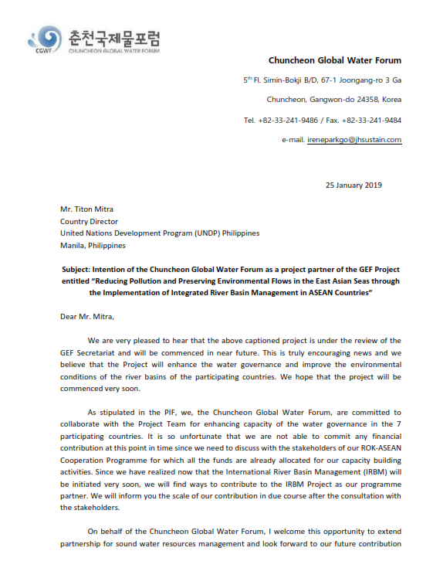

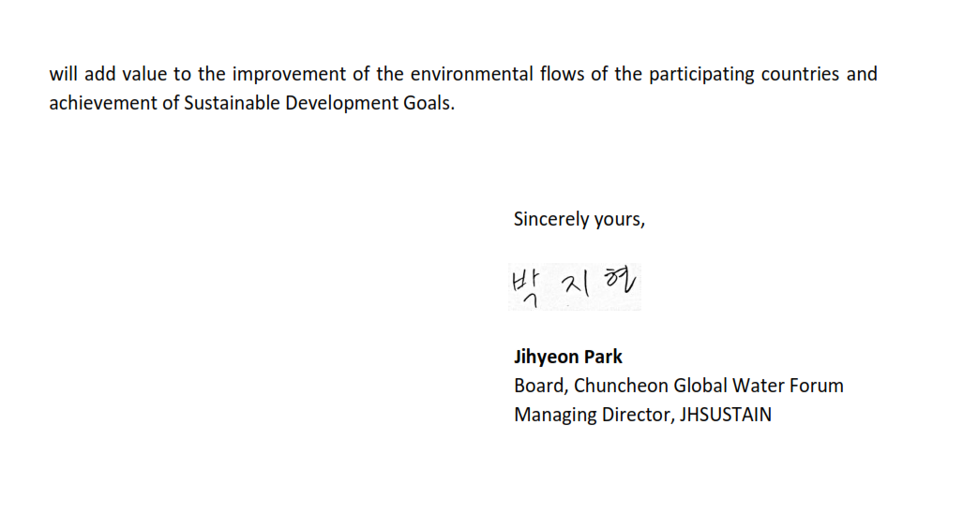

VIET NAM

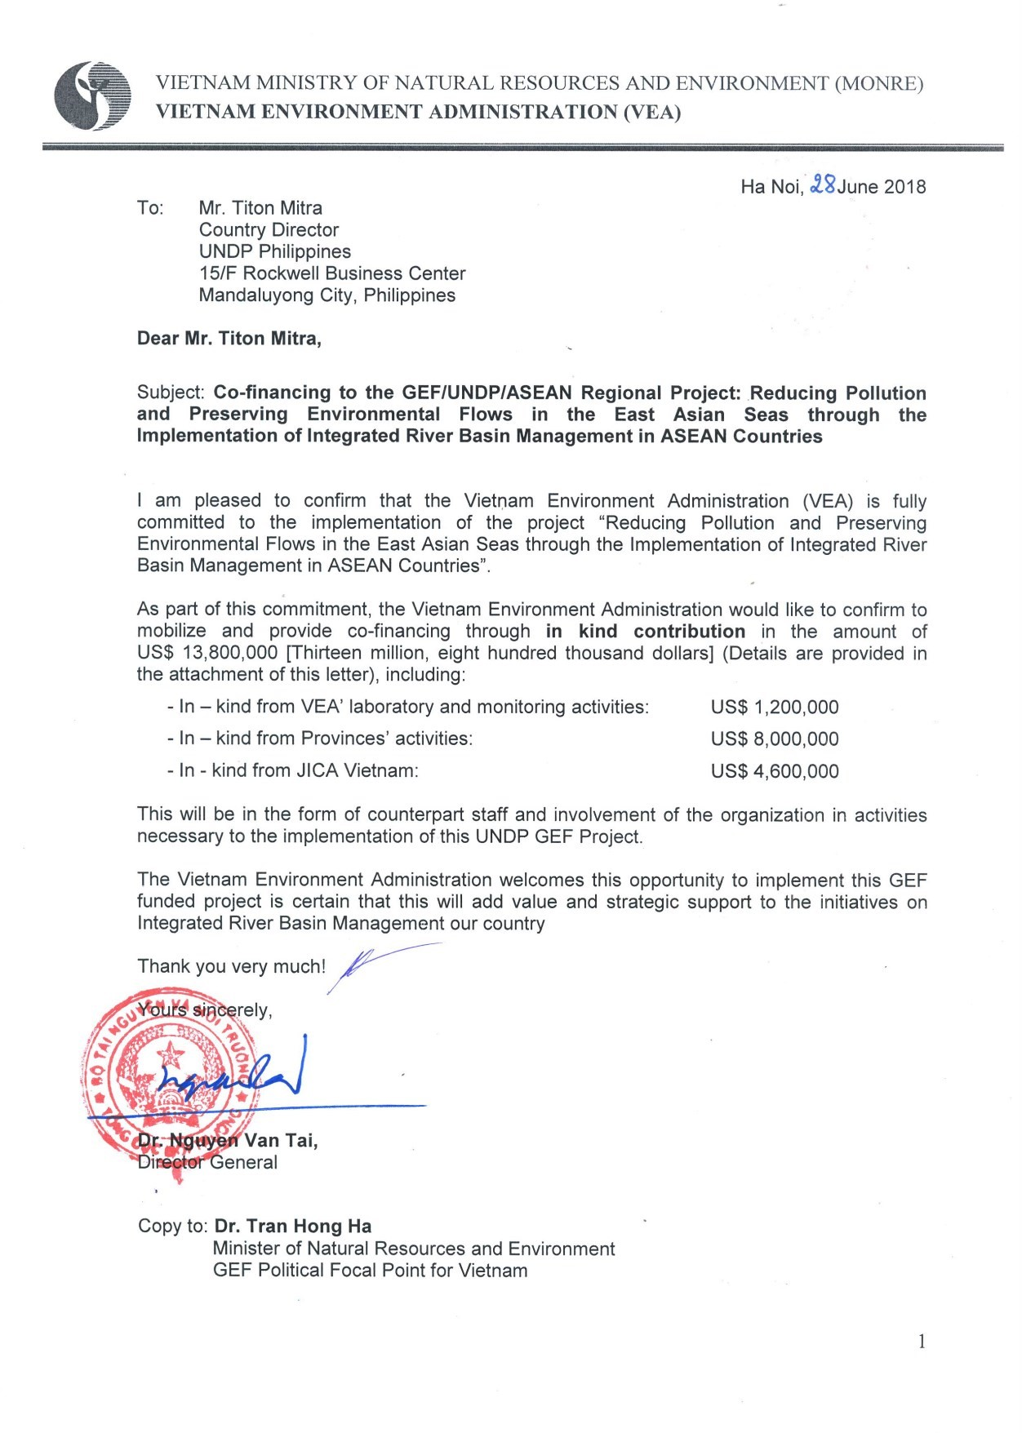
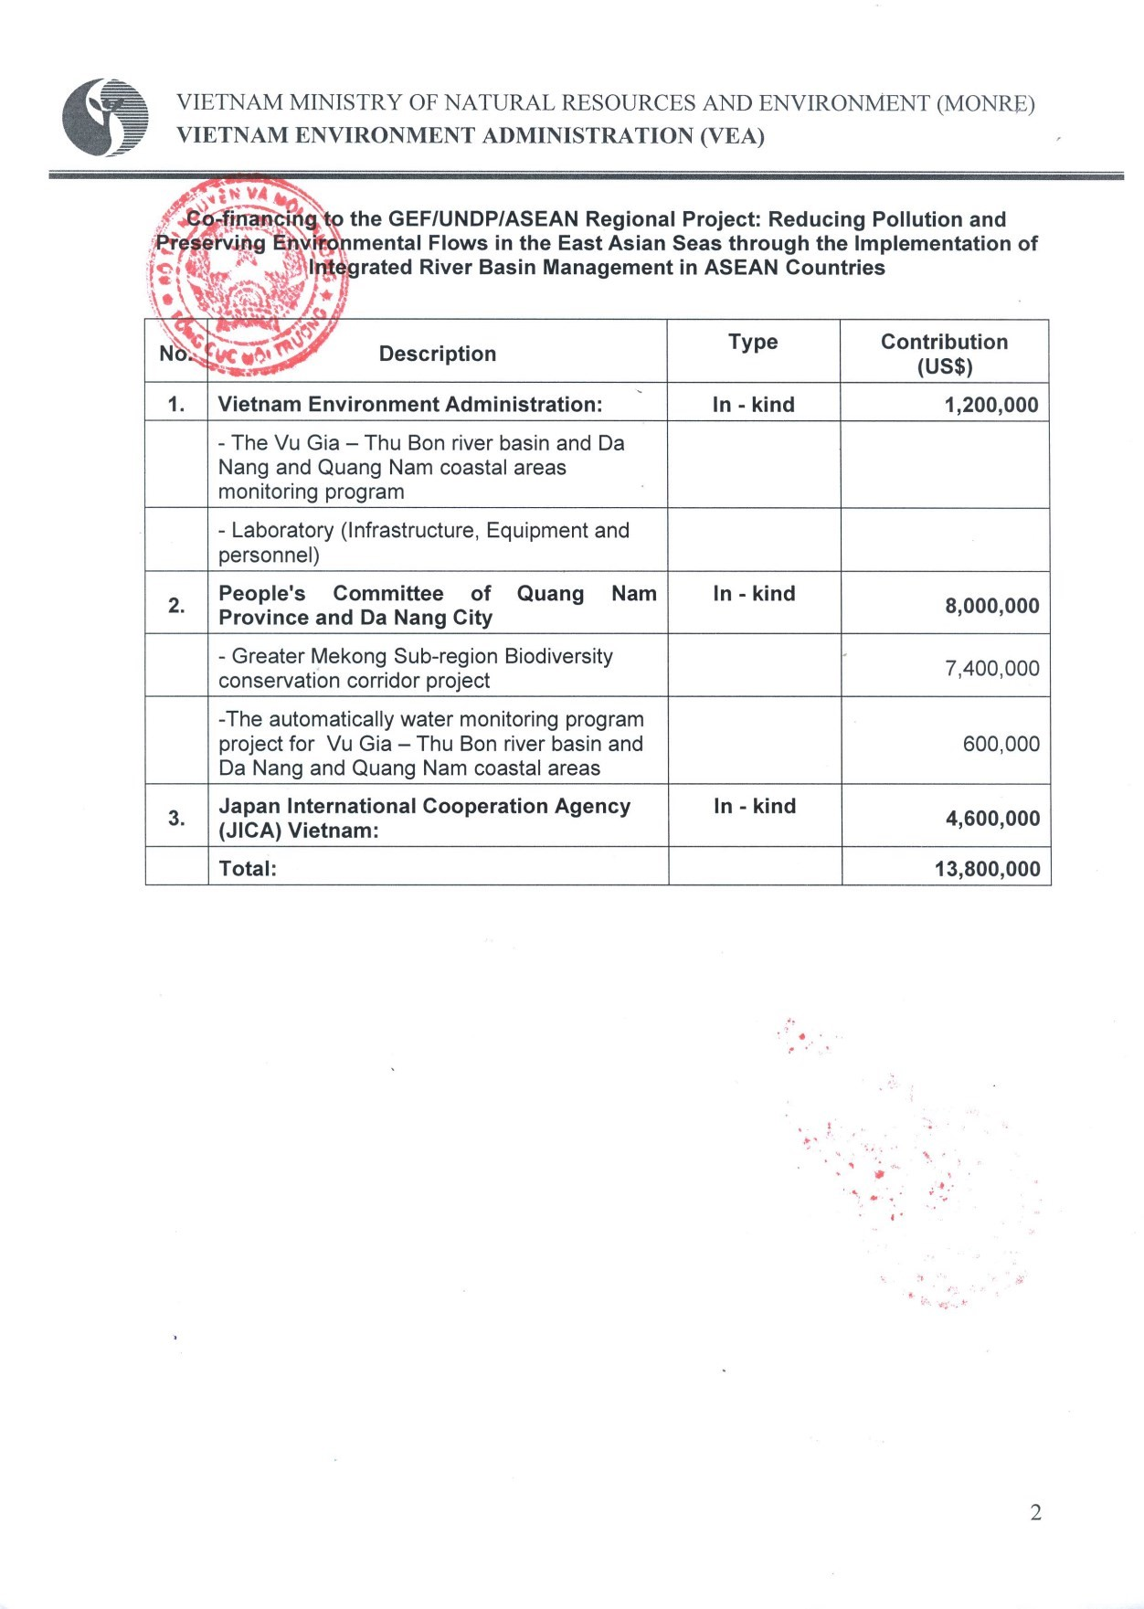

JAPAN INTERNATIONAL COOPERATION AGENCY (JICA)

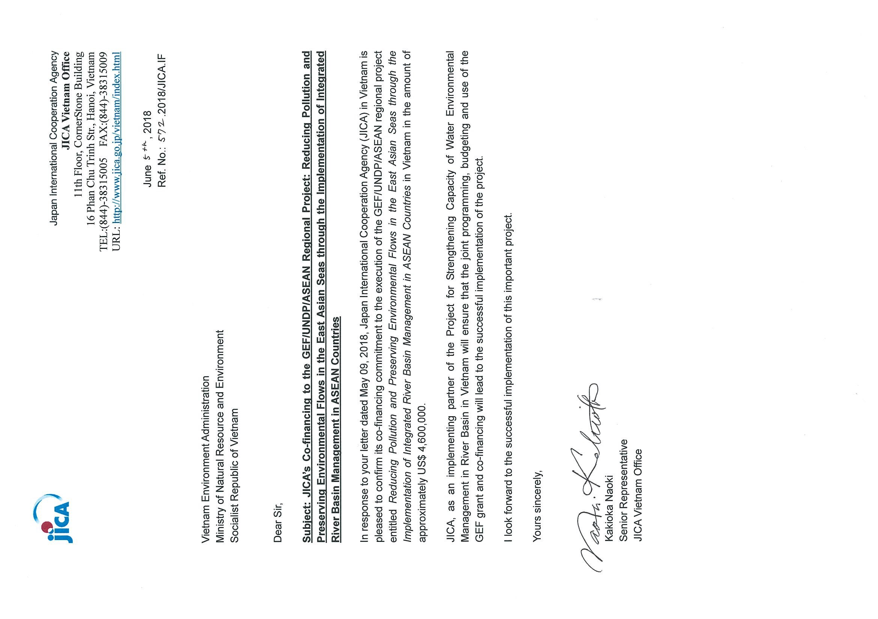
PARTNERSHIPS IN ENVIRONMENTAL MANAGEMENT FOR THE SEAS OF EAST ASIA (PEMSEA)

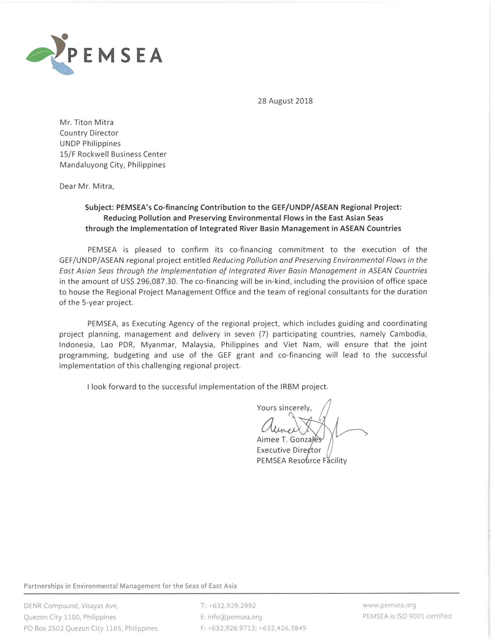

UNITED NATIONS DEVELOPMENT PROGRAMME (UNDP)

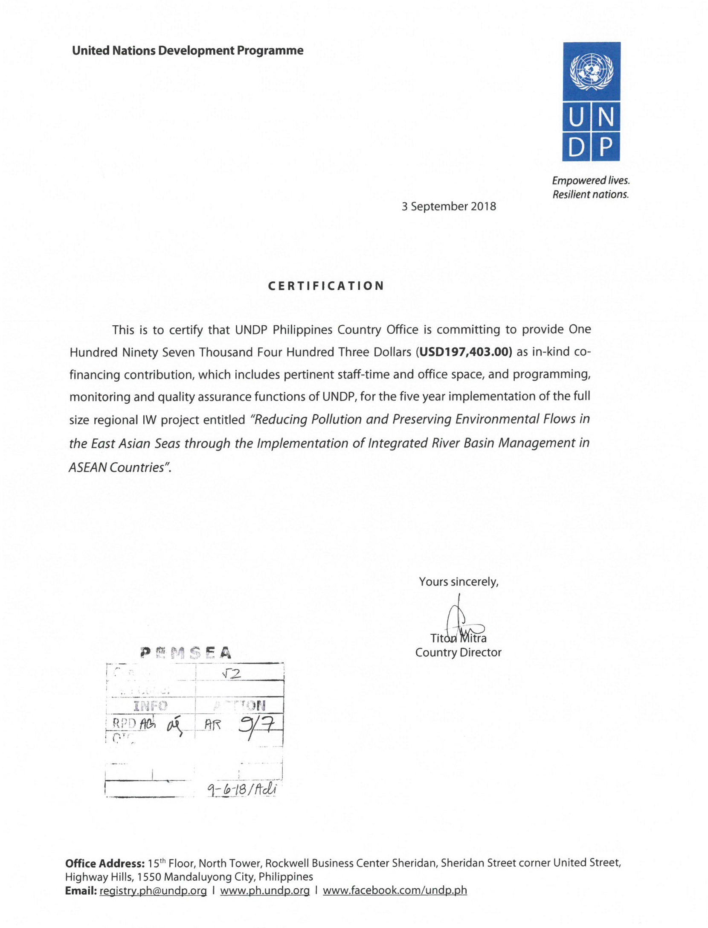

Annex K: National IRBM Pilot Project Proposals and River Basin Profiles

(Annex K is packaged in a separate document)

http://environment.asean.org/files/ASEAN%20Strategic%20Plan%20of%20Action%20on%20Water%20 Resources%20Management.pdf
Includes the following eight categories: environmental; financial; operational; organizational; political; regulatory; strategic; and other.
See http://www.undp.org/content/undp/en/home/operations/transparency/information_disclosurepolicy/
See https://www.thegef.org/gef/policies_guidelines
See https://www.thegef.org/gef/policies_guidelines
See https://www.thegef.org/gef/gef_agencies
See guidance here: https://info.undp.org/global/popp/frm/pages/financial-management-and-execution-modalities.aspx
Excluding project team staff time and UNDP staff time and travel expenses.
The costs of UNDP Country Office and UNDP-GEF Unit’s participation and time are charged to the GEF Agency Fee.
Prohibited grounds of discrimination include race, ethnicity, gender, age, language, disability, sexual orientation, religion, political or other opinion, national or social or geographical origin, property, birth or other status including as an indigenous person or as a member of a minority. References to “women and men” or similar is understood to include women and men, boys and girls, and other groups discriminated against based on their gender identities, such as transgender people and transsexuals.
In regards to CO_{2,} ‘significant emissions’ corresponds generally to more than 25,000 tons per year (from both direct and indirect sources). In collaboration with the
Forced evictions include acts and/or omissions involving the coerced or involuntary displacement of individuals, groups, or communities from homes and/or lands and common property resources that were occupied or depended upon, thus eliminating the ability of an individual, group, or community to reside or work in a particular dwelling, residence, or location without the provision of, and access to, appropriate forms of legal or other protections.

